This leaflet only gives general information. You must always discuss the individual treatment of your child with the appropriate member of staff. Do not rely on this leaflet alone for information about your child’s treatment.
This information can be made available in other languages and formats if requested.

Please have a look at our virtual prior to your visit. Here you will find - 360° walk-through of over 188,000 square feet of Alder Hey captured in 4K.
- 156 interactive 'hotspots'.
- 74 videos explaining what happens when you have a procedure or arrive for an appointment.
- Virtual signage to help you find your way around.

Alder Hey Children’s NHS Foundation Trust
Eaton Road
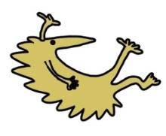
Liverpool
L12 2AP

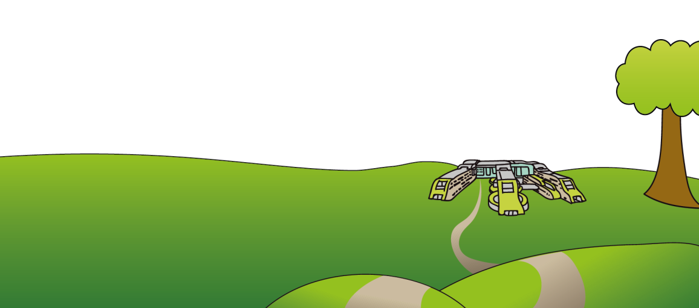
Tel: 0151 228 4811
www.alderhey.nhs.uk

© Alder Hey Review Date: May 2027 PIAG: 330

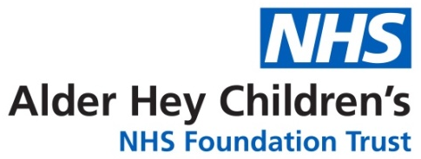

Major Trauma & Rehabilitation Service



Information for patients,

parents and carers

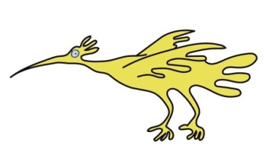
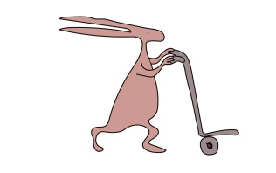

What is a Major Trauma Centre?
A Major Trauma Centre (MTC) is a specialised hospital which has the best available skills and equipment to treat patients who have sustained unplanned traumatic injuries.
Alder Hey is a Children's (Paediatric) Major Trauma Centre within the North West Regional Trauma Network. We receive and care for children from the North West, North Wales and the Isle of Man, 7 days a week. Children can be brought to us directly or transferred to us from a local hospital.

What to expect when you first arrive
Upon arrival at Alder Hey, your child’s injuries will be assessed either in the Emergency Department or on the ward. To do this quickly, there may be doctors from different specialties and people performing many tasks at the same time.
This may be very frightening and disorientating for you and your child, but it is necessary to ensure that they are given the best care as quickly as possible. This may include scans, X-Rays, or further investigations. In ED, you will be able to speak with the medical team and will be given updates by specialist nurses along the way.
You will also meet the Major Trauma Rehabilitation Coordinator Team and will be allocated a keyworker. The keyworker will be your link throughout your stay and support you to discharge and beyond Alder Hey.

Rehabilitation
When we talk about serious injuries we often think about broken bones, head, and spine injuries. However, serious injuries can

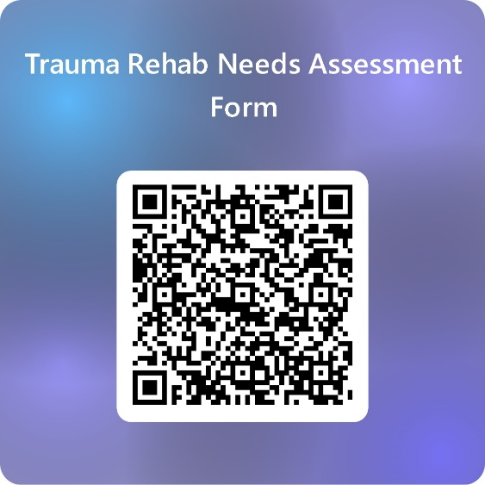

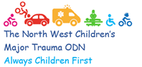 | 
 | 
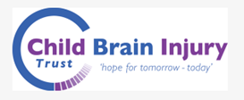 | 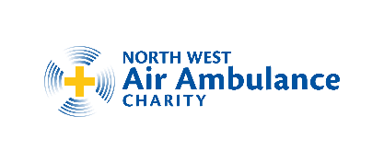
Follow us on Twitter: @AHTraumaRehab | 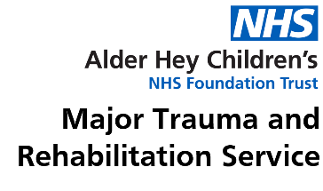

Notes and questions
Please use the space below to write any extra information or questions you want to ask your keyworker:

also involve internal organs, such as lungs, liver, spleen, and soft tissue such as muscle and skin. Our aim is to get your child back to, or as close to, their pre-injured health so you will engage with a range of rehabilitation specialists who will help to optimise your child’s recovery from their injuries. This may often include physiotherapists, occupational therapists, speech & language therapists, and psychologists. We will discuss and keep you up to date with your child’s individual rehabilitation plan throughout your stay. This will all be documented on your child’s rehabilitation prescription.

Support to family and siblings
Our team of Major Trauma Rehabilitation Coordinators are also here to help and assist with aspects of care for the family and siblings of an injured child as we are very aware that this experience can be very unsettling for everyone. Please reach out to them, don’t struggle.

Returning home
When you and your child are ready to return home a supportive and comprehensive discharge plan will be discussed. On discharge we will complete your child’s rehabilitation prescription, and you will receive a copy of this along with timescales for a follow up call. However, the team are available for you to contact should you need to speak to them sooner.
As part of our keyworker role, we will liaise with nursery or school with regards to formulating a plan for their return. This advice will also include returning to activities and/or sport.

Useful information about our hospital

Parking
The main entrance to Alder Hey is on East Prescot Road. If you’re travelling by car, please use the sat-nav postcode L14 5AB.
Cars should enter the hospital site from East Prescot Road and use the drop-off facilities near the East Prescot Road entrance, or use the multi-storey car park, which has its own entrance to the hospital via the lifts/stairs. The multi-storey car park has seven levels. The entrance to the hospital from the multi-storey car park is on the ground level.
Please note: There is a height restriction of 2.2 metres for our multi-storey car park.
Car Park Fees
Up to 30 minutes | Free
30 minutes to 2 hours | £3.50
2 to 6 hours | £5.00
6 to 8 hours | £6.00
8 to 24 hours | £8.00
Blue badge holders are not required to pay for parking.
Our multi-storey car park uses ANPR technology. When you arrive, you will be let in automatically (or issued a ticket if your vehicle registration is not picked up). You can pay for your parking in cash or with a debit/credit card at the machine in the atrium or by card at the barrier. At the pay station, enter your vehicle registration number and the charge for your stay with be displayed.
Useful numbers
Major Trauma and Rehabilitation Service
* majortrauma@alderhey.nhs.uk, or

* ahc-tr.major.trauma@nhs.net

( 0151 252 5821 (Ext: 2821)

Available Monday - Friday, 8am - 4pm

Your Coordinator is:

There may be times when you feel very much alone, especially when so much is happening to help your child, and you may struggle because you feel that you are unable to be in control of what is happening, as you always have been.
As a team, we offer a 24/7 service to anybody who feels that they may need to unload these feelings, to pray, or to have a chat. You may feel the need for some non-clinical support or just need a listening ear during your time in the Trust.
If so, then at any time, day or night, ask a staff member to contact an on-call member of the Spiritual Care team via switchboard.
Alternatively, visit the Sanctuary which is always open.

Patient Advice and Liaison Service (PALS Team) concerns and complaints
Our PALS team will speak to you about any concern you want to discuss. You can visit them in person in the hospital atrium near the treehouse from 9am to 5pm, Monday to Friday.

Or you can call them on:
PALS Team: 0151 252 5161
PALS@alderhey.nhs.uk
Write to PALS, Alder Hey Children's NHS Foundation Trust,
Eaton Road,
Liverpool,
L12 2AP

For Complaints. Please email complaints@alderhey.nhs.uk

If you are a Blue Badge holder, please have this to hand to scan the barcode on the exit barrier. If your blue badge does not have a barcode, please visit the concierge desk.
Overnight/long stay patients
In order to stay with your child while they are an inpatient, you can register for free parking at the concierge desk.
For frequent outpatient visitors, parking will be provided free to all those who come to our hospital for an appointment at least 3 times within a month, and for an overall period of at least 3 months. A ‘month’ is defined as a period of 30 days.
Please report to concierge desk to log your vehicle details.

Staying overnight
Patient bedrooms have been equipped with special parent beds, funded by Alder Hey Children’s Charity, so one parent or carer can stay overnight.

Self-catering on wards
Each ward has a kitchen area where parents/carers can make a hot drink, prepare food or heat up baby milk.

Free Wi-Fi
Free Wi-Fi is available to our patients and families throughout the hospital and our health campus. Just search for ‘Alder Hey Free Wi-Fi’ on your tablet, phone or laptop.

Visiting hours
Ward | Parents/carers | Other visitors
3A | 24 hours visiting | 1pm – 7pm
3B | 24 hours visiting | 1pm – 7pm
3C | 24 hours visiting | 1pm – 7pm
4A | 24 hours visiting | 1pm – 7pm
4B | 24 hours visiting | 10am – 7:30pm
4C | 24 hours visiting | 10am – 7:30pm
PICU and HDU | 24 hours visiting | 1pm – 7pm

Cash Office
In the atrium near the car park entrance, our Cash Office can help with queries about travel expenses. You’ll also find a free-to-use cash machine here. If the cash machine is not working, there are cash machines at the Sainsbury’s supermarket across East Prescot Road.

Shops and Restaurants
Treetops Restaurant
Coffee and Deli
 | Monday to Friday | Saturday & Sunday
Breakfast | 7:30am – 10:30am | 8am – 10:30am
Lunch | 11:45am – 2pm | 11:45am – 2pm
Evening | 3:45pm – 6:45pm | 2:30pm – 6pm
The Deli Bar opens Mon to Fri: 11am to 3pm

Teas and coffees and a range of fresh snacks, salads and sandwiches are served throughout the day.
There are coin-operated vending machines available 24 hours a day. The Atrium also has the following outlets:
The Baguette Co. | Monday to Friday | 8:30am – 4pm
Costa Coffee | Monday to Friday  Saturday  Sunday | 7am – 6pm  9am – 4pm  10am – 3pm
WHSmith (with a Marks and Spencer outlet) | Monday to Friday  Saturday/Sunday | 7am – 8pm  9am – 6pm

Ronald McDonald House
Ronald McDonald House is an independent charity which provides free on-site accommodation for families. This is usually only offered to parents who will have a child staying with us for a prolonged period and those that are not local to the hospital. The ward staff will usually approach you about this option.
Tel: 0151 252 5869
Spiritual Care Team – The Sanctuary (Tree House)
The Spiritual Care Team are here for all families, whether they profess any sort of religious affiliation or faith but may feel in need of some support. We are based in the lower floor of the Tree House, accessed via the purple lifts to the second floor.
The Sanctuary is offered as a quiet space for anyone who may feel the need to pray or who may just feel the need to seek some respite away from the stress and pressure of life in the hospital.

