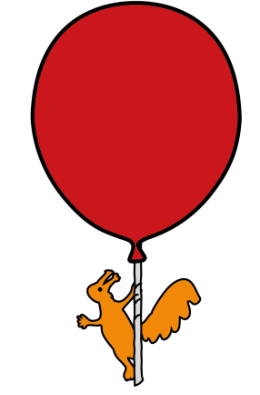
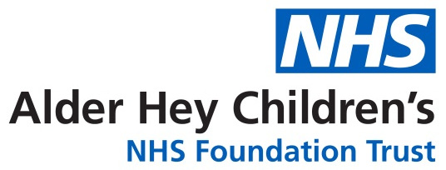

Ear, Nose & Throat

Information for patients who have attended Alder Hey ED with a Nasal Injury

Information for Parent/Carer

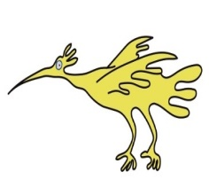
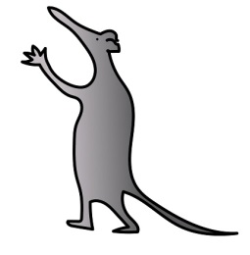

What to do next?
Your child may have sustained a nasal fracture. Here is what to look out for, and when and how to book an appointment with our ENT team if required.

What you should do now:
• Apply an ice pack wrapped in a cloth
• Use appropriate pain relief (e.g., paracetamol or ibuprofen)
• For nosebleeds: pinch the soft part of the nose, lean forward and hold for 10 minutes
• Avoid strenuous exercise and contact sports for at least 2 weeks

WHEN TO SEEK URGENT HELP!
• Persistent nosebleed not stopping after 15 minutes despite first aid measures
• Clear, watery fluid leaking from the nose
• Severe headache, eye pain, or vision problems
If you experience any of these symptoms, please go to your nearest Emergency Department

Once the swelling goes down (can take up to 3 days), these are signs you may have a nasal fracture:
- A crooked or “wonky” nose
- Difficulty breathing through the nose

How to book an appointment with ENT:
Step 1: Email the administrative team or call 0151 252 5302
Please send an email to: ENT@alderhey.nhs.uk
In your email, include:
- SUBJECT: Suspected nasal fracture
- Your child’s full name
- Date of birth
- A contact phone number
- Date of injury
- Brief description of how the injury occurred and your child’s current symptoms

Step 2: Appointment Confirmation
Once we receive your details, the ENT team will review your referral. If an appointment is required, we will contact you with a date and time, usually within 1–2 working days, by telephone or text message.

Please try to attend the first appointment offered, as nasal fractures need to be reviewed within a short time frame for best management.
Important: Timing Matters
We recommend review by ENT within one week of injury for optimal treatment options. After 2 weeks, the bones begin to set and moving them back into place may no longer be possible.

What may happen at your ENT appointment:
- Examination of your nose inside and out
- If a nasal fracture is confirmed, treatment options will be discussed. Depending on the injury and the child’s age, this may be performed in clinic with local anesthetic or as a short procedure under general anesthetic.
- Advice on healing, pain relief, and precautions

Key points:
- Early review helps to decide on best treatment options
- Please see the section above for symptoms that need urgent medical attention.
- Book with ENT for breathing problems or persistent appearance concerns
This leaflet only gives general information. You must always discuss the individual treatment of your child with the appropriate member of staff. Do not rely on this leaflet alone for information about your child’s treatment.
This information can be made available in other languages and formats if requested.

Please have a look at our virtual map : https://virtualtour.visual-eyes.co.uk/tour/alder-hey-childrens-hospital prior to your visit. Here you will find - 360° walk-through of over 188,000 square feet of Alder Hey captured in 4K.
- 156 interactive 'hotspots'.
- 74 videos explaining what happens when you have a procedure or arrive for an appointment.
- Virtual signage to help you find your way around.

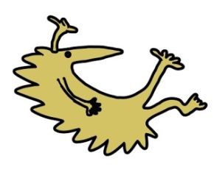
Alder Hey Children’s NHS Foundation Trust
Alder Hey
Eaton Road
Liverpool
L12 2AP
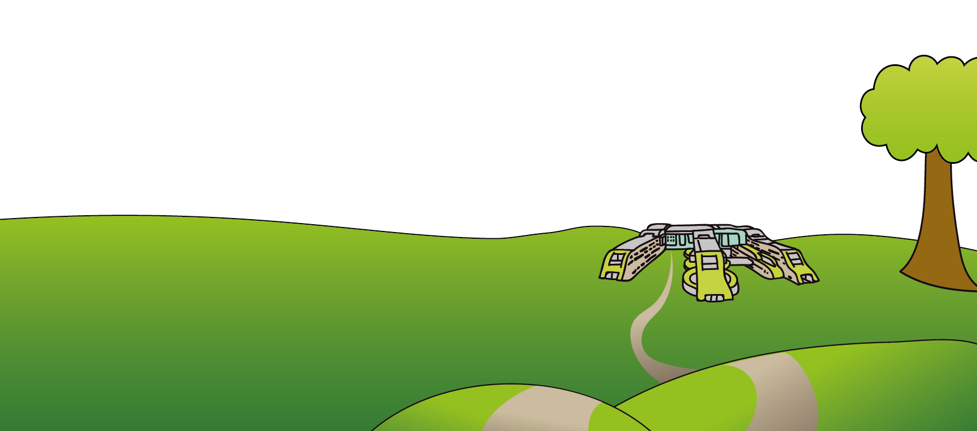
Tel: 0151 228 4811
www.alderhey.nhs.uk

© Alder Hey Review Date: April 2029 PIAG: 624

