
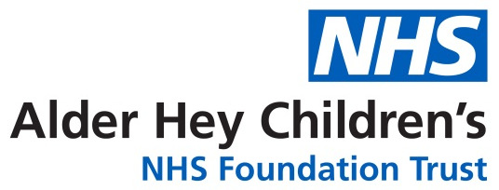

TUBEROUS SCLEROSIS COMPLEX (TSC) Paediatric Multidisciplinary Service at Alder Hey Children Hospital

Information for parents and carers

Why has my child been referred to TSC clinic?
Your child or young person has been diagnosed with Tuberous Sclerosis Complex (TSC). They have been referred to the TSC clinic because they will benefit from regular health monitoring, specialist advice, and support from a multidisciplinary team with expertise in TSC.
The TSC clinic works alongside your local paediatric team to ensure your child receives coordinated, ongoing care and appropriate signposting to other services if needed.
What is TSC (Tuberous sclerosis complex)?
TSC is a genetic condition that affects one million people worldwide. TSC causes non-cancerous (benign) growths to develop in different organs of the body, such as the brain, eyes, heart, lung and skin. The symptoms of TSC depend on where these growths occur and how they affect the body.
Every month about 10 babies are born in the UK with TSC. It is estimated that around 3,700 – 11,000 people in the UK live with TSC.
Common problems associated with TSC include epilepsy, autism spectrum disorder, learning needs, behavioural and sleep problems, skin issues, kidney problems and lung issues (lung issues tend to be less common in childhood). However, TSC affects individuals very differently, and the severity and combination of symptoms can vary widely.
Some individuals with TSC are diagnosed very early in life, sometimes even before birth, while others may not receive a diagnosis until later childhood, adolescence, or adulthood. Some people may have mild features and require minimal medical input, whereas others may need more specialist medical care.

Although TSC is a lifelong condition, many people with TSC lead full and active lives. With the right monitoring, treatment and support, many of the challenges associated with TSC can be managed effectively.
What is TSC Surveillance?
TSC surveillance means having regular check-ups and tests to look for problems that can be associated with Tuberous Sclerosis Complex (TSC). These checks help doctors identify changes early, sometimes even before symptoms appear, so treatment can be started at the right time.
Depending on age and individual needs, surveillance may include tests such as brain scans (such as MRI), abdominal scans, especially to monitor the kidneys, Electrocardiogram (ECG) – to check heart rhythm, Electroencephalogram (EEG) – to monitor brain activity and seizures, heart scan (echocardiogram / ECHO) – to assess heart structure and function.
These tests are carried out by the relevant specialist teams, either at Alder Hey Children’s Hospital or locally, as appropriate. The TSC team will maintain an overview of all surveillance and results.
What happens to the results?
The scan results when available are discussed in multidisciplinary team meeting (MDT) and the outcome is shared with the families and relevant health professionals involved in your child’s care
What does the TSC service provide?
Our specialist multidisciplinary service offers:
- Comprehensive assessment and surveillance
- Specialist advice, guidance and signposting
- Ongoing referrals when needed
- We work closely with your child’s local paediatrician to support care through a shared care approach.
Who will be present in the TSC clinic?
The team comprises of a Consultant Neurodisability Paediatrician, Paediatric Neurologist, Paediatric Nephrologist, and Physician Associate/ a Care-coordinator.
Who can Access the TSC service?
Any child or young person under the age of 16 years with a confirmed diagnosis of TSC within our catchment area can be referred to the clinic. Referrals can be made by a Local Paediatrician or Genetics Consultant. Referral forms are available on our website.
The ongoing care of your child will be managed by local pathways with advice from TSC MDT service as required.
How often will my child need be reviewed within the service?
We usually offer a clinical review once every 18-24 months, but this may depend on individual needs.
We value your feedback
Please help us improve the service we offer by sharing your comments on this publication.
Please email commpaedsqueries@alderhey.nhs.uk

Information & Support:
TSC TEAM
Community Division
Alder Hey Children’s
NHS Foundation Trust
Eaton Road
Liverpool
L12 2AP
Tel: 0151 228 4811

Alder Hey TSC website: https://alderhey.nhs.uk/services/tuberous-sclerosis-complex

Please get it touch with the Tuberous Sclerosis Association at, www.tuberous-sclerosis.org
or by calling 0207 922 7731.

Patient Advice and Liaison Service for Alder Hey (PALS)
Tel: 0151 252 5161
Complaints Team
Tel: 0151 252 5374
This leaflet only gives general information. You must always discuss the individual treatment of your child with the appropriate member of staff. Do not rely on this leaflet alone for information about your child’s treatment.
This information can be made available in other languages and formats if requested.
Alder Hey Children’s NHS Foundation Trust
Eaton Road
Liverpool
L12 2AP
Tel: 0151 228 4811
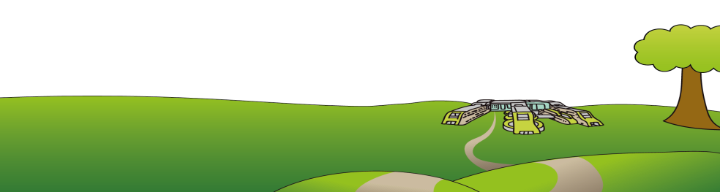
www.alderhey.nhs.uk

Alder Hey

