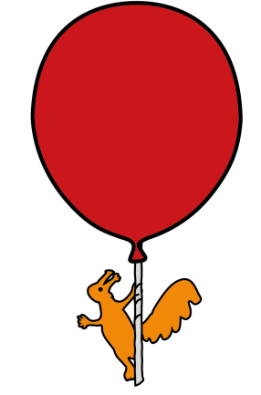


Department of Paediatric Ear, Nose & Throat Surgery

Tonsillectomy / Adenotonsillectomy

Information for parents / carers

General Information

- Following your child’s tonsillectomy, they should stay indoors for 3 days and off school for a further 10 days.
- Take your child to your nearest A&E if there are any signs of oozing or bleeding from their nose or mouth, or they are spitting out or coughing blood, or vomiting blood during the 2 weeks after their tonsillectomy.
- Your child should avoid contact with people with coughs and colds to minimise the risk of infection.
- Your child’s breath will smell, and their throat will look white.
- If your child has a temperature, vomits or/and their throat looks green they may have an infection. Go to your GP.

- Eating and drinking is an important part of your child’s recovery, and they should eat and drink normal food as soon as possible. This helps the throat to heal.

Pain Information

- After their operation your child may have a sore throat for up to 2 weeks. Pain may be worst 3-5 days after their operation. Giving their pain medicine regularly is the most effective way of relieving this pain.
- Giving your child their pain medicine 30 minutes before meals will help to reduce their pain, making it easier for them to eat. Your child should start to feel less pain about 30 minutes after taking pain relief. It may take up to an hour for the medicine to work properly.
- The tables show a good way of giving the medicines at the right time.
- In the first week after surgery, give paracetamol and ibuprofen regularly at the times shown in the table. Use morphine only if your child is still in pain 1 hour after paracetamol and ibuprofen.
- In the second week after surgery, give paracetamol if required at the times shown in the table. Use ibuprofen only if your child is still in pain 1 hour after giving paracetamol.
- Wait at least 4 hours before giving another dose of each medicine.

Week 1

On waking | Midday | Teatime | Overnight
Paracetamol | Paracetamol | Paracetamol | Paracetamol
And ibuprofen | And ibuprofen | And ibuprofen
Morphine (if needed) | Morphine (if needed) | Morphine (if needed) | Morphine (if needed)
 |  |  | Only if they wake
Week 2

On waking | Midday | Teatime | Overnight
Paracetamol (if needed) | Paracetamol (if needed) | Paracetamol (if needed) | Paracetamol (if needed)
Ibuprofen (if needed) | Ibuprofen (if needed) | Ibuprofen (if needed)
 |  |  | Only if they wake
- You must not give your child more than four doses of paracetamol or morphine in 24 hours, so you may have to wait up to 6 hours between doses.

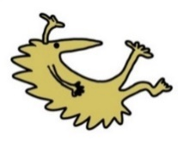
- You must not give your child more than three doses of ibuprofen, so you may have to wait up to 8 hours between doses.

- Write down the time that you give each dose, to help you remember.

How much pain relief should I give?

- The medicine doses your child receives from the hospital are based on your child’s weight.

- These doses may be different to the manufacturer’s doses shown on the side of the bottles of paracetamol or ibuprofen, which is based on a child’s age.

- The hospital will provide enough pain medication for the first week after surgery. After this time, further paracetamol or ibuprofen supplies can be obtained from your local community pharmacy.

- If your child is sick after having a dose of pain relief, do not repeat the dose. Wait at least 4 hours before giving any more pain relief.

Liquid medicine: measure out the right amount using an oral medicine spoon or syringe. Do not use a kitchen teaspoon as it will not give the right amount.

What if I forget to give it?

Give the missed dose as soon as you remember. You must wait at least 4 hours before giving any more.

- If you are not sure a medicine is working, contact the ward you were discharged from.

- Do not give extra doses of medicine, as this can be dangerous.

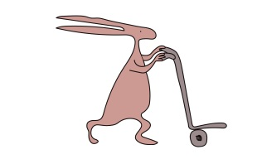
- Only give these doses to your child. Do not give these doses to anyone else, even if their condition appears to be the same, as you could do them harm.

- You will be provided with a 7-day supply of pain medicine on discharge. If more is required, please go to your GP or local community pharmacy.

Contact details:

If you have any problems or worries, please telephone the ward you were discharged from via the Alder Hey switchboard and the staff will be happy to help and advise you.

This leaflet only gives general information. You must always discuss the individual treatment of your child with the appropriate member of staff. Do not rely on this leaflet alone for information about your child’s treatment. This information can be made available in other languages and formats if requested.

Alder Hey Children’s NHS Foundation Trust
Eaton Road
Liverpool
L12 2AP

Tel: 0151 228 4811
www.alderhey.nhs.uk

© Alder Hey Review Date: Jan 2029 PIAG: M29

