  - NHS Equality Delivery System 2022

EDS Reporting Template
  - Alder Hey Children’s NHS Foundation Trust
Report 2025/2026

Contents
Equality Delivery System for the NHS 2

Equality Delivery System for the NHS
The EDS Reporting Template

Implementation of the Equality Delivery System (EDS) is a requirement on both NHS commissioners and NHS providers. Organisations are encouraged to follow the implementation of EDS in accordance EDS guidance documents. The documents can be found at: www.england.nhs.uk/about/equality/equality-hub/patient-equalities-programme/equality-frameworks-and-information-standards/eds/
The EDS is an improvement tool for patients, staff and leaders of the NHS. It supports NHS organisations in England - in active conversations with patients, public, staff, staff networks, community groups and trade unions - to review and develop their approach in addressing health inequalities through three domains: Services, Workforce and Leadership. It is driven by data, evidence, engagement and insight.
The EDS Report is a template which is designed to give an overview of the organisation’s most recent EDS implementation and grade. Once completed, the report should be submitted via england.eandhi@nhs.net and published on the organisation’s website.

Name of Organisation |  | Alder Hey Children’s NHS Foundation Trust | Organisation Board Sponsor/Lead
 |  | Alder Hey Children’s NHS Foundation Trust | Melissa Swindell, Chief People Officer  Nathan Askew, Chief Nursing Officer
Name of Integrated Care System |  | Cheshire and Merseyside

NHS Equality Delivery System (EDS)

EDS Lead | Angela Ditchfield |  | At what level has this been completed?
 |  |  |  | *List organisations
EDS engagement date(s) | September 2025 – Service identification requested  Leads engaged, and support and information provided  November 2025 – Check in with service leads, discussion regarding completion of evidence collection  Jan 2026- Committee Approval  Jan 2026- Peer review  Feb 2026 – Final Sign off by Trust Board prior to publishing |  | Individual organisation | Health Watch Liverpool  Freedom to Speak Up Guardian  REACH (Race Ethnicity and Cultural Heritage) Staff Network  LGBTQIA+ Staff Network  ACE-Disability Staff Network  Armed Forces Staff Network  Trade Union Representatives  Equality, Diversity, and Inclusion Steering Group
 |  |  | Partnership* (two or more organisations) | Merseyside and West Lancashire NHS FT
 |  |  | Integrated Care System-wide* | Cheshire and Merseyside ICS

Date completed | 26th Jan 2026 | Month and year published | Feb 2026
Date authorised | 29Th Jan 2026 | Revision date

Completed actions from previous year
Action/activity | Related equality objectives
Physical Health & Wellbeing Days held throughout the year providing staff with support on physical health issues, mental health support, external support etc | Objective 1
Secured funding from Charity to deliver Train the Trainer Active Bystander Training | Objective 1,2
Launched Mutual Mentoring Programme | Objective 1
Launched ‘Thriving Leaders’ training which includes Anthony Walker Training as part of the programme. There is also modules on EDI and Neurodiversity | Objective 1,2
Launched Carers Support Group | Objective 1
Launched Endometriosis Support Group | Objective 1

EDS Rating and Score Card

Please refer to the Rating and Score Card supporting guidance document before you start to score. The Rating and Score Card supporting guidance document has a full explanation of the new rating procedure, and can assist you and those you are engaging with to ensure rating is done correctly

Score each outcome. Add the scores of all outcomes together. This will provide you with your overall score, or your EDS Organisation Rating. Ratings in accordance to scores are below
Undeveloped activity – organisations score out of 0 for each outcome | Those who score under 8, adding all outcome scores in all domains, are rated Undeveloped
Developing activity – organisations score out of 1 for each outcome | Those who score between 8 and 21, adding all outcome scores in all domains, are rated Developing
Achieving activity – organisations score out of 2 for each outcome | Those who score between 22 and 32, adding all outcome scores in all domains, are rated Achieving
Excelling activity – organisations score out of 3 for each outcome | Those who score 33, adding all outcome scores in all domains, are rated Excelling

Domain | Outcome | Evidence – Service 1 Gender Identity Service | Rating | Owner (Dept/Lead)
Domain 1: Commissioned or provided services | 1A: Patients (service users) have required levels of access to the service | Alder Hey Children’s NHS Foundation Trust, in partnership with Royal Manchester Children’s Hospital, began providing a new regional children and young people’s gender service on 01 April 2024. Children and Young People Gender Service (Northwest) referrals are taken off the Arden and Gem National waiting list. Families are given the right to choose which gender service they want to access out of three available hubs located in Warrington, Bristol or London. Population served is children, young people and families from 0 - 18 years of age living in England or Wales. We also take some referrals from the Republic of Ireland, under the Treatment Abroad Scheme. Population have diverse needs including neurodevelopmental differences, mental health difficulties, psychosocial and gender distress. It is to be noted all current cases open to CYPGS North have waited a period up to 5 years prior to initial assessment. The service operates Monday - Friday between 09:00 - 17:00 to offer appointments throughout the day, online options are available to those with travel limitations. CYPGS has a diverse set of health care professionals in terms of age, ethnicity and lived experience. Currently CYPGS collect information relating to reasonable adjustments picked up at triage which is fed through to administration and clinicians to make adaptations. CYPGS administration have worked consistently hard to check all open cases demographics, so we are capturing data on protected characteristics.  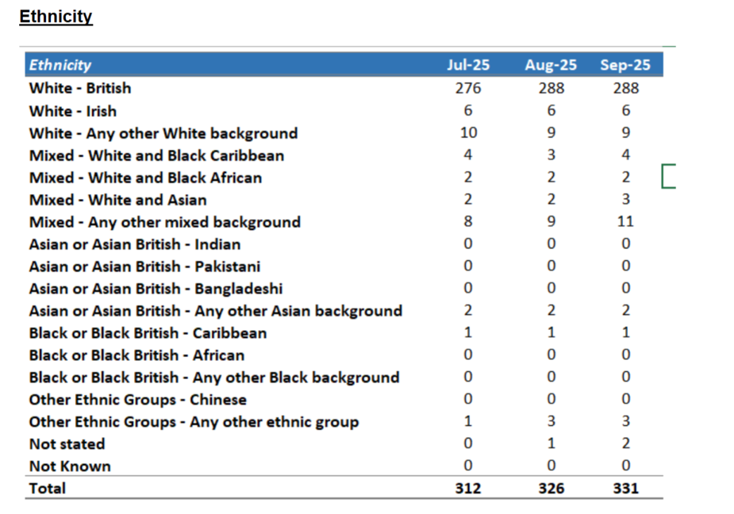  The proportion of children and young people on the current caseload diagnosed with Autism, ADHD, a learning disability or recorded as a looked after child is shown in the table below:  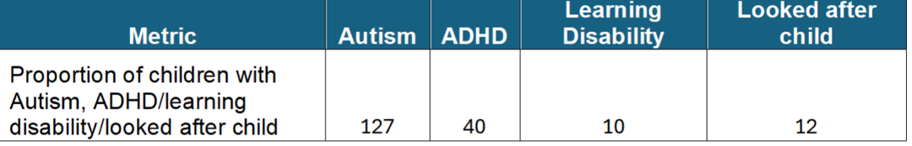  Area of improvement CYPGS recognise we are not capturing consistently religion / religious belief at point of triage and initial assessment. Here is the table for the breakdown by ethnicity. Just to note, these are the options that can be selected on Meditech so may not be the best descriptors, but it is all we have to pick from. It doesn’t always match the wording on the referral forms. | Achieving Activity  2 | Gender Identity Service Leadership Team
Domain 1: Commissioned or provided services | 1B: Individual patients (service users) health needs are met | CYPGS follows Alder Hey Trust policy and procedure around “was not brought.” Waiting times for children, young people and families are outside of CYPGS’ control, as we are a national service and the waiting list is managed by a separate organisation. In Quarter 2, the service received 75 referrals from the National Waiting List held by Arden and GEM Referral Support Service on behalf of NHS England. The service has confirmed there is sufficient capacity to receive 25 referrals per month from the National Waiting List from 01 April 2025 – 31 March 2026 plus up to a total of 10 transfers from Endocrinology Services should this be required.  The table below shows the average waiting times for initial assessment:  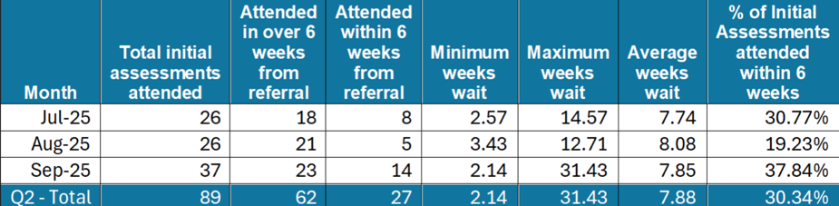  Interpretation services are available, and CYPGS has used interpreters and technology throughout the year. Reasonable adjustments are made where there is a language need and to ensure accessibility for wheelchair users. Speech and language therapy professionals support communication needs by providing resources such as visual aids, and coloured overlays are offered to children, young people and families when reviewing routine outcome measures and other documents.  Over the past year, CYPGS staff have undertaken continuing professional development and accessed reflective practice sessions focused on cultural sensitivities, helping deepen understanding of barriers and biases related to protected characteristics. Geographical and transport barriers that may affect access to healthcare are also recognised.  Children and young people from non-white backgrounds are underrepresented within the service. Therefore, a broader analysis of the barriers preventing children, young people and families from global majority communities from accessing the gender service is required. | Achieving Activity  2 | Gender Identity Service Leadership Team
Domain 1: Commissioned or provided services | 1C: When patients (service users) use the service, they are free from harm | Children and young people who access gender-suppressing or gender-affirming hormones through a private provider are not disadvantaged in their care; however, CYPGS does not condone the use of medication obtained through unregulated providers. Where appropriate, consent is sought to liaise with local agencies to support the young person’s care.  Staff are encouraged to seek support and guidance from Alder Hey’s Freedom to Speak Up Guardian, LGBTQ+ colleagues, the safeguarding lead nurse, and the EDI lead. CYPGS also recognises this as an area for further development, particularly in relation to the consideration of protected characteristics.  We need to strengthen our approach to collecting information and monitoring to better identify and support young people who may be vulnerable to radicalisation, including asking difficult but necessary questions to understand emerging ideologies. | Developing Activity  1 | Gender Identity Service Leadership Team
Domain 1: Commissioned or provided services | 1D: Patients (service users) report positive experiences of the service | Six compliments have been recorded on InPhase over the past year. The PPI Youth Advisory Group is also used to gather young people’s experiences of the service, with feedback regularly shared with senior leadership teams and at business meetings.  The CYPGS Youth Advisory Group collaborated with a local artist to design artwork for the entrance and reception area, ensuring the space reflects the voices, creativity, and experiences of young people. The project helped create a welcoming, inclusive environment and gave young people a meaningful opportunity to influence the look and feel of the service.  The service has continued to receive positive feedback from children, young people and their families. There were 2 formal compliments reported in Quarter 2:  Feedback from a family.  During an appointment, family said that admin staff member was lovely and helpful and commented that they always enjoyed talking to the staff member when they called up to arrange appointments.  Good Care (Excellence Report)  [Anonymized staff member] was brilliant on reception on the day, managing several issues at once.  There have been 0 formal complaints received in the reporting period.  To maintain the security of the Youth Advisory Group, the PPI contact list is routinely reviewed and updated; however, CYPGS recognises that this process requires further improvement.  Going forward, young people and parents/carers who wish to join the Youth Advisory Group or the Parent Advisory Group will be able to register directly via a QR code or online link. While this approach offers an accessible route for most, alternative arrangements will be available to support those who may have limited access to technology or who require additional assistance. | Achieving Activity  2 | Gender Identity Service Leadership Team
Domain 1: Commissioned or provided services overall rating |  |  | 7

Domain 1: Commissioned or provided services – 3 services reviewed
Domain | Outcome | Evidence – Service 2: Diabetes Service | Rating | Owner (Dept/Lead)
Domain 1: Commissioned or provided services | 1A: Patients (service users) have required levels of access to the service | We see a range of patients including patients from local area and out of area. If patients come to Alder Hey for a surgical procedure the diabetes team will manage and support their diabetes care whilst they are an inpatient. We also support patients on PICU/HDU. We care for Cystic Fibrosis Diabetes (CFD) patients referred from Wigan as their local hospital do not provide a CFD service. WE discuss all CFD patients in our monthly CFD meeting to offer expertise and advice. We review ward-based outliers, who may be an inpatient under other teams but requiring diabetes/hyperglycaemia support.  We offer a 24/7 emergency line - covered by a DSN and diabetes consultant.  We take referrals from GPs, ED directly to the Alder Hey diabetes Team, or patients attending ED directly. Also, Referrals from other hospitals whose patient has moved into the local area.  We use Adapted learning: Using Digibete as a resource which has information translated into multiple different languages.  Examples:  A 10-year-old patient whose mum could not read or understand numbers - We created a colour coded diagram, so she was able to understand which glucose levels were in target, above or below.  We have a youth worker who supports patients who struggle to attend appointments, and organises family fun days, peer support and events. She also tries to engage CYP in school to avoid them missing education.  We offer psychology support and have set up newly diagnosed support groups offering peer support to patients and parents.  Family Therapy is part of the diabetes team working with families to take a holistic approach to how diabetes can affect the family unit.  We run 8 Multi-Disciplinary Team (MDT) diabetes clinics per week - seeing 48 patients per week.  We offer a structured transition process.  Currently we offer 12 joint transition appointments a year with Liverpool Royal hospital - seeing 72 patients, and 12 joint transition appointments a year with Aintree hospital - seeing 72 patients. The Royal transition appointments are due to be increased from 2026 due to higher demand of patients choosing that hospital for their adult diabetes care. We hold weekly MDT meeting to discuss current inpatients and any concerning outpatients, as well as any other team business. The agenda for these changes weekly and includes Management, Governance, Service development and Education. These meetings are held via Teams, and once a month it is face to face.  Our dietetic service offer dietitian led clinics, and dietitian led coeliac clinics.  Our nurses also offer ad hoc diabetes nurse led clinics. | Achieving Activity  2 | Diabetes Leadership Team
Domain 1: Commissioned or provided services | 1B: Individual patients (service users) health needs are met | Our service is guided by Diabetes Best Practise Tariff Standards. We submit data quarterly to the National Paediatric Diabetes Audit (NPDA) to review data and highlight areas for improvement. There is a small working group within the team who meet monthly to discuss the data and areas to focus on for improvement. · PREM - Annual national survey for UK diabetes patients. · Family and friends’ questionnaires. · RCN Delegation guidelines for school visits/education. · GIRFT - First year of care. ·  We frequently use interpreters, either via the telephone or Face to Face.  We translate letters and step by step guides into the patient’s national language to ensure they have information they understand. We encourage patients using Digibete with translated resources.  Our youth worker is in the process of making a video guide of what patients should expect when coming to clinic to ease anxiety, especially for patients with ASD. ·  Insulin pump therapy is now discussed at diagnosis, and the waiting list time has significantly reduced so patients can use insulin pump therapy sooner and continuous glucose monitors are started at diagnosis.  We offer a structured transition service with Royal Liverpool University Hospital, and Aintree Hospital as mentioned above.  We used to offer a service for newly diagnosed patients, called Newtree, which provided more in-depth education and understanding, but it did not have a positive response and so our Newly diagnosed diabetes education folder has been updated and improved to include more in-depth information since there was a poor uptake for Newtree. This has improved the information provided to newly diagnosed patients | Excelling Activity  3 | Diabetes Leadership Team
Domain 1: Commissioned or provided services | 1C: When patients (service users) use the service, they are free from harm | Our team consists of 4 Diabetes Consultants 9 x Band6 Diabetes Nurse Specialists, none of these are Nurse Prescribers. (3 part time/6 full time) 1 x Band 7 Diabetes Nurse Specialist/Diabetes Clinical Manager, full time) Nurse Prescriber (March 2026) 1 x Diabetes Youth Worker (full time) 2 x Diabetes HCAs (part time) 2x Band 7 Diabetes Dietitians (part time) 1x Band 6 Diabetes Dietitian (part time) 1 x Dietitian Assistant (part time) 2 x Diabetes Psychologists (full time) 1 x Family Therapist (part time) 1x Psychology Assistant (part time) Newly appointed Band 6 Diabetes Nurse Specialist has allowed nursing patient caseloads to be reduced from 1:90-100pts to 1:60pts which has improved patient contact and monitoring. Many of our patients live in areas of high level of deprivation.  Regarding Safeguarding patients, our team have monthly and ad hoc safeguarding supervision for complex cases. The team have put in a requested to fund a part time Social Worker which would support the team workload and patient population. All our nurses have access to monthly psychology supervision from our Diabetes Psychologist.  We hold monthly Governance and Incident review meetings. The 24/7 Emergency Line service is part of BPT (Best Practice Tariff)- to help reduce ED attendances and admissions. The National Paediatric Diabetes Audit- submitted quarterly to measure patient outcomes for the 7 Care Processes which are · Thyroid · Eyes (Retinopathy Screening) · Urine ACR (Albumin/Creatinine Ratio) · Feet · Psychology · Ketone Education · Dietetic input (incl Coeliac) Adapt education and injection regimes according to patients’ capacity. (e.g. recent families were illiterate therefore set doses of insulin twice daily prescribed as opposed to multiple daily injections and picture guides used for meals and how to dial up injection pen | Achieving Activity  2 | Diabetes Leadership Team
Domain 1: Commissioned or provided services | 1D: Patients (service users) report positive experiences of the service | Positive feedback from FFT forms. HCAs have QR code in clinic for patients to scan and complete FFT. 24/7 Emergency Line support. Thankyou cards/gifts and donations from families Funding granted for family fun days and events. | Achieving Activity  2 | Diabetes Leadership Team
Domain 1: Commissioned or provided services overall rating |  |  | 9

Domain 1: Commissioned or provided services – 3 services reviewed
Domain | Outcome | Evidence – Service 3: Anaesthetic Pre-Assessment Service | Rating | Owner (Dept/Lead)
Domain 1: Commissioned or provided services | 1A: Patients (service users) have required levels of access to the service | The Anaesthetic pre-op assessment service currently receives approximately 1100 referrals per month from 16 specialities across the trust. Comprehensive pre-op assessments are completed for children and young people who have been listed for a surgical procedure under general anaesthesia, with the trust working towards ‘no pre-op, no surgery’. We work closely with surgical teams, ensuring a seamless peri-operative pathway for all patients and have close links with district general hospitals to ensure a shared care approach. The service is accessible from Monday to Friday 8am-6pm with initial access to our pathway co- Ordinator’s who can signpost families to specific members of the team, with an answer phone available out of hours. The service delivers 3 consultant led pre-op clinics per week, 3 clinical nurse specialist’s clinics and 2 triage clinics with electronic/ telephone triages being completed daily. The service offers a range of assessment methods to maximise access and reduce barriers, including face-to-face pre-op clinics, telephone/electronic triage, and remote follow-up where appropriate, enabling flexibility for families who may experience challenges attending in person (e.g., caring responsibilities, transport difficulties, neurodiversity-related anxiety, or other inclusion needs). The service also uses the ISLA electronic pre-operative assessment document to standardise data capture and improve visibility of clinical risks and reasonable adjustments across the pathway. The pre-operative team designed and implemented the ISLA electronic assessment document to improve accessibility and enable flexible assessment methods (including remote/telephone pathways where appropriate). This supports timely completion of pre-op assessments and improves continuity across the peri-operative journey. With an increasing number of referrals for support for patients with protected characteristics/ learning difficulties, the service devised the following pathway. Elective Peri- Operative Pathway for Children and Young People (>3 years old) with Significant  Behaviour’s that Challenge. This pathway has been utilised on many occasions in conjunction with support from the acute liaison and play specialists teams to ensure a collaborative working approach. As a result, patients and families have witnessed a significant reduction in barriers faced when accessing healthcare at Alder Hey as reasonable adjustments are recognised, highlighted to the wider MDT and implemented throughout the child’s surgical journey. Referrals are currently accepted via email to our consultant pre-op inbox where they are screened for suitability by the teams advanced nurse practitioner who will arrange for appropriate follow up either via telephone or face to face with the patient/ parent/ carers. The referrer also receives confirmation via email to confirm acceptance/ rejection of referral. Children and young people with diagnosed neurodiversity’s continuing to face significant barriers in accessing healthcare despite growing awareness. Many services remain inaccessible to this core group of patients due to lack of implemented reasonable adjustments, poorly adapted environments that can sometimes be overwhelming. As a result, many neurodivergent children face longer wait times, limited specialist availability, delayed  diagnoses and unmet health needs, highlighting a critical gap in equitable paediatric healthcare which the pathway aims to change. Key statistics are as follows: as of March 25, approximately 138,000 children are awaiting assessment for autism, with 316,000 awaiting an ADHD assessment in England (UK parliament committee 2025). With an estimated 1 in 7 children diagnosed neurodivergent, structural support systems are far behind the prevalence. An example is a 14-year-old patient with significant behaviours that challenge, facing barriers preventing access to clinics, investigation requests, examinations and treatment plans. As a result, the child was listed for a general anaesthetic to undertake a dental examination. Following referral to the CB pathway, a robust admission plan was devised, along with advanced planning with multiple specialities to ensure the above interventions could be completed under GA, minimising distress for the young person/ acting in their best interests, thus promoting enhanced access to healthcare. This resulted in the patient having a dental examination, bloods, eye examination, immunisations all under GA. With increasing numbers of referrals being received on a weekly basis, it has identified the  need for a learning disability practitioner to be incorporated within the team, thus allowing increasing access for this core of patients. To reduce barriers for children and young people who may require reasonable adjustments (including those with neurodevelopmental diagnoses and/or communication or sensory needs), the service supports implementation of the STAR Band / Yellow Band approach (“Say Hello with Yellow”). The Yellow Band acts as a consistent visual prompt across the peri-operative pathway, enabling teams to recognise and implement reasonable adjustments early and reduce reliance on families repeating information at multiple points of contact. Example (Yellow Band in practice): A child with a diagnosis of ASD was identified pre-operatively as requiring reasonable adjustments. Following discussion with the parent/carer, the benefits of the Yellow Band  were explained and consent gained, enabling early visibility of the child’s triggers, preferences and communication needs via the Special Indicator. This enabled advance allocation of a quiet space/cubicle on admission and prompted all teams (including recovery) to review the Special Indicator before interaction; in recovery this supported earlier parent presence and a calmer, more predictable wake-up for the child. For children with significant behaviours that challenge and those at highest risk of distress/escalation, the service has developed and utilises the Elective Peri-Operative Pathway for Children and Young People (>3 years) with Significant Behaviours that Challenge, in conjunction with acute liaison and play specialists. This supports equitable access by enabling advanced planning and multidisciplinary co-ordination. | Excelling Activity  3 | Surgical Leadership
Domain 1: Commissioned or provided services | 1B: Individual patients (service users) health needs are met | The Anaesthetic pre-operative assessment service meets individual patient needs through structured assessment, risk stratification and personalised planning to ensure children and young people are optimised for surgery and supported throughout the peri-operative pathway. The service has access to interpreter services (including support for families whose first language is not English and those requiring communication support) and can provide translated information where required. The service frequently provides reasonable adjustments for children and young people with protected characteristics and inclusion needs, supported by the implementation of the STAR Band / Yellow Band approach. The Yellow Band acts as a consistent prompt for staff to review and implement the child’s Special Indicator (SI) (including triggers, likes/dislikes, communication needs and agreed approaches), supporting continuity across pre- op assessment, admission, theatres and post-operative recovery. Example (Yellow Band in practice): A child with a diagnosis of ASD was identified pre-operatively as requiring reasonable adjustments. Following discussion with the parent/carer, the benefits of the Yellow Band were explained and consent gained. This enabled early visibility of the child’s SI, allowing a quiet space/cubicle to be allocated in advance and prompting all staff to review the SI prior to interaction. In recovery, staff reviewed the SI prior to waking the child and arranged earlier parent presence to support familiarisation and reduce distress, enabling a calmer, more predictable recovery experience. For children with significant behaviours that challenge, the service utilises the Elective Peri-Operative Pathway to coordinate multi-disciplinary planning (e.g., play specialists, acute liaison/psychology, learning disability support where available). This supports timely completion of necessary investigations and interventions and reduces the likelihood of repeated failed attempts, delayed treatment and distress-related escalation. Where relevant, the service monitors themes from non-attendance, patient contact, and family feedback to identify barriers to engagement and adapt how care is delivered (e.g., flexible contact methods, planned arrivals, and tailored appointment approaches). Overall, the service uses the Yellow Band/Special Indicator and the CB pathway to ensure equitable, personalised care and consistent reasonable adjustments, meeting health needs across protected characteristics and other health inclusion groups. he ISLA electronic document, developed by the pre-operative team, supports consistent personalised care by standardising assessment and improving the quality and visibility of key information (including clinical risks, communication needs, sensory triggers, preferred approaches and agreed reasonable adjustments). This strengthens continuity by ensuring information gathered during pre-op assessment is consistently accessible to teams supporting admission, theatres and recovery, and helps reduce reliance on families repeating information at multiple points of care. Where appropriate, the service can tailor the assessment approach (e.g., shorter contacts, staged information-gathering, flexible appointment structure) to support children and families who may find standard clinic environments or prolonged appointments challenging. | Excelling Activity  3 | Surgical Leadership
Domain 1: Commissioned or provided services | 1C: When patients (service users) use the service, they are free from harm | The Anaesthetic pre-operative assessment service promotes patient safety by ensuring clinical risk is identified early, appropriate triage is completed, and peri-operative plans are clearly communicated to the multidisciplinary team. The service works closely with surgical specialties and wider support services (e.g., play specialists, acute liaison/psychology, learning disability support where available) to reduce avoidable harm, particularly for children and young people who require reasonable adjustments. Implementation of the STAR Band / Yellow Band approach supports safety by prompting staff to review the child’s Special Indicator (SI) prior to interaction, reducing the risk of distress escalation, communication breakdown, delays to treatment, absconding risk, and avoidable restrictive interventions. Where appropriate, environmental adjustments (e.g., allocation of a quiet space/cubicle, planned arrivals, minimising waiting) and agreed approaches to examination/procedures are embedded in the care plan and shared across pre-op, admission, theatres and recovery. For children with significant behaviours that challenge and those at highest risk of escalation, the service uses the Elective Peri-Operative Pathway to coordinate advanced planning and role clarity, supporting safer delivery of care and reducing repeated failed attempts at procedures. This approach enables necessary interventions to be coordinated effectively (including completing multiple required assessments/interventions under one planned episode where clinically appropriate), minimising distress and clinical risk. The service encourages an open culture of incident reporting and learning (e.g., Datix), using themes from incidents, PALS/complaints and frontline feedback to refine pathways and strengthen preparation (e.g., ensuring early involvement of play/support teams when indicated, strengthening documentation of triggers and agreed approaches, and improving communication at handovers into recovery). Equality monitoring and protected characteristics are considered where relevant when reviewing incidents/complaints to identify any disproportionate impact and inform improvement actions. Example: Following pre-op identification of a child requiring reasonable adjustments, the Yellow Band prompted staff across admission, theatres and recovery to review the Special Indicator (triggers, preferred approach). A quiet cubicle was allocated in advance, and the recovery handover included the SI plan, enabling early parent support and a more predictable wake-up, reducing risk of distress-related harm and delayed care. In addition, the service is developing the Pre-op “Cinema Club” as a patient experience initiative to reduce anxiety and improve engagement for children and young people undergoing planned surgery. The initiative supports a calmer, more child-friendly pre-operative journey by improving communication, preparation and overall experience while families wait for surgery, and provides another mechanism for capturing feedback and identifying themes for improvement.’ Together, ISLA (digital documentation), flexible assessment methods, and experience initiatives such as Yellow Band and Cinema Club strengthen equitable access, continuity and patient experience across the peri-operative pathway. Developed by the pre-op team, the ISLA electronic assessment improves accessibility and standardises documentation, strengthening continuity, patient safety and the reliability of reasonable adjustments across the peri-operative pathway | Excelling Activity  3 | Surgical Leadership
Domain 1: Commissioned or provided services | 1D: Patients (service users) report positive experiences of the service | The Yellow Band / STAR Band initiative was developed directly in response to patient and family experience, originating from a PALS complaint relating to a neurodivergent child whose procedure was cancelled following distress on admission. The parent reported that their child’s sensory needs and triggers were not recognised on the day of surgery, resulting in observations being attempted and topical anaesthetic cream being applied without adequate preparation or adjustment. This led to escalation in distress (“meltdown”) and cancellation of the procedure after a lengthy wait, causing significant impact on the child and family. The complaint investigation identified a key theme of communication and consistency across handovers, specifically that information gathered in pre-op about triggers, likes/dislikes and reasonable adjustments was not being recognised or actioned by ward staff on admission. In response, a visible prompt (Yellow Band) was introduced to improve reliability: it prompts staff to read the child’s Special Indicator and implement agreed reasonable adjustments consistently across admission, theatres and recovery. Early feedback has been received from theatre staff, ward staff, play specialists and the LD team along with families that the Yellow Band provides a helpful, immediate prompt to recognise and act on reasonable adjustments, supporting calmer interactions and a more predictable peri-operative experience for children and families. Learning from PALS/patient experience is therefore being translated into practical service improvement to enhance experiences for patients with protected characteristics and other health inclusion needs. You said: My child’s sensory needs weren’t recognised on admission and this led to escalation and cancellation. We did: Developed the Yellow Band to prompt staff to read the Special Indicator (triggers/preferences/communication needs) before interaction. So that: Reasonable adjustments (e.g., quieter space, paced approach, early parent support in recovery) are implemented consistently to improve experience and reduce distress. | Achieving Activity  2 | Surgical Leadership
Domain 1: Commissioned or provided services overall rating |  |  | 11

Domain 2: Workforce health and well-being
Domain | Outcome | Evidence | Rating | Owner (Dept/Lead)
Domain 2:  Workforce health and well-being | 2A: When at work, staff are provided with support to manage obesity, diabetes, asthma, COPD and mental health conditions | The Trust currently employs 4,582 staff members at Alder Hey. During the reporting period, the overall sickness absence rate was 6.22 percent. In total, there were 7,747 recorded sickness episodes, and 3,357 employees experienced at least one period of absence.  Analysis of the data highlights several key trends. Nursing staff accounted for the highest number of sickness episodes, with 3,286 recorded during the year. The next largest group was Administrative and Clerical staff, who reported 1,305 episodes.  When examining long-term absences, the most common cause was anxiety and stress, which resulted in 535 episodes. The second most frequent cause was other musculoskeletal problems, with 83 episodes recorded.  Short-term absences were dominated by seasonal and common illnesses. Cold, cough, and flu were the leading causes, accounting for 1,530 episodes, closely followed by gastrointestinal problems, which contributed to 1,502 episodes.  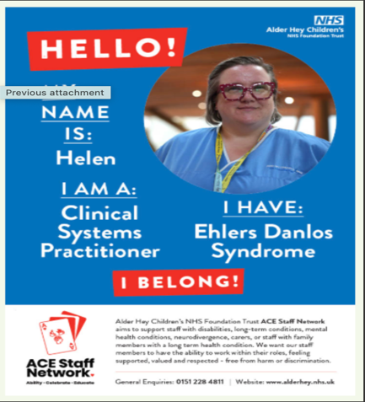  While we ask colleagues to declare whether they have a disability or long-term condition, we do not request details about the specific nature of their condition. This means it is difficult to report how many colleagues experience conditions such as obesity, diabetes, asthma, or COPD. Our ACE Disability and Long-Term Conditions Staff Network has actively encouraged staff to make declarations and has hosted engagement events within the hospital to promote the network and raise awareness about updating records on ESR. As a result, the proportion of staff declaring a disability increased from 4.27% in 2024 to 8.14% in 2025. In October the ACE network launched an inspiring initiative, People of the Posters. At its heart, ACE is about amplifying voices, celebrating difference, and creating space for everyone to thrive, especially those living with long term conditions or disabilities. The campaign powerfully highlights the importance of sharing experiences of disabilities and long-term conditions. We are committed to providing staff with education and support on the value to providing these adjustments, so colleagues can remain in work, thrive, continuing to deliver excellent care to our children and young people. We also want our children and young people to see that they too can have rewarding careers in the NHS, with our ACE colleagues acting as role models who inspire, represent, and encourage the next generation.  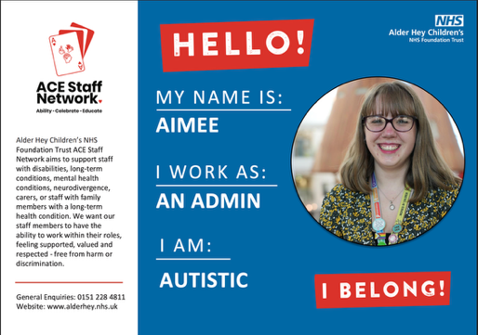  Wellbeing Days  Supported by one of our SALS Pals under the auspices of SALS we have run many wellbeing days for our staff over the last twelve months. Bringing in external organisations to offer both support and guidance to staff but also an element of physical health education and support. Days are planned for next year to link with specific calendar days throughout the year. Feedback from the wellbeing days is excellent and staff find them useful and helpful.  We have a Physical Health and Wellbeing group who provide information, support, and resources to staff. They provide information related to local fitness and wellbeing groups which are available to staff, promoting healthy eating and physical activity to prevent ill health. They offer signposting to locally available discounted gym memberships and sign posting to community support. The Physical Health & Wellbeing staff events run throughout the year offer staff advice, guidance from community organisations such as Citizens Advice, The Royal British Legion, Andy’s Man Club, yoga, meditation, mindfulness, lunchtime walks, massage, and drop-in sessions with the SALS Team. Over 12 external community organisations attended to offer information to our staff.  - Health checks including blood pressure and BMI  - Vaccinations  - Menopause  - Andy’s Mans Club  - Arts for Health  - Springfield Park  - Barclays  - National Energy Action  - The Apprenticeship Team  - Citizens Advice Bureau  - Unison  - The Alder Centre  - Sanctuary Team  - Credit Union  - The Brain Charity  - Smoking Cessation  We also offer a twice weekly bootcamp to staff which runs on a Tues/Thursday at 5pm and is held onsite. We offer free Self Defence and Fitness classes to staff, as well as an off-site fitness class which is free and is held the first Friday of the month between 6-7pm. We promote physical and mental health awareness throughout the year such as Diabetes week which was promoted through our communication channels and featured stories of our children and young people as well as our staff.  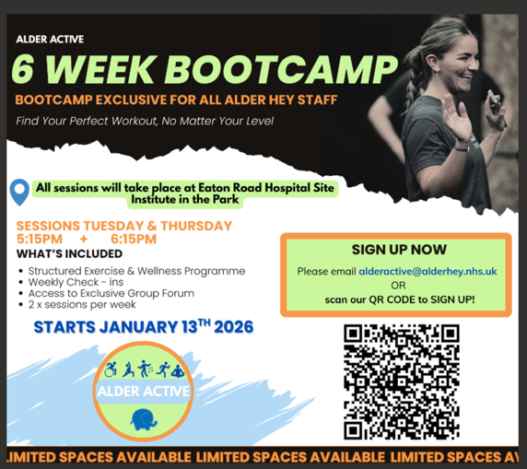  We have recently changed our Occupational Health provider to University of Hospitals Liverpool Groups. The new service so far has been a huge success, and the provider are SEQOHS accredited which means that they have been independently assessed to meet standards in safety, effectiveness and quality. In collaboration with the new occupational health partners, our staff have access to attend a walk in Smear Clinic at their own convenience.  From conversations with staff as well as recent feedback to our physical health survey, we have been making efforts to promote healthy eating options for our staff. Through this work, we have continued to offer a local service ‘Queen of Greens’, who provide affordable fresh fruit and vegetables across Liverpool and Knowsley. They do this using their van, which has drop off points at several spots throughout the local area including a newly established stop at Alder Hey once a week. We encourage healthy lifestyles, healthy eating, weight management programmes and support groups.  During October the Armed Forces Staff Network members took part in the Poppy Walk, Sefton Park in Liverpool. This was a 3km walk to plant your own wooden poppy tribute in honour of someone you may have loved and lost, and in recognition of what others have given and sacrificed for us all.  The Staff Advice and Liaison Service provide a listening and support service for all staff within the Alder Hey Community. The service is here to support all staff with any worry or issue that they may have and has a compassionate, person centred approach to supporting issues and problems that people may encounter within the Trust. The service can provide brief interventions to support staff and/or further signposting to external Mental Health services should this be required. The service also is the front door for staff who wish to access counselling for bereavement support. The service is closely linked to external secondary mental health and community sector services and maximises relationships across services to enable staff to receive the best quality care by minimising transitions and maximising trust. SALS has been designed to suit the needs of a busy workforce and aims to be accessible, responsive and person always centred with no need for formal referrals into the service. The ethos of the service is ‘it’s OK not to be OK’ enabling people to feel able to approach us and talk in a confidential space.  Working closely & collaboratively with SALS, the Alder Centre provides a service to anybody who has been affected by the death of a child be that staff members or families, which includes specialised counselling and a range of drop-in groups that individuals can access to support them at difficult times. The Alder Centre provides an in-house counselling service to any member of Alder Hey staff. This may be related to bereavement but, they also offer support around work and non-work-related issues like stress, anxiety, depression, and relationship problems. Our experienced, specialist Snowdrop Team provide a 24 hour, 365 days a year response service to families whose child dies at, or is brought to, Alder Hey following their death. One of our Bereavement Care Workers will be available to support the family within an hour of a child’s death and in the weeks following. The Alder Centre also provides a range of training courses and continuing professional development workshops, designed for anyone involved in helping relationships who is looking to develop their knowledge and skills. Our courses are delivered by qualified and experienced trainers who are themselves working in the subject areas and are therefore able to draw on their experience to enhance the theoretical input and student understanding.  Workforce Community Support Groups  We have a well-established Menopause Support Group, providing a safe and confidential space for staff to discuss any peri/menopause-related challenges they may be experiencing. While the group does not offer medical advice, it serves as a valuable forum for peer support and shared experiences. Meetings are held online each month, and a dedicated Teams channel offers a wide range of resources and information. Recently, we launched an Endometriosis Support Group in response to staff reaching out to the Staff Advice and Liaison Service (SALS). This group mirrors the menopause support model, offering a safe environment for staff to share experiences and provide mutual support. In addition, again listening to the needs of our staff, we have introduced a Carers Support Group for staff with caring responsibilities. This group provides practical advice, signposting to relevant services, and peer-to-peer support.  To address the theme of loneliness SALS has also set up, with the support of the Alder Hey Charity, a ‘Connection in your Community’ group which has been designed to bring staff together with the ethos of inclusivity to enable staff to connect with each other face to face and set the agenda for the group meetings with the overall aim to reduce people feeling alone and to help them build better networks both inside the trust and outside in our local community. All our support groups are attended by HR colleagues, who are available to provide guidance on any HR-related matters.  Schwartz Round  Schwartz Rounds are structured forums designed for healthcare staff to come together regularly to discuss the emotional and social challenges associated with their work. Unlike clinical meetings that focus on medical or technical aspects of care, Schwartz Rounds provide a safe and confidential space for staff from all disciplines to share their experiences, reflect, and support one another.  Schwartz Rounds typically occur monthly and are open to all staff involved in patient care, including clinical and non-clinical roles. Each round centres on a specific theme or case, introduced by a small panel of staff who share their personal experiences related to the topic. Following these narratives, the wider group is invited to discuss their own thoughts and feelings, facilitated by trained leaders to ensure a respectful and supportive environment.  Aims and Benefits  - Promoting Compassionate Care: By sharing stories and reflections, staff are encouraged to maintain empathy and compassion in their work.  - Supporting Staff Wellbeing: Schwartz Rounds help staff process the emotional impact of their roles, reducing feelings of isolation and stress.  - Breaking Down Hierarchies: The inclusive nature of the rounds allows staff from all levels and departments to contribute equally.  - Improving Teamwork: Open dialogue fosters understanding and collaboration across disciplines.  Impact  Research and feedback suggest that Schwartz Rounds can lead to improved staff morale, reduced burnout, and a more compassionate organisational culture. By prioritising the emotional wellbeing of staff, healthcare organisations can enhance both patient care and staff satisfaction.  Schwartz Rounds represent a valuable initiative in healthcare settings, offering a unique opportunity for staff to reflect on the human side of care. They reinforce the importance of compassion, support, and understanding among healthcare professionals, ultimately benefiting both staff and patients alike. Our Schwartz round, which has just celebrated its 10th anniversary, is an evolving and developing community with Rounds running every other month, which we are running as a hybrid approach (both in person and on teams) to encourage more attendance. Rounds are already planned for 2026 and are supported by the Schwartz Round steering group which meets once a month.  SALS Pals  SALS Pals are wellbeing champions who can offer compassionate support, help and guidance to their colleagues. SALS Pals receive bespoke training on mental health first aid which has been designed by our SALS TEAM to provide support at a local level within the organisation. As part of the training programme our SALS Pals are also offered regular supervision, knowing they have an open door in SALS if they want to refer any staff into the service, or get advice and guidance around what they may be hearing. We have over 100 trained SALS Pals in the organisation with regular training being offered for more SALS Pals across the organisation.  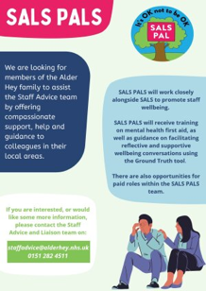  Health and Wellbeing Coaching  Working with a trained wellbeing coach who works within the organisation as part of a health and wellbeing project funded by the Charity, SALS have been offered a day a week of health and wellbeing coaching for staff, following the SALS pathway. This has been developed in partnership, with a clear pathway, governance and supervision offered in order that our staff can have a different offer to meet their specific physical health wellbeing needs.  The SALS team have developed many pathways across the organisation, including pathways with our staff side colleagues, our networks, FTSU, Restorative Clinical Supervision (RCS) the Alder Centre, the Chaplaincy, Arts for Health and our Patient experience team. Bringing all staff together who have the focus on wellbeing for staff and patients to collaborate and think about how we can make improvements is the ethos of SALS and we meet regularly as part of the Wellbeing Forum which we run every six months.  Period Poverty  With the support of the Charity we now have approximately 20 sanitary dispensers across the trust in a range of areas, including A&E, the atrium, Radiology Waiting Area, critical care waiting area, Theatres, all levels of outpatients and community locations so that staff, and patients and visitors to the trust are able to access complimentary sanitary products to help address period poverty. This project has been received excellently across the trust with feedback from staff and from visitors, all saying how invaluable they have found having access to sanitary products. To date we have had 300 pieces of individual feedback. The Charity have funded this for another twelve months, and we shall keep on collecting feedback to ensure that people are still finding this helpful. This work has been a collaborative effort with support from the Charity, from the SALS team, and from the facilities team, as it is our wonderful domestics who now refill the dispensers on a regular basis. We are also able to quickly monitor accessibility from the real time feedback from the QR code we have situated in the loos where we have placed dispensers. Recognising the financial impact on both staff and families and health inequalities, which touch us in Alder Hey the SALS team and Patient Experience team are working together to offer a more collaborative approach about how we can support everybody within our community. Launching a Christmas Project to support both children, young people and our families, as well as being mindful of our staff at this time of year, this has been developed, where we can cross link with services to offer the maximum support to all. Existing pathways around financial wellbeing are still in existence within the trust including access to Wage stream, Period poverty as previously mentioned, Pay it Forward, and a dedicated pathway to the CAB. | Excelling activity  3 | Human Resources Team  Staff Advice and Liaison Service  Occupational Health Team
Domain 2:  Workforce health and well-being | 2B: When at work, staff are free from abuse, harassment, bullying and physical violence from any source | We have several policies to support staff whilst at work: Flexible Working Policy, Domestic Abuse Policy, Reasonable Adjustment Policy, Respect at work Policy, Menopause Policy Zero Tolerance Policy and Domestic Abuse Policy. Alder Hey has signed the NHS Sexual Safety in Healthcare Organisational Charter aimed at tackling unwanted, inappropriate and/or harmful sexual behaviour in the workplace. As signatories to this charter, we commit to a zero-tolerance approach to any unwanted, inappropriate and/or harmful sexual behaviours towards our workforce. We have an executive sponsor and workstream lead who is taking this work forward and implementing initiatives to support the Charter.  Exit Interviews and Stay Conversations  During 2025 there were 68 exit questionnaires completed across the Trust (a reduction in 2024 when 97 were completed). The 2025 completion rate is low considering the number of leavers over the same period (519 over the same period). We ask the question of whether leavers would return to Alder Hey in the future. Due to the format of the previous exit questionnaire, it was not possible to analyse this as the response was a free text box for leavers to complete. Not all leavers were answering the question. We then created an updated exit questionnaire using a Microsoft form and placed this on the Trust intranet. We were hoping to see an increase in compliance due to the ease of access of the form as well as being able to analyse the data more easily and identify trends as to why people leave Alder Hey. Unfortunately, there has been some confusion as employees leaving the Trust are using a combination of the previous and current exit questionnaire. W followed this up with communication directly to the individuals to the current exit questionnaire.  The Personal Development Review (PDR) paperwork has been updated to include a section asking staff if they are considering leaving the organisation within the next 12 months. If they indicate they are thinking of leaving, they are invited to a stay conversation. Managers receive training on conducting effective PDRs and having effective wellbeing conversations. Each division will report their PDR progress as a KPI to the People Committee. We promote PDRs via our communication challenges throughout the year. We also offer PDR/Appraisal Training for Reviewers. This is a two-and-a-half-hour workshop designed to help reviewers understand the PDR process and ensure they have effective appraisal conversations,  We know that nurses aren’t just transferring between positions, but they are choosing to leave nursing as a profession. We also know that this impacts early career nurses more so than any other group. As a Trust we want nursing staff to feel supported, empowered and encouraged to thrive from their first day as a preceptee and then onwards throughout their career. By creating a supportive environment for our nurses to thrive, they are more likely to stay. As work continues within the Preceptorship space we have maintained and improved upon previous years successes with leaver rate continuing to decrease. Access to Professional Nurse Advocates and in turn Restorative Clinical Supervision has also increased across the organisation. We are currently achieving a 1:44 PNA to Nurse ratio, the ask from NHSE is to achieve a 1:20. To work towards achieving this goal, training continues to be supported within the trust. As such we have several people currently undertaking training some of whom have been supported through trust CPD whilst for others are supported through secured regional funding. Further places will also be facilitated as we progress through the 2025/2026 financial year.  To consolidate the work within the Restorative Clinical Supervision space, a clinical supervision policy is currently in development, this follows the recent success of the quality ward round which focused on clinical supervision within nursing. Upon ratification, the policy aims to further galvanise the support available to nurses within the Trust maintaining the focus of empowerment and encouragement. The Support for our People Toolkit is also now complete and available for all staff. This is a signposting aid which pulls together all wellbeing Trust initiatives to better highlight the support that’s available. The Lead for Nurse Retention role also continues to expand by assisting in a variety of interventions which includes but is not limited to pre-preceptorship support, internationally recruited development programme, values working group and the Trust thriving team’s agenda.  Working in partnership with our staff networks is central to ensuring that, at work, staff are free from abuse, harassment, bullying, and physical violence from any source. Staff networks provide a trusted forum for raising concerns, sharing lived experience, and shaping policies and practices that promote dignity, respect, and psychological safety. By engaging with these networks, the organisation strengthens its understanding of risks faced by different staff groups, supports early identification of issues, and ensures that prevention, reporting, and support mechanisms are inclusive, accessible, and effective.  In July this year we launched our first Mutual Mentoring Programme. The programme was co-designed with our staff networks. The Mutual Mentoring Programme is designed to foster reciprocal learning, build inclusive leadership capabilities, and help to enhance the understanding barriers faced by minoritised or marginalised staff, informing more inclusive policies and practices. Unlike the tradition top-down mentoring, this imitative promotes a two-way exchange of knowledge, experience, and perspectives. We had over 30 members of staff apply to take part, and each one has been paired with an executive or senior leaders within the organisation.  We have recently launched our new Trust Values:  Compassion: We recognise suffering and show care by taking intelligent action to stop or prevent it  Courage: We speak up, listen up, ​stand up, face change ​with hope, and do the ​right thing - even ​when it’s difficult.  Commitment: We show up, follow ​through, and stick ​with our shared ​promise to do our best ​for everyone that we serve.  Community: We connect across ​boundaries, include ​each other and create​a sense of belonging ​for everyone.​  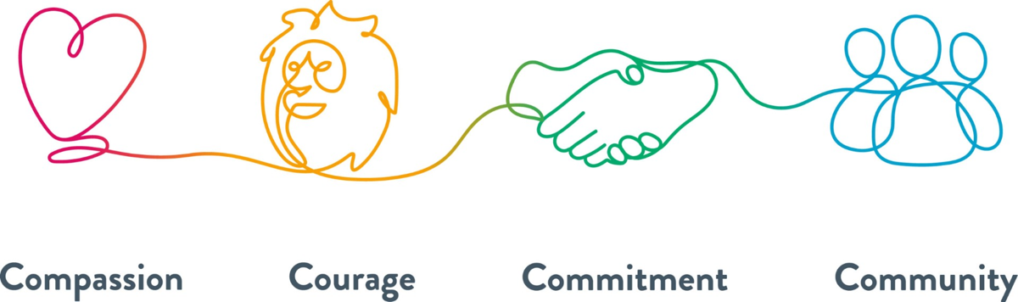  As part of the work to launch the values we developed a working group who supported the staff engagement and the development of the resources to support the launch. We have engaged with hundreds of staff over a 6-month period, attending team meetings, engagement events, training sessions, our staff networks and our Youth Forum, gaining feedback from staff. We also developed a questionnaire that we circulated to all staff, and we visited our community sites to ensure we reached as many staff as possible. We wanted to know what staff felt about the values, did they resonate and how could we ensure that we all live our values. | Achieving Activity  2 | Human Resources  Director of Nursing  Staff Advice and Liaison Service Team  Organisational Development
Domain 2:  Workforce health and well-being | 2C: Staff have access to independent support and advice when suffering from stress, abuse, bullying harassment and physical violence from any source | Part of the 2030 vision, here in Alder Hey, is to make this the best place to work, which is why it is important that all staff have access to Freedom to Speak Up, have no barriers and feel safe in accessing the service. Speaking up enhances all our working lives and improves the quality and safety of care. Listening and acting upon matters raised means that Freedom to Speak Up will help us be a great place to work and our patients will have the best care.  The trust Freedom to Speak up Guardian remains an active member of the trust providing regular drop-in sessions , visiting wards and departments, both on and off site, working in collaboration with the equality staff networks and the chairs and deputy chairs to support those staff who requires additional support and who may have extra barriers to raising concerns as a result of protected characteristics they may hold.  We have a Freedom to Speak Up policy, underpinned by NGO recommendations, this policy is currently under review, with a diverse task and finish group to undertake this review, to ensure it meets the needs of all staff.  We will be appointing a deputy to support our FTSUG and the service in December 2025, this appointment will ensure sustainability within the service and look to further develop the FTSU Champion network to ensure that it is representative of the Alder Hey population, which will aid the reduction of barriers to speaking up, faced by some staff.  The FTSU Visibility programme, continues, its purpose remains to heighten visibility of the FTSUG and to promote what the service offers, it also presents an opportunity for some ‘myth busting ‘to occur, so that staff have real clarity on what FTSU can and can’t do. The programme continues to attract members of the Board, so that they too remain visible, 2025 has seen monthly FTSU walkabouts with the CEO, which have been extremely well received and have resulted in positive changes occurring for staff raising concerns during these sessions, the CEO will maintain these sessions in 2026, with a plan already established.  A recent concern raised with the FTSUG, resulted in the EDI lead and FTSUG working collaboratively. The approach adopted, is currently being rolled out in the area the concern was raised and will be assessed and modified to ensure it is fit for purpose. Several other areas across the Trust have expressed an interest in adopting this approach in response to similar issues raised with their local leadership teams. This approach provides staff with an informal and supportive mechanism to raise concerns, issues, or challenges. Emerging themes from these areas will be systematically analysed and used to inform the development of targeted recommendations. Each area will be responsible for implementing these actions, supporting continuous improvement and contributing to the development of a more inclusive and positive working environment across the Trust.  Freedom to Speak Up training, Speak Up, is mandatory for all staff and can be accessed via Electronic Staff Records Portal (ESR), the currently we are 98% compliant. There are two additional courses available, Listen Up and Follow Up, these are currently not accessible through ESR, we are looking to address this in 2026, so that all leaders and senior leaders will also have access to this training.  Our staff networks continue to grow offering a safe space for staff to come together, share experiences and facilitate learning and development. They also support the organisation in delivering their strategic objectives, providing the staff with an opportunity to share their experiences, influencing decision making. The staff network chairs, and deputy chairs are provided with paid time to undertake their roles, and they are key members of the Equality, Diversity, and Inclusion Steering Group, and the Trusts Policy Review Group. The network chairs attend the EDI Steering Group to provide an update of each of the network's activity. Each meeting we spotlight one of the staff networks dependents on activity. All networks host awareness events throughout the year, raising awareness of the networks and their aims. We have four active networks and three fantastic support Groups  We have recently changed our Occupational Health provider to University of Hospitals Liverpool Groups. The new service so far has been a huge success, and the provider are SEQOHS accredited which means that they have been independently assessed to meet standards in safety, effectiveness and quality. They offer staff psychology and counselling support service to all staff. This is a service for staff who are seeking psychological support for issues related to their work.  Staff side have worked hard to collaborate and engage positively with staff groups and the EDI lead by identifying identified equalities representation as well as the promotion of better training for managers to understand the use of, and support given for flexible working agreements. With the aim of avoiding long term sickness and absence due to a variety of issues and increased awareness of what managers can do by way of stress risk assessments and supporting colleagues through periods of stress and anxiety.  Staff Side have worked closely and collaboratively with the HR team to aid and educate managers understanding and approach to long term sickness and how they can be proactive in avoidance of this situation arising and supportive of colleagues before this becomes an issue for the colleague and Trust to deal with. They have also identified the needs of equality central to policy reviews and the identification of issues, and their subsequent acknowledgement embedded into policies to avoid traps and barriers to working harmoniously. | Achieving Activity  2 | Freedom to Speak Up Guardian  Staff Advice and Liaison Service Team  Head of Equality, Diversity, and Inclusion
Domain 2:  Workforce health and well-being | 2D: Staff recommend the organisation as a place to work and receive treatment | In the 2024 survey, 2,696 staff members shared their feedback.  73.96% of respondents said they would recommend Alder Hey as a place to work, significantly higher than the national average of 60.90%.  89.59% said they would feel confident in the standard and quality of care Alder Hey provides if a friend or relative needed treatment. This is the highest score nationally, far exceeding the national average of 61.54%.  All scores have improved compared to the previous year.  We are continuing to strengthen our Equality, Diversity, and Inclusion (EDI) monitoring and exploring ways to better support staff through formal employee relations processes. Working closely with all staff networks, we aim to develop mechanisms that provide impartial support through an inclusion lens.  We have a dedicated ERoster Team who is responsible for managing the electronic staff rostering system to ensure safe, effective staffing and accurate pay. Their work includes supporting teams to build and maintain rosters, supporting managers with training and access, troubleshooting system issues, and ensuring compliance with staffing, contractual and regulatory requirements. They provide key workforce reports, and work closely with payroll, HR and clinical teams to support efficient workforce planning and service delivery.  Our active staff networks are available for staff to access. We want our staff to bring their whole selves to work, building an inclusive environment. Our staff networks attend the trust induction to provide information of how to join to our new starters. Our staff networks/support groups include:  - Race, Ethnicity, and Cultural Heritage (REACH)  - LGBTQIA+  - Armed Forces  - ACE: Disabilities and Long-Term Conditions  - Menopause support group  - Endometriosis Support Group  - Carers Support Group  All networks have key priorities that they work towards throughout the year, aligning to the organisational objectives. Throughout the year the staff networks have helped to support many celebration events. The Armed forces staff network held a Remembrance service in the Atrium Following the service, we had a ukulele band play wartime music, and a choir, catering offered a wartime menu. We held an Iftar during Ramadan asking staff to fast for the day then breaking the fast together with a meal and celebration. The local Imam came into the trust to support the event, and we invited staff, children and young people and their families along to help us break the fast. Our catering team also offered Iftar Boxes to families who were observing Ramadan. In September we held our first Onam event to celebrate the Onam Festival. It was an amazing event organised and support by many of our internationally recruited nurses. The events was attended by several of the executive team. We attended Liverpool PRIDE in July, with many of the staff network members and allies marching.  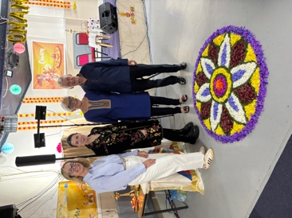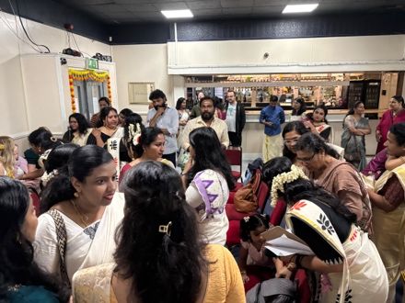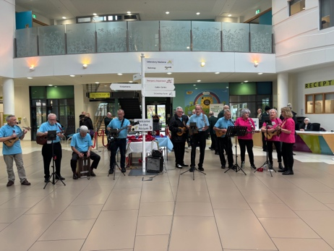  As well as the SAL’s Team, F2SUG and staff networks, staff are also able to access support and pastoral care from our Spiritual Care Team. They are there to support staff and offer staff areas of quiet and reflection within the Sanctuary space where the Spiritual Care Team are based. The Spiritual Care service can help support patients and their families/carers by:  - Offering support in a time of spiritual need  - Talking about baptism or blessing of patients  - Praying with patients and families, or just listening  - Contacting representatives of any other faiths and denominations as needed  - Providing a 24-hour 365-day service  The Spiritual Care team consists of two full-time staff, other staff who contribute to the 24/7 service, and several trained Spiritual Care volunteers. The Spiritual Care team are always happy to offer training at ward/department meetings for existing staff, or at Induction meetings for any new staff. There is a SOP guidance on how staff can access spiritual care support out of hours.    We have an online EDI plus learning programme which covers topics such as Anti-Racism, Allyship, Culture, Microaggression etc. It allows staff to access training on many aspects related to EDI. We also offer ‘Management Essentials Introduction to EDI’ programme which provides managers with an overview of how EDI impacts the organisation and offers them ideas of how they can better support staff. The training was co-designed with our staff networks, and they produced a video which is shown in the training, providing lived experience insight. We offer a bespoke Leadership and development programme ‘Thriving Leaders’. This six-month programme introduces leaders to EDI, neurodiversity, reasonable adjustments as well as providing them with a 4-week Anti-Racism programme that is delivered by the Anthony Walker Foundation.  Throughout the year, we have held monthly Lunch & Learn sessions, which are consistently well attended. Each month focuses on a different topic, with staff networks playing a key role in supporting and co-delivering several sessions. In November, the LGBTQIA+ Staff Network Chair led a Trans Awareness Lunch & Learn, and in July we held an extraordinary session with Gender Space, who shared their experiences and journey around trans awareness. During Black History Month, we also hosted an Anti-Racism Lunch & Learn, welcoming Lisa Shoko, Regional Anti-Racism Lead at Liverpool Women’s Hospital, to speak about their work.  These sessions provide staff with the opportunity to learn about a wide range of topics during their lunch break. Staff are actively encouraged to suggest areas of interest, allowing us to shape future sessions to reflect learning needs and priorities. | Excelling  Activity  3 | Human Resources  Organisational Development  Team  Head of Equality, Diversity, and Inclusion  Freedom to Speak Up Guardian
Domain 2: Workforce health and well-being overall rating |  |  | 10

Domain 3: Inclusive leadership
Domain | Outcome | Evidence | Rating | Owner (Dept/Lead)
Domain 3:  Inclusive leadership | 3A: Board members, system leaders (Band 9 and VSM) and those with line management responsibilities routinely demonstrate their understanding of, and commitment to, equality and health inequalities | The Trust Board remains fully committed to fostering an inclusive culture at Alder Hey, supporting both our diverse population and workforce. Equality, Diversity and Inclusion (EDI) is a strategic priority for the organisation and is embedded within governance arrangements. EDI is a standing agenda item at Trust Board, providing regular oversight, assurance, and opportunity for challenge, supported by routine EDI performance updates.  The Equality, Diversity and Inclusion Steering Group (EDISG), chaired by a Non-Executive Director, reports to the People Committee and provides assurance on progress against EDI objectives. The group identifies and monitors workforce EDI risks and tracks delivery against agreed actions. Staff Network Chairs and Co-Chairs are members of EDISG and provide regular updates on network activity, projects, and emerging themes. A monthly staff network spotlight enables in-depth reporting on impact, engagement, and risks, strengthening Board-level assurance.  Each staff network is supported by an Executive Sponsor who provides leadership, challenge and advocacy. Members of the Trust Executive Team demonstrate visible commitment to inclusion through regular attendance at staff network meetings and celebratory events, including Ramadan Iftar, Black History Month events, Liverpool PRIDE march, Remembrance Service, Diwali and Onam celebrations, and the Staff Network Christmas event. This visibility supports staff confidence, engagement, and psychological safety.  The Trust is committed to implementing the North West BAME Assembly Anti-Racist Framework, with clear executive ownership and Board support. An Anti-Racism Statement and supporting video have been developed and endorsed by the Executive Team. A designated Anti-Racist Executive Lead has been appointed (Chief People Officer), providing senior accountability and assurance on delivery and impact. We have recently put together our application for bronze status of the NW BAME Assembly Anti-Racist Framework  The North West BAME Assembly Anti-racist Framework  In October we launched our first Mutual Mentoring Programme with all executives and senior leaders taking part to support over 30 staff network members. The programme was co-developed with our staff networks, giving them the opportunity to shape the programme. This mentoring programme has so far been a huge success and a powerful approach to fostering inclusion, innovation, and leadership development across Alder Hey. We plan to hold a celebration event in May 2026, bringing everyone together to share their learning and celebrate the success of the programme.  A quarter of children in Cheshire and Merseyside live in poverty, 14.7% of these are living in absolute poverty. We know that living poverty increases the risk of a child experiencing adversity in childhood, and children in Cheshire & Merseyside experience poorer than national average outcomes across almost every key indicator of health. Inequality cuts across every member of some of our families and we know there is a difference of nearly 10 years life expectancy across our region. Improving children’s health outcomes and intervening early will support the 10 Year Health Plan’s commitment to raising the healthiest generation of children, as well as benefitting the health and opportunity for our future adult population.  In May 2024 the Trust employed a Consultant in Paediatric Public Health Medicine to lead the organisation’s ‘Improve my life chances’ area of work from our Vision 2030 strategy, recognising that children and young people in our community need support from many different services, not just Alder Hey. We have committed to work as a system with partners to redraw the map of health and social care, ensuring that all children, young people and families, particularly those unfairly impacted by health inequalities, can always find the right care they need in a system that is not always designed for them.  Some examples of our work to date and plans to tackle health inequalities for our children, young people and families include:  - Improve my Life Chances metrics for 2025/26 and beyond  The Trust is focusing on the following metrics, working with system partners to tackle health inequalities for its patients and wider community:  - Number of children < 10 years old waiting > 52 weeks for tooth extraction (based on Core20PLUS5 for CYP)  - Difference in waiting times for patients with a formally recorded learning disability (LD) compared to those without (related to Core20PLUS5 for CYP area of need and based on local need)  - Working with NHS England to improve the % of patients who have their ethnicity recorded (our initial target is 85% across the organisation) | Excelling  Activity  3 | Melissa Swindell Chief People Officer  Chief Nursing and AHP Officer, Nathan Askew
Domain 3:  Inclusive leadership | 3B: Board/Committee papers (including minutes) identify equality and health inequalities related impacts and risks and how they will be mitigated and managed | Board and Committee papers are required to identify equality and health inequalities impacts and associated risks, informed by the Trust’s Equality Impact Analysis (EIA) process and toolkit. Papers must clearly set out how identified impacts and risks will be mitigated, managed and monitored, including defined actions, accountable leads and timescales.  Our new QEIA toolkit supports paper authors to consider the potential impacts of decisions on people with protected characteristics and inclusion health groups, ensuring that equality is systematically embedded within decision-making. We have developed a new Quality, Equality, Impact Analysis (QEIA) process and toolkit to serve as a comprehensive resource for staff. This toolkit provides all necessary supporting information to facilitate meaningful QEIA completion. Through engagement with key stakeholders, we have refined the existing process to enhance ease of use while strengthening governance. The updated QEIA process will consider both health inclusion groups and individuals with protected characteristics. Reviews and approvals take place at accountable committees, with regular evaluations to ensure that mitigations are implemented, and emerging issues are identified.  All equality monitoring data and associated action plans are systematically reviewed through relevant accountable Committees, ensuring consistent oversight and scrutiny. Equality, Diversity and Inclusion (EDI) risks are formally recorded on the Board Assurance Framework, enabling regular Board-level review, challenge and assurance. Progress against actions and mitigating measures is routinely monitored, with clear escalation routes in place where progress is off track or emerging risks are identified. This ensures timely intervention, accountability and continuous improvement in the delivery of the Trust’s equality objectives. | Achieving Activity  2 | Melissa Swindell  Chief People Officer  Head of Equality, Diversity, and Inclusion  Chief Nursing and AHP Officer, Nathan Askew
Domain 3:  Inclusive leadership | 3C: Board members and system leaders (Band 9 and VSM) ensure levers are in place to manage performance and monitor progress with staff and patients | Equality reporting is routinely reviewed to provide assurance that the Trust is meeting the objectives set out within agreed equality action plans. This includes systematic monitoring of the Workforce Race Equality Standard (WRES), Workforce Disability Equality Standard (WDES), Gender Pay Gap (GPG), Equality Delivery System 2022 (EDS2), the EDI Annual Workforce Report, and the Patient and Carer Race Equality Framework (PCREF). The Trust has published its first Ethnicity Pay Gap Report and is currently analysing disability pay gap data in preparation for publication, demonstrating a continued commitment to transparency and addressing inequality.  All equality reports are reviewed and approved through the Equality, Diversity and Inclusion Steering Group (EDISG) and the People Committee and are formally signed off by the Trust Board prior to publication on the Trust’s public website. The People Committee receives regular progress updates against equality action plans, enabling effective scrutiny of performance, challenge where progress is off track, and escalation where required.  In addition, the Trust was reassessed against the Navajo Charter Mark in June, following two years of delivery against a co-produced action plan developed with the LGBTQIA+ Staff Network. The reassessment recognised areas of good practice and confirmed significant progress, alongside clearly defined actions for further development. Senior leaders continue to oversee delivery of the remaining actions to ensure sustained improvement and an inclusive experience for all staff and communities. | Achieving  Activity  2 | Melissa Swindell  Chief People Officer  Chief Nursing and AHP Officer, Nathan Askew
Domain 3: Inclusive leadership overall rating |  |  | 7

Third-party involvement in Domain 3 rating and review
Trade Union Rep(s): | Independent Evaluator(s)/Peer Reviewer(s):  Staff Networks and Staff Side colleagues have reviewed the report

EDS Organisation Rating (overall rating): 26

Organisation name(s): Alder Hey Children’s NHS Foundation Trust

Those who score under 8, adding all outcome scores in all domains, are rated Undeveloped

Those who score between 8 and 21, adding all outcome scores in all domains, are rated Developing

Those who score between 22 and 32, adding all outcome scores in all domains, are rated Achieving

Those who score 33, adding all outcome scores in all domains, are rated Excelling

Patient Equality Team
NHS England and NHS Improvement
england.eandhi@nhs.net

