Pregnancy and a CT scan
As a CT scan involves a dose of radiation, there is a risk to a developing baby.
Depending on which part of the body we have been asked to scan, females over the age 12 years will be asked to supply a urine sample for pregnancy testing.
Please do not take offence as this is Trust policy.

If you have any queries, please feel free to contact us on: 0151 252 5422.

This leaflet only gives general information. You must always discuss the individual treatment of your child with the appropriate member of staff. Do not rely on this leaflet alone for information about your child’s treatment.
This information can be made available in other languages and formats if requested.

Alder Hey Children’s NHS Foundation Trust
Alder Hey
Eaton Road
Liverpool
L12 2AP

Tel: 0151 228 4811
www.alderhey.nhs.uk

© Alder Hey
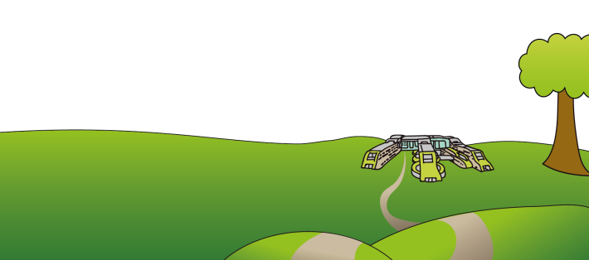
Review Date: March 2029 PIAG: 0033

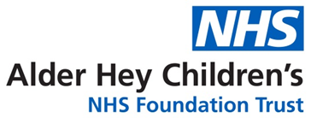

Radiology Department
C.T.
(Computerised
Tomography)
Scanner

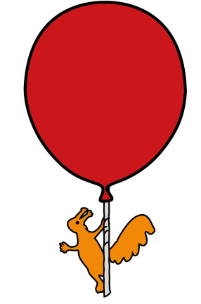

Information for patients
and carers

Your CT scan

Welcome to CT !
Your Doctor has referred you to us here in CT to have a scan. A CT scanner uses X-rays to give very detailed pictures of the inside of your body.
When you arrive a member of staff will greet you and explain what your test will involve.
You may need to get changed into a
hospital gown depending on which part of you we are scanning.
As some of our CT scans involve an
injection of x-ray dye, you will be given the option to have ‘Magic Cream’ to numb your skin so that you shouldn’t feel the cannula or butterfly needle. The cream takes at least 30 minutes to work.



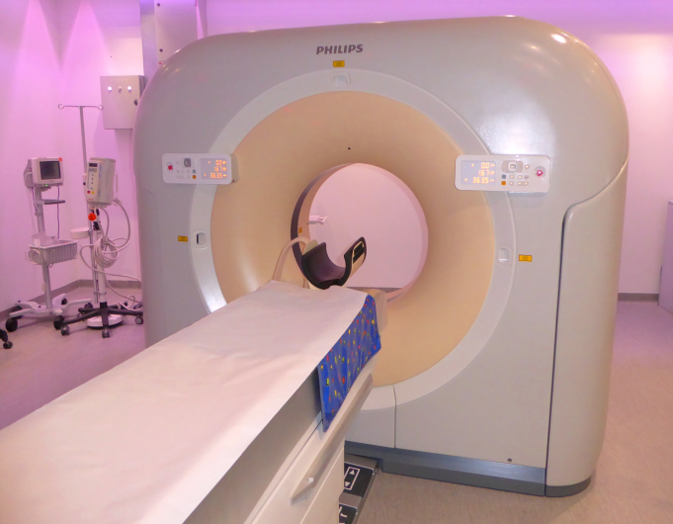

An adult can accompany you into the scan room and they must wear one of our special X-ray coats. (We have to check that any female relatives or carers are NOT pregnant before they can stay with you during a CT scan)
You will be asked to lie down on the scanner table and you must stay very still. The scanner looks and sounds a bit like a washing machine but it doesn’t take very long.
Once the scans are completed you can go. The pictures will be reported by a Radiology Doctor and sent on to the Consultant who referred you.


About the radiation involved
We are all exposed to natural radiation every day of our lives. This comes from the air we breathe, the food we eat and even from outer space.
In any one year our exposure will vary according to where we’ve lived, where we may have flown to and what we may have eaten.
Putting it into perspective
Each CT scan gives us a small
additional dose on top of this natural background radiation. The level of this extra dose varies with the type of
examination.



