
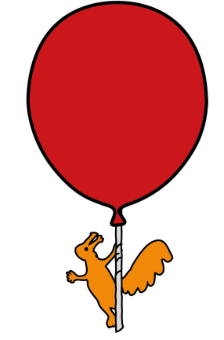

Emergency Department
E-Scooters & E-bikes
Patient Information Leaflet
Information for parents/guardians/carers/patients

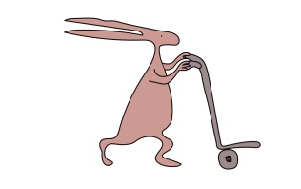

Electric scooters (e-scooters) and E-bikes are used in Liverpool and across the UK. In the Emergency Department at Alder Hey we are seeing injuries in young people from accidents involving e-scooters and e-bikes.
Both can go at high speeds, (much faster than a normal scooter or bicycle) and accidents can be associated with broken bones, facial injuries and more serious injuries that require admission to hospital.
E-SCOOTERS:
- E-scooters are treated by the law in the same way as driving a car or motorcycle. To ride them in public areas they need insurance, tax, and a valid license. It’s currently not possible to get insurance for privately owned e-scooters. It is therefore illegal for any young person under 17 and without a driving license to ride an e-scooter in a public area.
- Privately owned e-scooters are only allowed on private land (e.g., garden, driveway) and not public land (pavements, parks, and roads).
- Rental e-scooters can “ONLY” be ridden if you create an account with the company, hold a valid license and are over 16 years old.
- There are fixed penalty notices, fines and penalty points and the police can seize private e-scooters as they are illegal.
E-BIKES:
- You can ride an electric bike, or an 'electrically assisted pedal cycle' (EAPC), without a license or insurance if you're 14 or over.
- Rental e-bikes can “ONLY” be ridden if you create an account with the company, hold a valid license and are over 16 years old.
- Must have pedals that you can use to propel it
- Can have more than two wheels, for example a tricycle
- Must have an electric motor that can run continuously at a maximum power of no more than 250 watts, must have no electrical assistance once you reach 15.5 miles per hour (mph)
- If your electric bike fails to meet these requirements, it is illegal, and the police can seize it.

SAFETY:
- Wear a helmet due to the risk of skull fractures and brain injuries.
- Do not have multiple people (children or adults) riding as this can lead to more injuries.
- Supervise young people when they are riding.

Further information:


Scoot-Smart video


Merseyside Police
E-scooters/E bikes information


RoSPA safety information

This leaflet only gives general information. You must always discuss the individual treatment of your child with the appropriate member of staff. Do not rely on this leaflet alone for information about your child’s treatment.
This information can be made available in other languages and formats if requested.

Alder Hey Children’s NHS Foundation Trust
Alder Hey
Eaton Road
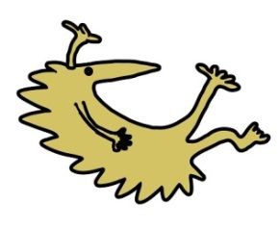
Liverpool
L12 2AP

Tel: 0151 228 4811
www.alderhey.nhs.uk

© Alder Hey Review Date: June 2029 PIAG: 406


