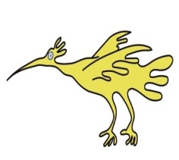



Complex Care Support Team
Preparing for Adulthood: What does good look like?

Information for Young People with Long-Term Needs

🌟 What is Preparing for Adulthood (Transition)?
Preparing for Adulthood is also called Transition.
It means getting ready to move from children’s health care to adult health care.
Transition helps young people become more independent and confident in managing your own health.

🧑‍⚕️ What Should a Good Transition Look Like?
A good transition doesn’t happen all at once.
It starts early – around age 13 or 14 – and takes time.
📝 A Good Transition Plan Should Include:
- 📅 Clear information about when transition will happen -This should come from each team you see.
- 🧍‍♀️ A personal plan just for you - It should include your needs, goals, and hopes for the future.
- 🔄 Regular check-ins with the health team - To see how things are going and change the plan if needed.
- ❓ Time to ask questions and share any worries - You should feel listened to.

🏥 At Alder Hey
We use helpful tools to support transition:
- 🟢 Ready Steady Go
- 🔟 10 Steps to Transition
These help make sure each young person gets the right support at the right time.

🤝 Feeling Supported
You and your family should not have to manage everything alone.
A good transition means you get the right help and support.

✅ Support Should Include:
- 🧑‍💼 A named person to help you - This might be a transition coordinator or key contact.
- 🗣️ Children’s and adult teams talking to each other -So they share important information and you get smooth, joined-up care.
- 💬 Support for feelings and mental health -This is especially important if you feel nervous or have complex needs.
- 📞 A clear plan for who to contact -You should always know who to call during and after the move to adult services.

🧍‍♂️ Learning to Take Responsibility
Transition should help young people take more control of their own health — but only when they’re ready.
It should happen step by step and at your own pace.
🧠 This Might Include:
- 📖 Learning about your health condition, medicines, and treatments -So you understand what helps you stay well.
- 💬 Having private time to talk to doctors or nurses - If you want, you can speak without a parent in the room.
- 🧾 Learning life skills for adulthood, like:
  - Ordering and collecting prescriptions
  - Booking your own appointments
  - Finding help with money or social care

👪 How Can Parents Help?
Parents and carers have an important role in helping you have a good transition.
They can help you feel ready for adult life.

✅ Ways Parents Can Support:
- 🗣️ Talk early about the future - Not just about health, but also about growing up, making choices, and becoming more independent.
- 🧍‍♀️ Encourage you to take part in your care - Go to appointments, ask questions, and explain your condition in your own words.
- 🏠 Practice life skills at home, like:
  - Taking medicine
  - Making phone calls
  - Booking appointments
- 🕰️ Be patient — learning independence takes time -Parents may need to give more help at first and less later.
- 🤝 Remember: your parents still matter - Even as you do more for yourself, they are still part of your support team.)

🏥 What Should I Expect from Health Services?
Health teams should give you and your family the right support during transition.
✅ Services Should:
- 📋 Have a clear transition plan - It should start early and be checked regularly.
- 📝 Give you information you can keep - This might be a leaflet or something online that explains what to expect.
- 🤝 Arrange a “handover” meeting - This is where you meet the adult team and learn about the new service.
- 💬 Support your feelings and mental health - They should offer help or refer to services if needed.
- 👨‍👩‍👧‍👦 Support parents and carers too - They understand this is a big change for families.
- 🧩 Make reasonable adjustments if you have
  - A learning disability
  - Autism
  - Sensory needs
  - Adult services should continue to support these needs.

🆘 What If I Need Extra Help?
Some young people and families need more support — and that’s OK.
If you find transition hard or have complex needs, help is available.

✅ What You Can Do:
- 🗣️ Tell your health team early - They can change the plan to give you the right support.
- 👥 Ask if other people can help, like:
  - A youth worker
  - A social worker
  - A psychologist
  - A learning disability nurse
- 🏥 At Alder Hey, you can speak to the Complex Care Support Team - They help when you see lots of different teams and things are hard to manage.

📅 Key Transition Milestones
Here’s what usually happens as you grow up and move to adult services:
Age | What Happens
12–14 | 🔹 First talks about the future start  🔹 You might get a transition passport or health summary
14–16 | 🔹 You are more involved in appointments  🔹 You begin to learn independent skills (like speaking up and understanding your health)
16–17 | 🔹 A transition plan is written  🔹 You might meet some of the adult team  🔹 Planning begins for college, work, or support service
18+ | 🔹 You move fully to adult care  🔹 You are supported in managing your health  🔹 You and your parents can give feedback to help improve the service

🌟 Final Thoughts
Transition is a journey.
It doesn’t happen in just one day — it takes time.
When done well, transition helps young people:
- 🌱 Thrive in adulthood
- 💪 Feel confident in looking after their health
- 🌍 Be ready for the future
You and your family are not alone.
Transition is a team effort.
You, your family, and the healthcare team all work together to make sure it’s done right.

❓ Need Support or Have Questions?
If you see 3 or more health teams, you can contact the Complex Care Support Team for help.
They can give you:
- Advice
- Support
- Guidance to help with the transition.

CONTACTS
Phone:

0151 293 3663
Email:

WEBSITES
[Website currently under construction]
www.readysteadygo.net
https://10stepstransition.org.uk/

This leaflet only gives general information. You must always discuss the individual treatment with the appropriate member of staff. Do not rely on this leaflet alone for information about your treatment.
This information can be made available in other languages and formats if requested.


Alder Hey Children’s NHS Foundation Trust
Alder Hey
Eaton Road
Liverpool
L12 2AP

Tel: 0151 228 4811
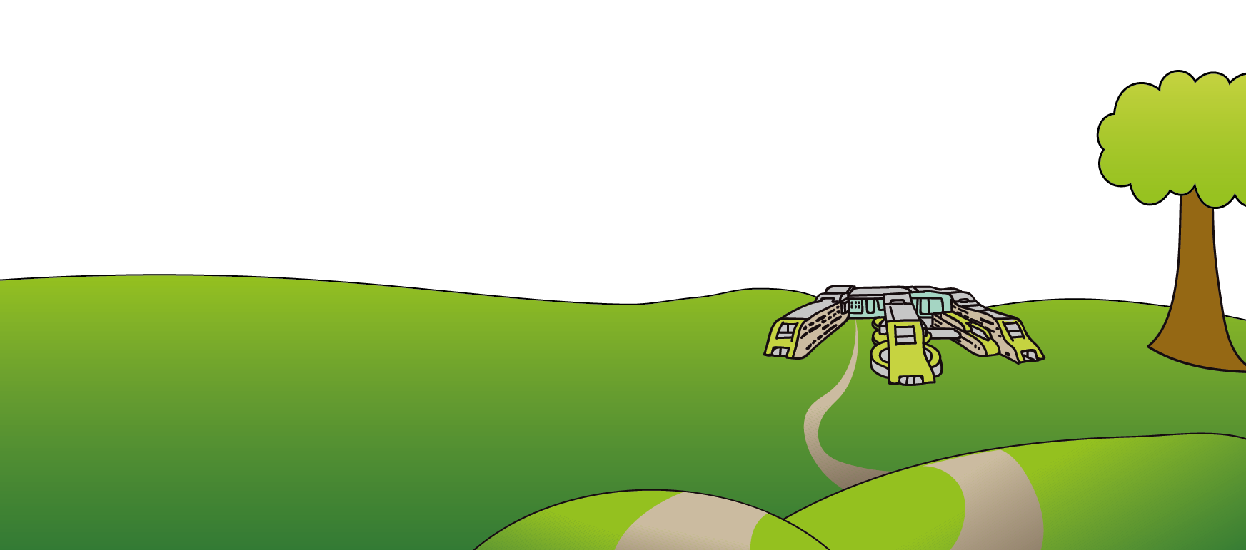
www.alderhey.nhs.uk

© Alder Hey Review Date: PIAG:

