‘Inspired by Children’

How to apply for NHS jobs
Helping to recruit the future NHS workforce

User guide content:
SECTION 1: About the NHS and its ‘Values’ Page 2.
SECTION 2: About Alder Hey Children’s NHS Foundation Trust Page 2.
SECTION 3: NHS recruitment (it’s all about skills, potential and values) Page 3.
SECTION 4: NHS Jobs website Page 3.
SECTION 5: The application process and your ‘supporting Information’ Page 4.
SECTION 6: The ‘interview’ Page 4.

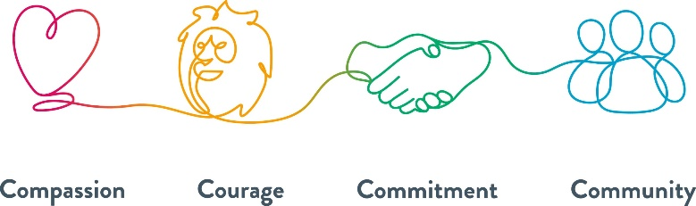

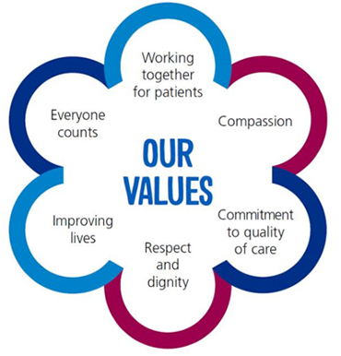
SECTION 1: About the NHS and its ‘Values’
The NHS ‘Values’ are:
In the UK, we have all used the NHS at some point. But what exactly is the NHS?
The NHS is the term used in the UK to describe the collective publicly funded healthcare systems of the United Kingdom. It’s made up of a wide range of different organisations with different roles, responsibilities and specialities. These organisations provide a variety of services and support to patients and carers. Examples include GP services, GP Out of Hours, Acute Hospitals including Emergency Departments and Cancer Care, Mental Health Services and Social Care.

SECTION 2: About Alder Hey Children’s NHS Foundation Trust
What we do, how many children and young people we treat and more.
Each year, we provide care to more than 450,000 children and young people.
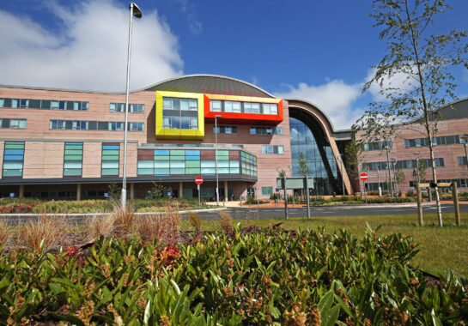
Alder Hey Children’s Hospital, located in Liverpool UK, is at the heart of Alder Hey and is one of Europe’s biggest and busiest children’s hospitals, where we treat everything from common illnesses to highly complex and specialist conditions.

We know that a children’s hospital is different and that our job is more than just treating an illness. To us, every child is an individual. As well as giving them the very best care, we set out to make them feel happy, safe and confident as they play, learn and grow. At Alder Hey, we are here to look after a child and their family and that includes mums, dads, brothers and sisters.

Alder Hey offers a number of specialist services and we are one of only two providers in the North West designated to receive the specialist children’s top-up to national tariff for this work. We are one of the two accredited major trauma centres for children in the North West and are also nationally commissioned as one of four epilepsy surgical centres, a service we provide in partnership with Manchester Children’s Hospital. As the regional cardiac surgical centre, we continue to lead in developing the cardiac network across the region to provide seamless care pathways for children with congenital heart problems. The Trust also is one of four commissioned paediatric national craniofacial units.

The Trust employs a workforce of 4,115 staff who work across our community and hospital sites. As a teaching and training hospital, we provide education and training to around 900 medical and over 800 nursing and allied health professional students each year.

About Alder Hey Children's NHS Foundation Trust - Alder Hey Children's Hospital Trust

SECTION 3: NHS recruitment (it’s all about skills, potential and values)
Values Based Recruitment (VBR) is about seeking to recruit staff with values that are the same as the organisation. It is used in the NHS to ensure that the NHS has the right workforce, with the right skills, in the right numbers, with the right values, to support effective team working and deliver excellent patient care and experience.

The NHS wants to recruit like-minded people which is why what you put in your ‘supporting information’ is very important.

SECTION 4: NHS Jobs website

Jobs can be found on NHS Jobs and the Trust’s website
1
Click on the hyperlink or use the QR code below to firstly register or login:

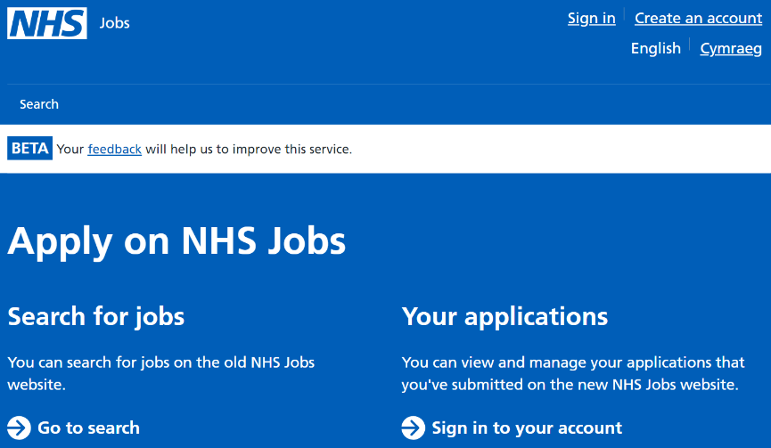
https://www.jobs.nhs.uk/

You can search for jobs on the old NHS Jobs website…

Ensure that you use a professional email address when registering or applying for jobs

2

3
Once you have registered for an account, you can:
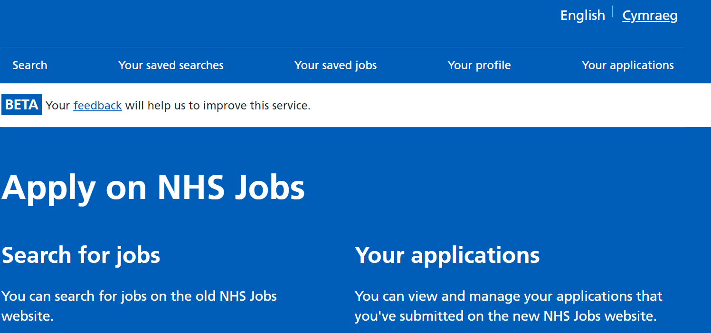

- View and manage your applications that
you’ve submitted on the new NHS Jobs
website
- Create your profile
- View your saved jobs and searches

SECTION 5: The application process and your ‘supporting information’
For first time applicants there is a lot to complete but once you have done this it can be saved for next time if required.

The sections to complete are:
- This is your time to shine!
- Think back to the NHS values
- Research your employer and their ‘Values’

1
Personal information

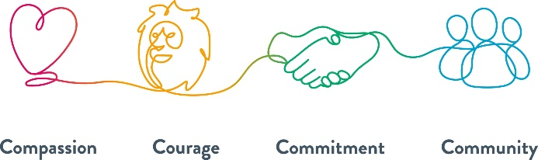
2
Qualifications

3
Employment history

- Don’t assume that the employer will know your skills and experience from your employment history
- Go through the job description and the personal specification and describe how you can do the job
- Sell yourself and your skills and knowledge
- Proofread and review your spelling, punctuation and grammar

4
Referees

5
Supporting information * see below

6
Monitoring information

The ‘supporting information’ section is key. You need to sell yourself to show how you meet all the criteria in the job description and personal specification documents. You need to demonstrate that not only do you have the skills and knowledge for the job, but you also share Alder Hey’s values!

SECTION 6: The ‘interview’

- Values based interview
- 45 minutes to 1 hour, at least 2 interviewers
- Prepare, prepare, prepare
- Talk about yourself
- Why do you want the job?
- Think about questions that might be asked. “Tell me about a time when…” scenario questions
- It’s a two-way process – what would you like to ask?
You can also access support with interview guidance by clicking on the hyperlink or using the QR code below this:
Be My Interviewer - NHS Jobs


What to do next……

- If you have any questions please email recruitment@alderhey.nhs.uk
- In addition to the NHS Jobs site, Alder Hey specific vacancies can also be found on our website using the QR code below:


‘Good Luck’ with your application!

