


Complex Care Support Team

Preparing for Adulthood: What does good look like?
Information for Parents and Carers of Young People with Long-Term Needs

What is Preparing for Adulthood?
Preparing for Adulthood (Transition) is more than just a transfer from one service to another. It’s a thoughtful, planned process that prepares young people with long-term health needs to move from children’s to adult healthcare. This involves not just the medical aspects of care, but also emotional, social, and developmental support. A well-managed transition helps ensure that young people continue to receive high-quality care while becoming more independent and confident in managing their own health.

Why do we need transition to adult services?
Transitioning to adult services is essential to make sure that your child continues to receive care that is right for their age, stage of life, and changing needs. As young people grow older, their medical, emotional, and social needs shift and adult services are designed to reflect that.

Without a proper transition:
- Your child may miss out on the opportunities and resources that adult services offer, like access to adult mental health support, reproductive health advice, or vocational services.
- Young adults might remain in children’s wards, where the environment and support are not suitable for their age.
- Children’s services could become overwhelmed, making it harder for babies, toddlers, and younger children to access the care and support they need.

Transition helps everyone — it keeps children’s spaces open for young children, while ensuring young people are cared for in a way that respects their growing independence and maturity.

What Should a Good Transition Look Like?
Planned
Preparing for Adulthood does not happen overnight. It starts early – at 13 to 14 - and happens gradually, at different starting points depending on the specialty and how frequently they are seen. You should expect:
- Clear communication about the timeline for transition from each specialty your child is seen by.
- An individualised transition plan that reflects your child’s specific needs, wishes, and aspirations.
- Regular check-ins and reviews with your healthcare team to monitor progress and update the plan.
- Opportunities for you and your child to ask questions and express concerns along the way.
- In Alder Hey, we use the Ready Steady Go Programme and 10 Steps to Transition as frameworks according to the individual needs of the young person. The links for these are at the end of this leaflet.

Supported
Families should never feel left to figure it out alone. Good transition includes:
- A named transition coordinator or key contact person to guide your family through the process.
- Discussions between paediatric and adult teams, so important information is shared and care continues seamlessly.
- Emotional and psychological support, especially if your child is nervous or has complex needs.
- A clear plan for whom to contact during and after transfer, so there’s no confusion.

Empowering
Transition should encourage young people to gradually take on more responsibility for their health, at a pace that’s right for them. This may include:
- Teaching young people to understand their condition, medications, and treatments.
- Giving them opportunities to speak directly to healthcare professionals, sometimes without a parent present.
- Helping them navigate practical aspects of adult life, such as managing prescriptions, making appointments, and accessing social care or financial support if needed.

How Can I Support My Child?
Your role is vital in supporting a positive transition experience. Here are some practical ways you can help:
- Start conversations early about the future, not just about healthcare, but also about growing up, choices, and independence.
- Encourage your child to be involved in their care by attending appointments, asking questions, and learning to explain their condition in their own words.
- Practice life skills at home, such as managing medications or making phone calls.
- Be patient, independence takes time, and support may need to be tailored as your child matures.
- You’re still a key partner in their care, even as their role becomes more central.

What Should I Expect from Services?
- Offer a structured transition programme that starts early and is reviewed regularly.
- Provide written materials or digital resources that outline what to expect.
- Specialties may arrange for a “handover” meeting or clinic, where your child meets the adult team and learns about the new service.
- Continue to support your child’s emotional well-being and offer referrals if mental health support is needed.
- Support families through the emotional side of transition, recognising this is a big change for parents as well as young people.
- If your child has additional needs (e.g. learning disability, autism, sensory needs), adult services should have plans in place to continue any reasonable adjustments or enhanced support.

What If We Need Extra Help?
Some young people and families need more support, and that’s okay. If your child is struggling with the idea of transition or has complex needs:
- Let your clinical team know early so they can adapt the process.
- Ask if there is a youth worker, social worker, psychologist, or learning disability nurse who can help.
- Speak to the Complex Care Support Team within Alder Hey – if you or your child comes under multiple specialities that are challenging to coordinate, the team is available to offer support and advice.
Key Milestones to Look Out For
Age | What Happens
12–14 | First discussions about transition begin. Your child may receive a transition passport or health summary.
14–16 | Your child becomes more involved in appointments. Skills for independence are encouraged (e.g. self-advocacy, learning about their condition).
16–17 | A transition plan is in place. Your child may begin meeting members of the adult team. Planning for college, work, or social support may begin.
18+ | Handover is complete. Adult care begins. Your child continues to be supported in managing their care independently. Feedback is collected to improve the process.

Final Thoughts
Transition is a journey, not a one-off event. Done well, it supports young people to thrive in adulthood, with the tools, confidence, and support they need to manage their health and their future.

You are not alone in this. It’s a team effort, you, your child, and the healthcare professionals working together to get it right.

Need Support or Have Questions?
Please contact the Complex Care Support Team:
- If your experience with transition is challenging – we need to understand, assist and address this.
- If your child has 3 or more specialities involved and you require advice, support and guidance navigating through transition.

CONTACTS


Phone:
0151 293 3663
Email:
PFA@alderhey.nhs.uk

WEBSITES
[AH Website currently under construction]
www.readysteadygo.net
https://10stepstransition.org.uk/
https://contact.org.uk/help-for-families/information-advice-services/preparing-for-adult-life/
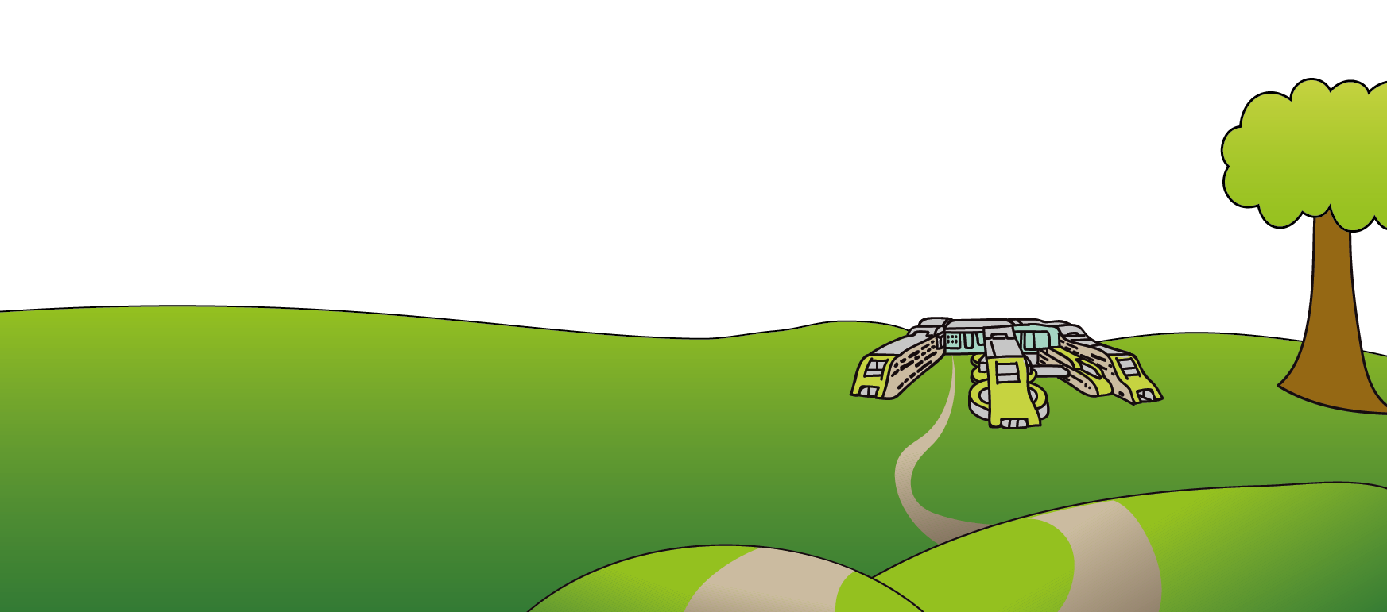
This leaflet only gives general information. You must always discuss the individual treatment of your child with the appropriate member of staff. Do not rely on this leaflet alone for information about your child’s treatment.

This information can be made available in other languages and formats if requested.


Alder Hey Children’s NHS Foundation Trust
Alder Hey
Eaton Road
Liverpool
L12 2AP

Tel: 0151 228 4811
www.alderhey.nhs.uk
© Alder Hey Review Date: May 2028 PIAG: 614

