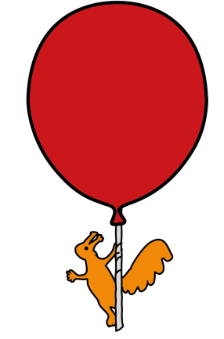
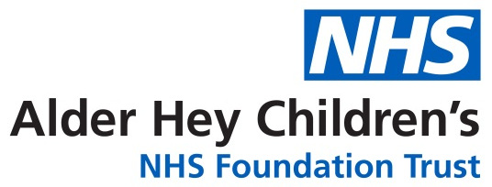

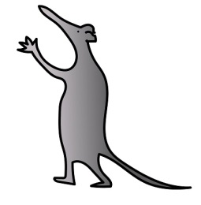

Heamatology/Orthopaedic/Pharmacy Department

VENOUS THROMBOEMBOLISM (VTE) PREVENTION

Information for Parents and Carers

What is Venous Thromboembolism/Thrombosis?
Venous thrombosis is when a blood clot occurs in a vein and blocks the flow of blood.
The most common type of venous thrombosis is when it occurs in a deep vein in the leg or arm – this is known as a Deep Vein Thrombosis (DVT).
Sometimes the clot can break off and travel through the body and end up blocking a blood vessel – this is called an embolism. If this happens in the arteries in the lungs it is known as a Pulmonary Embolism (PE). A PE can be fatal.
Venous thromboembolism (VTE) is the term used to describe both DVT and PE.
Clots can also sometimes occur in the veins of the brain, and these are called Cerebral Venous Sinus Thrombosis (CVST) – this may be referred to as a type of stroke.
What are the risks of this happening?
Children are 10 times less likely to develop venous thromboembolism than adults, but it still can happen. It is more likely to happen if your child is hospitalised and if they are aged 13 years or above. Other known risks factors for this happening include:
RISK factors
Patient related | Hospital admission related
- Age 13 years and above.  - Obesity/being overweight.  - Having cancer or cancer treatment.  - A chronic health condition such as nephrotic syndrome, inflammatory bowel disease, sickle cell disease or autoimmune disease, congenital heart disease, metabolic and endocrine diseases; hyperinsulinemia.  - Dehydration.  - Pregnancy or 6 weeks after birth.  - Patient or family member having a blood clot in the past.  - The combined (oestrogen and progesterone) oral contraceptive pill.  - Having a central venous line – this is a device inserted into a large, central vein that allows medicines to be administered. Examples include PICC lines, port-a-caths and tunnelled Hickman/Broviac lines. | - Reduced mobility/long periods in bed for longer than 3 days.  - Having an operation – especially on abdomen or bones.  - Having an anaesthetic.  - Being in intensive care.  - Severe trauma.  - Serious infection/sepsis.  - Severe burns.
How is VTE prevented?
General recommendations for all patients are to stay active; drink plenty,keep mobile and to make sure they do the physiotherapy exercises they have been given.
The doctors, nurses and physiotherapists on the ward will advise you on this.
On admission to hospital a risk assessment is done on all children and young people aged 13 years and above.
This will consider any specific risk factors your child may have and help the doctors decide if they are at risk of VTE and whether they need medication and/or any compression stockings in addition to the general recommendations above.

If the doctors have assessed your child’s risk of developing VTE as low, your child will not need any medication but you should still be aware of the signs and symptoms of them developing VTE.
What are the signs and symptoms of VTE, what should I look out for and what should I do?
Signs and symptoms of VTE can vary, and it is important that you know what to look out for.
A Deep Vein Thrombosis (DVT) can cause
- Swelling and throbbing pain in the limb, usually in one limb (calf or thigh if it's in the leg).
- It may also feel warm and tense and be painful to touch.
- It can look red, or the skin can be darkened around the painful area – this may be harder to see on brown or black skin.
- Sometimes only the pain is present.
These symptoms can also happen in your child’s arm or tummy if that is where the blood clot is.
A DVT is a medical emergency – if you suspect your child has symptoms of a DVT whilst in hospital please let the nurse or doctor know as soon as possible. If this happens after your child has been discharged – call your GP as soon as possible.
A pulmonary embolism (PE) can cause
- Slow or sudden onset of breathlessness or difficulty breathing,
- Pains in the chest that are worse when taking a breath or coughing,
- Coughing up blood
- Sometimes collapse or fainting/very low blood pressure/light headedness.
- There may also be the signs and symptoms of a DVT (see above)
A cerebral venous sinus thrombosis (CVST) can cause
- Severe headache
- Fits
- Vomiting
- Weakness or numbness of an arm or leg
- Excessive drowsiness or long pauses in breathing (apnoes)
Both PE and CVST are a medical emergency; if you suspect your child has symptoms of a PE or CVST whilst in hospital, it is important to let the nurse or doctor know immediately. If this happens after your child has been discharged, call 999 straight away
What medication could my child need?
If your child is considered at risk of VTE and needs medication to prevent VTE, the medication is likely to be a type of ‘anticoagulant’ which is a drug that prevents clots from forming. Anticoagulants are sometimes also known as ‘blood thinners’.
The anticoagulant used at Alder Hey is a type of heparin called enoxaparin (the brand name is Clexane®). This is an injection given just under the skin. This is known as a subcutaneous injection or ‘subcut’ for short.
All heparin-type medications are made using materials that come from pigs. If you have any strong personal beliefs (dietary/religious) that could make enoxaparin an unsuitable option then please discuss this with your doctor.
The doctors will decide if your child needs to have enoxaparin whilst in hospital. They may also decide your child needs to carry on having enoxaparin after being discharged home.
If this is the case, you will receive information and advice on how to give enoxaparin and for how long. The nurses will show you how to administer the injection to your child before they are discharged home. You should not try to do this if you have not been shown how. Refer back to the ward or department that you have been discharged from if you have any questions.
You will also be given information in a separate ‘dosage information sheet’ provided with the medication that will tell you the dose, how many times a day and for how long to give it for. The dosage information sheet will tell you how to administer the dose in step by step instructions.
You should make sure the enoxaparin injection is given as prescribed, that it is given at the same times/times every day and that no doses are missed.
Sharps Bins
You should also have been provided with a sharps bin to keep the used syringes in until they can be disposed of safely. Needles and syringes can cause serious injuries if they are not disposed of safely and correctly. You should keep the sharps bin out of the reach of children.
If you need more sharps bins please contact your child’s GP.
Once the sharps bin is full, or you no longer need it, you should close and lock the cover securely. Do not close and lock the sharps bin until you have finished with it as when it has been locked it cannot be opened again.
Sharps and sharps bins should NEVER be disposed of in the regular household waste. Different areas/councils have different arrangements in place for disposal so you should contact your local council (and/or GP) to arrange collection and disposal.
Are there side effects from the medication?
Like all medicines, enoxaparin can cause side effects, although not everybody gets them. Some of the side effects are listed below. More detailed information on the side effects will be in the manufacturers patient information leaflet provided with the medication – you should read this carefully.
Your child should stop using enoxaparin and talk to a doctor straight away if they get any signs of a severe allergic reaction (rash, difficulty breathing, swallowing, swelling of the eyes, face, lips, tongue, mouth or throat).
Your child should stop using enoxaparin and seek medical attention immediately if they get a red, scaley, widespread rash with bumps under the skin and blisters along with a fever. This could be something called acute generalized exanthematous pustulosis. The symptoms usually appear at the beginning of treatment.
Because enoxaparin is an anticoagulant or blood thinner - it may increase the risk of bleeding. You should look out for nosebleeds, increased bruising, increased bleeding from cuts, bleeding from gums after brushing or flossing teeth, blood in urine, or red/black coloured stools. You should let your child’s doctor know if your child has any of these symptoms.
You should also let the doctor know if your child is taking any other medications that may affect bleeding eg aspirin, warfarin, clopidogrel, ibuprofen or other NSAIDs, steroids such as prednisolone; or any medicines that increase potassium levels in their blood eg potassium salts, some diuretics, or some heart medications.
In rare cases enoxaparin can also cause low platelets. Platelets are clotting cells that help stop bleeding. Your child’s doctor may request blood tests to check their platelet count

Who to contact if you need help
If you are concerned your child is more unwell, call 111 or attend your local emergency department.
If you need general advice, contact your local hospital.
Each department/ward may have different arrangements, there may be a specialist nurse you can contact, or you may be given details of your child’s consultant’s secretary. Find out who you should contact if you need help before you go home. You can record these details below
Who to contact………………………………
Contact details……………………………….
In case of an emergency – dial 999
References
Venous Thromboembolism (VTE) in Infants, Children, and Adolescents. Thrombosis UK Fact Sheet. www.thrombosisuk.org. Publication date Jan 2024. Review date Jan 2026.
Blood clots: Reducing the Risk. Patient Information Leaflet. Buckinghamshire Healthcare NHS Trust. Leaflet Code WZZ1294 Version 3. Reviewed Jan 2021.
Venous Thromboembolism (VTE) Patient Information Leaflet. Widnes Urgent Treatment Centre. Bridgewater Community Healthcare NHS Foundation Trust. Version No: BRIDGE0339 – April 2024-April 2027.
NICE guidance; Venous thromboembolic diseases: diagnosis, management and thrombophilia testing. Information for the public Published: 26 March 2020. Available at Venous thromboembolic diseases: diagnosis, management and thrombophilia testing. Accessed 11.8.2025.
NHS conditions A-Z; DVT (Deep Vein Thrombosis). Available at DVT (deep vein thrombosis) - NHS. Accessed 11.8.2025.
NHS conditions A-Z; Pulmonary Embolism. Available at Pulmonary embolism - NHS. Accessed 11.8.2025.
Clexane Patient Information leaflet. Sanofi. Available at https://www.medicines.org.uk/emc/product/12804/pil. Accessed 11.8.2025

This leaflet only gives general information. You must always discuss the individual treatment of your child with the appropriate member of staff. Do not rely on this leaflet alone for information about your child’s treatment.
This information can be made available in other languages and formats if requested.

Please have a look at our virtual map https://bit.ly/3TKgoXi prior to your visit. Here you will find - 360° walk-through of over 188,000 square feet of Alder Hey captured in 4K.
- 156 interactive 'hotspots'.
- 74 videos explaining what happens when you have a procedure or arrive for an appointment.
- Virtual signage to help you find your way around.

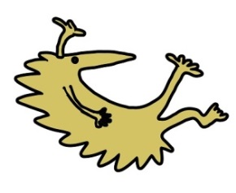
Alder Hey Children’s NHS Foundation Trust
Alder Hey
Eaton Road
Liverpool
L12 2AP

Tel: 0151 228 4811
www.alderhey.nhs.uk

© Alder Hey Review Date: October 2028 PIAG: 616

