


Physiotherapy Department – Oncology Unit

How Physiotherapy Can Help Your Child undergoing cancer treatment

Information for parents

Introduction

A physiotherapist may see your child during their treatment. This is because they might experience side effects from their illness or from their treatment which can sometimes affect their walking.

The physiotherapist may monitor your child and offer advice on activities / exercises to help.

Benefits of exercise

It is important that when children are treated for cancer that they still exercise when they feel well, and it is beneficial they do so!


Benefits:

- Helps to keep muscles strong
- Helps to keep joints mobile and healthy
- Improves bone density
- Improves fitness
- Helps to regulate weight
- Can improve cancer related fatigue
- Helps to lift mood
Activity ideas

Keeping children active really helps during treatment. While your child is on treatment it is better for them to do regular short bursts of activity rather than a lot in one go. Below are some ideas for activities to do with your child;

- If your child needs bed rest they can still be active by using their hands and feet to pop bubbles or pat a balloon
- Encourage your child to walk or crawl even if it’s only a short distance
- If they have a wheelchair they could walk pushing their chair for a short distance instead of sitting in it
- If stairs are difficult, try going up and down them on their bottom
- Heel walking and standing on heels can help to keep muscles in the foot and ankle strong (these often get weak)
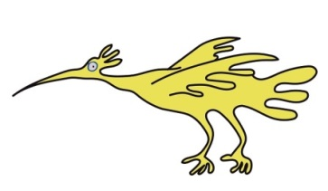
- Make exercise fun, younger children often enjoy games including crawling / rolling / obstacle courses, older children may enjoy exercises on the Wii Fit / Kinect
- Children should join in with PE at school
- Children can do non-contact sports even if they have a line in place

Who to contact for further details
The following link may also provide useful advice about exercise during cancer treatment
https://www.cclg.org.uk/publications/Everyday-life/Keeping-active-during-and-after-treatment/KEEPACTV

This leaflet only gives general information. You must always discuss the individual treatment of your child with the appropriate member of staff. Do not rely on this leaflet alone for information about your child’s treatment.
This information can be made available in other languages and formats if requested.

Alder Hey Children’s NHS Foundation Trust
Alder Hey
Eaton Road
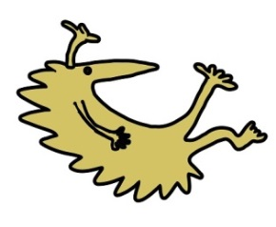
Liverpool
L12 2AP


Tel: 0151 228 4811
www.alderhey.nhs.uk

© Alder Hey Review Date: Feb 2029 PIAG: 0036

