Contact us

If you have any problems or questions, please contact a member of
the team who will be happy to discuss them with you.

Telephone: 0151 252 5318
Email: orthotics@alderhey.nhs.uk

This leaflet only provides general information. You must always discuss the individual treatment with the appropriate staff member.
Do not rely on this leaflet alone for information about the treatment.
This information can be made available in other languages and formats if requested

Alder Hey Children’s NHS Foundation Trust
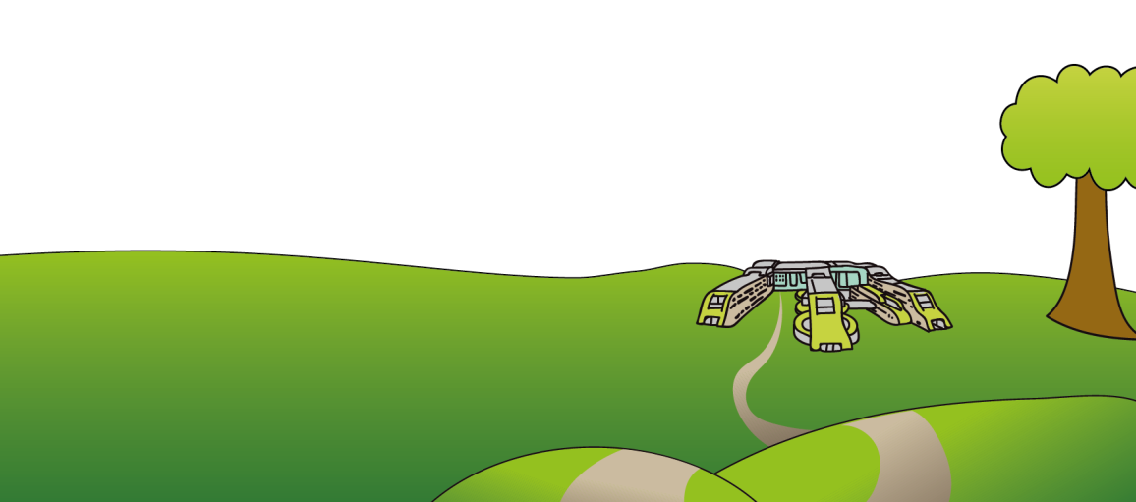
Eaton Road
Liverpool
L12 2AP

Tel: 0151 228 4811
www.alderhey.nhs.uk

© Alder Hey Review Date: August 2027 PIAG: 158


Orthotics Department

Neck Braces
and Collars

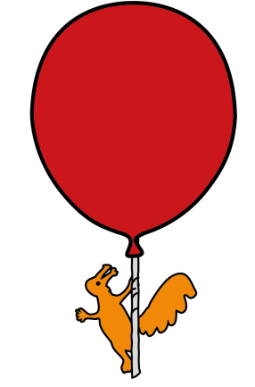

Information for
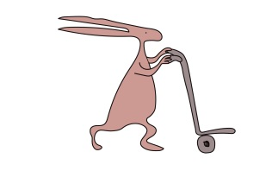
patients, parents and carers

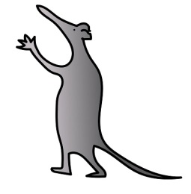
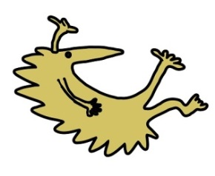

Why has a neck brace/collar been prescribed and what is my child entitled to?

- Your child will be provided with one neck brace at a time due to regular growing and change in children.

- A second will be provided only when the brace is deemed as no longer clinically effective or beyond repair. A second brace will also be provided if your child grows and the brace no longer fits.

- Neck braces can be used for many reasons, some being:

1) Support the mass of the head
2) Limit movement in the neck and spine
3) Support weakened muscles
4) Support vertebrae in the spine which have weakened or become instable
5) Reduce pain/ increase comfort
6) Prevent further injury or deformity

Care of the brace

- Regularly clean the neck brace with mild soap and water, towel dry and keep away from direct heat sources i.e. radiator, as the material may distort.

- It is your responsibility to bring the device to the orthotics department for repairs as and when necessary i.e. when straps or pads become worn down.

- It is also your responsibility to contact the department if the wearers condition changes or if the brace no longer fits correctly.

How is a neck brace fitted and wearing the brace.

- The neck brace will be fitted by one of our trained Orthotists in clinic or by a consultant or specialist in the fracture clinic.

- The Orthotist will advise you on how to properly fit your child’s brace but when putting the brace on, ensure the brace is in the correct place i.e. the right way around and the straps should be pulled tight enough to ensure it does not move around or slide up and down, but not too tight so that they cause discomfort.

- If there are any pads i.e. chin pads, please ensure these are all still intact and are in the correct place.

- The Orthotist will advise you of when and how long the knee brace needs to be worn for, although this is usually as much as possible or whenever weight bearing.

What issues do I need to be aware of?

- Some marking of the skin is normal, as is a build-up of some hard skin. Provided this is not excessive, painful and discolouration clears, this is nothing to worry about. If it is any of the above, contact the department.

- Sometimes braces can lead to sores, blisters, pain or rubbing, if any of this arises, contact the department.

- The size of the neck may increase or decrease due to swelling. Therefore, it is important to regularly check the straps and the overall fitting of the brace to ensure it is still secure and not too tight. If any of this occurs, please contact the department.

