What issues do I need to be aware of?

- Some discolouration of the skin is normal, as is a build-up of some hard skin. Provided this is not excessive, painful and discolouration clears, this is nothing to worry about. If it is any of the above, contact the department.

- Sometimes knee braces can lead to sores, blisters, pain or rubbing, if any of this arises, contact the department.

- Due to the nature of some of injuries or underlying conditions commonly diagnosed prior to prescribing a knee brace, the size of the limb may increase or decrease due to swelling. Therefore, it is important to regularly check the straps and the overall fitting of the brace to ensure it is still secure and not too tight. If any of this occurs, please contact the department.

Contact us

If you have any problems or questions, please contact a member of
the team who will be happy to discuss them with you.

Telephone: 0151 252 5318
Email: orthotics@alderhey.nhs.uk

This leaflet only provides general information. You must always discuss the individual treatment with the appropriate staff member.
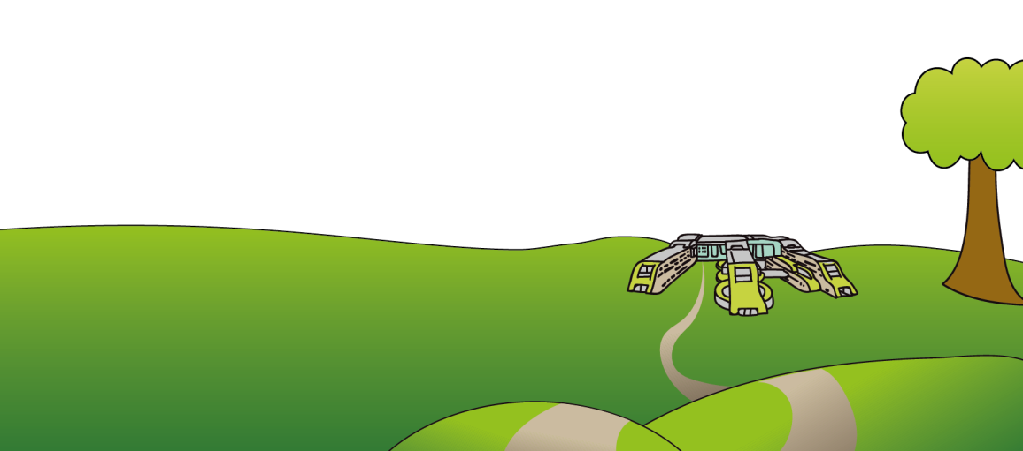
Do not rely on this leaflet alone for information about the treatment.
This information can be made available in other languages and formats if requested

Alder Hey Children’s NHS Foundation Trust
Eaton Road
Liverpool
L12 2AP
Tel: 0151 228 4811
www.alderhey.nhs.uk
© Alder Hey Review Date: August 2027 PIAG: 157


Orthotics Department

Knee Braces

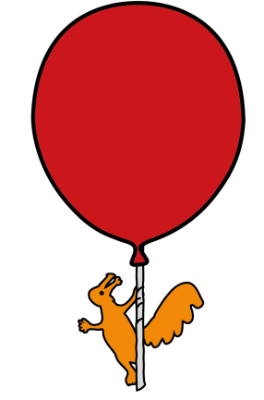

Information for
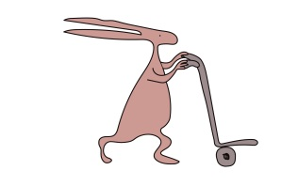
patients, parents and carers


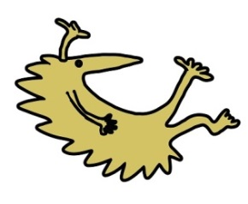

Why has a knee brace been prescribed and what is my child entitled to?

- Your child will be provided with 1 knee brace at a time, or 2 if both knees are affected due to regular growing and change in children.

- A second will be provided only when the brace is deemed as no longer clinically effective or beyond repair. A second will also be provided if your child grows and the brace no longer fits.

- Knee braces can be used for many reasons, some being:

1) Immobilise or reduce movement in a knee i.e. post-surgery
2) Reduce pain in the knee
3) Offload a specific area of the knee
4) Support the knee following trauma, i.e. fracture to prevent further injury, reduce pain and/or swelling
5) Protect the knee
6) Hold the patella (knee cap) in the correct place during movement in gait (walking)

Care of the brace

- Regularly clean the knee brace with mild soap and water, towel dry and keep away from direct heat sources i.e. radiator, as the material may distort.

- It is your responsibility to bring the device to the orthotics department for repairs as and when necessary i.e. when the velcro is worn down.

- It is also your responsibility to contact the department if the limb changes or if the brace no longer fits correctly.

How is a knee brace fitted, and wearing the knee brace.

- The knee brace will be fitted by one of our trained Orthotists in clinic or by a consultant or specialist in the fracture clinic.

- Please attend clinic with appropriate footwear that fastens rather than slips on to provide adequate stability and support whilst fitting the knee brace.

- Please attend with clothing that can ideally fit over the brace as most work best with direct skin contact.

- The Orthotist will advise you on how to properly fit your child’s brace but when putting the brace on, ensure the knee joint of the brace is in the correct place and the straps should be pulled tight enough to ensure it does not move around or slide up and down, but not too tight so that they cause discomfort.

- The knee joints should be approximately level with the middle of the knee cap.

- The Orthotist will advise you of when and how long the knee brace needs to be worn for, although this is usually as much as possible or whenever weight bearing.

