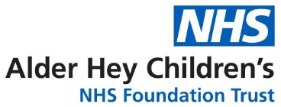
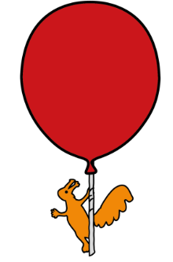

Department of Infectious Diseases & Immunology
PEP (Post Exposure Prophylaxis) Regime
Information for young adults and for parents of children 12 years and over (and weigh over 40kg)

Introduction
A doctor or nurse has made an assessment following an event. During this event, you/your child may have been exposed to Human Immunodeficiency Virus (HIV) or other viruses carried in the blood, such as hepatitis B or C. If this was a sexual exposure, there may be a risk of other sexually transmitted infections or an unwanted pregnancy.
In some cases, a short course of drug treatment may be prescribed. This treatment is known as Post Exposure Prophylaxis or “PEP".
What is PEP?
There may be a risk of catching HIV following the recent exposure. This risk can be greatly reduced by taking a course of "Post Exposure Prophylaxis", or "PEP", for 28 days. Starting PEP as early as possible, taking every dose as prescribed and completing the 28-day course provides the best protection against infection. Therefore:
- The first dose of medication should be taken as soon as you receive them.
- Attend the follow up appointments as advised by the person who prescribed the PEP

What are the medications involved?

The treatment consists of a combination of two tablets, containing three active drugs. All three are antiviral drugs that are effective against the HIV virus. Used together, there is evidence¹ that they can reduce the risk of developing HIV infection following exposure. The names of the medicines are:
- Blue tablets containing 200mg of Emtricitabine and 245mg of Tenofovir

- Pink tablets containing 400mg of Raltegravir (Isentress®)

When should medications be taken?
The first dose of Emtricitabine / Tenofovir (one tablet) and Raltegravir (one tablet) should be taken as soon as you receive them. After the first dose continue with the medications as stated below:
- Emtricitabine / Tenofovir – One tablet to be taken ONCE each day (every 24 hours).

- Raltegravir – One tablet to be taken TWICE a day (every 12 hours).

Following the first dose, these medications should be taken just after a meal (e.g. 7am and/or 7pm). If you have taken your first dose outside of these usual times, discuss with a pharmacist or doctor how you can start taking the medicines at mealtimes.
Missing Doses
Doses of the tablets should not be missed. Missing doses may increase the chance that the treatment doesn’t work. If a dose is missed it should be taken as soon as possible and then continue as before. If you have difficulty remembering when a dose of the medicine is due, use an alarm, e.g. on your mobile phone.
Are there any side effects?
PEP medicines can cause side effects such as feeling or being sick, headache and tiredness. If side effects are experienced and the medicines cannot be continued, please seek medical advice as soon as possible, as alternatives may be available.
Patients who have kidney disease, may not be able to take Emtricitabine/Tenofovir. The doctor who has prescribed the medication should be informed about the kidney disease, as an alternative may need to be taken.
If a rash or flu-like illness (e.g. sore throat, fever, muscle pains, enlarged glands) occurs whilst taking this medicine, or during the 12 weeks after finishing treatment, it is important you contact the clinic immediately to discuss the symptoms. This is to ensure there is not an allergic reaction or signs of HIV infection.
I am/my child is taking other medications; can I still give them PEP?
The PEP medicines may interact with other medicines, including those you/your child have bought yourself and herbal remedies. If any medications, prescribed or non-prescribed are being taken, please let medical staff know. Do not start any new medication without discussing with your/your child’s GP first. Adults may drink alcohol within recommended limits whilst taking these medicines.
Important Advice
- Do keep the medicines in a cool, dark, dry place, and out of the reach of children.
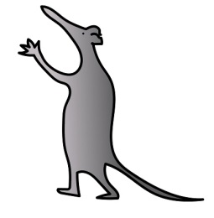
- Do not have unprotected sex or donate blood until you have been cleared of the risk of any blood borne viruses.
- Do not use recreational or 'street' drugs whilst taking PEP.
- Do not take more than the recommended dose of your PEP
- Do not give your medicines to others.

Advice in Pregnancy and Breast Feeding
The available evidence² is that the recommended drugs are safe after 12 weeks of pregnancy, but we have less information about the safety of the drugs in early pregnancy. You/your child must tell your doctor if you could be pregnant. You/your child should take precautions to avoid becoming pregnant or fathering a child while taking the medicines.
Follow Up Appointments
At the follow up clinic appointment the potential side effects of these medications will be discussed in more detail. Appropriate monitoring, follow up and support will also be arranged by the doctor or nurse.
Contact numbers
If you have any concerns regarding any aspect of PEP, please contact:
Monday to Friday 9am – 5pm: Infectious Diseases & Immunology Nurse on 07766443940
Outside of these hours, call Alder Hey hospital on 0151 252 4811 and ask for the on-call Infectious Diseases / Microbiology Consultant.

References

- Post-exposure prophylaxis guidelines for children and adolescents potentially exposed to blood-borne viruses. 2021. Foster C, Tudor-Williams G, Tickner N, Bamford A. Available online: www.chiva.org.uk/files/4016/3636/5619/CHIVA_PEP_2021_Final.pdf Accessed Jan 2023

- British HIV Association guidelines for the management of HIV infection in pregnancy and postpartum 2018 (2020 third interim update). Gilleece Y, Tariq S, Bamford A et al. HIV Med. 2019;20 Suppl 3:s2-s85

This leaflet only gives general information. You must always discuss your individual treatment with the appropriate member of staff. Do not rely on this leaflet alone for information about your treatment.

This information can be made available in other languages and formats if requested.

Alder Hey Children’s NHS Foundation Trust
Alder Hey
Eaton Road
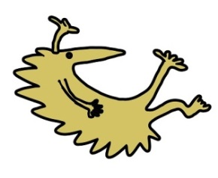
Liverpool
L12 2AP

Tel: 0151 228 4811
www.alderhey.nhs.uk
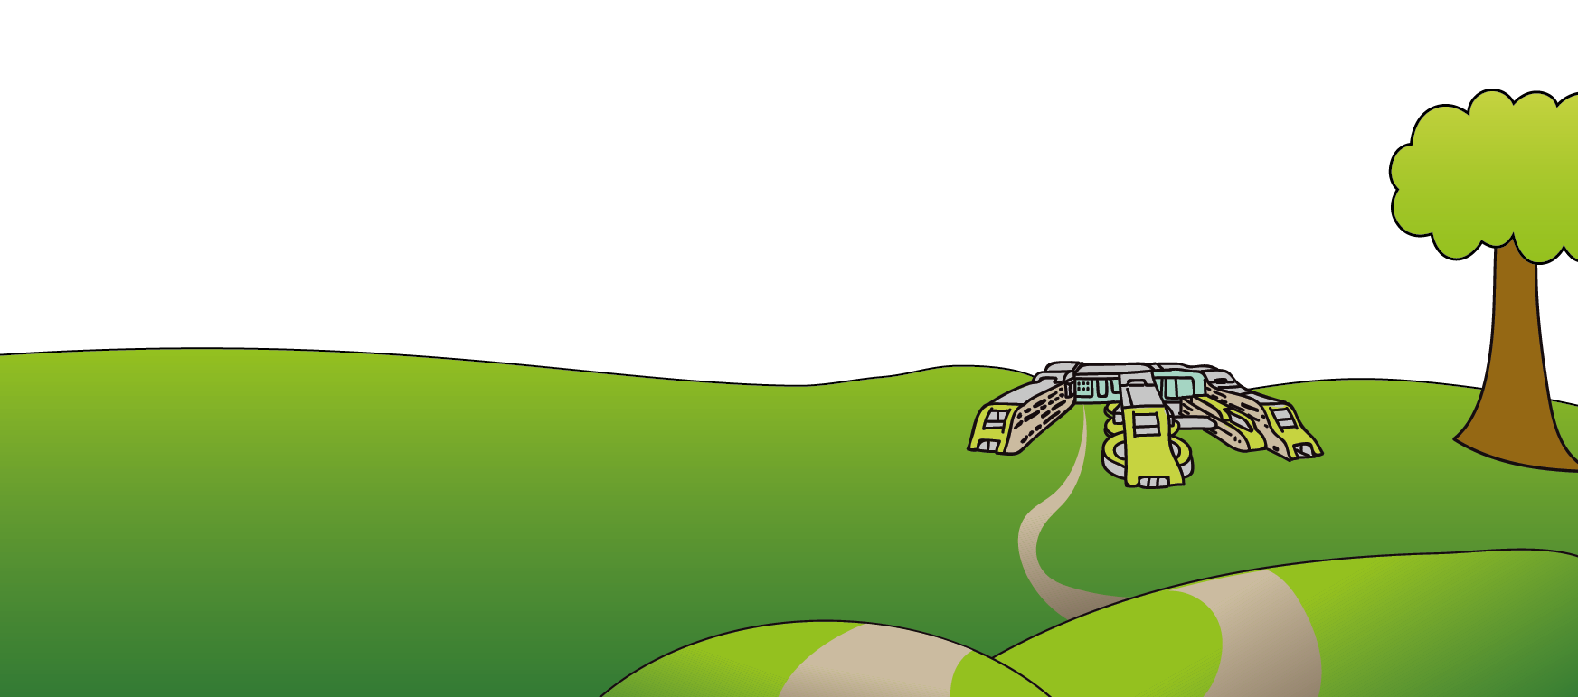

© Alder Hey Review Date: May 2026 PIAG: M10

