**What issues do I need to be aware of?**

* Sometimes footwear may lead to discolouration of the skin, which is normal, as is a build-up of some hard skin. Provided this is not excessive or painful and discolouration clears, this is nothing to worry about. If it is any of the above, please contact the department.
* Sometimes devices can lead to sores, blisters, pain or rubbing, if any of the above arises, contact the department.

**Contact us**

If you have any problems or questions, please contact a member of

the team who will be happy to discuss them with you.

Telephone: 0151 252 5318

Email: orthotics@alderhey.nhs.uk

This leaflet only provides general information. You must always discuss the individual treatment with the appropriate staff member.

Do not rely on this leaflet alone for information about the treatment.

This information can be made available in other languages and formats if requested

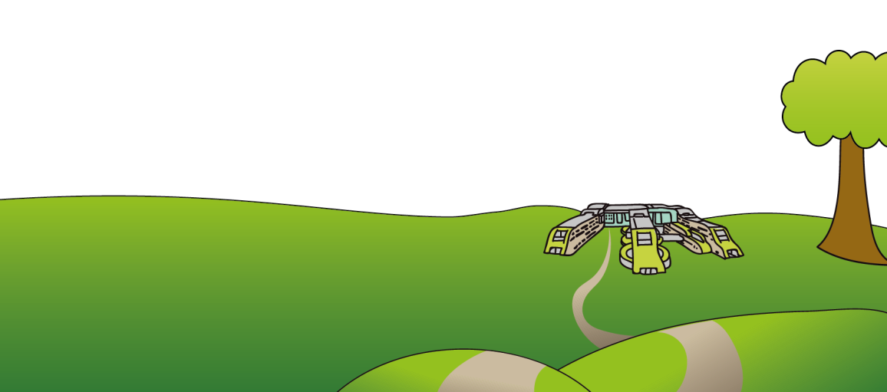

Alder Hey Children’s NHS Foundation Trust

Eaton Road

Liverpool

L12 2AP

Tel: 0151 228 4811

[www.alderhey.nhs.uk](http://www.alderhey.nhs.uk)

**© Alder Hey Review Date: August 2027 PIAG: 155**



**Orthotics Department**

**Orthopaedic Footwear**

**& Footwear Adaptations**

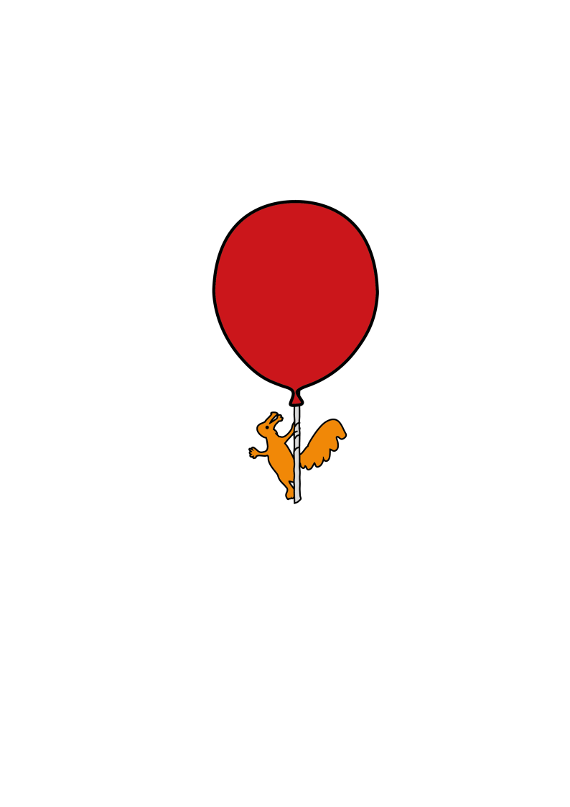

**Information for**

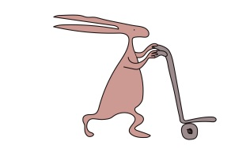**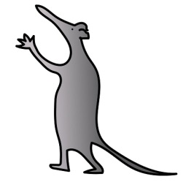patients, parents and carers**

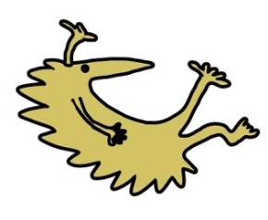

**What is my child entitled to? How to care for your child’s feet and the footwear/adaptions.**

* Your child will be prescribed with one pair of shoes due to the regular change and growth in children. A second pair will be provided when the original pair are deemed beyond repair or no longer clinically effective by an Orthotist or the Technician.
* It is your responsibility to care for the footwear and return them to the department for repairs and checks as and when necessary i.e. worn soles or fastenings.
* Please regularly check your child’s feet for rubs, blisters etc. when removing the footwear. Also check inside the shoes for any loose objects that may damage your child’s feet.
* The shoes can be cleaned by yourself with polish if they are leather or a brush for nubuck or suede.
* The Orthotist may take appropriate measures or casts if necessary to order your footwear.

**When should my child wear their adapted footwear?**

* This will be determined on an individual basis and will be explained in detail to you by your Orthotist when the footwear is being fitted.

**Why has my child been prescribed footwear adaptions?**

* There are many types of footwear adaptions and many reasons for them, some including:

1) To increase support and stability in the foot and ankle

2) To improve gait pattern (walking style)

3) To reduce pressure and pain in vulnerable or painful foot

4) To increase or encourage movement

5) To accommodate a leg length discrepancy or unequal shoe size.

**What style shoe is most suitable?**

* Shoes need to have a fastening rather than be a slip on, i.e. lace, Velcro, buckles
* The sole unit must be solid i.e. trainers with air pockets are not suitable
* The heel needs to be enclosed by the shoe to increase support and hold the foot within the shoe
* They should be flat shoes i.e. not heels.
* No sandals, flip flops, etc.