


Acute Pain Service
Advice on Pain Relief following Multi-Level Surgery
Information for parents and carers

Introduction

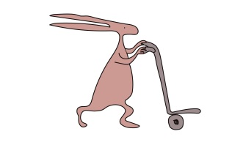
Good pain management is a priority following multi-level surgery, not only immediately after the operation, but also after discharge home. During the weeks after surgery, your child will require periods of intensive physiotherapy. It is important to continue good pain relief during this time so that your child can participate in the necessary exercises to aid their recovery.

Your child will be discharged home with several pain-relieving medicines. These medicines are listed below.

Paracetamol

- This is the most widely used pain relief medication and can be given 4 times a day. It can be used alone or in combination with other pain relief medications.

Ibuprofen

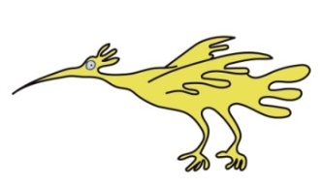
- Ibuprofen works by reducing swelling and inflammation and can be given 3 times a day. Ibuprofen can cause indigestion and heartburn which could make your child feel sick, so it is important that your child takes it with or after food. While your child is taking ibuprofen regularly, a medication called omeprazole will be given for your child to take at home to reduce symptoms of heartburn and indigestion.

Morphine sulphate

- This is a strong pain killer and can be given up to 4 times a day. Morphine can cause constipation, so laxatives (usually lactulose) will be given for your child to take at home while he/she is taking this pain medication. Encouraging your child to drink plenty of fluids will also help.

Diazepam
- Diazepam is used to control muscle spasms and can be given up to 4 times a day. Diazepam may make your child more sleepy than usual. Spasms can be a particular problem during physiotherapy or when your child is settling to sleep. You may find it helpful to give diazepam at these times.

After discharge from hospital

Your child will continue to need regular pain relief. Paracetamol, ibuprofen, morphine and diazepam can all be given at the same time, if required. Ideally try to spread the doses out evenly during the day.

Do not wait for the pain to get bad before giving your child their pain relief medication. It is best to try and give pain relief before pain starts. You should not worry about giving your child medicines to reduce their pain. Your child will feel much better if they are not in pain.

It is important to follow the instructions on the bottle / packet and that you do not give the medicine more often than the instructions advise. To keep track of the pain relief medicine your child has received, and when you gave it, you may find it helpful to keep a note of what time you gave each medicine.

Getting repeat prescriptions from your GP

You will go home with a week’s supply of pain medicine and diazepam. Please contact your GP to supply repeat prescriptions in the weeks following surgery.

As pain gets better – reducing pain relief

When your child does not seem to need regular pain relief, you should start to miss out some of the doses.
- Continue with regular paracetamol and ibuprofen until your child no longer needs breakthrough doses of morphine.
- At this point continue regular paracetamol and start just giving ibuprofen as required rather than regularly.
- Continue with paracetamol until your child no longer needs breakthrough doses of ibuprofen.

- At this point start just giving paracetamol as required rather than regularly.

As pain gets better – reducing diazepam

- Muscle spasm may be problematic in the first week after surgery. You may need to give diazepam regularly up to 4 times a day if this is the case.
- As your child recovers, spasms should lessen. You may notice there is a pattern to when your child has spasm. You can continue to give diazepam as required rather than regularly.

Pain relief before physiotherapy

You should continue to give pain relief and diazepam about one hour before any physiotherapy, so that the pain relief is working during and after the session.

In general, you should give pain relief for as long as your child is complaining of pain. If you have any concerns about how long you should continue giving your child pain relief medicine, you can contact Lara Pearn or Kristine Gatti on 0151 252 5949.

Please read any information leaflets that come with the medicines for advice (additional information can be found at http://www.medicinesforchildren.org.uk/search-for-a-leaflet).

General information about side effects of medicine

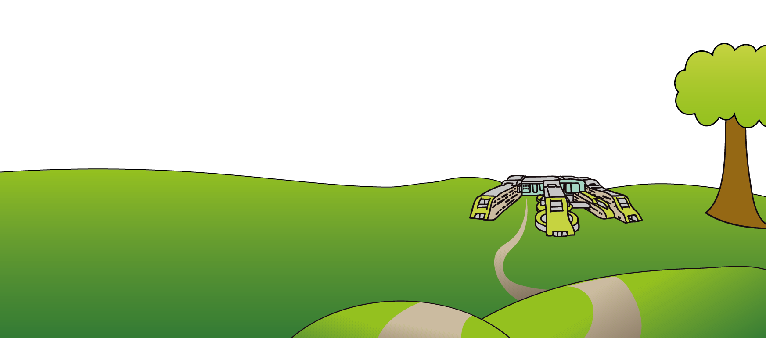
A side effect is an unwanted reaction or symptom from a medicine, sometimes called an ‘adverse drug reaction’. All medicines can have side effects. If your child experiences any side effects, it is important to discuss this with a doctor or pharmacist so a decision can be made if the medicine should be stopped.

Anyone can report side effects of medicines to the Medicine and Healthcare products Regulatory Agency (MHRA). To find out how to make a report, ring MHRA helpline on Freephone 0808 100 3352 or visit their website www.yellowcard.gov.uk

Alder Hey Children’s NHS Foundation Trust
Eaton Road
Liverpool
L12 2AP
Tel: 0151 228 4811
www.alderhey.nhs.uk
© Alder Hey Review Date: August 2028 v2 PIAG: 065

