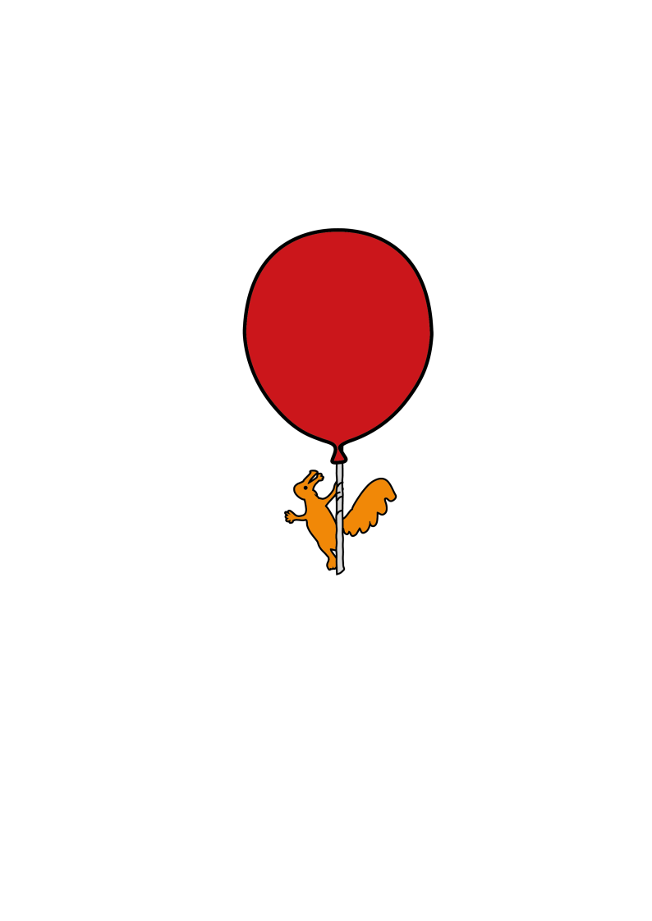

Inpatient Acute Pain Service

**Discharge Information after Sedation for Procedures**

Information for parents and carers

**Introduction**

This leaflet aims to provide you with information about how to care for your child once you are at home.

Most children appear to be alert and active after they are discharged from hospital. However do not be surprised if your child complains of feeling dizzy or being tired. Your child may feel dizzy and uncoordinated for the next couple of days.

**For the next 24 hours**

* **you should** encourage your child to rest
* **you should** make sure your child’s activities are supervised by a responsible adult
* 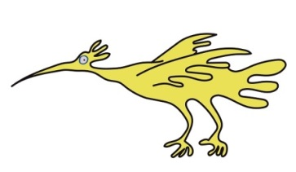**Do not** let your child ride a bike
* **Do not** let your child take part in any outdoor activities
* **Do not** give your child any fizzy drinks
* **Do not** give your child hard to digest foods such as chips, burgers.

**What to do if your child starts to vomit**

If your child vomits on the way home or when you get home, do not be alarmed. Do not give your child anything to eat or drink for one hour. After that, you can start giving your child a small amount of water or juice. Then gradually start to increase the amount of fluid you give to your child. Once your child can keep fluids down you can begin to give them a light diet.

**If the vomiting continues, please contact your GP out of hour’s telephone number or your nearest Emergency Department**



**Who to contact if you have any worries**

The staff on the ward where your child’s procedure took place are happy to talk to

you should you have any worries or concerns and you may contact the ward for

advice at any time. The phone number for Alder Hey switchboard is over the page.

Please contact your GP out of hour’s or go to your nearest Emergency Department if you are unable to contact the ward or clinic where your child’s procedure took place.

This leaflet only gives general information. You must always discuss the individual treatment of your child with the appropriate member of staff. Do not rely on this leaflet alone for information about your child’s treatment.

This information can be made available in other languages and formats if requested.

Alder Hey Children’s NHS Foundation Trust

Alder Hey

Eaton Road

****Liverpool

L12 2AP



Tel: 0151 228 4811

[www.alderhey.nhs.uk](http://www.alderhey.nhs.uk)

**© Alder Hey Review Date: July 2028 PIAG: 305**