**Raising Concerns**

For advice, support or to raise a concern, contact our Patient Advice and Liaison Service (PALS).

**T:** 0151 252 5161 (PALS)

**E:** [PALS@alderhey.nhs.uk](mailto:PALS@alderhey.nhs.uk)



**Contact Us**

Community Physiotherapy Service

Alder Hey Children’s NHS Foundation Trust

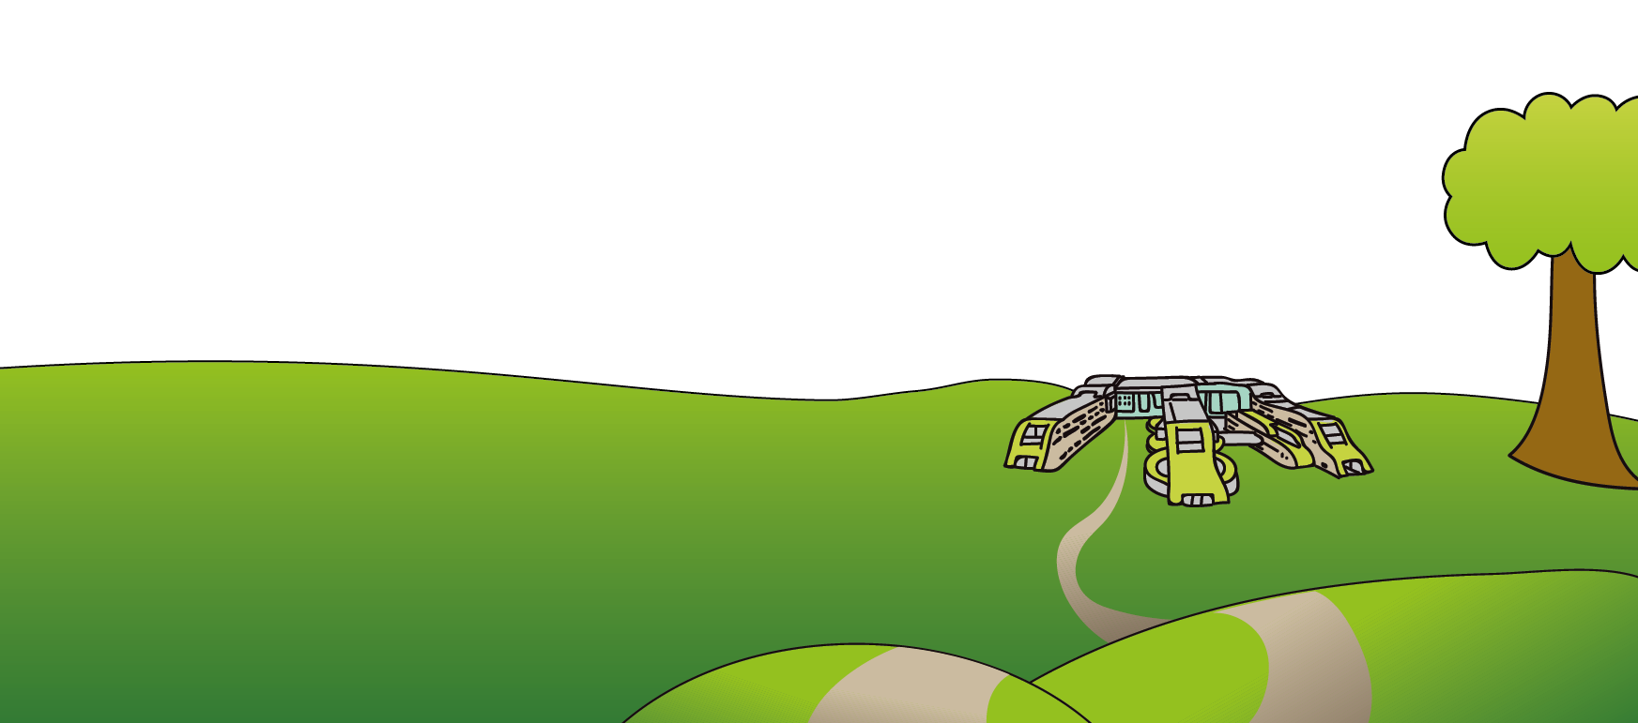

**1st  Floor**

**Kilby House**

**Liverpool Innovation Park**

**L7 9NJ**

Tel: 0151 607 2700

[www.alderhey.nhs.uk](http://www.alderhey.nhs.uk)

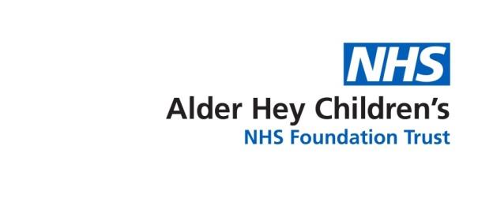**Language and Accessible Support**

This information can be made available in other languages and formats if requested.

**Liverpool Community Physiotherapy Service**

**The Picture Communication Symbols ©1981–2019 by Tobii Dynavox.** All Rights Reserved Worldwide. Used with permission. Boardmaker® is a trademark of Tobii Dynavox. With thanks to Sandfield Park School.

**My First Community**

**Physiotherapy Appointment**



This leaflet only gives general information. You must always discuss the individual treatment of your child with the appropriate member of staff. Do not rely on this leaflet alone for information about your child’s treatment.

Alder Hey Children’s NHS Foundation Trust

**Information for Children**

**& Young People with Alternative Communication**

Eaton Road

Liverpool

L12 2AP

Tel: 0151 228 4811

**© Alder Hey**

**Review Date: March 2028**

**PIAG: 252**

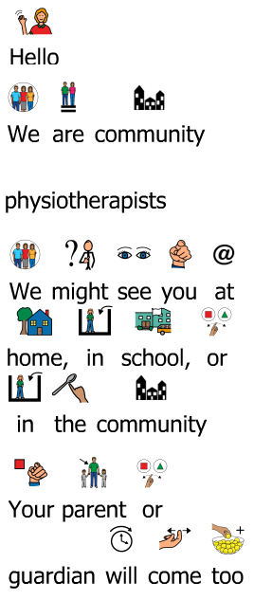

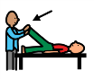Hello.

We are physiotherapists

in the community.



We might see you in your school

or your home or in the community.

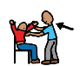

Your parent or guardian will be with you.

We might ask you:

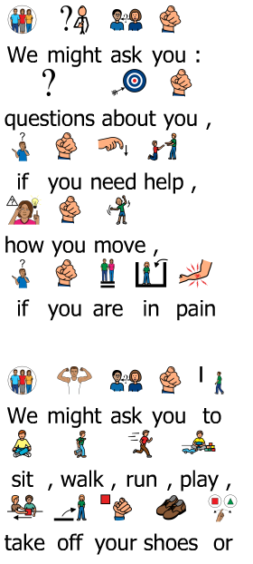

* Questions about you



* If you need help to move?



* If you are in pain?

We might ask you to:



* play or sit or stand or run, if you can

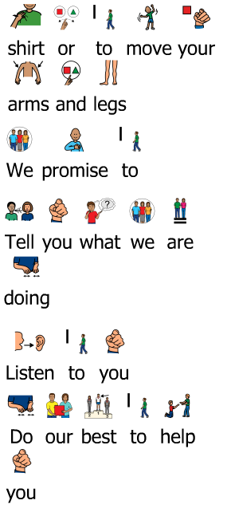

* take off your t-shirt or your shoes



* move your arms or legs, if you can



**We promise to:**



1. …Tell you what we are doing



1. …Listen to you





1. …Do our best to help you