

Ophthalmology Department

**Visual Electrodiagnostic Testing (EDT)**

Information for Parents and Carers

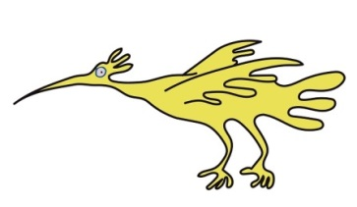**Introduction**

This leaflet is to provide you with information about Visual Electrodiagnostic

Testing and what to expect at your visit.

**What are electrodiagnostic tests and why test?**

* We record the electrical activity from the brain and eye in response to a stimulus like a flash of light or a moving checkerboard pattern on a TV screen.
* By measuring your child’s responses we get a clue about the health of their visual system and this can help your eye doctor in the management of your child’s condition.

**What happens?**

At the start we will introduce ourselves and take a short history, which may include asking about family members vision.

We will then wash the areas of the skin that we are going to place the electrodes on, which is the surface of the forehead, top of head and back of the head or around the eye, and connect them to our recording system. The electrodes are like bright colour ribbons in your child’s hair and don’t hurt. We then show them patterns or flashes of light to see how their brain/eye responds. We may need to use an eyepatch to see how each eye is working on its own.

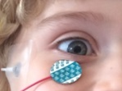

We occasionally may need to instill dilating eye drops to get more detailed retinal responses. We may test your child’s night vision by switching the room lights off and sitting in the dark for up to 20 minutes (less for younger children).

**Are there any risks?**

Testing often involves flashing lights and you should tells us if you or your child or anyone else in the room suffers from photosensitive epilepsy. There is a risk of inducing a seizure if they have photosensitive epilepsy and we may choose to omit certain testing.

We occasionally instill dilating eye drops which have some risk associated (See PIAG 007) though these are unlikely to occur. Please ask for the eye drop sheet if drops are required and you wish to know more.

**What to do if you have any concerns**

If you are concerned about your child at all whilst you are in the clinic, please speak to the clinician seeing you.

If you have any concerns after you have left the clinic, please contact Ophthalmology or your child’s GP.

**Are there any alternative ways of obtaining the same information as these tests provides?**

At present there are no other tests available to give the same information about visual pathway function.

**What will happen if my child does not have these tests?**

Your child’s eye specialist will not have a complete picture of the medical condition, and it will be harder to make a diagnosis.

This may delay any treatment needed.

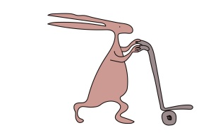**How long will these tests take?**

Usually between 45 minutes to 1 ½ hours.

**What should I do before the tests?**

Give medication as usual unless advised otherwise.

Your child should eat and drink as normal.

Bring your child’s glasses with you even if they are not worn fulltime.

You may want to bring a selection of toys/books/music etc to entertain your child during the tests.

You may also wish to bring bottles to feed your child, or drinks and snacks if they are likely to become fretful when hungry.

**What will happen after the tests?**

We will take off all the electrodes. You will be free to go. Sunglasses or a cap may help if your child has had eye drops.

We will then analyse the electrical responses we have recorded and prepare a report for your eye specialist who will go through it the next time you see them.

**Your consent to these tests**

****You do not have to have these tests, if you do not wish to, though it will be in your child’s best interest to attend.

**Where are these tests performed?**

In the Ophthalmology 2.2 Waiting, EDT lab.

**Important message**

Please confirm that your child will be attending.

**Going back to school**

Your child can return to school following testing though if they had eye drops may have difficuly focussing on small detailed close work. It is advisable to inform your child’s teacher.

**For further information about the tests**

Please contact: Dr. Deepthy Jayakrishnan, Visual Electrophysiology Services

Royal Liverpool University Hospital

0151 706 4218 / 4225

**For further information**

If you have any queries or need further information please telephone

**Ophthalmology Department on: 0151 252 5215**

You may find this animation by Bradford University about EDT informative and might even want to show it to some older children, please note Bradford’s approach is slightly different to ours and we don’t routinely use eye drops or thread electrodes or expect you to wash your hair before attending.

<https://www.youtube.com/watch?v=l1WxLDTUKW0>

or type Bradford Visual Electrophysiology using YouTube

This leaflet only gives general information. You must always discuss the individual treatment of your child with the appropriate member of staff. Do not rely on this leaflet alone for information about your child’s treatment.

This information can be made available in other languages and formats if requested.

Alder Hey Children’s NHS Foundation Trust

Alder Hey

****Eaton Road

Liverpool

L12 2AP

Tel: 0151 228 4811

[www.alderhey.nhs.uk](http://www.alderhey.nhs.uk)

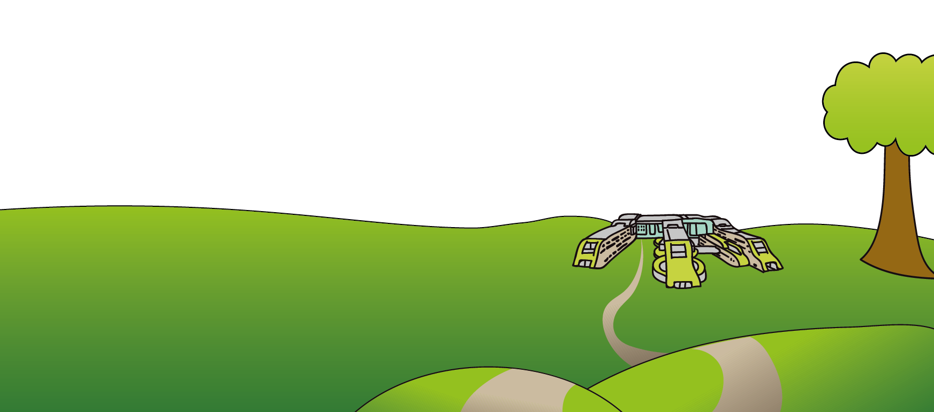

**© Alder Hey Review Date: June 2028 PIAG: 498**