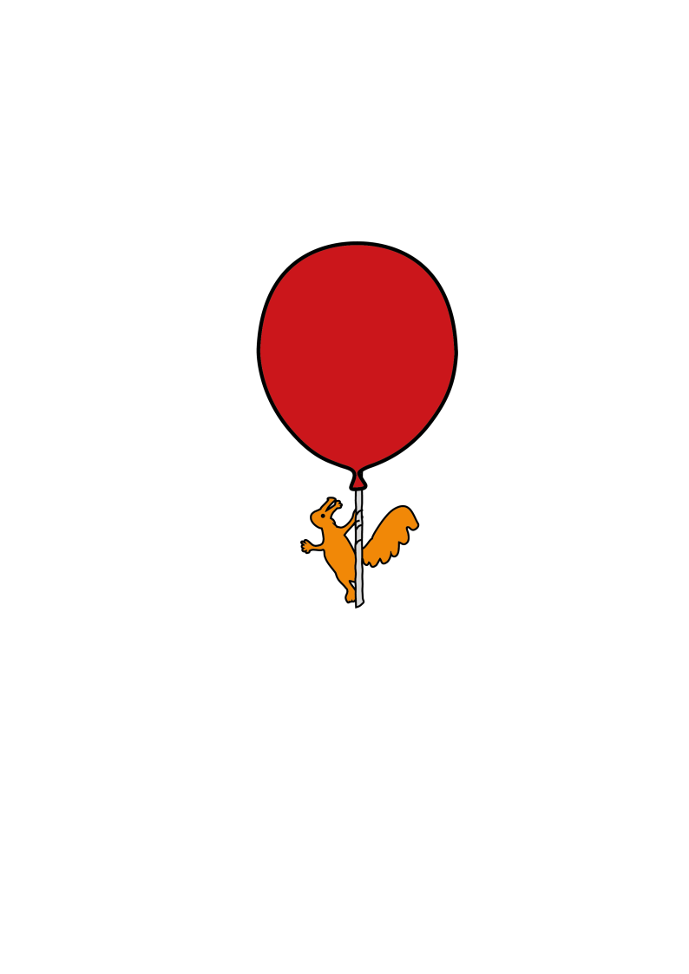

AUDIOLOGY

**Sound Sensitivity**

Information for Parent/Carer





**Sound Sensitivity**

**What is sound sensitivity?**

Some children are sensitive to certain sounds, and they seem to find some sounds uncomfortable or upsetting. This is sometimes called hyperacusis. A more extreme fear of certain sounds is known as phonophobia. It is different for each child. The sensitivity is often to sudden, loud sounds, such as sirens, vacuum cleaners, motorbikes, fireworks, balloons popping, hair dryers and hand dryers. For some children it is the type of sounds (which might not seem that loud to other people) can be problematic, and not how loud it is.What causes sound sensitivity?

It can be a normal phase that children go through. A lot of young children find loud, sudden sounds scary, particularly if they don’t fully understand why the sound has happened. Most children change as they learn to understand what the noise is, where it comes from and that it is not anything dangerous. It is common for a child with additional sensory issues or complex needs to experience sound sensitivity. The occupational therapy team, your paediatrician or Child and Adolescent Mental Health Service (CAMHS) might be able to give more specific support.

**What can you do to help?**

In order to break down your child’s association of anxiety with noise exposure, here are a few suggestions on how to handle the situation and reassure your child. These suggestions can be used by everyone.

**Reassure your child:** When your child becomes distressed by exposure to sound, move them away from the sound (if possible) and comfort them. Try to explain the source of the sound to the child, to help them understand.

**Remove the fear factor:** A child’s fearful reaction to the sound will often diminish if they can exercise some control over the noise. Encourage the child to clap their own hands, to play with toys that make a noise and to stop/start the vacuum cleaner at home.

**Desensitisation:** Humour is a great way of removing the fear and If your child is scared of the hairdryer or the washing machine, you could dress it up with big glasses and stick some funny ears on it and give it a silly voice, for instance. It is very hard to be scared of something that you are giggling at. Repeated gentle exposure to the noise may help to reduce the child’s anxiety and desensitise them to the sound. Tape record several the uncomfortable sounds and play them with the tape recorder set to a very low volume. Gradually, over a period of days or weeks, the volume can be increased. Practice with the sounds while playing, in a way that the child can control. By exposing the child to sounds in controlled conditions, the association of noise with fear can be gradually broken.

**Relaxation and Breathing:** Breathing techniques can help to relieve anxiety and give your child something else to focus on rather than the sound that is upsetting. There are lots of free apps. A very easy way is to use your child’s hand and encourage them to breathe in and out as they trace their way up and down their finger-tips. There are lots of suggestions for relaxation techniques for children available online including:

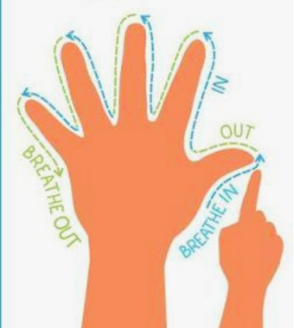

[www.relaxkids.com](http://www.relaxkids.com)



[www.5pointscale.com](http://www.5pointscale.com)

**Traffic light system:** Children should not be forced to stay in a situation that is obviously causing them distress (for example, singing during a school assembly). This may compound their apprehension and make them associate a situation with pain. If fear of a specific situation has become established, it is important to gradually desensitise the child, with time and care.

Older children may be reassured if they are told they have the teacher’s permission to leave the classroom for a few minutes at any point if they are exposed to an adverse noise. Children can be greatly reassured that they can leave a room, for a short time, if noise becomes distressing to them.

**Protection:** The use of ear plugs, muffs or defenders should be avoided except in extreme or short-term, unavoidable situations. Exposure to normal and tolerable sound is crucial if the ear and brain are to establish normal sensitivity.

This leaflet only gives general information. You must always discuss the individual treatment of your child with the appropriate member of staff. Do not rely on this leaflet alone for information about your child’s treatment.

This information can be made available in other languages and formats if requested.



Alder Hey Children’s NHS Foundation Trust

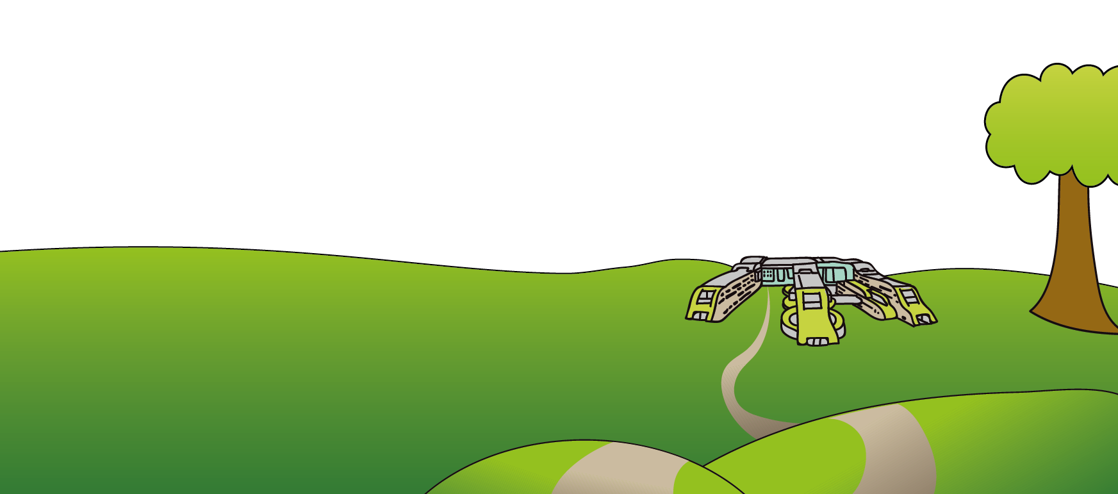Alder Hey

Eaton Road

Liverpool

L12 2AP

Tel: 0151 228 4811

[www.alderhey.nhs.uk](http://www.alderhey.nhs.uk)

**© Alder Hey Review Date: February 2028 PIAG: 585**