

**Quality Account 2024-25**

**‘*A healthier, happier and fairer future where every child and young person can achieve their full potential’.***



CONTENTS

**Part 1:**

**STATEMENT ON QUALITY FROM JOHN GRINNELL, CHIEF EXECUTIVE OFFICER**

**Page 3**

**Part 2:**

**PRIORITIES FOR IMPROVEMENT AND STATEMENTS OF ASSURANCE FROM OUR BOARD**

**Page 4**

**Part 3:**

**OTHER INFORMATION. QUALITY PERFORMANCE 2024/25 Page 32**

**APPENDIX 1:**

**REPORTING AGAINST CORE INDICATORS Page 117**

**ANNEX 1:**

**STATEMENT ON THE QUALITY REPORT BY PARTNER ORGANISATIONS Page 118**

**A Message from our Chief Executive Officer**

I am delighted to welcome you to our Quality Account for 2024/25, my first as Chief Executive of Alder Hey. On looking back over the last 12 months, I am once again awestruck by the sheer hard work, dedication and commitment to children and young people that is described in these pages, which is huge testimony to our amazing staff. All the more so, as these achievements have been delivered against the backdrop of a hugely pressured environment for the service as a whole, both financially and operationally.

2024/25 saw the second year of the delivery of our Vision 2030 strategy, with significant progress against each of the key priority areas, from the work on patient experience with the launch of ‘Our Promises’ to children, young people and families, through to the tour de force that is the ‘Beyond’ programme and its incredible work, alongside our partners, to really make a difference to lives impacted by poverty and other factors that drive poor health outcomes.

It was also the second year of the new NHS Patient Safety Strategy, and the implementation of the safety architecture designed to focus organisations on continuous learning and taking action from adverse events. Alder Hey has fully embraced this approach and we have successfully undertaken a number of learning reviews that have resulted in significant changes to our systems and processes, particularly in relation to deteriorating patients. This has been underpinned by our successful participation in a national pilot of Martha’s Rule.

As well as continuing to deliver improvements across expected national standards for waiting times for elective operations and for emergency and urgent care, we have made significant progress with our own local priorities including medication safety and infection prevention and control. All of this requires constant vigilance and focus on providing the best treatment and care within the safest possible systems. This year and in the year ahead, our aim is to make better use of technology to help our staff achieve this more efficiently and effectively. This report describes some of the projects this year, with we hope a lot more to come with the implementation of our AI strategy in 2025/26.

The latest technology, state of the art equipment and world class facilities that Alder Hey has invested in aims to enable our staff to provide the best care to our patients; we in turn are committed to looking after them, given the vital role they all play. I want to thank each one for their unstinting support as we continue to strive for excellence together.

As Chief Executive, I commend our Quality Account for 2024/25 to you. I am confident that the information set out in the document is accurate and a fair reflection of the key issues and priorities that our teams have developed within their services. The Board is incredibly proud of all that has been achieved in a year of unprecedented challenge for the NHS. As this report demonstrates, at Alder Hey we remain as ever, fully focused on children and young people, doing everything we possibly can to deliver our vision for a healthier, happier and fairer future, where every individual can achieve their full potential.

**John Grinnell**

**Chief Executive Officer**

**Part 2: Priorities for Improvement and Statements of Assurance from our Board**

**2.1 Priorities for improvement in 2025/26**

The Alder Hey Board approved Vision 2030 in March 2023. Vision 2030 builds upon clear, long term strategic ambitions (originally set out as a blueprint in 2011) and has been endorsed by the Board and Council of Governors throughout its development and implementation.

Significant progress has been made during 2024/25 with our people, wider stakeholders and system partners. Year 2 of the Vision 2030 transformation programme has been defined and is under implementation with underpinning programme and benefits realisation plans. The Trust’s values continue to underpin all that we do and how we do it throughout the most challenging period in NHS history.

Vision 2030 drives a focus on four areas of children and young people’s needs placing their needs at the centre:

* Get me well
* Personalise my care
* Improve my life chances
* Bring me the future

These are supported by five strategic objectives:

* Outstanding care and experience
* Collaborate for children and young people
* Revolutionise care
* Support our people
* Pioneering breakthroughs.

In 2024/25 we achieved:

**Outstanding care and experience**

* This year we continued to drive improvement in patient safety through our Patient Safety Board, delivering against the patient safety strategy and our Patient Safety Incident Reporting Plan (PSIRP).
* We have laid the foundations to transition our patient experience and clinical effectiveness boards to work in the same Brilliant Basics approach and drafted our Quality Strategy ready for launch in Q1 2025/26.
* With ongoing work through our Tissue Viability Team, we saw a 50% reduction in grade 2 pressure injury, with a noticeable reduction in device related pressure. We have also continued to see a reduction in medication errors, particularly those relating to TPN through the quality improvement work of those teams.
* Alder Hey has continued to see a rise in non-elective demand through our Emergency Department. Building work on our new urgent care centre is underway and the teams have been piloting new pathways of care, including the development of paediatric same day emergency care pathways in readiness for opening its doors in 2025/26.
* We launched ‘Our Promises’ to children and young people and their families and developed our children and young people’s charter in association with our young volunteers and our Forum. We committed to providing free meals to resident parents as part of Sophie’s Legacy which has had a positive impact for our families.
* We opened our state-of-the-art cinema in association with the Alder Hey Children’s Charity and Medicinema UK, the first cinema in a dedicated children’s hospital in the UK. The cinema provides distraction, enjoyment and fun to children and young people in our care at no cost to them or the NHS. Since opening in November 2024 over 1,000 children and young people have enjoyed the benefit of escapism through film.
* We recruited to our patient safety investigators, and our patient safety partners as part of our continued embedding of PSIRF.
* We were selected as a pilot site for phase 1 implementation of Martha’s Rule. At the end of the pilot Alder Hey have deployed Martha’s Rule into all inpatient areas with the use of a what’s app process for parents and staff to escalate directly to our 24/7 Response Team.

**Collaborate for Children and Young People**

* We continue to develop our local, regional, national and international networks and collaborate with a wide range of partners to improve outcomes for children and young people through educational excellence. Such collaborations include: our work with the Liverpool City Region, The Prince’s Trust and Elevate Business Partners to maximise career opportunities for young people from across the region; building new local partnerships which support young people with mental health challenges get into volunteering; enhancing our offer to partner higher education institutions (both in terms of placement capacity and learning experience); strengthening our relationships with apprenticeship providers; and exploring new international partnerships which focus on learning and supporting professional development.
* ‘Beyond’, the children and young people’s transformation programme hosted by Alder Hey on behalf of the Cheshire and Merseyside Integrated Care System (ICS) has continued to deliver in 2024/25. This is a large-scale programme of delivery against the NHS Long Term Plan for children and young people, focused on priority themes including Learning Disability and Autism, Childhood Obesity, Mental Health and Wellbeing, Respiratory Disease, Diabetes, Epilepsy and Oral Health in line with CORE20+5 CYP. Beyond continues to focus on addressing health inequalities and has worked with Barnardo’s and the Institute for Health Equity to develop a Health Equity Framework, informed by insights from children and young people. Beyond drives collaborative improvements via a range of evidence-based interventions and has reached nearly 50,000 children, young people and professionals in Cheshire and Merseyside.
* Alder Hey continues to lead and contribute to the transformation of children’s services in Liverpool. Developed in partnership with primary and community care, our urgent and emergency care offer now includes a Paediatric Assessment Unit to directly manage the most acute medical presentation as well as a symptom checker available through our website, providing information and advice on several of the most common illnesses in children to support A&E attendance decision making for families. The Trust works in partnership with Liverpool City Council’s Public Health Team, jointly leading the ‘One Liverpool’ plan’s Healthy Children and Families cohort, and working in wider partnership with City Council services, NHS trusts and voluntary and community sector organisations to drive systematic improvement in outcomes for children, young people and families.  This programme includes the mobilisation of family hubs across the city and multi-agency approach to improving lung health within the city.
* The Alder Hey ‘*Wellbeing Hub*’ which launched in November 2024, co-locates health, wellbeing and poverty proofing offers for children, young people and families is growing in its popularity.  This service is the umbrella under which all patient experience offers sit (PALS, Chaplaincy, access to external charities) and is funded by the Alder Hey Children’s Charity. The Hub links directly to Vision 2030 and provides up-to-the-minute understanding and access to poverty proofing and wellbeing offers for our children and young people, carers and their families.
* Alder Hey continues as a core member of the North West Congenital Heart Disease (CHD) Partnership, which has seen the joining of the Partnership Board with the CHD Operational Delivery Network Board this year – a key indicator of the maturing collaboration and reputation of the network. The Board continues to strive for a fully compliant, resilient and clinically safe service model for adults and children across the North West of England, North Wales and the Isle of Man.
* During 2024/25 the Liverpool Neonatal Partnership (LNP) continued to grow; led jointly by Alder Hey and Liverpool Women’s NHS Foundation Trust. The two trusts continued working together in partnership to provide a world class neonatal service for all babies requiring the highest intensity of neonatal medical and surgical care. Acuity has continued to remain high across the partnership, which further highlights the need to ensure that the service continues to provide a safe and sustainable quality of care to all patients. Building work for the new surgical unit commenced on site at Alder Hey in October 2023 with the start of the service diversion works, giving a projected completion date of October 2025. The Charity has worked extremely hard to provide amazing support to the neonatal campaign and they have reached the target of £3million to support the project. Recruitment into clinical roles has continued at pace throughout the year alongside continuing QIS training for staff on both sites. A rotational workforce model has been implemented to ensure that all nursing, advanced neonatal nurse practitioner and consultant posts rotate to work across both sites. The Partnership Programme has moved from commissioning to delivery phase and has therefore been divided into five main workstreams who meet regularly, and their work feeds up into the LNP Operational Programme Board on a bi-monthly basis.
* Collaborative working between Alder Hey and the Royal Manchester Children’s Hospital is supporting our jointly hosted clinical networks to work together to improve standards and lead the way for the development of more joined up care in the region, for example in cardiology, burns, major trauma, paediatric critical care, surgery and cancer, as well as more digitally enabled multidisciplinary working.
* Alder Hey continues to deliver new models of care within community and mental health services for children and young people. Successful investment during 2023/24 has enhanced the delivery of mental health care to young people including: mental health support to schools; assessment and diagnosis for neurodevelopmental conditions; and development of our community-based therapy teams, including the expansion of a sensory service to children and young people in Sefton. Partnership working with third sector colleagues has enhanced post diagnostic support to children and young people with neurodevelopmental needs. This includes the development and implementation of peer support workers in autism spectrum disorder during 2023/24.
* Alder Hey continues to be an integral member of the Cheshire and Merseyside Mental Health Programme Board and associated groups. The Trust continues to lead the Crisis Care Programme for children and is recognised along with specialist mental health trusts as a lead provider of children and young people’s mental health services. The Trust is a member of the MHLDC (Mental Health, Learning Disability and Community) Provider Collaborative.
* Alder Hey plays an active role in the ICS Digital Programme, actively contributing to ICS wide programmes and developments. The Trust Chief Transformation & Digital Officer (CTDO) is the newly appointed Chair of the North West Digital, Data and Technology Skills Development Network which helps support the professional and personal development of digital and data staff and services across the region. Finally, Alder Hey is regarded as a digitally mature organisation across the ICS, nationally and globally and as such plays a leadership and support role working in collaboration with others.

**Revolutionise Care**

* The last year saw the Digital and Data Futures Strategy deliver a significant amount of digitally enabled change where Alder Hey embraced new technology, realising a number of benefits. Following Alder Care go live in 2023, the programme has been in an optimisation phase, with system enhancements being prioritised by clinical and operational teams ahead of being implemented. This continuous improvement model has seen many services reap further benefits for staff, children and young people through the programme.
* The service played a key role in the digitisation of Sunflower House along with the establishment of the NHS Children and Young People’s Gender Service (North West) including digital pathways and reporting. The Trust has also started on a journey with the NHS Federated Data Platform with the theatre utilisation application live in certain specialties.
* The Digital and Data Strategy is currently being refreshed and will be complemented by a dedicated Artificial Intelligence (AI) Strategy in 2025. Ensuring alignment with the 2030 Vision, the Digital, Data and AI Strategy will be governed via the 2030 Transformation Collaborative.

**Supporting Our People**

* As an integral part of the Trust’s 2030 Vision, the People Plan outlines the innovative approach that had been taken in partnership with Strasys to address the challenge from the workforce perspective. The People Plan outlines how to address immediate challenges whilst building a thriving workforce that helps improve the life chances of children and young people; a plan which also considered the diverse and specific needs of individual staff members and balances the need to develop a workforce to deliver on the new ways of working.
* Our objective was to use all available data (both qualitative and quantitative) across the organisation, including performance, quality, and finance and extract the ‘human stories’ in our workforce. In parallel with the development of Vision 2030, we also treated our workforce as our ‘population’ to understand their needs, behaviours, and motivations and determine what we could do to enable an environment where they can thrive and improve care for our children and young people. This led to the work we have undertaken on workforce segmentation to deliver more precise workforce interventions with clear benefits cases to deliver the Trust’s objectives.
* The plan is based around the three key themes identified for our people in Vision 2023, which are ‘Thriving @ Alder Hey’, ‘Developing the Professional Development Hub’, and ‘Workforce Planning’. It identifies potential savings, efficiencies and improvements across three distinct areas: productivity, wellbeing and staff retention. We have seen improvements across all areas of the Staff Survey as well as reductions in sickness absence and turnover. This new approach has created opportunities to elevate conversations about our workforce with the Trust Board and across the organisation and whilst doing this, our thinking and insights have advanced, helping us to critically develop the next steps of the ‘why’ and the ‘how’ of what we need to do to continuously improve colleague experience and ultimately patient care.
* Our 2024 Staff Survey results were another key achievement: 62% of colleagues submitted a response, with 2,696 staff completing a questionnaire which is more than ever before. This year has again seen excellent results for Alder Hey, with improvements across all of the people promises and themes compared to 2023, and scoring higher than average in our comparator group, including best in class for the people promise ‘We are compassionate and Inclusive’. 73.96% of staff responded that they would recommend Alder Hey as a place to work and 89.59% as a place for friends and family to receive care. Both results again improving on last year with the latter once again being the top score in our comparator group of 122 acute and community trusts.
* Our commitment to staff wellbeing and to the development of a compassionate and inclusive culture continued throughout 2024/25. The Staff Advice and Liaison Service (SALS) celebrates its fifth year at Alder Hey and continues to provide support to all staff and learners within the organisation as a one door ‘listening service’. The service acts as a hub within the organisation and has had over 15,000 contacts (approximately 3,000 individual staff members) to date, representing 50% of the workforce.
* The Trust continued to develop its digital capability in its workforce systems; focusing on increasing levels of attainment in e-roster as an essential tool to optimise workforce productivity through effective rostering and bank and agency staff use. As well as improvements with pay accuracy and rota management and the implementation of a new recruitment system Trac further reduced the average Time to Hire metric to 35 days.
* We have seen significant progress in regard to driving forward the Equality Diversity and Inclusion (EDI) agenda. The Equality, Diversity and Inclusion Steering Group (EDISG) reports directly to Trust Board and oversees the strategic ambitions of the organisation. This ensures that EDI is integrated into our policies and practices as an employer, healthcare provider and procurer of services, driving the growth of a diverse and inclusive culture at Alder Hey. We continue to work closely with our equality staff networks to promote equality and inclusion, enhance communication, and improve staff engagement and experience.
* We continue to champion a working environment that encourages all staff to ‘speak up’ and ‘listen up’ through our Freedom to Speak Up Guardian and team of champions. The Freedom to Speak up Guardian continues to work in partnership with the Human Resources and SALS teams to embed a safe and just learning culture, with additional focus and interventions on avoidable employee harm.

**Pioneering Breakthroughs**

Research

* Alder Hey has over 75 staff dedicated to supporting research activity. Around 100 principal investigators lead a varied portfolio of almost 200 clinical research studies at any one time. These range from observational studies that assess how patients respond to treatment through to complex, interventional clinical trials that provide our patients with the latest medicines. Alder Hey recruited just under 2,000 participants to research studies during 2024/25.
* We host one of a handful of NIHR-funded clinical research facilities (CRF) dedicated to paediatric research. This provides children and young people with access to cutting-edge, early-stage clinical trials and experimental clinical research in a state-of-the-art dedicated facility within the main hospital.
* In addition to the CRF, we have grown our research infrastructure in 2024/25 as we saw installation of an NIHR funded MRI scanner and a Mobile Research Unit that will better enable us to engage with wider communities about research and allow us to deliver studies outside of the hospital setting.

Innovation

* Alder Hey continues to drive forward the development, evaluation, and implementation of cutting-edge health technologies. Leveraging a state-of-the-art health technology development facility and a multidisciplinary team, our innovations support safer, more efficient, and more patient-centred care across the Trust.
* In 2024/25, Alder Hey’s innovation responded to 84 challenges submitted by clinical teams and services. This resulted in five projects progressing to the active build stage and two being piloted within the same year. This agile, demand-led pipeline ensures that frontline staff are supported to identify, escalate, and resolve challenges. The service continues to be recognised as a national exemplar in NHS innovation.

**2025/26 Priorities**

After consultation and discussion with key stakeholders and Trust Board the following areas of quality improvement for 2025/26 have been agreed:

**Priority 1 Patient Safety**

* 5% reduction in number of incidents rated low harm and above per thousand bed days
* 5% increase in number of incidents rated no harm per thousand bed days
* >90% compliance with national PSIRF standards
* 10% reduction in Category 2 pressure ulcers from baseline

**Priority 2 Deteriorating Patient**

* 5% reduction in the number of unplanned admissions from an inpatient bed to HDU
* 5% reduction in the number of unplanned admissions from HDU to PICU

**Priority 3 Medication safety**

* 10% reduction in the number of incidents resulting in harm
* 10% reduction in the number of prescribing or administration incidents reaching a patient
* 10% reduction in the number of ten-fold medication incidents
* Near miss medication incident reporting to be maintained >50%

**Priority 4: A Just and Learning Culture**

* 5% increase in team and organisational safety culture average on staff survey
* 0.5% reduction in staff turnover from 24/25 figures
* 100% learning from PSIIs to be shared at SQAC/PSB/Patient safety meeting/Divisional Governance meetings

**Priority 5 Access to care**

Continue to deliver on the safer waiting list management programme established in 24/25

* + - 5% improvement on RTT compliance from baseline
    - 1% of RTT waiting list at 52+ weeks
    - 78% ED waiting time under 4 hours
    - 95% DM01 (Diagnostics) under 6 weeks
    - Zero patients waiting 2+ years for follow up appointment

**2.2. Statements of Assurance from the Board**

**2.2.1. Review of Services**

During 2024-25, Alder Hey Children’s NHS Foundation Trust provided 53 relevant health services. Alder Hey has reviewed all the data available to them on the quality of care in all these relevant health services. The income generated by the relevant health services reviewed in 2024-25 represents 100% of the total income generated from the provision of relevant health services by Alder Hey for 2024-25.

**2.2.2. Participation in Clinical Audits and National Confidential Enquiries**

Clinical Audit is a key aspect of assuring and developing effective clinical pathways and outcomes. National clinical audits are either funded by the Health Care Quality Improvement Partnership (HQIP) through the National Clinical Audit and Patient Outcomes Programme (NCAPOP) or through other means. Priorities for the NCAPOP are set by NHS England (NHSE) with advice from the National Clinical Audit Advisory Group (NCAAG).

During the reporting period 1st April 2024 - 31st March 2025, 14 National Clinical Audits and 5 National Confidential Enquiries covered NHS services that the Trust provided.

During that period the Trust participated in 86% (12 out of 14) National Clinical Audits and 100% (5 out of 5) National Confidential Enquiries which it was eligible* to participate in full details are provided in tables 1 and 2 below.

*Eligible: National Clinical Audits, (NCAPOP and other national quality improvement projects, which NHSE advises Trusts to prioritise for inclusion in their Quality Accounts for 2024-2025.

**Table 1**

| **National Audit** | **Participation** | **% Cases Submitted** |
| --- | --- | --- |
| **Children** |  |  |
| **1055 Paediatric Intensive Care Audit Network** **(PICANet)**  January 2024, PICANet has expanded the Audit to collect:   * Extra Corporeal Membrane Oxygenation (ECMO) data set (ECMO referral event) * ECMO referral data (ECMO referral event) * Prevalence of delirium (Admission event) * Prevalence of Central-Line Associated Blood Stream Infections and Catheter Associated Urinary Tract Infection (Admission event)   January 2025 saw a further expansion to submit:   * ECMO referral data for inhouse patients (ECMO referral event) * Planned discharge to actual discharge timings (Admission event) * Use of Palliative care services (Admission event) * Data on Long Term Ventilation (Admission event) | Yes | 1. Admission events: submitted **992** cases which was 87% of cases available. 2. ECMO referral events: submitted **34** cases which was 100% of cases available. |
| **Acute Care** |  |  |
| **1043 National Major Trauma Registry (NMTR)**  *Note: changed in March 2024 from Severe Trauma* – *Trauma Audit & Research Network (TARN).* | Yes | Submitted **163** which was67% of 242 cases available for 2024-25 to date. |

|  |  |  |
| --- | --- | --- |
| **Cardiac** |  |  |
| **1057 National Cardiac Arrest Audit (NCAA)**  (Resuscitation Council). | Yes | Submitted **12** cases which was 44% of cases available. |
| **1054 Congenital Heart Disease Audit (CHD)**  (National Cardiac Audit Programme) | Yes | Submitted **820** cases which was 100% of cases available. |
| **1064 National Audit of Cardiac Rhythm Management** **(CRM)**  (National Cardiac Audit Programme) | Yes | 1. Pacemaker submitted **28** cases which was 75.6% of cases available. 2. Electrophysiology submitted **52** cases which was 75.3% of cases available. |
| **Long Term Conditions** |  |  |
| **1044 National Paediatric Diabetes Audit (NPDA)**  (Royal College of Paediatrics & Child Health) | Yes | Submitted **47** cases which was 100% of cases available. |
| **1058 Epilepsy 12**  (RCPH National Audit of Seizures and Epilepsies in Children and Young People). | Yes | Submitted **66** cases which was 100% of cases available. |
| **1075 National Respiratory Audit Programme (NRAP) – Paediatric Asthma Secondary Care**  Note: Changed in January 2024 from Children and Young People Asthma Audit – National Asthma & Chronic Obstructive Pulmonary Disease Audit Programme. | Partial | *A* discrepancy between the number of patients identified by the CYP Transformation Programme Respiratory Workstream as eligible for the NRAP audit and those identified by NHSE was noted in December 2024.  Whilst 137 submissions have been made during 2024/25 this was escalated to IDigital in December 2024 for support to ascertain the correct eligible patient cohort to enable further data submissions. |
| **1088: Audit of Blood Transfusion against NICE Quality Standard 138**  (National Comparative Audit of Blood Transfusion) | Yes | Submitted **40** cases which was 100% of cases available. |
| **1088: Bedside Transfusion Audit**  (National Comparative Audit of Blood Transfusion) | Yes | Submitted **40** cases which was 100**%** of cases available. |
| **1065 UK National Haemovigilance Scheme**  (Serious Hazards of Transfusion) | Yes | Submitted **9** cases which was 100% of cases available.  * MHRA excluded **4** cases (didn’t meet criteria for ‘process’) and SHOT excluded **3** cases (didn’t meet criteria for ‘near miss’) |
| **1089 UK Cystic Fibrosis Registry**  (Cystic Fibrosis Trust). | Yes | Submitted **97** cases which was 100**%** of cases available. |
| **1051 UK Renal Registry Chronic Kidney Disease Audit**  (UK Kidney Association) | Partial | The UK Renal Registry Annual Report 2021 published in June 2023 noted several gaps in the data fields from the Trust due to IT issues.  Work is currently underway with UK Kidney Association for the direct transfer of data from Meditech to Renal Registry (UKKA). Test dataset has been sent which should reduce the number of missing data and reduce manual data entry required with the current system.  As a result, partial submissions have been completed with approximately 75% of the dataset submitted. |
| **1051 UK Renal Registry** **National Acute Kidney Injury Programme**  (UK Kidney Association) | Yes | Submitted **901** cases which was 100% of cases available. |
| **1090 National Neurosurgical Audit Programme** | Yes | Submitted **473** cases which was 100% of cases available. |

**Table 2**

| **National Confidential Enquiries** | **Participation** | **% Cases Submitted** |
| --- | --- | --- |
| **1078 National Confidential Inquiry into Suicide and Safety in Mental Health (NCISH) – Suicide in Children and Young People**  (University of Manchester.) | Yes | **0** cases included in the study which was 100% of cases available. |
| **1077 Perinatal Mortality and Morbidity Confidential Enquiries (MBRRACE-UK)**  (Term Intrapartum Related Neonatal Deaths) (National Perinatal Epidemiology Unit). | Yes | Submitted **28** cases which was 100% of cases available. |
| **1076 Child Health Clinical Outcome Review Programme –** **Juvenile Idiopathic Arthritis**  (National Confidential Enquiry into Patient Outcome and Death). | Yes | Submitted **13** cases which was 100**%** of cases available. |
| **1076 Child Health Clinical Outcome Review Programme – Testicular Torsion**  (National Confidential Enquiry into Patient Outcome and Death). | Yes | Submitted **7** cases which was 100**%** of cases available. |
| **7020 Child Health Clinical Outcome Review Programme – Emergency (non-elective) procedures in children and young people**  (National Confidential Enquiry into Patient Outcome and Death). | Yes | Submitted **6** cases which was 100**%** of cases available. |

**2.2.3. Actions arising from National Confidential Enquiries**

The reports of the National Clinical Audits & Confidential Enquiries were reviewed by the Trust in the reporting period **1st April 2024 – 31st March 2025** and Alder Hey Children’s NHS Foundation Trust intends to take the following actions to improve the quality of healthcare provided.

|  |  |
| --- | --- |
| **National Clinical Audit** | **Actions/Recommendations** |
| **1055 Paediatric Intensive Care Audit Network** **(PICANet).** | * None reported for 2024-25 |
| **1043 National Major Trauma Registry (NMTR)**  *Note: Changed in March 2024 from Severe Trauma* – *Trauma Audit & Research Network (TARN).* | * New NMTR platform available to accept submissions was made available from October 2024 * National audit data now being submitted for all eligible patients within the allotted timeframe (within 30 days of discharge for patients from 01/01/25 onwards). * Publication of report unconfirmed at the time of reporting*.* |
| **1057 National Cardiac Arrest Audit (NCAA)**  (Resuscitation Council). | * None reported for 2024-25. * The Resuscitation Team audit all Trust 2222 calls, and any trends are highlighted in training sessions with any NCAA data implemented into simulations, where appropriate. This serves to ensure healthcare providers are equipped with the best techniques for handling cardiac arrests. * Alder Hey is involved in delivery of the Paediatric Life Support Course, an externally credited international course which is written and chaired by the Trust’s Lead for Resuscitation. * The national report noted that Alder Hey has an overall cardiac arrest survival rate of 92%, making it the second-best performer amongst peer hospitals. This exceptional performance is attributed to the dedication and skills of the staff, as well as the high level of engagement in resuscitation training. |
| **1054 Congenital Heart Disease Audit (CHD)**  (National Cardiac Audit Programme) | * All actions raised from the Data Quality Audit for the year April – March 2023-24 were already in practice or have now been put into practice. |
| **1064 National Audit of Cardiac Rhythm Management** **(CRM)**  (National Cardiac Audit Programme) | * None reported for 2024-25 |
| **1044 National Paediatric Diabetes Audit (NPDA)**  (Royal College of Paediatrics & Child Health) | * Report published in March 2025 covering 2023/24 data with benchmarking against the report findings is noted below: * The Alder Hey Diabetes Service does not align with the sufficient staff to meet the suggested 2024 staffing guidelines set out by the National Children’s and Young People’s Diabetes Network (NCYPDN). * There is a need to investigate and address regional variations in outcomes to ensure equitable access to care for all children and young people with diabetes. Commissioners should use data from the National Paediatric Diabetes Audit (NPDA) – both quarterly and annual reports – along with other reliable data sources and peer review findings to evaluate and improve equity of care across regions. A patient care officer (PCO) post has now been approved and filled to support data collection and reporting. * Diabetes services should provide comprehensive, multidisciplinary support for children and young people who are overweight or obese, including input from dietitians. The team has an ongoing plan in place to deliver this. * All children and young people with Type 1 diabetes – regardless of ethnicity or socioeconomic status – should have equitable access to diabetes-related technologies. This includes understanding and addressing barriers faced by groups identified in the Core20PLUS5 framework. This will be reviewed. * Hybrid closed loop (HCL) systems should be offered to all eligible children in line with NICE Technology Appraisal guidance and NHSE and Wales implementation plans. The NPDA will continue to support this effort by providing relevant data. This will be reviewed. |
| **1058 Epilepsy 12**  (RCPH National Audit of Seizures and Epilepsies in Children and Young People). | * None reported for 2024-25 |
| **1075 National Respiratory Audit Programme (NRAP) – Paediatric Asthma Secondary Care**  Note: Changed in January 2024 from Children and Young People Asthma Audit – National Asthma & Chronic Obstructive Pulmonary Disease Audit Programme. | * None reported for 2024-25 |
| **1088: Bedside Transfusion Audit**  (National Comparative Audit of Blood Transfusion) | * None reported for 2024-25 |
| **1088: Audit of Blood Transfusion against NICE Quality Standard 138** (National Comparative Audit of Blood Transfusion) | * None reported for 2024-25 |
| **1065 UK National Haemovigilance Scheme** (Serious Hazards of Transfusion) | * None reported for 2024-25 |
| **1089 UK Cystic Fibrosis Registry**  (Cystic Fibrosis Trust). | * None reported for 2024-25 |
| **1051 UK Renal Registry National Acute Kidney Injury Programme**  (UK Kidney Association) | * None reported for 2024-25 |
| **1051 UK Renal Registry Chronic Kidney Disease Audit**  (UK Kidney Association) | * Work currently underway with UK Kidney Association (UKKA) for direct transfer of data from Meditech to Renal Registry. Test dataset has been sent. This should reduce number of missing data and reduce manual data entry required with current system. Currently working to accurately identify all eligible patients, and the registration criteria, from Meditech. |

|  |  |
| --- | --- |
| **National Confidential Enquiries** | **Actions/Recommendations** |
| **1078 National Confidential Inquiry into Suicide and Safety in Mental Health (NCISH) – Suicide in Children and Young People** (University of Manchester | * Annual report published Spring 2024/25 with recommendations being reviewed by Community & Mental Health Division. * 0 cases recorded at the Trust therefore no submissions were made to NCISH. |
| **1077 Perinatal Mortality and Morbidity Confidential Enquiries (MBRRACE-UK)**  (Term Intrapartum Related Neonatal Deaths) (National Perinatal Epidemiology Unit). | * None reported for 2024-25. * In January 2025, MBRRACE-UK launched the Cascade process. This combines the notification of neonatal deaths to MBRRACE-UK and child death overview panels (CDOPs) into a single step. Changes to the timescales for submission of data to Cascade moved from 30 days to 2 working days of the death. Processes have now been put into place to enable the Trusts Safeguarding team to submit this data to ensure compliance with the 2 working days timeframe. * To improve the process of providing patient data from case notes for NCEPOD peer review meetings the Trust Access to Health Records team assist in extracting the required clinical information from patient case notes and the hospital record system. |
| **1076 Child Health Clinical Outcome Review Programme – Juvenile Idiopathic Arthritis**  (National Confidential Enquiry into Patient Outcome and Death). | * Data submissions completed in 2024/25. Report due to be published November 2025. * A lunchtime webinar on 13/02/2025 was held by NCEPOD to present the findings of the NCEPOD report - ‘Joint Care?’ – A review of the quality of care provided to children and young adults with juvenile idiopathic arthritis. The report authors from Alder Hey and main contributors were in attendance. * An audit against the report recommendations will be undertaken once published. |
| **1076 Child Health Clinical Outcome Review Programme – Testicular Torsion**  (National Confidential Enquiry into Patient Outcome and Death). | * The report “Twist and Shout” was published in 2024. An audit was completed against the report recommendations with themes and recommendations shared at the February 2025 Clinical Effectiveness Oversight Group (CEOG). * Patient information leaflets that contain all the relevant information to meet the NCEPOD recommendations are provided alongside e consent and with post operation information. |
| **7020 Child Health Clinical Outcome Review Programme – Emergency (non-elective) procedures in children and young people**  (National Confidential Enquiry into Patient Outcome and Death). | * None reported for 2024-25. Report to be published late 2025 |

**2.2.4. Actions arising from Local Clinical Audits**

There was a total of **157** Local Clinical Audits registered in the reporting period 1st April 2024-31st March 2025 of which: 46 were completed (29%), 2 not started (1%), 19 cancelled (12%), and 90 continuing into 2025/26 (58%).

The reports and learning from local divisional clinical audits completed during 2024/25 were reviewed across the Trust with learning shared at the monthly Clinical Effectiveness and Outcomes Group (CEOG). Examples of a selection of completed local audit reported recommendations or actions are listed below.

| **Audit ID** | **Local Audit** | **Actions** |
| --- | --- | --- |
| 7111 | Review of Laser Hair Removal Patients in Alder Hey Plastic Surgery Department (2017-2024) | Audit findings presented at the Plastic Surgery Clinical Governance meeting (May 2024).  **Action:**   * Creation of patient satisfaction feedback form for patients who have undergone laser treatment (30/10/24). |
| 7113 | Ward Documentation Audit | Audit findings presented at the Trauma & Orthopaedics Monthly meeting (August 2024).  **Action:**   * To improve the documentation techniques and include the necessary accreditation details (06/09/24). |
| 7125 | Audit to evaluate the use of low-dose Computer Tomography (CT) head protocol at Alder Hey Children's Hospital | Audit findings presented at the Radiology audit meeting (September 2024).  **Actions:**   * The low-dose CT head protocol for Picture Archiving and Communication System (PACS) has already been put in place *(no date provided).* * To reaudit use of protocol*.* |
| 7127 | (Forearm Fracture Recovery in Children Evaluation) FORCEing the issue: Adherence to Torus Fracture Nice Guidelines | Audit findings presented at the Trauma & Orthopaedics audit meeting (June 2024).  **Action:**   * Work with Emergency Department to improve co-operation on patient management (07/08/24). |
| 7128 | The Management of Children with Acute Musculoskeletal Infection - 12 Month Audit of Alder Hey Children's Hospital | Audit findings presented at the Paediatric Surgery Audit meeting (July 2024).  **Action:**   * Work with Emergency Department to improve cooperation on patient management (30/11/24). |
| 7131 | Training Needs of SHO level junior doctors in surgery at Alder Hey: Are we meeting the requirements? | Audit findings to be discussed with educational lead and presented to the department at the next audit.  **Action:**   * Increased focus when making the weekly plan to allocate Senior House Officers (SHOs) to appropriate training environments (01/01/25). |
| 7132 | Improving efficiency of paediatric orthopaedic fracture clinic: scan reporting | Audit findings presented at the Trauma & Orthopaedics Multi-Disciplinary Team meeting (May 2024).  **Action:**   * Scan reporting list now in place and reviewed Monday-Friday (12/06/24). |
| 7144 | Urinary Tract Infection (UTI) under 16 yr old children | Audit findings presented at the General Paediatrics teaching session (February 2025).  **Action:**   * Formulate local guidelines for UTI. |
| 7159 | Ankle Foot Orthoses in contracture Management in Ambulant Duchenne Muscular Dystrophy (DMD) boys in Liverpool | Audit findings presented at the Physiotherapy and Orthotic Group (May 2024).  **Actions:**   * Study plan already in place and actions already completed. * Group to agree terminology for type of device and definitions for compliance categories. * Use data to inform planned study on treatment adherence. |
| 7164 | Controlled Drugs (CD) Waste audit | Audit findings to be circulated to the pharmacy senior management team in June 2024.  **Action:**   * CD book to be designed that will enable waste records of partially used vials to be signed and countersigned by different members of staff to those who retrieved the original CD from the cabinet (25/04/25). * Recirculation of safety alerts relating to biobin usage to dispose of waste and waste records required. (25/04/25). * Inclusion in the updated mandatory training module for Medication Safety to include a section relating to CD (25/04/25). |
| 7165 | Audit of Liverpool Tier 3 cases held by Specialty, Associate Specialists (SAS) staff on a rotating basis. | Audit findings presented at the local audit meeting.  **Action:**   * Situation-Background-Assessment-Recommendation handover model will be used by Junior Trainee Doctors when they rotate through placements (17/07/25). |
| 7166 | Patient and family feedback for North Sefton's community joint Physiotherapy and Occupational Therapy Service (POTS) | Audit findings discussed at staff meeting.  **Actions:**   * To continue the joint clinics when ever possible. * The appointment letter now suggests parents contact our services prior to the appointment if they wish to discuss anything prior to the appointment. |
| 7170 | Audit on paediatric tracheostomy safety | Audit findings presented at the Ears, Nose & Throat Departmental meeting (July 2024).  **Actions:**   * Increased awareness and education on Tracheostomy safety and environment checks (01/05/24). * Communicate standards used in Trust to appropriate staff and the rationale behind it (01/05/24). * Teaching targeted to staff taking care of tracheostomy in-patients (01/05/24). |
| 7183 | Risk and prevalence of oral mucositis in Alder Hey oncology patients | Audit findings discussed with the core Photobiomodulation (PBM) group within the unit  **Recommendation:**   * Photobiomodulation to be used as a form of non-pharmacological pain relief in addition to standard care measures. |
| 7192 | Re-audit – Improving efficiency of Paediatric Orthopaedic fracture clinic: scan reporting | Audit findings presented at the Alder Hey Orthopaedic departmental meeting (August 2024).  **Actions:**   * Daily Senior House Officer (SHO) is assigned to track and update the scan reporting list which details requested scans, date of scan request, date seen in clinic, date given to the patient, and follow-up date. * To report scans before the patient comes back for follow-up. If the scan is not reported, follow up date is postponed and Radiology secretary contacted. |
| 7193 | Audit of Radiology Reporting times of A&E plain films at a tertiary Paediatric Hospital | Audit findings presented at the Departmental Audit meeting and Radiology Consultants meeting (September 2024).  **Action:**   * Reminders for weekend plain film reporting – particularly the Emergency Department plain films performed on Sundays (03/10/25). |
| 7204 | Audit of weight measurement on Neurology ward at Alder Hey Children Hospital. | Audit findings presented at the Departmental Seminar meeting (November 2024).**Action:**   * Lead has already started the process of reminding the nurses on the designated days for weight measurement. * Re-audit (31/12/24). |
| 7206 | An Audit of Case Notes of Children and Young People attending the Sexual Assault Referral Centre within the Rainbow Centre | Audit findings circulated and disseminated to Forensic medical and paediatric teams. To be presented to NHSE at next quality visit (October 2024).  **Action:**   * Establish new methods of recording information to meet accreditation requirements (01/01/26). |
| 7214 | Exploring Sefton Child & Adolescent Mental Health Service (CAMHS) adherence to the ‘Was Not Brought’ (WNB) policy | Audit findings presented at the Sefton CAMHS Business meeting and the Extended Leadership meeting (December 2024)  **Actions:**   * Template letter to be created citing WNB to be sent to young people and their families (31/12/24) * Delivery of training sessions for clinicians (31/01/25). |
| 7221 | Documenting intraoperative line insertions and removals using the standardised proforma on AlderCare | Audit findings presented at the weekly teaching session with Paediatric Surgery team  **Actions:**   * Deliver teaching session on use of the Intravenous access insertion/removal proforma (05/12/24). * Meet with AlderCare Team to discuss improvement of the proforma and incorporation of theatre coding (22/10/24) * Re-audit (04/02/25). |
| 7224 | Assessing the necessity of post adenotonsillectomy follow-up for obstructive sleep apnoea patients in a tertiary centre: a comparison with national guidelines. | Audit findings presented at the Ears, Nose & Throat departmental meeting (January 2025)  **Actions:**   * Tonsillectomy patients with recurrent tonsillitis do not require follow ups post-op (31/05/25). * Tonsillectomy and Adenoidectomy patients for Obstructive Sleep Apnoea with no other comorbidities can be Patient Initiated Follow-Up discharged 31/05/25). |
| 7227 | Contemporary Outcomes of Delayed Sternal Closure after Paediatric Cardiac Surgery | Audit findings presented at the Cardiac Surgery Team Meeting (January 2025).**Action/Recommendation:**   * None required – Audit reported “Our unit outcomes showed less superficial and deep sternal wound infection compared to the the published data in the literature.” |
| 7228 | A Clinical Audit of Sefton Child & Adolescent Mental Health Service (CAMHS) adherence to the ‘Was Not Brought’ (WNB) Policy for New Patients CHOICE appointments. | Audit findings presented via MS Teams by lead (December 2024).  **Actions:**   * Training session on WNB Policy delivered to admin and clinician staff (12/02/25). * Develop a standardised process for recording the clinical decision making for first appointments (12/02/25). * Procedural changes: develop a new letter template citing the WNB policy with Expert By Experience and parent/carer groups (12/02/25) * RE-audit. |
| 7233 | Self-assessment of compliance against the national PSIRF Standards Assurance Framework | Audit findings presented at the the weekly Patient Safety Programme meeting and Patient Safety Board (January 2025).  **Action:**   * Self assessment against national standrds completed enabling the development of an action plan to further improve the quality of PSIRF delivery. * Recommendations will be used to help inform the PSIRP review and patient safety programme milestones for 2025. * Progress of complaince to be monitored via monthly Patient Safety Board meetings. |
| 7247 | Compliance with 'Twist and Shout' Testicular Torsion recommendations outlined in the NCEPOD report findings | Audit findings presented at Urology meeting and CEOG Febraury 2025.  **Action/Recommendation:**   * Information leaflets that contain all the relevant information to meet the NCEPOD recommendations are provided alongside e-consent and with post operation information. |
| 7270 | Audit of Cone Beam Computed Tomography (CBCT) Requesting & Reporting in the Dental Department at Alder Hey. | Audit findings presented at the Departmental Clinical Governance meeting.  **Actions:**   * Formalise workflow with CBCT reporting and consider the value of a dedicated template in virtual patient records. * Re-audit 1 year after implementation of change. |
| 7273 | Clinical audit assessing the use of arterial lines compared to enduring standards. | Audit findings presented at the Critical Care Team (February 2025).  **Actions:**   * Remind Critical Care Unit (CCU) staff about the importance of labelling arterial lines during training sessions (ongoing). * Ensure arterial line labels are easily available in theatres and CCU (ongoing). * Re-audit in 3-months (31/05/25). |
| 7277 | Acute Scrotal Pain: Compliance with ‘Get It Right 1st Time’ (GRIFT) guidelines | **Actions:**   * Emergency Department (ED) SHO education, regarding GRIFT guideline and prompt onward referral (28/02/25). * Include within acute scrotal pain document for ED/Paediatrics Surgery (28/02/25). |
| 7288 | Audit to identify correctly the individual to be exposed to ionising radiation | Audit findings presented at the Radiology Governance meeting (February 2025) then cascaded down through smaller team meetings.  **Actions:**   * Lead Radiographers for each modality to check compliance of holder badges every 3 months. To be reported to & monitored via governance meeting. * Complete quarterly audits – review results through governance meeting and complete yearly audit report. * Monitor for incorrect referrals and raise incidents – report to be prepared for radiation protection committee. * Re-audit – repeated annually as a requirement of the IR(ME)R Employers Procedures. |
| 7305 | Sefton Mental Health Support Team: Reviewing Practice against Standard Operating Procedure Guidelines | Audit findings discussed with Clinical Lead (1January 2025) and presented with Multi Disciplinary Team (February 2025).  **Actions:**   * Refresher training on Iaptus and Meditech Software Systems (30/04/25). * Best Practice Guidelines created (booklet) for team members (30/04/25). * Standard Operating Procedure updated (30/04/25). |
| 7311 | Evaluating the Management and outcomes of CTEV patients: An efficiency and quality review of the Ponseti clinic | Audit findings presented at the Local meeting with Unit Consultant (February 2025).  **Actions:**   * Increase prenatal counselling through education programmes. * Enhance counselling services. * Organise classes for pre-natal womens and women with strong family history of clubfoot. * Continue monitoring and minimising pressure related complications. * Continue Ultra Sound Scan screening protocols to avoid missed cases. |
| 7101 | Sefton Mental Health Support Team (MHST) Compliance with Reviewing and Documenting Risk: Risk Assessment Follow-Up Audit. | Audit findings presented at the Multi Disciplinary Team (April 2024).  **Actions:**   * To continue to use the risk assessment template. * Continue reviewing risk assessment processes. |
| 7093 | Immunoglobin-A (IgA) vasculitis patients lost to follow-up. | Audit findings presented at the Paediatric Nephrology Team meeting (April 2024).  **Action:**   * Letter sent to families to arrange review by GP for urinalysis (15/04/24). |
| 7015 | Missed Antenatally Diagnosable Cardiac Lesions - Investigating the Rate of Missed Diagnosis in Centres around Northwest England. | Audit findings presented at the Surgical Quality Assurance & Improvement meeting (April 2024).  **Action:**   * To retrain/refresh/upskill cardiac views training of obstetric sonographers (31/12/28). |
| 6985 | Audit of Training needs and engagement within Occupational Therapy and Physiotherapy at Alder Hey | Audit findings presented at the Staff meeting  **Actions:**   * Monthly training to be offered for all three services and identified in job plans. * Training leads will attend monthly governance meeting to enable review across services. |
| 7088 | Actual place of death compared to preferred place of death of all children and young people (CYP) known to the Specialist Palliative Care Team (SPCT) at Alder Hey Children's Hospital | Audit findings presented at the Team Operational meeting (June 2024).  **Actions:**   * To understand how we decide that a child is ‘too sick to move’. * To meet with Derian House to understand their challenges and plans going forward. * To undertake a piece of work to understand numbers of referrals to the service and the source of these referrals. * Maintain dialogue between North West and North Wales Paediatric Transport (NWTS), critical care, North West Ambulance Service (NWAS) and commissioners to explore how we might be able to offer this service to families in the future. * To capture numbers of referrals to SPCT from oncology to understand if referral numbers have reduced in line with reduction in deaths. |
| 6996 | An Audit of Venous Thromboembolism (VTE) Risk Assessment & Prophylaxis Implementation in Paediatric Adolescent Patients >14 years old. | Audit findings presented at the Trust’s VTE Working group (June 2024).  **Action:**   * Develop an electronic VTE risk assessment tool that can be completed on AlderCare (30/12/24). |
| 7075 | NHS Pre-employment Checks Audit | Audit findings presented at the Audit and Risk Committee (June 2024).  **Action/Recommendation:**   * Fundamental changes to the pre-employment checks process and the introduction of Trac will support the Trust to meet the six NHS Employment Check Standards before being cleared to commence employment. Processes are in place to ensure this information is recorded appropriately. * An annual audit on pre-employment checks will be undertaken to ensure ongoing and future checks remain compliant against the standards. |
| 7069 | Audit of Tuberculosis Management at Alder Hey Children’s Hospital | Audit findings presented at the Infectious Diseases (ID) / Micro Academic meeting (June 2024).  **Actions:**   * Improve documentation. * ID team to re-audit in the future. |
| 6367 | Patient and parent acceptability of different forms of oral hydrocortisone to treat Congenital Adrenal Hyperplasia (CAH) | Audit findings presented to Pharmacy and Endocrine teams in (July 2024).  **Actions:**   * Provide more information to families about obtaining supplies of oral hydrocortisone in the community (31/10/24). * Ensure prescribers are aware of which formulations can be prescribed by GPs (31/10/24). * Introduce the newly licensed hydrocortisone oral liquid into Alder Hey (31/10/24). * Disseminate results at a relevant paediatric conference (31/10/24). * Feedback results to Diurnal Limited (31/10/24). |
| 7072 | Audit of antimicrobial prescriptions for Coughs and Colds (tonsillitis) in Alder Hey Children’s Hospital | Audit findings presented at the Pharmacy Department and Infectious Disease Department (November 2024).  **Actions:**   * Review guidelines and engage with Emergency Department. * New training that will engage with prescribers. |

**2.2.5. Participation in Clinical Research**

Alder Hey has been named as one of the top children’s healthcare providers in the world, treating children and young people with diverse needs, ranging from the common to the rare, and from the quickly remedied to the complex and chronic. The Trust has a proud history of delivering ground-breaking research, and of devising and implementing advances in the health outcomes and healthcare experience of children, young people and families.

Alder Hey has over 75 staff dedicated to supporting research activity. Around 100 principal investigators lead a varied portfolio of almost 200 clinical research studies at any one time. These range from observational studies that observe how patients respond to treatment through to complex, interventional clinical trials that provide our patients with the latest medicines. Alder Hey recruited just under 2000 participants to research studies during 2024/25.

We host one of a handful of NIHR-funded Clinical Research Facilities (CRF) dedicated to paediatric research. This provides children and young people with access to cutting-edge, early-stage clinical trials and experimental clinical research in a state-of-the-art dedicated facility within the hospital.

In addition to the CRF, we have grown our research infrastructure in 2024/25 as we saw installation of an NIHR funded MRI scanner and a Mobile Research Unit that will better enable us to engage with wider communities about research and allow us to deliver studies outside of the hospital setting.

Some examples of the high-quality research activity taking place in 2024/25 are as follows:

|  |  |
| --- | --- |
| **ELSA** | The ELSA study was designed to develop a system for identifying children who are at risk of Type 1 Diabetes. Children aged 3-13 years can have a simple finger stick blood test to find out their risk of developing type 1 diabetes in the future. Those with positive results will be undergo more blood tests and follow up at our CRF ward.  The ELSA study at Alder Hey aim to utilise the Mobile Research Unit, supporting our research strategy in delivering research outside of the hospital setting as participants do not have to be hospital patients to take part in the study. |
| **ADHOPE** | The ADHOPE study forms part of a growing number of studies that our Dermatology team are delivering. The study opened in May 2024 and is designed to review the effectiveness of Lebrikizumab in adults and adolescents with moderate to severe atopic dermatitis. The study successfully achieved its recruitment target and was a great success for the team. |
| **DYNE** | The DYNE study opened in 2024 and forms part of our wider neuromuscular portfolio. The purpose of this first-in-human study is to evaluate the safety, tolerability, pharmacodynamics, efficacy and pharmacokinetics of DYNE-251 administered to participants with Duchenne Muscular Dystrophy, caused by mutations amenable to exon 51 skipping.  The study is now in follow up following a successful recruitment period. |
| **BASIS** | The BASIS study aims compare whether wearing a nighttime brace is any better or worse than wearing a full-time brace in preventing curve progression children with Adolescent Idiopathic Scoliosis.  Over the last 6 months, Alder Hey has been the lead recruiting site, and in recognition, achieved an award for participant recruitment from the British Society for Children’s Orthopaedic Surgery at the end of 2024. |
| **CHAFFINCH** | CHAFFINCH is a single site study, led and delivered by our Paediatric Medicines Research Unit. The study opened in June 2024, with the purpose of assessing the acceptability of an age appropriate, Oro dispersible tablet of furosemide in neonates and children under 12 years old.  The study is now in follow-up after successfully achieving its recruitment target in December 2024. |

**2.2.6. Use of the Commissioning for Quality and Innovation (CQUIN) payment framework**

There were no mandatory CQUINS for 2024/25.

**2.2.7. Statements from the Care Quality Commission (CQC)**

Alder Hey is required to register with the Care Quality Commission and its current registration is in place for the following regulated activities: diagnostic and screening procedures, surgical procedures, treatment of disease, disorder or injury, and assessment or medical treatment for persons detained under the 1983 Mental Health Act.

In September 2024, the CQC inspected compliance with the Ionising Radiation (Medical Exposure) Regulations 2017 (IR(ME)R). During this inspection, CQC identified areas of good practice with no safety concerns, there were however multiple areas for improvement which resulted in an Improvement Notice being issued to the Trust.

The Trust was instructed to submit a project plan to CQC inspectors to address both recommendations and the regulatory contraventions within a 12-week timeframe. Implementation of the project plan was overseen by the Safety and Quality Assurance Committee of the Board. All actions were completed within the specified timeframe leaving CQC assured that the measures taken or planned will maintain compliance with IR(ME)R in the future. The improvement notice was subsequently closed.

No further inspections took place during 2024/25, and the Trust continues to be rated as ‘Good’ overall with a rating of ‘Outstanding’ for the caring domain. CQC made recommendations for improvement following the inspection and the Trust, which have been actioned to completion

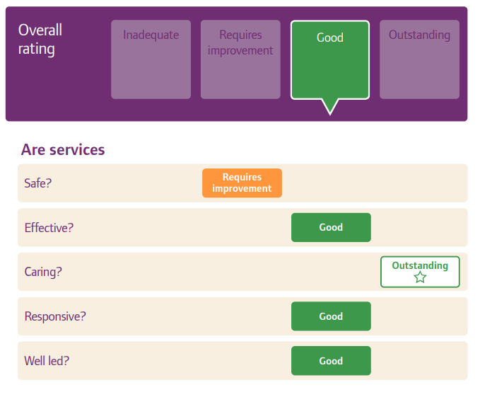

**2.2.8. Trust Governance Model 2024/25**

The Trust continues to operate a well-established devolved governance model supporting the Trust’s commitment to be a clinically led organisation.

This current approach to governance means that Divisional Directors and the Research Director are empowered to adapt arrangements within their own Divisions, linked to strategic objectives and the Trusts Vision 2030 in a way that ensures the best outcomes for the patients in our care, with the best experience possible for children, young people, and families throughout their journey.

Divisional Directors for Medicine, Surgery, Community and Mental Health and the Director of Research, for Research and Innovation attend Trust Board meetings as members of the Executive Team, improving engagement and cross-divisional working, providing enriched debate, and supporting effective decision-making both strategically and at operational level.

In 2025 the Trust will transition to an integrated governance model, revising our processes, reducing duplication and variation between our services. We will ensure there is flexibility in our approach for individual services, whilst having a robust, standardised model with clear roles and responsibilities.

The new model will ensure the whole organisation are:

* Clear on their individual, team and divisional roles and responsibilities
* Follow a standard process, with variation where required
* Consistent with reporting and oversight
* Develop a whole organisation approach to problem solving and learning

**2.2.9. Data Quality**

Alder Hey Children's NHS Foundation Trust has a Data Quality Strategy in place from 2022-2025. The vision of the strategy is “To strive to achieve the highest quality of data that is parallel to the outstanding care that we provide”. The aims focussed on in the strategy are:

* **Improve patient care**: Improve patient care by the development of a BI dashboard of which helps to identify any demographic errors that can be fixed on a daily basis, with consistency of checking of the spine, which is the patient demographics via the General Practitioner (GP) as the Trust has to ensure the details, we hold align with the details held by the GP. Working in collaboration with data quality training lead to ensure role- based training and training plans are available.
* **Support population health management**: Development of dashboards to ensure the patient journey was compliant with the relevant referral’s associated to the correct visit, ensuring follow up appointments are appropriate for the health management of the patient.
* **Support commissioning decisions and policy developments:** Development of the Data Quality policy including expansion of the steering groups and ongoing projects to help with and supporting decisions for improvement.
* **Create, support and improve patient-centric analyses**: Development of reports needed to analyse any missing information and capturing of real time discharge and missing referrals, analysis of the BI dashboard for any improvements within the patient pathway.
* **Support Clinical Audit, Service Evaluation, Research, and Innovation:** Development of Audits to ensure compliance with data quality and patient confidentiality, with floorwalking to ensure audits are completed regularly.
* Future expansion plans include:
* Spot Checks for ensuring data quality demographics are updated and the Trust can check areas for compliance. If not compliant will introduce refresher training for staff in this area (4 per year)
* Confidentiality Audits (4 per year)
* Suspicious behaviour reports (4 per year)
* Information Security Floor Walks (4 per year) - potential to be incorporated into the Spot Check Audit.
* **Support and improve dashboard development:** Working with analytics to ensure development and improvement of BI dashboard to confirm compliance with the national CDS dashboard as per NHSE require the demographics to be within a certain range. This is checked weekly to ensure the numbers are kept within range.
* **Improve analysis more generally**: Development of dashboards and reporting to include the ongoing development of audits to ensure patient confidentiality and DQ is being adhered to by running reports on.

The Trusts’ Chief Transformation and Digital Officer is the accountable Executive Officer with the Associate Director of Digital Transformation responsible for the delivery of the strategy. Governance is provided via a bi-monthly Data Quality Steering Group which reports into the Digital Oversight Collaborative with bi-annual reporting into the Finance, Transformation & Performance Committee (FTPC).

The Trust submit records to Secondary Uses Service (SUS) for inclusion in the Hospital Episode Statistics, which are reported on a variety of schedules ranging from daily, weekly and monthly. Performance is reported via DQMI (Data Quality Maturity Index) and CDS Data Quality Dashboard. For all metrics submitted and monitored via DQMI, Alder Hey demonstrates standards above or equal to national standards.

Alder Hey is viewed favourably when reviewing metrics from external bodies, including NHSE and Model Hospital, and has evidenced approach to updating metrics where data quality issues have been identified. Thus, working with the development of specific training plans to ensure the area’s requiring additional refresher training, to determine the reduction of errors and fixes required. Thus, the new development of a BI Dashboard to help to identify any demographic errors and fix them as they come in daily as well as capturing the monthly reports all in one place.

The Trust has robust safe waiting list management protocols in place, including data validation. Several dashboards are utilised within the Trust’s reporting infrastructure that enables validation. This supports users to monitor current patient status on the Patient Tracking Lists (PTL) and flag up and resolve data quality issues for these patients, as well as identifying any missing referrals

Mersey Internal Audit Agency (MIAA) recently conducted a Data Quality Review Assignment Report 2024/2025 at Alder Hey, with the objective of the review to provide assurance that systems and processes are in place to accurately report performance against the Trust’s key performance indicators. Two primary indicators were focused on of DM01 compliance (Diagnostic waiters) and Elective Recovery which are reported to Trust Board via the Integrated Performance Report. This final report was released in September 2024 and declared Alder Hey as having Substantial Assurance for these metrics.

Alder Hey went through a significant upgrade to their EPR system (Meditech) in September 2023 with an extensive exercise to ensure timely and accurate data quality was resumed following implementation.  The development of a new BI dashboard for data quality captures all activity daily to provide assurance that systems and processes are in place for accurate reporting.

**2.2.10. Data Security and Protection Toolkit (DSPT) attainment levels**

The Data Security and Protection Toolkit (DSPT) v7 for 2024/25 has undergone significant change to adopt the National Cyber Security Centre’s Cyber Assessment Framework (CAF) as its basis for cyber security and IG assurance.

The Trust submitted an interim assessment in December 2024 and will publish its final submission by 30th June 2025. The submission process is supported by an independent two-phase audit process by Mersey Internal Audit Agency (MIAA) with an assurance opinion provided regarding robustness of evidence against the revised standards.

The information governance function continues to deliver a broad workplan and works collaboratively with the wider digital and cyber security service. Assurance of compliance and reporting of key information governance activities are reported and monitored through the Trust’s governance and committee structures.

During 2024/25, zero data security incidents were reported to the Information Commissioners Office (ICO).

**2.2.11. Clinical Coding Error Rate**

The Trust was subject to the Payment by Results clinical coding audit during the reporting period by the Audit Commission and accuracy rates reported in the latest published audit for that period for diagnoses and treatment coding (clinical coding) were:

* Primary Diagnoses: Correct 93%
* Secondary Diagnoses: Correct 96%
* Primary Procedures: Correct 95 %
* Secondary Procedures: Correct 90%

The above figures for primary diagnosis and primary procedure exceed the 90% recommended accuracy scores required for Data Security & Protection Toolkit Data Standard 1 attainment level of Standards Met. The figures for secondary diagnosis and secondary procedures exceed the 80% recommended accuracy scores required for Data Security & Protection Toolkit Data Standard 1 attainment level of Standards met.

The auditor noted the Clinical Coding department has a good working relationship with clinicians which includes undertaking speciality validations.

**2.2.12. Learning from Deaths**

During the period 1st April 2024 to 31st March 2025, 75 inpatients died (including in ED). 1 of these cases had a community review as opposed to a hospital review since most care was provided in the community. This comprised the following number of deaths which occurred in each quarter of that reporting period:

* 20 in Q1
* 21 in Q2
* 14 in Q3 (+1 community death)
* 18 in Q4

By 1st April 2025, 45 case record reviews and 6 investigations (2 learning reviews and 4 rapid reviews) have been carried out in relation to the 75 deaths reported. Whilst many adult Trusts only conduct mortality reviews on cases where deaths are unexpected or flagged through an incident, it is the policy of Alder Hey that all inpatient deaths are reviewed.

In 4 cases, a death was subjected to both a case record review and an investigation. The number of deaths in each quarter for which a case record review or an investigation was conducted was:

* 20 in Q1
* 21 in Q2
* 7 in Q3
* 0 in Q4

None (representing 0%) of the patient deaths during the reporting period are judged to be more likely than not to have been due to problems in the care provided to the patient.

This number has been estimated using the hospital mortality review process established in Alder Hey Children’s NHS Foundation Trust. Every child that dies in the Trust has a Hospital Mortality Group Review (a group consisting of multidisciplinary professionals from a range of specialties across the Trust) and usually at least one departmental review prior to this. The aim is for the departmental reviews to be completed within 2 months and the hospital mortality review within 4-6 months. There are occasions when the hospital reviews are delayed whilst awaiting completion of internal investigations/learning reviews, Coroner’s cases, and postmortems, as it is essential that each case is discussed thoroughly and with all the relevant information available to the group. As part of the HMRG process the families are invited to provide any feedback to be considered in the review.

The Trust continues to identify learning points through the mortality review process. Some of the recent learning points have included:

* Ensure preoperative screening is completed.
* Consideration of early redirection of care when all management options have been considered and none are realistic.
* If despite correct care, there is not the improvement as expected it is vital to consider other less common causes. This results in earlier diagnosis of rare conditions altering decision making and informing family counselling.
* It can be difficult to diagnose some of the congenital heart conditions on antenatal scans. The cardiac team continues to feedback the postnatal diagnoses to provide on-going learning for the fetal screening team. In addition, it is vital that the parents are counselled appropriately so they have realistic expectations hence avoiding potentially futile operations.
* Hereditary Haemorrhagic Telangiectasia (HHT) is an uncommon condition but there is now the option for genetic screening. However, it is imperative that any further imaging is undertaken in timely manner following positive screening result.
* Communication can be challenging when there are multiple teams involved and a very complex, fast moving clinical scenario. There must be clear/consistent communication to the parents.
* The Congenital Diaphragmatic pathway continues to be modified as it was highlighted in a few cases that the perinatal risk calculations were not clearly communicated potentially impacting on the treatment options.
* There is the possibility that recent bypass surgery may increase susceptibility for a translocated infection from the bowel. Hence, there was discussion about the potential for stat aminoglycoside dosing and this will be reviewed in the current guidelines.
* Positive learning was the speed at which plasma exchange was facilitated on ECMO because of the hard work of PICU, haematology and the NHSBT service.
* There were a few cases transferred into Alder Hey, which related to concealed pregnancies and the issues associated with these. The lack of antenatal care results in the babies being born in poor condition and can have several complex issues that have not been identified earlier. These mothers are often very vulnerable due to the variety of factors that may have resulted in them concealing their pregnancies.
* Linking with PRUDIC Welsh equivalent to SUDIC can be problematic so currently reaching out to the North Wales team to try and ensure that processes are initiated consistently.
* There was learning relating to organ donation in that whilst initial assessment had ruled out eligibility due to COVID19. This was later confirmed not to be an absolute contraindication, particularly as it had only been detected on routine testing.
* Concerns were raised that some very unstable patients were transferred out of area into AHCH when they were critical and whether there was any possibility of beds nearer to them.

There was one case highlighting that the Specialised Palliative Care team (SPCT) could not provide on-call cover over a weekend. This had no impact in the care provided in the case discussed but there was a clear need identified. The SPCT now have a 24/7 medical on-call service. Therefore, should this clinical scenario occur again in the future an on-call service is provided over the weekend.

Several cases have highlighted delay in activating the SUDiC or ALTE pathways and there is ongoing work relating to this area. First, the internal child death review processes have been reviewed and new processes/pathways rewritten to clarify and hopefully simplify going forward. The next step is to roll out across the organisation supporting learning so that clinicians are more confident in such situations. Previously, such cases were probably more identifiable but now it is important to consider all unexpected deaths even if in hospital.

There have been several cases relating to pre-hospital issues. There were potentially avoidable delays in receiving appropriate care with confusion as to where the receiving centre should be. The Trust is discussing these with our local ambulance service to ensure that there are no concerning features.

Over this period, reviewing cases it was clear that a learning event relating to community deaths needed to be held ensuring that all the key stakeholders understood the Alder Hey mortuary process and bereavement support. There was considerable learning obtained from this event which can only be of real benefit going forward for all the stakeholders and the families involved. The admission criteria to Alder Hey was clarified, which was a revelation to some of the external agencies as many were unaware of the process. The communication pathways are now clearer which should hopefully prevent any delay or confusion. A directory of bereavement support services across the region will be shared so that local support can be accessed.

Unfortunately, escalation of deteriorating patients continues to be an issue as each case is slightly different, and a policy relating to observations has been introduced across the Trust. This stipulates when observations should be completed and when to escalate. In addition, radiographers are able, if undertaking an investigation and identify a life-threatening emergency, to put out an arrest call.

37 case record reviews were completed after 1st April 2024 which related to deaths which took place before the start of the reporting period. None (representing 0%) of these deaths in this period are judged to be more likely than not to have been due to problems in the care provided to the patient.

**2.2.13. Freedom to Speak Up**

Alder Hey has an established system in relation to Freedom to Speak Up (FTSU), as required by the National Guardian’s Office. Driven by the Trust Board, we seek to develop a culture that is responsive to feedback and focused on learning and continual improvement. The FTSU service is now ‘business as usual’, continuing to provide a safe place for staff to raise concerns, ensuring that the learning from these concerns, are embedded, locally and Trust wide.

The Freedom to Speak Up visibility programme, maintains the Freedom to Speak Up (FTSU) Guardians profile within the Trust and is supported by the staff networks, promoting to staff, that the perceived barriers to speaking up, can be overcome. The walk-about visits are also supported by the Chief Executive Officer (CEO), the Executive Directors and the Non-Executive Directors, which not only demonstrates to staff that FTSU is supported by the senior leadership team, but also allows the team to meet staff and understand some of the challenges they may face, first hand. The attendance of the senior leadership team has been well received across the organisation.

The Deputy Freedom to Speak Up Guardian (FTSUG) post is due to be advertised and is hoped the successful candidate will be in post shortly. This appointment is a clear demonstration of the commitment of the Board to the FTSU service. This post will allow the service to further grow and develop, with a focus on the FTSU champion role, is a service that helps promote the principles of Freedom to Speak Up, signposting staff to the FTSUG and can be a first point of contact for staff wishing to raise concerns and forging stronger links with the Staff Liaison Service (SALS), Patient Advisor Liaison Service (PALS), to provide more ports for staff to raise concerns.

Attendance by the FTSUG, at the Thriving Teams meetings (part of the THRIVE framework focuses on promoting overall wellbeing of individuals through preventative measures) continues, significantly enhancing the triangulation of gathered intelligence from across the organisation, allowing a clear vision of areas of concern. This will be further improved, by the work of the Director of Culture and the work undertaken by her team in creating a thriving teams index (the THRIVE index identifies six essential dimensions for workplace well-being: Psychological Safety, Trust, Community, Autonomy, Purpose and Growth).

2024/25, has seen the development of a smart phone FTSU app, and whilst it is still in its infancy, it is due to be launched in 2025. The primary driver for the development of this app was to allow staff the ability to report to FTSU, truly anonymously, as currently we do not have this option, although the FTSUG does maintains staff confidentiality should they wish.

Further features of this app, is the ability for staff to see the progress of their concern, know what lessons have been learnt and embedded and to be able to report any concerns of detriment post closure of the case, over a 12-month period. It is also hoped that it will generate reports, on trend and themes and be able to ‘talk’ to the National Guardians Office, reporting portal, which will significantly aid quarterly reporting.

**2.2.14. Statement on Resident Doctors Rota Gaps**

Paediatrics continues to face a resident doctor shortage, with difficulties to recruit and gaps regularly appearing on junior (ST1-3) and middle grade (ST4+) rotas, and resident doctors choosing to work less than full time. This is more sharply felt at Alder Hey due to the breadth of services and the number of rotas required to support the clinical teams, both in and out of normal working hours.

It is also impacted by resident doctors unable to support out of hours practice due to personal health concerns; and the Trust supporting Trainees requiring extra support (TRES). Furthermore, there is significant risks over staff absence through maternity and sickness.

Further operational support was offered with the Operations Manager commencing in post in January 2025. This has had a positive impact on resident doctor morale and improved rota management.

To understand how other trusts worked we met with Paediatric Clinical Leads at Manchester Children’s Hospital and Bristol Children’s Hospital. A Gold Compliant rota is based on 1:32 people template Whole Time Equivalent (WTE). Following conversations with Paediatric Clinical Leads at Manchester and Bristol, the rota has been reviewed. With resident doctor support the Trust has introduced self-rostering via Health Rota as a pilot for 12 months, March 2025 - March 2026.

Traditionally, the Trust aims to run a minimum rota of 1:13 WTE ST1-3 and 1:24 WTE ST4+. However, for 2025 - 2026 period the rota is operating at 1:16 WTE ST1-3 and a 1:29 WTE ST4+. To address this, the Trust has proactively recruited two clinical fellows to support the ST1-3 rota and five clinical fellows to support the ST4 rota.

Self-Rostering has been met with positivity from the resident doctors who report increased flexibility, greater autonomy and an improved work life balance. The communication with resident doctors has increased and the administration processes have become more responsive and reliable. The rostering software is more user friendly, with the senior administrative support in place, we are effectively mitigating errors whilst maintaining transparency.

The Trust is conscious that unfilled gaps have a detrimental effect on training opportunities and morale amongst our resident doctors. Unfortunately, there are potential 4 WTE maternity leave vacancy gaps for the March to September 2025 rota. Furthermore, after commencement in post one of the ST4s is unable to contribute to the On-Call Rota and is being supported as Trainee Requiring Extra Support (TRES). This remains a challenge going into 2025/26 due to the current culture around working patterns and training needs as trainees are choosing to work 80% which is now the new ‘full-time.

All locum gaps are sent to resident doctors at Alder Hey and wider Deanery through Patchworks. The rota has built in resilience shifts, day shift 3rd on (D3) and night shift 3rd on (N3), to ensure that the Trust is maintaining core staffing levels with a minimum of 2 ST4+ on site.

Senior managers are kept informed of any gaps on the rota and consistently updated with any challenges with regular meetings between the Operational Manager and Medical Staffing Co-ordinator to highlight any potential issues and maintain open communication.

Fortnightly meetings take place with support from Senior Managers, HR and Clinical Leads with resident doctor input to address rota issues, including developing the Shape of Training work within the organisation, which looks at potential reforms to the structure of postgraduate medical education and training across the UK. It helps us to consider how best to deliver a workforce that meets the needs of future patient and models of service. Check-ins take place with our resident doctors every 6 weeks to create an open forum with management present; and we welcome and encourage feedback from our resident doctors.

The resident doctor’s Forum (RDF) work closely with the Guardian of Safe Working to plan for safe junior doctor staffing.

We are successfully meeting the RCPCH Trainee Charter recommendations on providing resident doctors with education development time within their work schedule. This is continuing professional development time which is built into their personal rota’s.

GOLD compliance (70% time within Specialty) for our sub-specialty training in paediatrics is also known as GRID trainees, is not being met. At present our GRID trainees are in Specialty 61%-71%, which is a marked improvement, however it is historical at Alder Hey. These percentages are based on time within teams working hours. The requirement is 1:32 WTE ST4+ rota to meet GRID GOLD compliance. Unfortunately, as a Trust there are not enough allocated Residents to be able to commit to this in our ST4+ rota. However, the rota shifts have been adjusted to enable GRID Residents to have more time within their specialties.

There is regularly engagement with the Medical Education Team to ensure the needs of doctors in training working on-call and out of hours are met.

The aim is to create a 1:15 ST1-3 Rota and 1:30 ST4+ Rota through Clinical Fellow recruitment within during 2025/26. There is a review taking place to look at the contributions of other allied health care professionals (Advanced Care Practitioners, Physician Associates, Clinical Fellows) to the out of hours activity to support our medical rota. We are also exploring numerous options from having a split General Paediatric and Speciality Rota, to allow trainees to undertake self-rostering.

The Rota Operational Manager anticipates further challenges as many Residents are choosing to work at 80%, as the new “full time”.

**2.2.15. Seven Day Hospital Services**

Evidence exists that lack of access to resources at weekends across the NHS can be associated with delays to care and increased risk of adverse outcomes. The 7 Day Hospital Services Programme supports Trusts to reduce this variation in the levels of care and potential outcomes experienced by patients admitted at the weekend.

This work is built on 10 clinical standards developed in 2013 by the NHS Services, Seven Days a Week Forum. With the support of the Academy of Medical Royal Colleges, four of these clinical standards were made priorities for delivery to ensure patients admitted in an emergency receive the same high quality initial consultant review, access to diagnostics and interventions, and ongoing Consultant directed review at any time on any day of the week.

Successful highlights and forward view for the 7-day hospital services:

* We have successfully established a team of high dependency paediatricians with five appointments now in post. Appointment of these dedicated HDU specialists will support compliance with Standards 2 and 8.
* A business case was approved and recruitment of seven consultants is underway to provide consultant cover 24/7 and resident during daytime, weekdays and weekends. A plan is underway to appoint fellows and senior ANPs to support a middle tier rota as resident on call-24/7/365.
* We have completed our ‘Pathways and Thresholds’ Work Programme to define admissions and referral criteria to medical specialties (including general paediatrics). Team responsibilities are better understood, and it is clear to consultants, trainees, other clinical staff and to families, which consultant is leading the patient’s care, again supporting Standards 2 and 8.
* The Acute Response Team is a team of nurse practitioners and advance nurse practitioners and has been in place for three years. They have the necessary skills and competencies (all staff HDU trained) to support acute care including but not limited to deteriorating patients.
* The Trust is continuously focussed in improving patient care and safety for patients attending ED through the ‘ED@ its Best Programme’. This programme has supported change with improvement of the ED service delivery model in a sustainable and compassionate way. The Urgent Treatment Centre (UTC) – has been established which is a standalone facility where children presenting with urgent but not emergency needs can be scheduled into bookable appointments and managed by the most appropriate clinical team. This ensures staff with the most appropriate skills see the most appropriate patients to improve effective, efficient decision making and treatment. The Centre is currently run by PC24 who deliver a range of NHS urgent and primary care services covering.
* Paediatric Assessment Unit (PAU) – Has continued to provide direct access for clinical teams working in primary care to refer patients to General Paediatric clinicians on the same day. This has improved access and experience for children, reducing the need for them to attend the emergency department. (24/7 365). Both Emergency Department and the PAU is supported by the Virtual Ward team from 8am to 9 pm for early discharge of patients.
* Virtual wards are in place to assist patient flow and plans are in place to continue to increase the cohort of patients who can get better at home.
* The Response team consists of 24/7 365 days a week band 8a Senior Clinical Site Practitioner and band 7 Clinical Site Practitioner. The responsibilities include situational awareness of the deteriorating patient and critical care step-downs, Site management including staffing out of hours. The team is also the initial responder to Martha's Rule request, undertaking an immediate rapid review. The Team supports as outreach for critical care.

**Forward view**

* The Trust is now working on implementing the Hospital Optimisation Programme led by the Chief Medical Officer. The aim of the process is to look at a robust and safe escalation process 24/7/365, aligning with optimum workforce to support the process. This programme will also ensure everyone is using the same system for reporting/logging/handover and patient deterioration.
* The Trust is in the process of appointing 8 clinical fellows who will support the out of hours on-call as part of the junior doctor rota, enhancing resilience.

**Part 3: Other Information – Quality Performance in 2024-25**

Launched in 2023/24, 2024/25 saw the continued mobilisation and practical efforts to make our Trust strategy ‘Vision 2030’ a reality, ensuring that our strategic goals meet the evolving needs of our community using our ‘Brilliant Basics’ programme to drive both operational efficiency and strategic growth across the organisation.

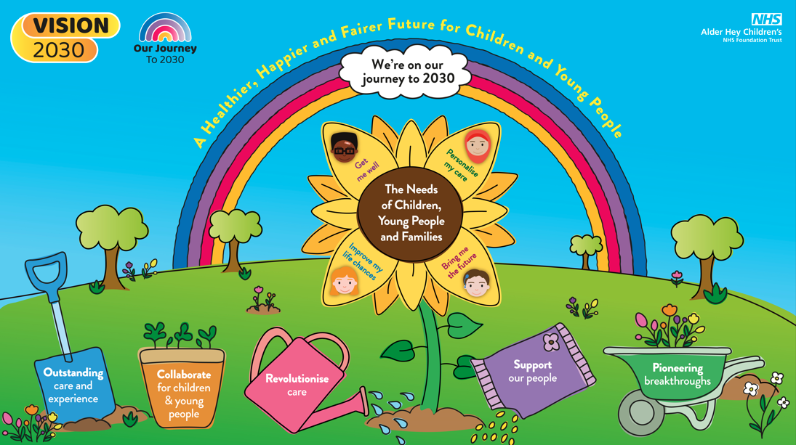

The needs-led objectives for 2024/25 were delivered through the Trust 5 strategic goals were:

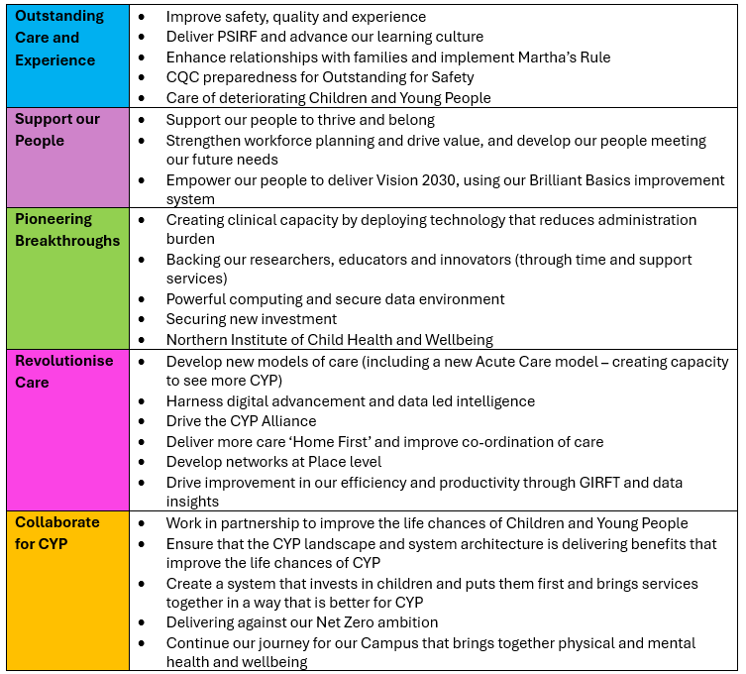

The key priorities that we set out for 2024/25 are summarised in the table below. This section of the Quality Account provides examples of the outstanding work and achievements of the Trust and reflects the extraordinary dedication and commitment of our staff.

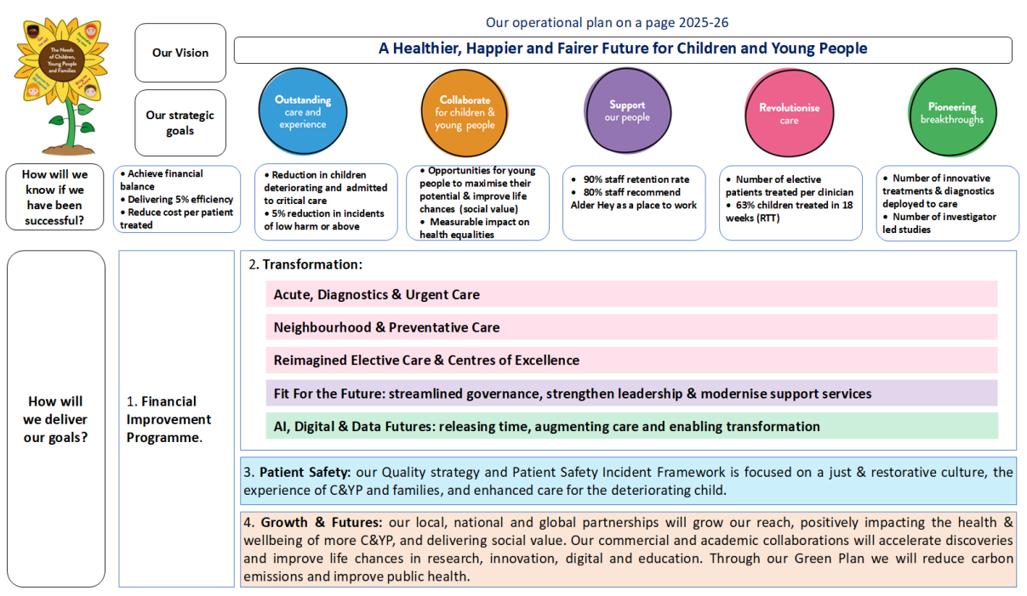

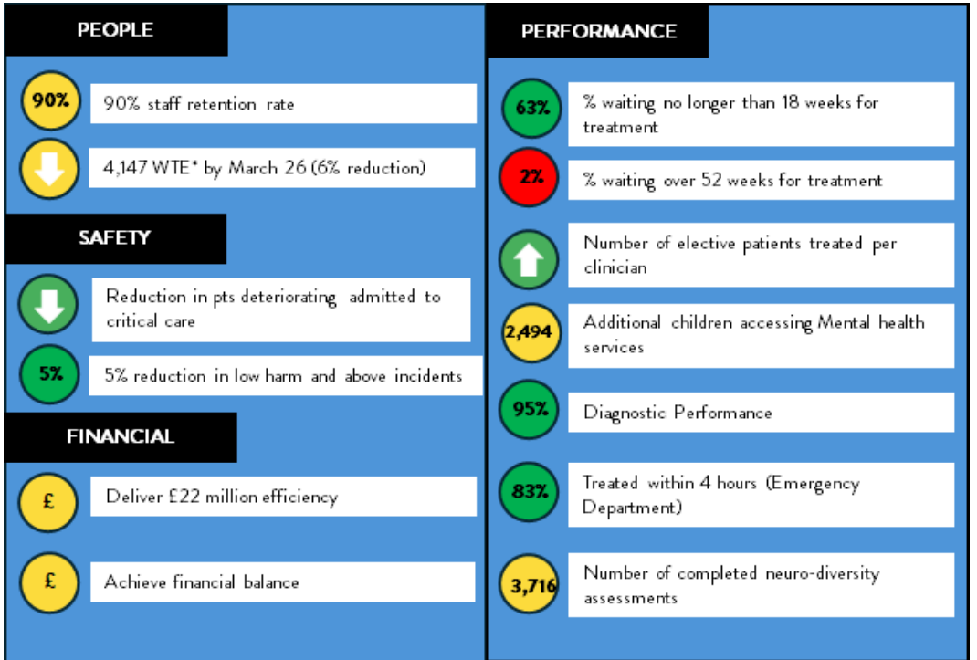

**3.1. Priority 1. Safe Care**

**3.1.1. Incident Reporting**

**Incident reporting**: During 2024/25, Alder Hey continually demonstrated a strong incident reporting culture. There was a sustained improvement in the Trust’s performance position in relation to incident reporting compared to previous years with a total of 9,078 incidents recorded compared to 8,572 in 2023/24

The Trust transitioned to the Learn from Patient Safety Events (LFPSE) service in May 2023 and continued during 2024/25 with NHSE to produce a new Recorded Data Dashboard (RDD).

Towards the end of 2024, NHSE made the RDD available exclusively to providers to support in identifying and resolving any data quality issues between what is stored in LFPSE compared to the data stored within our local risk management system (Ideagen InPhase).

In April 2024 InPhase became part of Ideagen and is now called (Ideagen InPhase).

A local data validation exercise was undertaken, and feedback shared with NHSE and Ideagen InPhase. Mitigations have been put in place where discrepancies have been identified as far as possible, and work will continue to validate the data locally on an ongoing basis prior to wider publication of the RDD.

Ideagen **InPhase**: Throughout 2024/25, the Trust continued to develop and optimise its electronic risk and incident management system (Ideagen InPhase) across the organisation during Phase 2 of the transition (Phase 1 was completed between May 2023 – April 2024).

There has been sustained engagement and use of the core modules available at launch as evidenced through a consistently strong reporting culture, ongoing refinement of the forms to adapt to division / board requirements and further refinement of dashboards and reports by the Data and Analytics Team.

Additional development and functionality for the system is seen as a key priority for the Trust’s 2030 Vision. An Ideagen InPhase Programme Board was re-established for oversight and monitoring of core objectives for Phase 2. Core themes for oversight include Development, Optimisation and Relationship. The relationship element at the time of Phase 2 was set up to improve communication between us and the vendor to ensure we are receiving the optimum support for the system and module specifications. Regular meetings have been established with Ideagen InPhase’s Account Manager, Customer Success Manager and Project Manager. This ensures communication is more direct and effective.

Lack of Ideagen InPhase developer resources was seen as a key gap for the ongoing support of the system. This has been addressed by the appointment of a Risk Management Systems Lead who commenced in post on 3rd March 2025. This role will provide training, development, and creation of new features in the system, along with general system maintenance.

*The following objectives have been agreed for* Ideagen *InPhase 2:*

* Clear system and module ownership, roles, and responsibilities
* Improved patient safety
* Increase functionality in the Ideagen InPhase system for the reporting and management of risk and incidents
* To improve overall user experience
* Improved reporting/dashboard functionality
* Develop outstanding modules from Phase 1 (Mortality, Legal, Freedom to Speak Up, Audits)

A key element of the procurement of Ideagen InPhase was ensuring the system was LFPSE (Learn from Patient Safety Events Service) compliant. Whilst compliant, Ideagen InPhase are still pilot testing the version 6 implementation. Work continues with the Ideagen InPhase Account Manager to enable transition to version 6, due to be released in 2025.

**3.1.2. Risk Management**

The Trust continued to promote a culture of robust risk management throughout 2024/25 through its monthly Risk Register Oversight meetings to validate risks with divisions and corporate functions with a continued focus on the proactive management of risks including addressing overdue risk reviews, lack of / overdue actions and challenging risk scores when adequate mitigations are in place to assist divisional / corporate teams and provide assurance to the Board and its sub-committees that the Trust has effective and robust risk management systems and processes in place.

To support the Trust’s wider risk management process and the ongoing development of the Trust’s Risk Management reporting, an updated Risk Appetite Statement was agreed by the Board in September 2024. The aim will be to deploy agreed risk tolerances in active risk management decisions, initially on a pilot basis in one or more of the clinical divisions throughout 2025.

An introduction to Risk Management training package was implemented in 2024/25 to support staff to develop their understanding of risk management, including risk assurance and risk appetite and assist in providing assurance that the Trust has in place a comprehensive system of internal control.

**3.1.3. Patient Safety**

The Patient Safety Board (PSB) continues to meet monthly and provides assurance to the Safety, Quality and Assurance Committee (SQAC) and Trust Board.

The Trust made the transition from serious incident framework (SIF) to the Patient Safety Incident Response Framework (PSIRF) in January 2024 with 2024/25 seeing the implementation of our first PSIRF policy and plan.

Throughout 2024/25, Alder Hey Patient Safety Programme have made significant strides in enhancing patient safety. Through focused initiatives, we have addressed potential risks, engaged stakeholders, increased learning, and improved patient outcomes.

The year has seen programme updates on the transitioning to PSIRF which has shifted our approach to patient safety underpinned by four key objectives including compassionate engagement for all involved; a considered and proportionate approach to patient safety incidents; utilisation of a range of system-based approaches to learning and revised governance and oversight processes.

In line with the national PSIRF standards the Trust employed two patient safety investigators who commenced in post in August 2024 to support the roll out and embedding of PSIRF across the Trust.

In October 2024 following a robust recruitment process facilitated by our young volunteers and children and young person's forum, 40 children and young people were appointed as our patient safety partners to work alongside the Patient Safety team.

2024/25 has seen the following workstreams transition to business as usual:

* Learning disabilities and/or autism
* Clinical negligence and litigation
* Total parenteral nutrition (TPN)
* Neonatal and newborn screening

Our patient safety team have developed a competency framework assessment for our PSIRF implementation and engagement with standards. It is our goal to achieve >90% compliance with PSIRF standards in 25/26.

2024/25 saw the completion of the MIAA PSIRF review which found substantial assurance in our PSIRIF implementation. Two recommendations were made and noted, with an implementation plan developed to continue to embed PSIRF, align to the recommendations and provide further assurance.

In line with our PSIRF governance process all incidents reported as moderate harm or above, and any patient safety incident where it is felt that the opportunity for learning and improvement is significant, are presented and reviewed at the weekly Patient Safety Incident Response Investigation (PSIRI) Panel, to determine the appropriate learning response if required Patient Safety Incident Investigation (PSII) or Patient Safety Review (PSR) plus any associated system wide learning or areas for improvement. This approach has remained iterative with a CPD day undertaken (March 2025) to enable change to the processes to enable more streamlined and effective approach to incident management, review and learning.

The Trust Board receives a quarterly ‘Learning from patient safety incidents’ report on findings and system learning identified at the PSIRI panel.

The following learning responses have been commissioned 2024/25, this does not include Initial reviews.

|  |  |
| --- | --- |
| After Action Review (AAR) | 10 |
| Multidisciplinary team (MDT) review | 2 |
| Thematic analysis | 2 |
| Patient Safety Incident Investigation (PSII) | 3 |

* During 2024/25 we completed 2 PSII’s following Never Events (retained surgical instrument and wrong site procedure). This identified a systems issue around NATSIPPS 2/LOCSIPPS implementation throughout the organisation. As a result, this has been prioritised as an Improvement workstream in the patient safety programme for 2025/26. The third PSII (wrong route/administration of medication) is ongoing at the time of publication
* A learning review following the deterioration and death of a child within the organisation, was undertaken throughout 2024. This focused on the specific event itself and applied a just restorative learning approach to the review. Furthermore, a systems wide review around patient deterioration was commissioned. The deteriorating patient has been prioritised as an Improvement workstream in the patient safety programme for 2025/26.
* Thematic reviews were commissioned for data breaches and delay/lost to follow up patients and are informing further work for improvement in these areas. This is expected to be completed in early 2025. This work is reporting into the PSIRI panel, Safe Waiting List Management Oversight Board and Patient Safety Board.

NHSE Patient Safety Training Level one – essentials for patient safety for all clinical and non-clinical staff within the Trust is monitored through the Integrated Performance Report. Additionally, all board members were expected to undertake essentials of patient safety for Board and senior leadership teams.

The table below demonstrates the Trust compliance achieved in 2024/25 against two mandatory patient safety e-learning modules, introduced to support PSIRF.

|  |  |
| --- | --- |
| **E-Learning Modules** | **% Compliance** |
| Level 1a Essentials for Patient Safety (All staff) | **99%** |
| Level 1b: Essentials of patient safety for boards and senior leadership teams* | **100%** |

*\*For all board members*

Several key clinical and non-clinical staff have also completed several patient safety modules offered by the national Health Safety Incident Investigation Branch (HSSIB).

In May, June and July 2024, Consequence UK provided training sessions for those acting in oversight, engagement (patient, family and staff) and learning response roles.

The Trust’s promotion of a transparent incident reporting culture is reflected at the weekly Patient Safety Meeting (PSM) led by the Chief Nursing, AHP and Experience Officer which continues to be well attended by multi-disciplinary teams.

A weekly learning bulletin continues to be disseminated following each meeting highlighting good catches, themes, and key messages to promote patient safety engagement across the Trust and share findings for learning purposes.

The weekly PSM is an open forum underpinned by a ‘just culture’ which is supportive and psychologically safe. Those staff affected by patient safety incidents are afforded the necessary managerial support and given time to participate in learning responses. All staff will work within our Just Culture principles. Divisions have processes in place to ensure that managers work within this framework to ensure psychological safety.

Patient Safety Incident Review Meetings

The Trust has established governance systems and processes in place to support the oversight and review of reported patient safety incidents. Weekly divisional patient safety incident meetings remained in place throughout 2024/25 to oversee and investigate all reported patient safety incidents.

The following patient safety driver metrics are monitored within the Trust IPR with 2024/25 targets being met.

* **Number of incidents rated low harm and above (Physical and/or Psychological) per thousand bed days**: an indicator which should demonstrate a downward trend or remain within the top quartile of comparator organisations.
* 2024/2025 (n = 20.7) seen a 27.4% decrease on incidents rated low harm and above per thousand bed days compared to 23/24 (n = 28.5). On average we experienced 40 less incidents per month rated harm in 24/25 compared to 23/24, 23/24 is the year our new risk management system went live.
* The objective 2025/26 plan is a 5% reduction on 2024/25.
* **Number of incidents rated no harm per thousand bed days**: an indicator which should demonstrate an upward trend or remain within the top quartile of comparator organisations.
* **2024/25 seen a 6**.2% increase on incidents rated no harm per thousand bed days from 69.4 incidents per thousand bed days in 2023/24 and 73.7%
* The objective 2025/26 plan is a 5% increase on 2024/25

Priorities for 2025/26

Following an update and approval by Trust Board in March 2025 of our patient safety incident response plan (PSIRP), our local patient safety priorities for 2025/26 are:

* The recognition and escalation of the deteriorating patient
* Delay and/or lost to follow-up appointments/treatment
* Medication Safety – omission/delay of critical medications
* Documentation – consent & medical record keeping
* IT system failure leading to patient harm

In addition to our local patient safety priorities, we have identified two further improvement priorities:

* To improve safety culture through enhancing levels of psychological safety and civility across the Trust
* To improve how we identify and share learning across the Trust.

Alder Hey NHS Trust commits to implementing in full the requirements and intent of the patient safety incident response requirements, including the engagement and involvement standards which apply to all affected by a patient safety event of harm.

The Trust does not underestimate the volume of work required to deliver the national requirements, nor the step change in culture and attitudes required at all levels of the organisation. However, it believes that if the changes required are achieved, it will make a tangible and positive impact on sustainable safety improvements for the Trust. Furthermore, there will be a kinder, more compassionate and inclusive approach to the way patient safety events are evaluated and responded to.

**3.1.4. Medication Safety 2024/25**

The Medication Safety Team have reviewed their visions and goals for 2025/26 in response to successes and learning from 2024/25. The vision remains to reduce to zero medication incidents that cause patient harm.

We also continue to:

* Respect medicines as agents of benefit and risk.
* Work together to improve medication safety within the Trust and with external partners.
* Engage with innovative practices to improve safety.
* Promote excellent practice.
* Support an open and proactive reporting culture to encourage ideas and challenges from staff.

Medication is part of treatment for almost every patient who is admitted to hospital. Prescribing, dispensing, and administering medicines for children can be complex and require specialist knowledge and experience.  Medication errors are one of the most common types of incidents reported in UK hospitals.

We continue to aim to reduce the number of medication errors in Alder Hey for three main reasons:

* **Medication errors can harm patients** - Patient safety is paramount to all care given at Alder Hey and although most medication errors do not cause harm, a small number of medication incidents do cause harm. The Medication Safety Team aims for no avoidable harm to patients from medication errors.
* **Medication errors can increase the length of stay in hospital** or increase the cost of their stay because more tests, investigations or treatments are needed. These factors can negatively impact future care and relationships between the hospital and families.
* **Medication errors can have consequences** for patients, their families and the staff involved which can result in anxiety, fear and possible time off work.

Review of 2024/25 Medication Safety Goals

The table below shows we have achieved our goals in 3 target areas, and in the other 2 areas, a reduction in medication incidents has occurred, but not by 25%. The number of administration and prescribing incidents reaching a patient reduced by 9%. The number of ten-fold medication errors reduced by 21%.

|  |  |  |  |
| --- | --- | --- | --- |
| **Medication Safety Goals for 2024/25** | **2023/24 Total** | **2024/25 Goal** | **2024/25 Actual** |
| Reduce the number of medication incidents resulting in harm to patients by 25%.  (NCC MERP category E or above*) | 56  (19) | 42  (14) | 39  (10) |
| Increase the percentage of near-miss reporting. (NCC MERP category A and B*) | 49% | > 49% | 51% |
| Reduce the number of incidents of moderate harm to zero. (NCC MERP category F or above*) | 1 | 0 | 0 |
| Reduce the number of prescribing or administration incidents reaching a patient by 25%.  (NCC MERP category C or above*) | 606 | 454 | 552 |
| Reduce the number of ten-fold incidents by 25% | 48  (17 reached a patient) | 36  (13 reached a patient) | 37  (11 reached a patient) |

The internationally recognised NCC-MERP categories for medication errors are now embedded into the incident reporting and analysis system in Alder Hey. See Figure 1 for details.

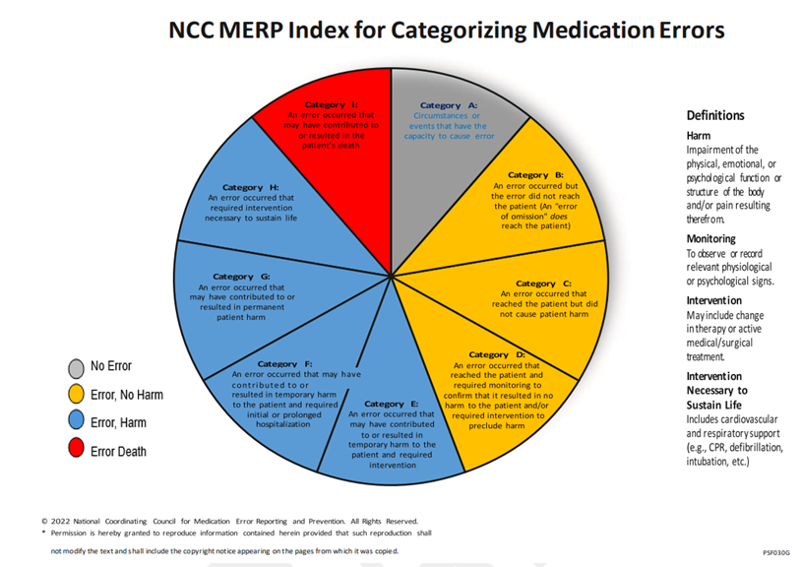

Medication incidents are reported using the Trust’s incident reporting system Ideagen InPhase. Incident details are then emailed to managers of the area where the incident occurred, and other key individuals. Medicine, Surgery and Community and Mental Health Divisions hold weekly incident review meetings and monthly Governance/Assurance meetings to monitor medication and other types of incidents.

Alder Hey’s Medication Safety Committee (MSC) a subgroup of the Drug and Therapeutics Committee meets monthly to review medication errors reported, identify learning from the types of errors and themes occurring and develop Trust-wide actions which aim to prevent similar errors happening in the future.

The MSC also responds to national and regional safety alerts and other concerns regarding medication safety, including shortages of critical medicines.

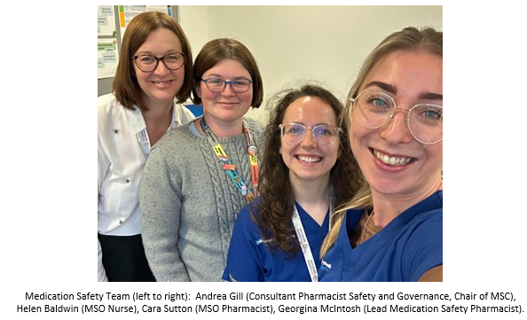

Alder Hey is unique in having a nurse/pharmacist combination providing the role of Medication Safety Officer (MSO). The MSOs are vital assets for the promotion of safe use of medicines in the Trust. In 2024, a Senior Medication Safety Pharmacist project role was made permanent due to Trust recognition that this role had made a significant contribution to achieving medication safety targets. The team have also been successful in obtaining temporary funding for a Governance and Safety Pharmacy Technician who will joining the team in May 2025.

The team work hard to promote near-miss reporting. Reviewing processes considering these reports supports a good safety culture within the Trust and hopefully prevents errors occurring which could cause harm to patients. 51% of all medication incidents reported were ‘near misses. This percentage has increased from 43% over the last 2 years.

Figure 2 shows the number of medication incidents reported in Alder Hey since 2014. 1535 medication incidents were reported in 2024/25. This is a slight increase compared to 2023/24 (1462 incidents, 4.8% increase)

The number of medication incidents reported has increased since 2014, however, the number of incidents causing physical harm to patients has reduced since then. The proportion of incidents causing harm has decreased in 2024/25 and accounts for 2.5% of reported incidents.

Figures 2 and 3 show the number of medication incidents reported and the number causing harm since 2014 adjusted for inpatient activity (incidents per 1000 inpatient admissions).

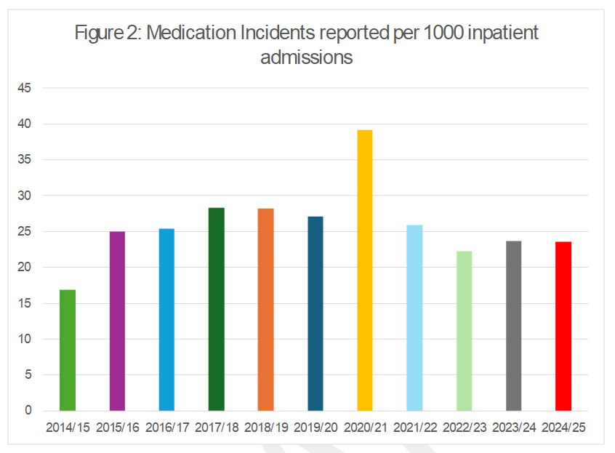

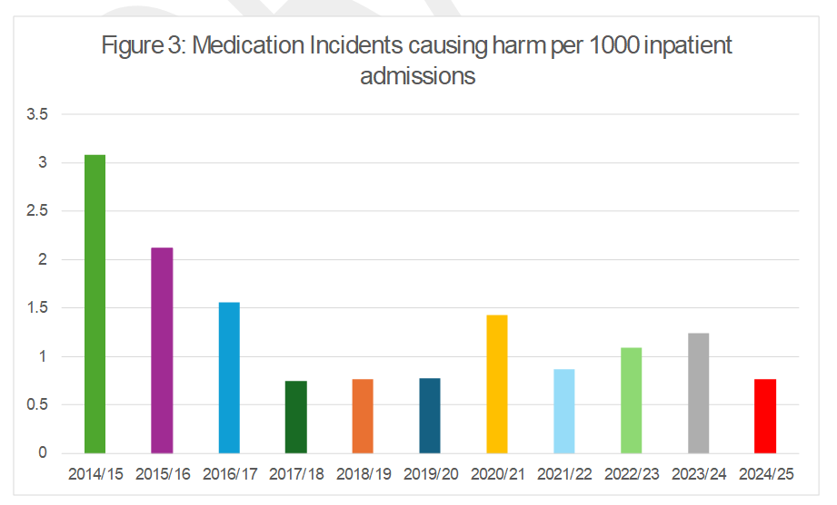

Actions taken to improve safe use of medicines in Alder Hey

Actions taken in 2024/25 to reduce the number of medication errors reaching patients and causing harm are described below under 5 headings:

1. **Produce robust data capture mechanisms to inform and monitor improvement plans**

The Medication Safety team have developed incident dashboards to allow robust data interrogation and production of metrics to drive improvement. The team have created dashboards including ‘All medication incidents’ and more specific dashboards for ‘chemotherapy’, ‘tenfold errors’, ‘controlled drugs’ etc. The dashboards produced are intuitive and enable ward/department managers to use filters to investigate drugs or processes causing incidents in their areas. The team have embraced opportunities to improve data capture within the Ideagen InPhase reporting system and have demonstrated their dashboards to colleagues across the ICB as exemplars of good practice.

Progress against targets is reported quarterly to the Trust Patient Safety Board using standardised QI methodologies e.g. ‘A3 Thinking’ (<https://leanconstruction.org/lean-topics/a3/>). Other QI methodologies used include PICK charts (Possible, Implement, Challenge and Kill) to demonstrate improvements, PDSAs (Plan, Do, Study, Act) to test out ideas and new Patient Safety Incident Reporting Framework (PSIRF) processes comprising rapid reports and thematic reviews.

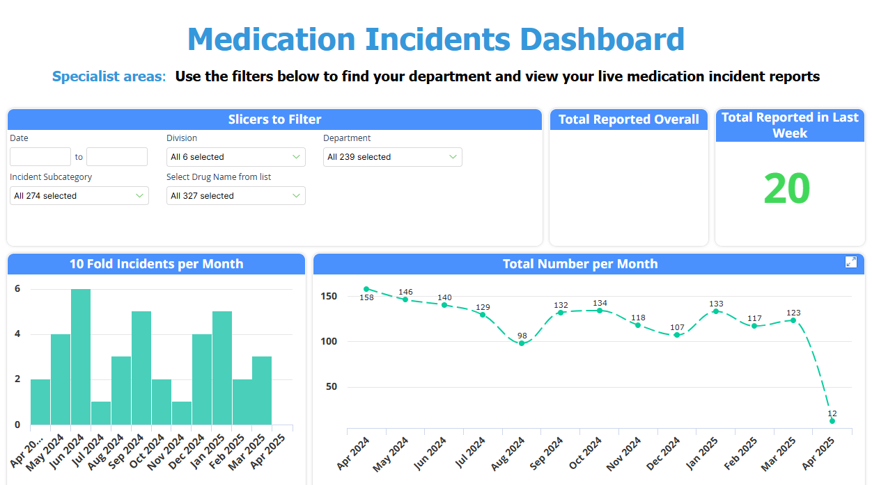

1. **Engage key stakeholders across the organisation in identifying, planning and undertaking improvement plans**

Engagement with key staff within the Trust through Medication Safety Collaboratives following the Institute for Healthcare Improvement (IHI) breakthrough collaborative series has been particularly successful. Collaboratives celebrate medication safety achievements, look at current issues, and discuss priority projects. Incorporating feedback from attendees into project plans ensures that objectives are realistic and focused on achieving targeted outcomes. Eight collaboratives have now been held with increasing attendance. Most attendees are matrons/ward managers who cascade information to their teams. Support from the Chief Pharmacist and Associate Chief Nurses has helped ensure staff are released to attend these sessions and the QI team now use this methodology for other patient safety initiatives.

MSC meetings and Medication Safety Collaboratives bring together those with an interest in medication safety and those responsible for influencing practice. These multi-disciplinary groups, in combination with incident data, incident deep-dives and thematic reviews have identified priority projects in line with PSIRF including:

* New documents/guidelines (including a new Trust-wide IV drug dosing/administration guideline; updated medicines competency workbook for new nurses; expanded single-checking list and a variety of other clinical guidelines)
* New educational interventions (include prescribing and administration training for Parenteral Nutrition (PN); redesigned IV certificate training and supporting introduction of IV passports for student nurses across Liverpool)
* New strategic processes (include supporting the re-launch of closed loop technology; multiple changes to Electronic Prescribing and Medicines Administration (EPMA); automated cabinets for parent/patient medicines administration; TPN administration processes and IV infusion pump functionality)

1. **Provide mechanisms for feedback from those involved in medication errors**

MSOs investigate, provide feedback and support both those involved in medication errors and those investigating incidents to try to develop preventative solutions. Their consistent approach and feedback help to improve the quality of incident reports and encourage staff involvement in both reporting and suggesting how incidents can be prevented in the future in individual departments.

To keep staff engaged with medication safety we circulate regular newsletters, safety alerts and quarterly updates on progress towards our medication safety goals. We have worked with the Trust communications team to circulate medication safety information using a standard email address and promote the 'Medication Safety SharePoint page' which includes a variety of resources to support safe use of medicines. Any staff interested in medication safety are encouraged to join the MSC, attend a collaborative or get involved in other medication safety projects as relevant to their area of expertise.

We are continually looking at how we can improve communication with staff. We have recently produced electronic feedback forms for nursing, medical and pharmacy staff involved in medication errors. These forms have replaced the previous ‘medication error reflection tool’ which was considered to be too punitive and didn’t support the new PSIRF approach to error investigations. Following feedback from the ward managers a guideline for managing staff involved in medication incidents has been produced, aiming at supporting staff under the PSIRF guidelines.

Feedback on prescribing errors is currently provided by approximately 80% of prescribers and themes identified have been shared with the EPMA development and Post-Graduate Education teams so prescribing systems and induction training can be adjusted to help prescribers 'get it right first time'.

Alder Hey has recently appointed 40 Patient Safety Partners, including patients, family members and members of the public. The Medication Safety Committee (MSC) are hoping to recruit those with an interest in medication safety to get involved in priority setting for next year.

1. **Lead strategic projects to reduce risk of medication errors**

Standardised QI/PSIRF templates focusing on data-driven improvements are used to feedback overall progress to the Patient Safety Board and to structure more specific projects. These include.

* reducing administration errors with Parenteral Nutrition (PN)
* reducing tenfold errors
* implementing Dose-Error-Reduction software onto IV infusion pumps
* reducing dispensing errors

1. **Develop effective national links with key stakeholders in paediatric medication safety**

Our team attend national Medication Safety Officers (MSOs) webinars and the Northwest MSO (NWMSO) Network. We established the national Paediatric MSOs Group in 2023 to meet an unmet need and link with the Chief Paediatric Pharmacist’s Group and Neonatal and Paediatric Pharmacists Group. We ensure that paediatric medication safety issues are incorporated into wider ICS processes (including valproate safety measures) and our lead pharmacist is on the NWMSO steering group to influence the regional agenda. She also presented learning from a thematic review of IV paracetamol ten-fold errors at a national MSO webinar.

An exciting new development is the Alder Hey Medication Safety team linking in with the national Paediatric Patient Safety Specialists group to standardise approaches to PN safety. We also plan to work together nationally with colleagues to reduce risk of extravasation in paediatrics.

Education and Training

Medication Safety Officers (MSOs) provide bespoke medication safety education packages for qualified nurses, doctors, and pharmacists as well as undergraduates from both Liverpool John Moores and Edge Hill Universities. The content of these sessions is developed from themes and trends identified from medication incident reports relevant to those attending. Sessions were re-designed in 2024/5 to be more interactive and use story-based elements to increase participant engagement and learning. This includes a live interactive quiz focusing on key trends. Staff attending achieve points throughout the quiz with a live leaderboard at the end. Feedback from attendees at these sessions has been very positive.



New Medication Safety Projects for 2025/26 will include:

* Increase compliance with closed loop Bedside Medication Verification (BMV)
* Reduce delays or omission of critical medicines.
* Engage with Patient Safety Partners regarding medication safety.
* Embed Senior Governance Pharmacy Technician into the team.
* Support development of national guidelines to reduce extravasation in paediatrics.

**3.1.5. Infection Prevention and Control (IPC)**

The IPC committee (IPCC) continues to meet bimonthly and provides assurance to the Safety, Quality and Assurance Committee (SQAC) and Trust Board.

A significant number of IPC policies, guidelines and standard operating procedures (SOPS) have been developed, reviewed, or updated to ensure the continuation of safe and effective IPC practices.

There will be substantial strides forward in the delivery of IPC and Antimicrobial Stewardship (AMS) in 2025/26 with the implementation of ICNET, (a surveillance software), which is on track to go live in May 2025. The ICNET system will interface to the Trusts Laboratory Information System and the Patient Electronic Medical Record. This will launch a revolution in the management of microbiology laboratory results, critical to ensure patient safety and prevent healthcare associated infections and antimicrobial resistance. This will allow the IPC and AMS teams to operate in a proactive, efficient manner, replacing the retrospective system for HAIs alerts, tracking and audit with a real time system that uses inbuilt and internally configurable automated algorithm alerts.

**Healthcare -associated Infections (HCAIs) metrics**

In response to the rising number of HCAI cases requiring mandatory reporting to UKHSA (excluding MRSA bloodstream infections), the IPC department introduced a Standard Operating Procedure (SOP) for HCAI surveillance. This ensures that all HCAI cases are accurately recorded and includes post-infection reviews (PIRs) for bloodstream infections, healthcare-acquired viral GI/respiratory infections, and cases of colonisation or infection by multidrug-resistant organisms. Efforts to refine our PIR process are ongoing to better align with the NHSE Patient Safety Incident Response Framework (PSIRF).

Additionally, the IPC and AMS teams actively participated in the Point Prevalence Survey on healthcare-associated infections, antimicrobial use, and antimicrobial stewardship. This initiative supports benchmarking of IPC and AMS practices across England and helps identify opportunities for improvement.

**2024/25** **IPC Achievements**

* External review recommendations were enacted in 2024/25 through a full-service review and restructure of the team and support them in readiness for ICNET.
* A Senior Apprentice Data Scientist has been appointed to the team. This post will provide scientific support to the ICNET system and increase the research capacity within the team.
* The IPC department has established a research collaboration with the University of Liverpool (Global Health & Infectious Diseases department) focused on the development and validation of specific paediatric metrics to monitor healthcare-associated infections and antimicrobial resistance in neonates and children.
* A productive collaboration between the Paediatric Public Health Consultant and the DIPC has successfully secured NHSE funding to support opportunistic flu vaccinations for children and young people (CYP) attending the emergency department and outpatient clinics. Additionally, the team has taken proactive steps to provide vaccinations for long-stay CYP within our care.
* Development of clinical educational framework based on the IPC National Educational framework but has been tailored for paediatric practice. The delivery to clinical teams and IPC link champions will be supported by a new role in IPC providing audit and educational support across the Trust.
* The appointment of the IPC Programme Administration Manager has seen significant improvements in the reporting structures and assurance frameworks which contribute to the IPCC:
* Surveillance data is provided to individual wards monthly – the data provided includes UKHSA & IPC Team updates, the number of HCAIs, IPC Audit scores, Hand Hygiene scores and information relating to Post Infection Reviews. Ward and Department accreditation data is also provided by the IPC Team.
* The IPC dashboard consolidates all IPC data collected for each division within Alder Hey. The IPC dashboard has been designed to provide governance and operational management teams with usable infection control metrics that can be used to populate monthly reports. The dashboard is being refined whilst in the pilot phase.
* During the IPC committee, the IPC Assurance Framework (AF) is used as a tool to help us conduct self-assessments on our compliance with national IPC guidelines, to uphold our quality standards and identify risks. The AF contains criteria for assurance with the 10 IPC domains included in the Health and Social Care Act 2008: code of practice on the prevention and control of infections, which also align with the World Health Organisation (WHO) core components for effective IPC programmes and 2023 (WHO) Global Strategy on IPC, and other related disease-specific infection prevention and control guidance issued by UK Health Security Agency (UKHSA).
* The assurance plan has been developed using the National Infection Prevention and Control Board Assurance Framework (BAF) to effectively assess the Trust compliance set out in the National Infection Prevention and Control Manual (NIPCM), the Health and Social Care Act 2008: code of practice on the prevention and control of infections, and other related disease-specific infection prevention and control guidance issued by UK Health Security Agency (UKHSA).
* Effectively divided the IPC Champion meeting into two separate groups - one for acute clinical staff and another for community clinical staff - ensuring that each group derives maximum benefit from the sessions. Additionally, we consistently deliver educational sessions aligned with the Educational Framework, accompanied by regular updates.
* A refresh of the Patient Information Leaflets with plans in progress to develop age and developmentally appropriate information across several platforms. The IPC team are working closely with the Youth Forum and patient safety partners to launch these in 2025/2026.
* We have collaborated with the IT Digital Team to enhance workflows for clinical staff in Meditech. As part of this initiative, multiple IPC care plans have been consolidated into a single plan, simplifying the process for staff to add items to patients' worklists. This improvement will also streamline the audit process for care plan usage. The updated workflow is scheduled to go live in April/May 2025. Additionally, we have introduced template notes designed to provide staff with clear and concise guidance on the precautions necessary for managing infectious patients.
* The IPC team, in collaboration with the PICU Quality Improvement and Green Project Director, has launched the Gloves Smart campaign to reduce unnecessary glove use across the Trust. Over the next year, they will assess the impact of this initiative to measure its benefits.
* The DIPC is an active member of the Cheshire and Merseyside IPC collaboration group, developed by C&M ICB to scale up IPC practices across the region. The group has recently published a C. difficile prevention toolkit.
* The DIPC is a member of the Healthcare Infection Society (HIS) wastewater and AMR specialist interest collaboration group to advance water-safe care in the UK.
* The DIPC has an active role in construction/refurbishment projects (like new NICU) and actively participates in water safety and ventilation committees in the Trust.

**2024/25 IPC Challenges**

* The UKHSA reportable Healthcare Associated Infections (HCAI) are currently entered by a manual process. The UKHSA audit identified that some cases had not been reported. When this was investigated, a significant number were related to postmortem findings and therefore excluded. The remaining unreported data were attributed to human entry errors by staff no longer in post but have been rectified. The implementation of ICNET will remove any chance of human error in the future as the system reports directly through to UKHSA.
* The current IPC team of practitioners is extremely resource limited but despite this in 24/25 the team successfully managed seven outbreaks and tracked staff and patients across 132 exposures.
* The transition from a manual track-and-trace process to an automated system, supported by BI, significantly improved our efficiency in quickly identifying exposed patients. This automated dashboard proved invaluable for both Measles and Pertussis cases.
* Despite the clinical demands, the team has seen successful enhanced recruitment efforts, strengthening the reputation in practitioner roles thus attracting more applicants per post. However, filling a senior position remains a challenge, and we are currently reviewing the needs of the team and the seniority of this role.
* The IPC Team encountered challenges due to an increase in patients colonised or infected with Pseudomonas. Consequently, the standard operating procedure (SOP) has been reviewed to enhance management processes. Additionally, discussions have been held with colleagues from other hospitals to refine workflows and improve practices related to water safety. We have established a Clinical Water Safety group comprised of a dedicated core team of staff members who work collaboratively. This group serves as a proactive initiative to address water-related safety concerns within clinical environments, ensuring the highest standards of hygiene and patient care. Through shared expertise and coordinated efforts, the team will focus on implementing best practices, conducting risk assessments, and developing robust protocols to mitigate water safety risks effectively.
* The transformation of our IPC department into a data-driven programme continues to be a work in progress. The IPC team is working closely with the ICNET implementation team to adapt it to our setting and is providing mentorship to our Apprentice Data Scientist to overcome these challenges and integrate meaningful clinical data into our routine activities.

**IPC Future Plans for 25/26**

* Implementation of ICNET and measure the benefits of the system, evaluating its impact on streamlining processes, improving data accuracy, optimising resource allocation, and achieving better clinical outcomes through timely interventions and informed decision-making.
* Implement standardised audit checklists and frameworks to ensure consistency across all departments. Digitalising these tools can streamline data collection and analysis.
* Provide continuous training for staff on IPC protocols and the importance of audits. Empower employees to view audits as supportive rather than punitive, fostering a culture of accountability and improvement.
* Share the results of audits promptly and transparently with relevant teams. Develop action plans and track progress to close identified gaps effectively.
* Involve multidisciplinary teams in the auditing process, including medical, nursing and AHP clinical teams, and administrators, to ensure IPC standards are understood and upheld organisation wide.
* Regularly monitor trends in infection rates and IPC compliance metrics to assess the long-term impact of audits. Use this data to refine and adapt strategies.

**3.1.6. Zero Preventable Deaths in Hospital**

**Refer to section 2.2.12 of this report for detail supporting the stats below.**

|  |
| --- |
| **Aim:** To eliminate preventable deaths from Alder Hey  **Targets**:  Zero preventable in hospital deaths during 2024/25  **Outcomes**:  Zero preventable deaths during 2024/25 |

**(Source; Output from Review of Inpatients Deaths by Hospital Mortality Review Group)**

**3.1.7 Reduction in preventable pressure ulcers**

***Aim***: Prevent/Minimise Pressure ulcers while patients are in our caseload.

***Targets***: 2024-2025

1. Reduce the occurrence of Category 2 medical device-related pressure ulcers.
2. Achieve zero tolerance for preventable Category 3 and Category 4 pressure ulcers while patients are under our care.
3. Achieve 90% or above compliance with the Tissue Viability monthly audit.
4. Ensure 100% compliance with Tissue Viability documentation and submit CQUIN reports quarterly.
5. Expand the Tissue Viability service to include daily ward rounds in all departments/wards to minimise or identify skin damage and pressure injuries early.
6. Increase the availability of afternoon slots in the Tissue Viability clinic.

**Outcomes:**

1. Achieved an 84% reduction in Category 2 pressure ulcers compared to last year. Last year, there were 25 incidents of Category 2 ulcers, while this year, there were only 5 (3 inpatient, 2 community).
2. No preventable Category 3 or Category 4 pressure ulcers were reported in 2024-2025. However, 1 Category 3 pressure ulcer was reported, and it was deemed **not preventable**.
3. Achieved an overall 95% compliance rate in the Tissue Viability monthly audit.
4. No CQUIN 12 reports were submitted for 2024-2025 as they were not requested by the ICB.
5. Daily ward rounds have been successfully established.
6. Afternoon clinic slots have been introduced.

*Data source: Internal Clinical Incident System*

A pressure ulcer is a localised damage to the skin and /or underlying tissue, usually over a bony prominence (or related to a medical or other device), resulting from sustained pressure (including pressure associated with shear).

The damage can be present as intact skin or an open ulcer. They can be very painful and debilitating and are often preventable. It is recognised that immobilised and acutely ill neonates and children are at risk of developing pressure ulcers, particularly in a critical care environment.

Most pressure ulcers within our organisation are associated with medical devices such as cannula and endo-tracheal tubes which are reflective of national research showing that most paediatric pressure ulcers are device related.

**Focus on Reduction of pressure ulcer, especially Medical Device-Related Pressure Ulcers (MDRPU)**

Alder Hey remains committed to reducing the occurrence of Medical Device-Related Pressure Ulcers (MDRPUs). These types of pressure ulcers, caused by the use of medical devices, should be categorised similarly to other pressure ulcers, wherever possible. If the ulcer occurs on a mucosal membrane, it is not categorised but should be recorded as a mucosal pressure ulcer. It is crucial to document the details of both the device and the cause of the wound, if known, such as ties being too tight, incorrect securement systems, or tubing placed under the patient.

MDRPUs can often develop in difficult-to-assess anatomical sites such as the bridge of the nose (from a Continuous Positive Airway Pressure (CPAP) mask) or the top of the ear (from oxygen tubing). Therefore, careful consideration of tissue depth is essential when categorising these ulcers. (National Wound Care Strategy Programme - Pressure Ulcer Categorisation 2024).

Pressure ulcers are classified into categories 1 through 4. Any deep tissue damage will be closely monitored. If the damage is unclear after 2-3 weeks, it will be classified as "unstageable." An unstageable ulcer will generally be considered a minimal Category 3 pressure ulcer. The classifications are as follows:

* **Category 1:** Non-blanchable erythema of intact skin.
* **Category 2:** Partial-thickness skin loss.
* **Category 3:** Full-thickness skin loss.
* **Category 4:** Full-thickness tissue loss with exposed bone, tendon, or muscle.
* **Unstageable:** Full-thickness tissue loss where the base of the ulcer is covered by slough or eschar, making it impossible to assess the stage.

These categories are taken directly from the International Pressure Ulcer Guidelines (EPUAP, NPIAP, PPPIA 2019, pp. 203–205) and reflect the National Wound Care Strategy Programme's recommendations and clinical pathways for 2024.

Alder Hey continues to prioritise education and training for staff in the prevention, recognition, and treatment of pressure ulcers. Emphasis is also placed on ensuring staff are familiar with the correct reporting procedures to improve incident reporting and the overall quality of care.

**Table 1** outlines the pressure ulcers identified during the care of our patients. Incident reports indicate an increase in cases of MDRPUs in previous years, reflecting a growing awareness among staff in reporting such incidents through our local reporting system. The data suggests that, as awareness has increased, the number of incidents has started to decrease in the most recent period.

Table 1.

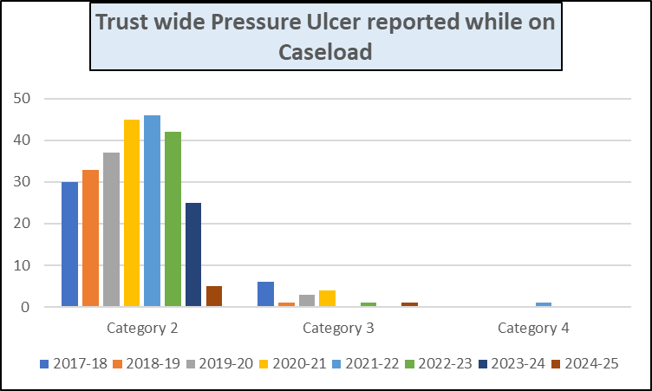

**Table 2** Shows number of Pressure Ulcers Reported per year (2017-2025)

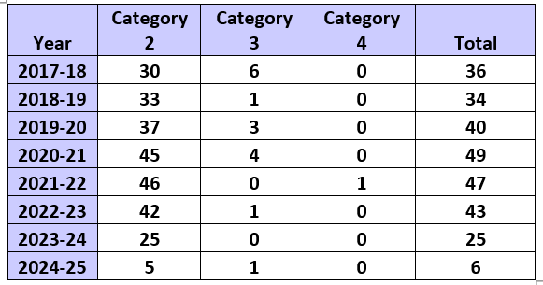

**Table 3 shows, Trust wide Category 2 Pressure Ulcer Incidents Reported**

The Trust's aim is to reduce the occurrence of Category 2 pressure ulcers, with particular focus on those related to medical devices. To achieve this goal, the Tissue Viability team initiated daily ward rounds to identify early signs of skin damage and implemented prophylactic dressing under medical devices as a preventive measure.

To support this initiative, we followed the **Test of Change** methodology and employed the **Plan-Do-Study-Act (PDSA)** format to monitor and evaluate the effectiveness of the interventions.

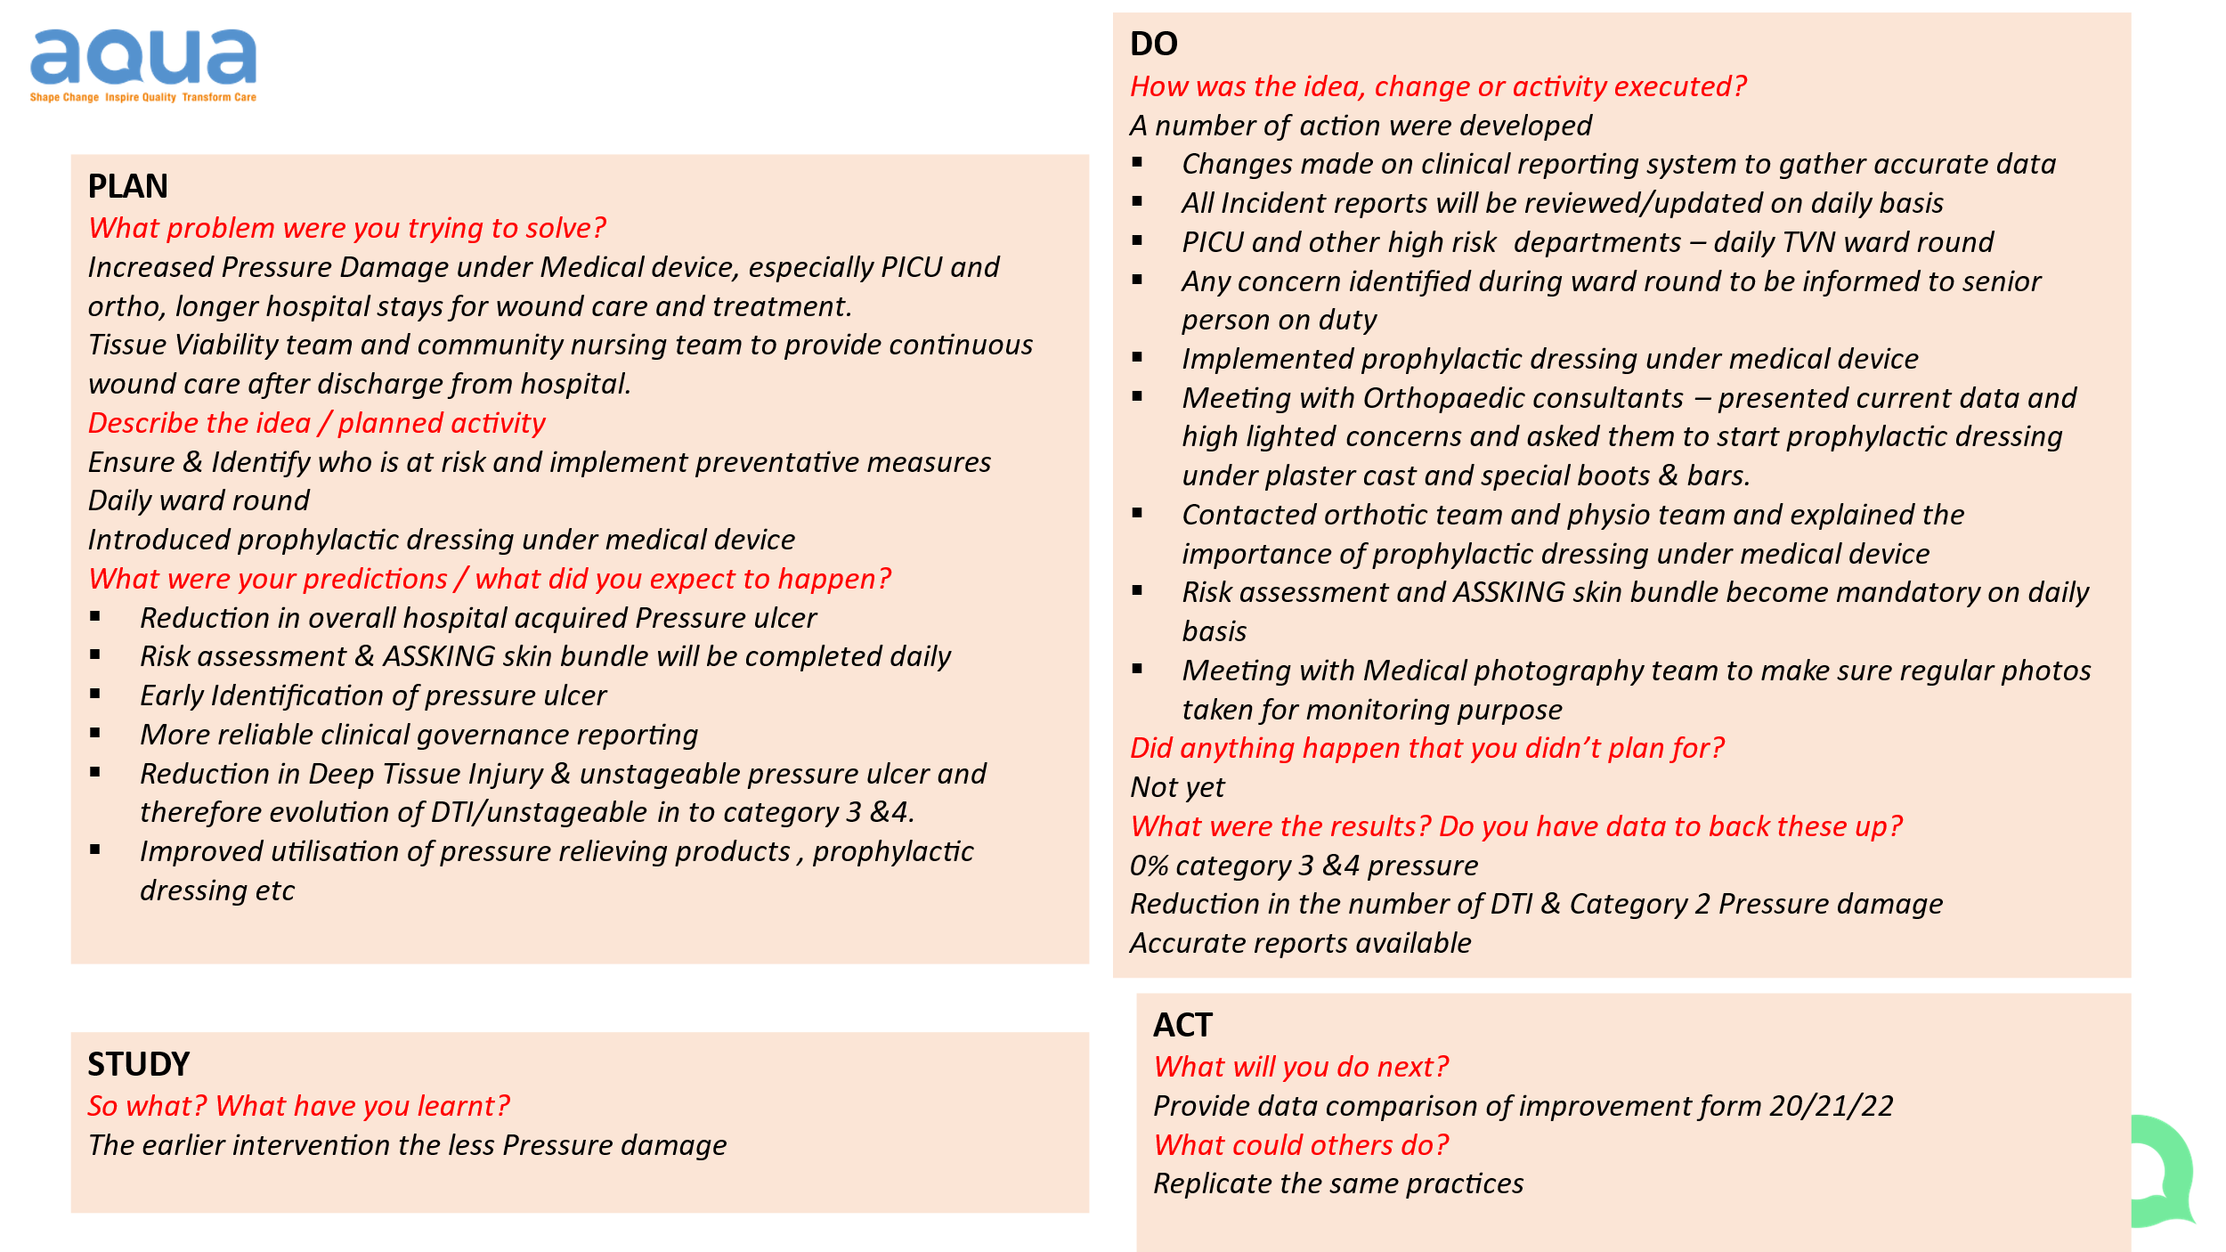

**Table 3**

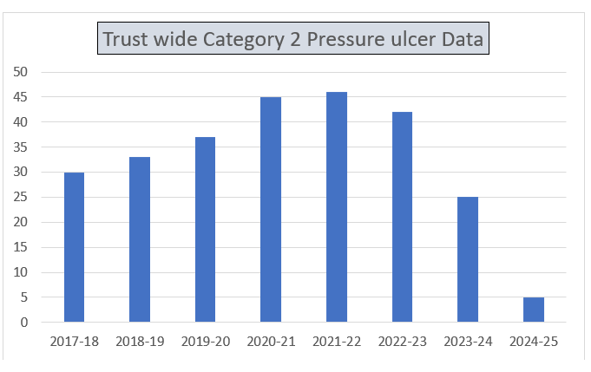

**Table 4** Monthly Report of Pressure Ulcer incidents reported for 2024-2025 across the trust.

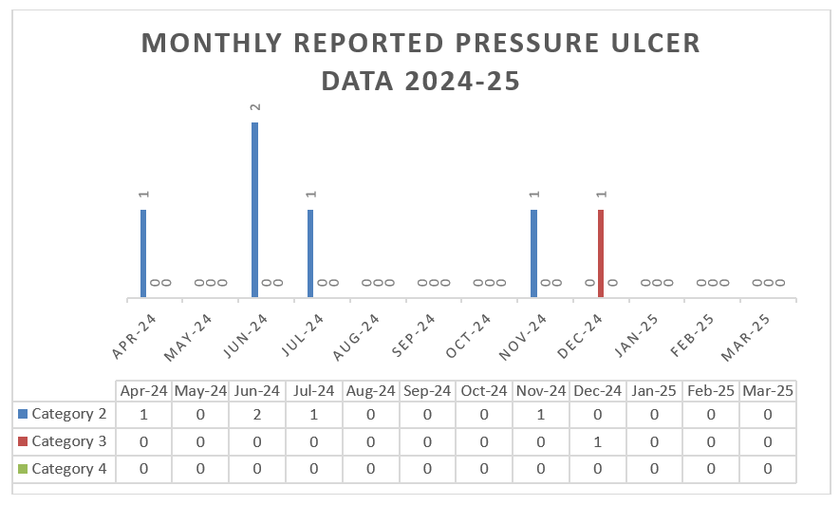

**Table 5:** 12-Month Tissue Viability Audit Scores for the Full Trust, Including Community Settings

The Trust expects that the Braden Q Risk Assessment and ASSKING Skin Bundle be completed within six hours of patient admission. This will be captured through the Tissue Viability audit.

Any ward that fails to complete the risk assessment within the required six-hour timeframe or does not update the assessment based on the patient’s clinical changes will be reported to the ward managers for corrective action. These cases will also be discussed in the monthly at the Tissue Viability Link Nurses meeting.

Tissue Viability Monthly Documentation Audit 2024-2025: **Overall Compliance – 95%**

**Table 5**

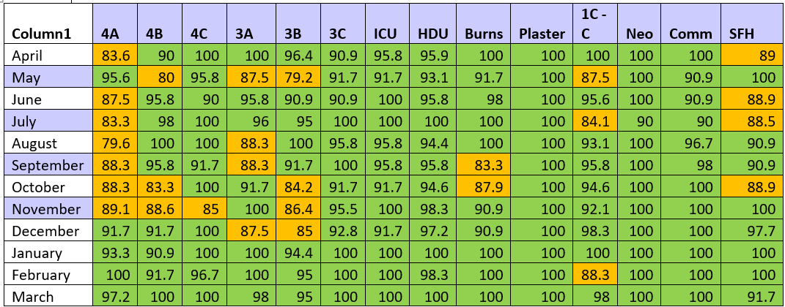

**Improvements & Achievements**

* **The data highlights** the continued success in maintaining a 0% rate of Category 4 pressure ulcers and 0% rate of Category 3 preventable pressure ulcers in the Trust. This is a significant achievement in our efforts to reduce preventable pressure ulcers.
* An impressive 84% reduction in Category 2 pressure ulcers. This reduction can be attributed to several key factors, including increased awareness and improved education across the Trust. As a result, there has been a notable increase in pressure ulcer reporting across various departments. All clinical areas, including community services, physiotherapy, and outpatient departments, have now adopted consistent reporting of any pressure injuries, particularly those related to medical devices. This comprehensive reporting reflects a stronger culture of vigilance and accountability within the Trust.
* A Trust-wide initiative was implemented, introducing daily Tissue Viability ward rounds. This has been a crucial measure in preventing wound deterioration, reducing deep tissue damage, and minimising the occurrence of Category 2 pressure ulcers, particularly in high-risk units. These ward rounds have significantly enhanced the early identification of skin damage, allowing for prompt and effective interventions to prevent further deterioration.
* Tissue Viability Clinic Expansion to offer afternoon appointments, increasing its capacity and ensuring more timely wound care. This extension is designed to support both inpatient and outpatient care. For example, patients who are clinically fit for discharge can now be discharged on time and referred to the Tissue Viability Clinic for ongoing wound review. This approach reduces the need for prolonged hospital stays for wound management, enhances discharge efficiency, and supports a smoother transition to community care. Additionally, any concerns identified during clinic visits are immediately communicated to the surgical team, who can organise a follow-up appointment during their next clinical visit.

By offering this specialised clinic, the Trust expects a reduction in wound infections, wound dehiscence (surgical complication), and associated complications, ultimately leading to reduced hospital stays and associated treatment costs. Early interventions also contribute to fewer long-term wound care needs.

* **Educational Initiatives:** The Tissue Viability service has actively contributed to the education of both internal and external healthcare professionals. Notably, **an abstract on the use of prophylactic dressings under medical devices was presented at the Wound Care UK** Conference, showcasing the positive impact of this strategy on pressure ulcer prevention.
* Throughout the year, the Tissue Viability team has facilitated ongoing wound care workshops. These workshops also include competency assessments for staff, ensuring that all healthcare providers are equipped with the latest knowledge and skills in wound management.
* Organised a Paediatric Wound Care Study Day, which saw over 100 attendees from across the UK. This event served as a valuable training opportunity for both internal and external staff, strengthening expertise in paediatric wound care.
* **Surgical Site Surveillance and Support**: The Tissue Viability service plays an integral role in the surgical site surveillance pathway. We ensure timely wound care and wound reviews for surgical patients, which is critical in preventing surgical site infections. This proactive approach has improved patient outcomes and streamlines wound management in surgical settings.
* **Expansion of Tissue Viability Staffing** to include four full-time staff members, ensuring we have the capacity to support the growing demands of wound care across the Trust.
* **Trust-Wide Implementation of Specialised Air Mattresses** across all relevant clinical areas to prevent pressure injuries. This initiative has proven to be both **clinically effective** in reducing the incidence of pressure ulcers and **cost-effective** in the long term by minimising the need for more intensive wound care and reducing hospital stay durations related to pressure injuries.
* **Standardised Training and Guidelines Implementation for TED Stocking Application, Removal, and Skin Assessment**: This initiative aims to:
  + Standardise the process for the correct application and removal of TED stockings across all staff members.
  + Ensure adherence to best practices for skin assessment before, during, and after the use of TED stockings to prevent skin damage and other complications.
  + Provide staff with the necessary tools, knowledge, and protocols to monitor and maintain patient safety and comfort when using TED stockings.

**Future goals and plans for 2025/26**

* **Preventing and Minimising Pressure Ulcers (Category 2-4):** Our continued focus will be on **preventing and minimising the occurrence of preventable pressure ulcers**, particularly in **Category 2-4**.
* **Establishment of a Centralised Hub for Specialised Dressings:** We aim to create a **centralised hub station** for specialised wound care dressings. This will streamline the distribution process, ensuring that **clinically appropriate dressings** are always available for patients when needed. This approach will also enhance **cost-effectiveness** by reducing wastage and optimising the use of resources across the Trust.
* **Introduction of a Minimal Skin Assessment Form for Non-Inpatient Areas:** To improve the identification and management of skin issues in **non-inpatient settings** (e.g., Day Case, SDC, SAL, etc.), we plan to implement a **minimal skin assessment form**. This form will help standardise skin assessments in these areas, ensuring early detection of potential issues and allowing for timely intervention.
* **Negative Pressure Therapy Training for Junior Doctors:** Recognising that **junior doctors** are responsible for managing negative pressure wound therapy during weekends, we propose providing specialised training in **Negative Pressure Therapy.** This training will enhance their ability to manage complex wounds, reduce complications such as wound dehiscence, and promote more effective wound healing.
* **Tissue Viability Audit Compliance Target of 90% and Above:** We will set a Tissue Viability audit compliance target of 90% and above for the next financial year. Continued focus on improving audit completion and adherence to best practices will help ensure consistent delivery of high-quality care across the Trust.

**Priority 2. Access to Care**

**Urgent & Emergency Care**

In urgent and emergency care, our Emergency Department (ED) served 68,900 children and young people, which is 113% of the attendance levels recorded in 2019/20 before the pandemic. Despite this increase in numbers, 82.7% of children and young people who came to our Emergency Department were either admitted, transferred, or discharged within four hours, successfully meeting the national target of 78%. The average time for ambulance handovers was 24 minutes, and we are actively collaborating with NWAS to improve this further.

**Elective Care**

Diagnostic performance has improved throughout the year with 96% of children and young people waiting under 6 weeks for a diagnostic test.

The Trust has successfully reduced its elective care waiting list by 13%, which has decreased the time it takes for children and young people to access care. Additionally, the number of children and young people waiting over a year for treatment has dropped by 70%. Furthermore, in CAMHS, there are currently no children waiting more than 52 weeks for care.

**Follow up Care**

We have successfully managed over 11,000 long wait follow-up appointments, reducing the total from a peak of 6,000 in July down to 3,000.

**3.2.2.2. Improving Outpatient Care**

Improving access and experience in the Outpatient Service has continued to be a high priority to Alder Hey, with over 389,000 outpatient appointments and over 70,500 digital appointments have taken place in 2024/2025.

Alder Hey delivered an Outpatient Transformation Programme in 2024/25 which focussed on three main areas of improvement – digital Innovations, improvements to the physical clinic room space in Outpatients and improvements to the environment and experience for children, young people and families attending the department.

Improvements made in 2024/25 include:

* Completion of the redevelopment of the Fracture clinic service, providing increased clinic space and improved facilities.
* Improved access and utilisation of clinic rooms across the Alder Hey hospital site and in community clinic settings.
* Expansion of phlebotomy resources / information on the Trust website for children, young people and their families and carers.
* Dedicated steering group to optimise patient journey within the department.
* Sensory Environment Project undertaken with the Alder Hey Youth Forum, the Chameleons and Sefton Parent Carer Forum. This included a video being produced and additional sensory equipment for children and young people coming to the Outpatient Department.
* Working towards National Autistic Society accreditation for the Catkin Building.
* Digital automation of routine admin processes within the service, with the aim of releasing staff time to provide a more personalised service.
* Implementation of a play programme – e.g. magician / readers / crafts within waiting areas.
* Relocation of GP phlebotomy from main Outpatients to the Catkin Building, including set-up of a weekly phlebotomy clinic in Southport, as a step closer to delivering paediatric phlebotomy services in the community.

**Priority 3. Great place to work – Staff Survey**

**Focus:** 85% of staff recommend Alder Hey as a place to work.

In 2024, the Trust achieved a response rate of 62% with 2,696 staff completing the NHS Staff Survey questionnaire, an increase from 60% in 2023.

73.96% of Staff responded that they would recommend Alder Hey as a place to work and 89.59% as a place for friends and family to receive care. Both results showing an improvement from 2023 with the latter response once again being the top score in our comparator group of 122 Acute and Community Trusts.

2024/25 has seen excellent results for Alder Hey with improvements across all the people promises and themes compared to 2023 results. Whilst our comparator group scores have remained largely static, with average scores decreasing in 3 of the 7 people promise themes, we have scored higher than average in our comparator group, including a best-in-class score for the people promise ‘We are compassionate and Inclusive’.

In addition, we have maintained or improved in 19 out of the 21 sub-scores and scored above average in our comparator group for 20 out of 21 sub-scores, again scoring just below average for our appraisals despite improvement year on year.

As well as being ranked top in our comparator group for the people promise of ‘We are compassionate and inclusive’, Alder Hey ranked top of the comparator group for the sub-scores ‘Raising Concerns’ and ‘Negative Experiences’ as well as for 15 individual questions including:

* Care of patients / service users is my organisation’s top priority.
* My organisation acts on concerns raised by patients / service users.
* When errors, near misses or incidents are reported, my organisation takes action to ensure that they do not happen again.

The table below provides an overview of our results across the seven key NHS People Promises and the additional themes of staff engagement and morale over the last three years highlighting our consistent improvement in all areas.

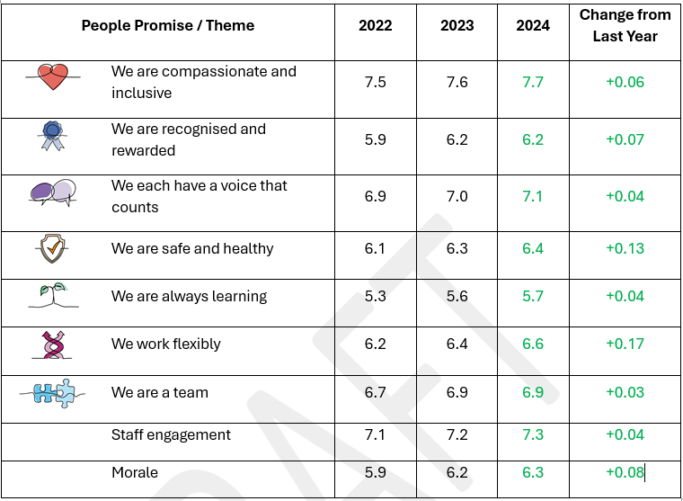

As in previous years, the overall Trust results are reviewed at Trust Board and shared with staff across the organisation. As well as the Trust level results, we also have a comprehensive feedback plan to ensure that each eligible team and department receive their own local data from the Staff Survey to discuss together in a ‘Big Conversation’. This is their chance to discuss their own local results and agree local actions they can take to improve their own experience of working within the team.

**Areas for improvement**

There are clearly many positive results from the Staff Survey, and we have shared and celebratedour results across the Trust and with individual Teams and Divisions.

However, there are also areas for improvement. Despite a consistent improvement over the last few years in staff opinion of the appraisal process, there is still work to be done around further improving the link between the appraisal conversation and the practical impact this has on staff performance in their role. To address this, a new appraisal process has been designed and will be implemented in April 2025.

Whilst we have seen results that indicate staff experiencing discrimination overall has decreased, including best-in-class results around staff not experiencing discrimination from the public, when staff are indicating that they have experienced discrimination this year’s data shows that this is more likely to be on the grounds of ethnicity. We will be working closely with our Race, Ethnicity and Cultural Heritage (REACH) network to identify how the Trust can address this over the next 12 months.

In addition, a continued area of focus for 2025/26 will be on improving the consistency of experience for our staff across the Trust. It is clear from our results that there is variability in experience across our divisions and staff groups which we need to understand and address.

To ensure that we see improvements across the above areas and others, a Staff Survey Action Group has been launched with key stakeholders from across the Trust.

**Future priorities and targets 2025/26**

* increasing how many staff take the opportunity to use their voice and complete the survey, giving us a more complete picture of staff experience across the Trust.
* We will continue to strive for an improvement in all our results,
* We will focus on improving the number of staff who recommend Alder Hey as a place to work, against a target of 85%.

**Priority 4. Advocate for Children and young people**

**Focus:** Improve access and advocate for children and young people (CYP) in the wider system through working with partners.

At Alder Hey, we recognise and act on our role as an advocate for the wellbeing and health of our children and young people (CYP).  It is our ambition to positively impact social value and lead others to do so, to enhance the well-being and life chances of CYP and make a positive contribution to our local economy and community. The Trust’s continued commitment to advocate for CYP is outlined below with some recent examples.

* Continued hosting the Beyond Cheshire and Merseyside (C&M) Children, Young Person (CYP) Transformation Programme on behalf of the Cheshire and Merseyside Integrated Care System (ICS) embedding and ensuring CYP voice and transformation is prioritised in our system.
* Supported the Alder Hey Children’s Charity ‘Put Children First’ campaign, working with government to develop a ‘children’s NHS’ that seeks to reduce health inequality and sustain an NHS fit for the future.
* With Liverpool City Region we hosted partners across Cheshire & Merseyside to agree our collective role to go further faster on neighbourhood health, for children, young people, and families.
* Responded to the NHS Change consultation to inform the new 10 Year Health Plan. Our response represented the views of CYP and Alder Hey staff, including calls for a CYP commissioning framework and cross-departmental population health strategy to ensure CYP remain a priority for this government.
* Advised ongoing national CYP transformation and policy development at NHSE, supporting an engagement event with national partners on government’s three proposed transformation areas to inform 10 Year Plan development.
* Continued partnership as part of the Children’s Hospital Alliance network of specialist NHS trusts working together to improve the quality, access and experience of hospital care for children and families.

**Priority 5. The Safest Place**

**Promoting Safety and Quality at Alder Hey Children’s Hospital**

Alder Hey Innovation continues to drive forward a culture of safety and quality through the development, evaluation, and implementation of cutting-edge health technologies. Leveraging a state-of-the-art health technology development facility and a multidisciplinary team, our innovations support safer, more efficient, and more patient-centred care across the Trust.

**Innovation Pipeline**

In 2024/25, Alder Hey’s innovation responded to **84** challenges submitted by clinical teams and services. This resulted in **5** projects progressing to the active build stage and **2** being piloted within the same year. This agile, demand-led pipeline ensures that frontline staff are supported to identify, escalate, and resolve patient safety issues efficiently. The service continues to be recognised as a national exemplar in NHS innovation.

**Little Hearts at Home – Digital Platforms Work Stream**

The *Little Hearts at Home* platform, co-developed with community nursing teams, empowers nurses to capture patient observations from home and alerts clinicians if readings breach red flag parameters. A clinician dashboard enables ongoing monitoring of trends over time.

In 2024/25, the platform supported **126 patients**, with **47 currently active**.

* Early success has drawn national interest, with **Newcastle due to begin piloting** by the end of April 2025.
* New development work is underway on a **clinical pathway for HSP/IgA Vasculitis** and a **parental access portal**, ensuring the platform evolves to meet patient and family needs.
* Further data is being gathered to measure the impact on unplanned admissions and emergency contacts.

**Robotic Process Automation**

Building on previous success, Alder Hey has significantly expanded its robotic process automation capability to streamline administrative workflows and improve data accuracy.

* In 2024/25, 8 new automations were created, building on the 17 from the previous year.
* To date, over **134,000** patient records have been updated, saving in excess of **20,000 hours** of manual input time.
* New areas of automation are being explored within Booking & Scheduling, Community and Access to Records.
* Automation team built a yearlong priority back log (Agile Framework) which creates a shared, transparent view to focus on Trust needs and have created a dashboard to track and publish benefits.

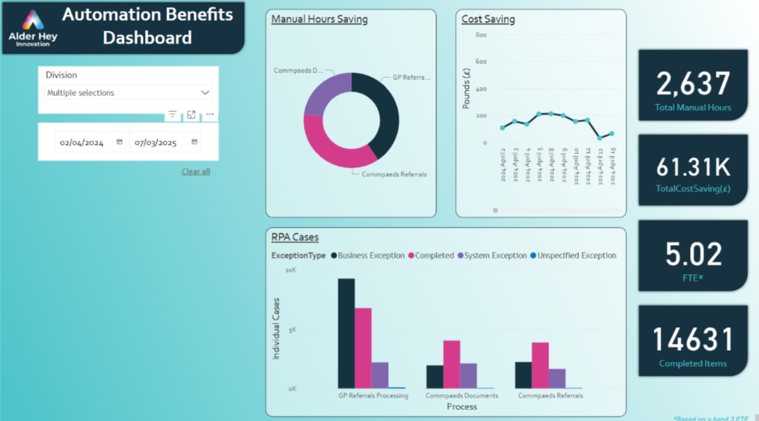

**Isla Care – Remote Wound Monitoring**

This secure digital platform enables families and clinicians to upload and review photos, videos, and audio to monitor wound healing remotely.

In 2024/25 AI capability to automatically request images was enhanced based on patients’ information in referral notes, which reduced clinician administration time and increased time to diagnosis.

**T2Tx**

T2tx is a groundbreaking software platform designed to transform the management of childhood systemic lupus erythematosus (cSLE), enabling personalised disease monitoring, proactive care, and improved patient outcomes through collaboration between clinicians, patients, and families.

**Anticipated Benefits for Patients and Families:**

The impact of T2Tx could be transformative for children living with cSLE:

* Improved Outcomes: Proactive disease management may lower the risk of severe organ damage.
* Reduced Hospital Admissions: Better monitoring and intervention reduce the need for emergency care.
* Enhanced Quality of Life: Patients and families benefit from a more structured, transparent, and supportive care journey.

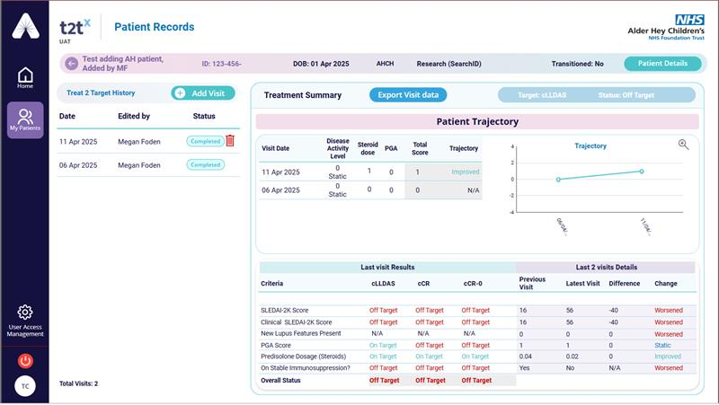

**Speech Path**

Speech Path is an innovative digital platform designed to transform the at-home speech therapy experience for children with a Cleft Palate. By combining gamified exercises, personalised therapy plans, and guided support, Speech Path fosters consistent practice, improved speech outcomes, and stronger collaboration between families and clinicians.

By making therapy interactive and accessible, Speech Path aims to:

* Increase children’s engagement with therapy.
* Improve speech outcomes through consistent practice.
* Empower parents with tools to support their child’s progress.
* Reduce clinic dependency, freeing Speech and Language Therapists (SLTs) to focus on new cases and complex challenges.

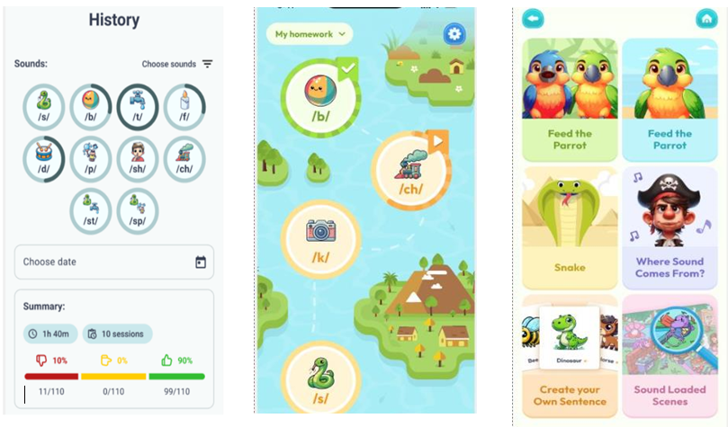

**Plans for Further Improvement in 2025/26**

* **Scale and Spread**: Expand the *Little Hearts at Home* platform across additional conditions and partner hospitals across the Congenital Heart Network.
* **AI & Automation**: Broaden the use of robotic process automation into patient-facing and clinical safety tasks, particularly around safeguarding alerts, clinical audit, and medication reconciliation.
* **Integrated Digital Pathways**: Complete development of new pathways in remote monitoring (e.g., HSP/IgA Vasculitis) and ensure real-world implementation and evaluation.
* **Impact Evaluation**: Strengthen our data infrastructure to better capture and analyse the safety, experience, and efficiency impacts of innovation across the Trust.

Alder Hey remains committed to being the safest place for children and young people. Through strategic investment in innovation, we aim not only to address today’s challenges but also to proactively shape safer systems of care for tomorrow.



**3.3.12. Championing Health, Wellbeing and Engagement**

Alder Hey continues to implement a cohesive organisational approach to supporting health and wellbeing. Interventions that lead to positive outcomes for employee wellbeing are those where health care staff have options within a whole-system approach (NHS Employers, 2025). This includes a focus on the whole employment experience such as workload, autonomy, employee voice and management processes.

Our award-winning approach has been recognised for its excellence and innovation with national and global health awards over the past four years and our diverse range of options continues to adapt and develop to the post-pandemic operational context. There are various challenges facing the NHS, including financial issues, patient care backlogs, healthcare inequalities, and meeting the needs of a rising population with complex health needs (Khan, 2023), which are exacerbated by health inequalities in our local region. This contributes to a vicious cycle of mounting pressures on existing staff which exacerbate difficulties around staff wellbeing and retention (BMA, 2024).

Effective delivery of NHS services relies on a safe and well workforce. Data published by NHS Digital reveal a steady increase in sickness absence rates, which surged during the pandemic and have remained elevated compared to pre-pandemic levels (Majeed, 2024). The Trust continues to support a workforce affected by complex and acute mental health difficulties. Mental illness accounts for 8%–12% of sickness absence each year in the UK labour force, compared with around 25% per year in the NHS workforce (Majeed, 2024).

Burnout levels remain high and whilst showing some improvement, the percentage of staff reporting being unwell because of work-related stress remains high at 41% in the 2024 national staff survey. In our local NHS staff survey, this trend was mirrored with 51.83% reporting coming to work despite not feeling well enough to perform duties and 26.83% of staff reporting feeling burnt out.

An organisational health and wellbeing approach

Our approach to staff support at Alder Hey is closely informed by an evidence base regarding what works, for whom, and in what context. Initiatives need to integrate the dual responsibility of individuals and their employing organisations to stay well. A recent review of employee wellbeing found that individual-level interventions that do not engage with working conditions are less effective (Fleming, 2024). Rapid access to support within an organisational context is more effective, and offers a clear return on investment (LSE, 2022).

The Staff Advice & Liaison Service (SALS) and other support mechanisms in the organisation, therefore, take an organisational health and wellbeing approach in line with the NHSE Organisational Health and Wellbeing framework. The diagram below summarises our organisational offers in line with this framework with supporting information relating to four of the key indicators.

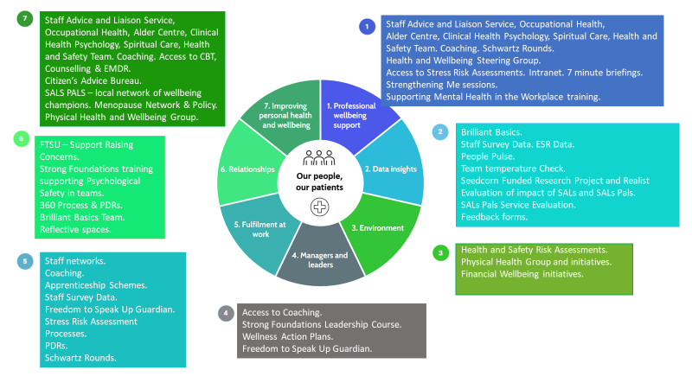

**Improving personal health & wellbeing**

Staff Advice and Liaison Service

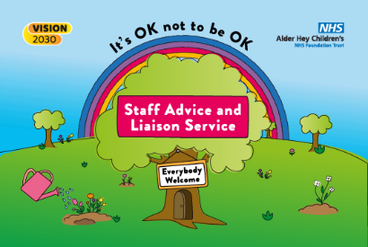The Staff Advice and Liaison Service (SALS) celebrates its fifth year at Alder Hey and continues to provide support to all staff and learners within the organisation as a one door ‘listening service’. The service acts as a hub within the organisation and has had over 15,000 contacts (approximately 3000 individual staff members) to date, representing 50% of the workforce. Feedback from staff accessing the service remains very positive with 100% of a sample surveyed saying that they would recommend the service to friends or colleagues in the organisation.

On average, the service receives 90 new referrals per month. Contact data tells us that there are an average of 346 contacts in the service per month with the service seeing staff an average of 4.5 times, indicating that the service is well used in the organisation and, crucially, that a little can go a long way when it is tailored to an individual and provided at the right time. Providing a responsive and person-centred service is key. Underpinning the model is the message that ‘It’s OK not to be OK’ and SALS aims to normalise distress, provide a positive experience of help seeking, and liaise with appropriate individuals and services to develop a network of support around an individual.

There is a focus in SALS on systemic intervention and the dual responsibility of an individual and an organisation to support their wellbeing. Considerable focus is also given to supporting staff to both transition to and navigate through services, providing a “safety net” of support during what can be extremely difficult journeys and processes. SALS organically adapt to the welfare needs of our workforce during acute and difficult times. This has included an intensive, targeted and trauma informed response to the Southport Incident.

The SALS team supported a focused response to staff directly and indirectly affected and impacted by the major incident in Southport in July 2024 which included outreach to 36 teams affected in addition to individual support for those most affected. SALS offered psychoeducation about secondary and vicarious trauma through the sharing of a trauma leaflet and attendance at Trust-wide briefings. SALS also supported the coordination of debriefs and worked closely with our Clinical Health psychology colleagues. Following the impact on the community connected to the riots, our psychologist attended the Trust wide “Safety and Support Listening Sessions” in conjunction with the REACH network, our EDI lead and Chief People Officer. We have also provided support and a safe place for colleagues affected by moral distress and moral injury whilst also supporting the organisation to gather information to inform intelligent action and a compassionate strategic response.

Proactive Prevention

Alongside support for critical incidents, SALS consistently support a whole community approach to proactively supporting health and wellbeing through a preventative approach. This included a spotlight feature and live educational sessions during Mental Health Awareness Week focussed on the global theme of “Movement”. In May 2025, we plan to arrange a month of accessible activities focused on this year’s theme: ‘Community’.

For World Suicide Prevention Day (10 September 2024) SALS worked with the global theme “Changing the Narrative on Suicide" with the call to action "Start the Conversation". The call to action encourages everyone to start the conversation on suicide and suicide prevention. Every conversation, no matter how small, contributes to a supportive and understanding organisation. Initiating these vital conversations can break down barriers, raise awareness, and create better cultures of support. A psychologist from the SALS, invited members of the Trust to a live education session featuring helpful information about suicide and mental health first aid.

SALS psychologists regularly support wellbeing activities in the Trust with the support of SALS Pals including the physical health and wellbeing day, and team wellbeing events. With support from the Charity as part of the Bright Ideas programme, SALS started a ‘Connection in your Community’ group which is underpinned by a Compassion Focused Therapy Framework and focuses on building restorative connections, enhancing people’s support networks, and reducing loneliness, which is understood as a public health issue. *The group will run monthly, exploring different locations across the campus to ensure maximum access and inclusion for all staff.*

SALS also continues to deliver the workshop ‘Strengthening Me’ which focusses on psychological models and ideas that can support health care professionals. This draws on evidence and understandings from biology, psychology, and neuroscience to support staff in staying well and feeling strong and has been designed to support the recovery of staff, alongside the recovery of services during the global pandemic. This has now been delivered to over 500 staff. In line with NICE Guidelines on Employee mental health (NG212, 2022), SALS has also developed ‘Supporting Mental Health in the Workplace’ Training available to all staff. This online training involves two modules: 1) Strengthening Me – to support individual mental health awareness, 2) Strengthening Others – to support a proactive and preventative approach to managing mental health at work in line with the principles of psychological first aid.

Working in unity

Building relationships and developing pathways are crucial to the emotional health and wellbeing of our staff. We, therefore, connect with others in the Trust to support individuals to navigate systems on their help seeking journey, and to ensure that offers feel coordinated and cohesive.

The Trust has a well-developed and active group of Professional Nurse Advocates who work closely with SALS and have all received SALS Pals Training which is a model of wellbeing champions across the Trust. SALS also work closely with our Lead for Nurse Retention and our Freedom to Speak up Guardian (FTSU) and have a pathway in place for signposting staff to both areas. SALS also work closely with our Staff Side Colleagues when needed.

SALS have also developed a pathway with community colleagues for staff with neurodiverse children who may be struggling to navigate and understand the service pathways or the implications. This new pathway has enabled staff to be able to quickly speak to an identified professional to gain insight and education around the next steps for their child, which will support our own staff staying happy and healthy in work. Similarly, a new pathway is being developed with our colleagues in the Alder Centre to offer education and guidance to support their own children at difficult times of bereavement.

As well as informal networks and support for staff, many of these groups of staff are also part of our Health andWellbeing Forum.The Forum, which meets bi-monthly brings colleagues together with other stakeholders to present, share and discuss information and staff support initiatives. Members of this group include Clinical Health Psychology, The Alder Centre, Lead for Nurse Retention, Arts for Health, SALS, SALS Pals, Chaplaincy, Network Leads, and interested and committed colleagues from across the organisation who then cascade information to their services and teams. Outputs of the Forum include the development of a Supporting Staff Community Resource Pack and support for the ‘Create, Revive and Thrive’ programme which is led by the Arts for Health Team and includes art classes for staff to attend. In the first year of this programme, 92 members of staff participated and this year the team plan to extend this further.

Financial Wellbeing

A range of options are still in place for our staff to support with the overall cost of living crisis that began over a year ago. Some of our initiatives include cheaper food options at our restaurant, our Pay it Forward Scheme, which has been very well received by our staff, access to Wage stream which is an app that facilitates flexible access to wages, offering benefits like reducing financial worries and potentially increased retention. We work closely with Barclays bank who attend site once a month and offer mortgage advice clinics for our staff to attend. We have retained our partnership with Liverpool Citizens Advice (CA) for our staff to use, with staff accessing the service to gain advice and support. Feedback from the CA suggest our workforce utilise the service for specialist support on parenting advice, domestic abuse, debt, benefits advice and visa support. SALS recently renegotiated our CA contract to ensure we are getting the best value for money from the service, and SALS now pay per referral rather than per month. SALS have also continued with our ‘Sway’ leaflet with up-to-date financial offers externally to support staff to access and benefit from local offers of financial support. Since this pathway was developed, 95 individual members of staff have accessed this service, and feedback has been uniformly positive. Staff have also further benefitted from the continuation of the Charity-funded period poverty intervention, where staff, families and visitors in need can access free sanitary products on site.

Physical Health

Outputs from our growing physical health group include fresh fruit and vegetables available once a week via a community projected called Queen of the Greens; development of physical exercise groups; and sign up for the third year in succession to the NHS Games. The group has also developed a ‘SWAY’ leaflet which can signpost staff to national, local and community-based activity to support with their physical and holistic health and wellbeing. There was also a dedicated day to physical health which focused on offering blood pressure checks and reintroducing some exercises classes. Feedback from attendees showed that the most popular activity was the general health check, which included a blood pressure and BMI checks.

The menopause support group continues to be active and now has 200 members. The group has trialled menopause ‘Walk and Talks’ in Springfield Park to support utilisation of our community space and encourage physical activity and access to nature. The group are currently exploring inviting more guest speakers and experts to the group to be able to offer our staff more targeted advice. The menopause policy has been live now for nearly 12 months and a great source of information for both managers and staff across the organisation.

Professional wellbeing support

SALS work as part of a wider community of stakeholders supporting professional wellbeing support. This includes, our HR colleagues, the Organisational Development team, FTSU Champions, Occupational Health, and Clinical Health Psychology colleagues. The SALS team also work closely with our communication team to share relevant information and have provided a revised and updated intranet as a base to signpost colleagues. SALS contributes to a ‘Thriving Teams’ MDT to support team functioning and offer bespoke sessions to teams to support the development of professional wellbeing. Team level interventions have demonstrated improvements on the team temperature check and the staff survey and case studies have been presented to Board to share learning.

In terms of professional health and wellbeing and development, staff have also been able to access growing internal coaching and mentoring. We have enhanced our coaching offer with coaches across specialities and disciplines offering a mixture of wellbeing and more general coaching to colleagues. Our Strong Foundations Leadership course is going from strength to strength and is now booked into cohort 43. To date over 800 staff have accessed our Strong Foundations course, and we currently have over 100 staff waiting to access the programme.

We continue to provide 7-minute briefings covering seven key points in seven minutes on topics including ‘Kindness’ to target and support civility at work, and ‘Moral Injury’ and ‘Stress’ which has been shared with colleagues and distributed in live briefings, in for example in the Emergency Department Wellbeing Week in 2025.

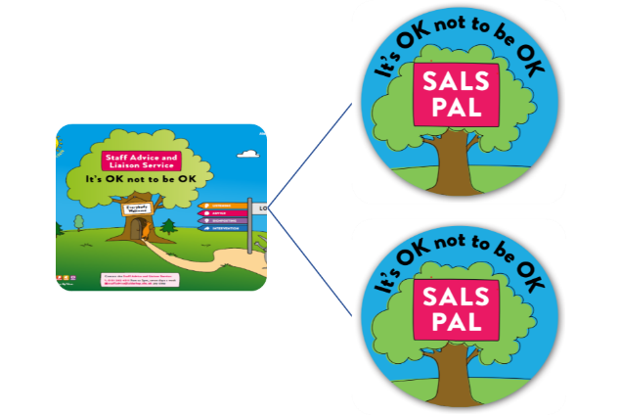Induction processes have been renewed and enhanced with a new policy waiting to be ratified which includes Health and Wellbeing conversations at Induction. This is alongside the training which supports Health and Wellbeing conversations as part of their routine PDR. A newly formed group is looking at enhanced offers to staff for their induction, with the aim that staff are well informed and clear on the Trust Strategy and priorities and how they can seek support and help in their first 100 days. Some of these initiatives include tours around the hospital and market stalls as part of the extended induction process.

We have also supported an increase in trained facilitators to run Schwartz Rounds, providing staff with safe spaces to process and reflect on the emotional impact of work. Alder Hey has recently relaunched face to face rounds and is currently piloting hybrid rounds, running 3 hybrid rounds in the last 3 months. Themes reflect the focus for the organisation and have refocused more directly on patient care including ‘A shift that made my day’, ‘A Patient I will never forget’, and ‘The Power of Community’. Feedback highlights the forum is a beneficial space in normalising distress and unifying colleagues, with 100% of people recommending Schwartz to colleagues.

Relationships

There are several networks now available to staff to help form relationships and foster belonging. These include: the Race Ethnicity and Cultural Heritage (REACH) Staff Network; Lesbian, Gay, Bisexual, Transgender, Transsexuals, Queer, Questioning, Intersex, Asexual, Agender + (LGBTQIA+) Staff Network; Ability Celebrate Educate (ACE) Network, and the Armed forces network.

After the completion of the two-year project funded by NHSE to pilot a model of paid wellbeing champions, our SALS Pals programme has now been rolled out across the organisation. We now have 110 SALS Pals who are trained to provide a listening ear in their department and to offer compassionate conversations. This hub and spoke model supports an organisation-wide approach focusing on improving connection & communication, with the aim of minimising distress & maximising trust.

In the last year, we have built on learning from the pilot to develop guidance around the most effective implementation of SALS Pals within existing service budgets. This guidance has been designed for individuals and the organisation to ensure there is governance and quality in the delivery of SALS Pals. Two teams from the original pilot have continued funding SALS Pals through their own departmental budget: Emergency Department and the Speech and Language Therapy Team. We are closely monitoring activity now that additional funding has been withdrawn across the Trust, and we continue to review sustainability.

Data Insights

We continue to work on innovative ways to understand staff experience, wellbeing and team functioning to supplement the intelligence that we gather from our annual Staff Survey. To support the evaluation of our interventions within teams, we have developed an innovative “Working Safe & Well” team temperature check. This tool assesses levels of engagement, burnout, wellbeing, psychological safety and patient safety culture. The tool is being used by the Organisational Development team to evaluate changes in team culture and has been shared with our Brilliant Basics colleagues. We are also in the final stages of development of another innovative tool called the “Thriving Staff Index”. This will be our first measure of staff thriving in the organisation and will support us to further understand how staff are functioning in both their working and non-working lives. The tool will support staff to reflect and “check-in” on themselves and will offer support and guidance to empower them to stay well, prevent suffering and access help if needed. We also plan to develop a “Thriving Teams Index” this year which will give us more intelligence about team functioning across a range of indicators and can be triangulated with other key performance and quality indicators. This problem-sensing approach to team functioning will help us to intervene quickly where teams are struggling or suffering, prevent difficulties from arising or worsening, and share learning from teams who are thriving.

Outcomes and Impacts

Our organisational health and wellbeing offer, along with our work on supporting and developing managers and leaders, and wider work on improving employee policies and processes, has had an impact on staff retention rates, employee engagement, and sickness absence. The proportion of staff absent from work due to mental health reasons continues to decline, from 2.2% in April 2023 to 1.9% in April 2025.

Thanks to a Seedcorn Research fund made available through our Clinical Research Division and Alder Hey Charity, SALS have recently completed a realist evaluation, which is a method of assessing the effectiveness of interventions by exploring underlying mechanisms that explain how and why they work, for whom, and in what circumstances, to understand further how the service impacts staff and the organisation. The study evaluated how SALS is being used, explored the impact of the service and integrated insights to develop models of staff support. These models focus on the ingredients of change with the intention to share this learning. The project included an audit of SALS data over the past five years and an in-depth analysis of existing contacts to the service. Key findings are summarised below:

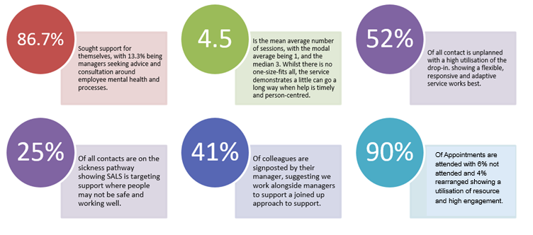

The main reason for contacting the service was for workplace issues, followed by mental ill health. As part of the realist evaluation, 32 qualitative interviews were undertaken with staff members to build a model of what works, for whom and why. A summary of these findings is presented in the figure below:

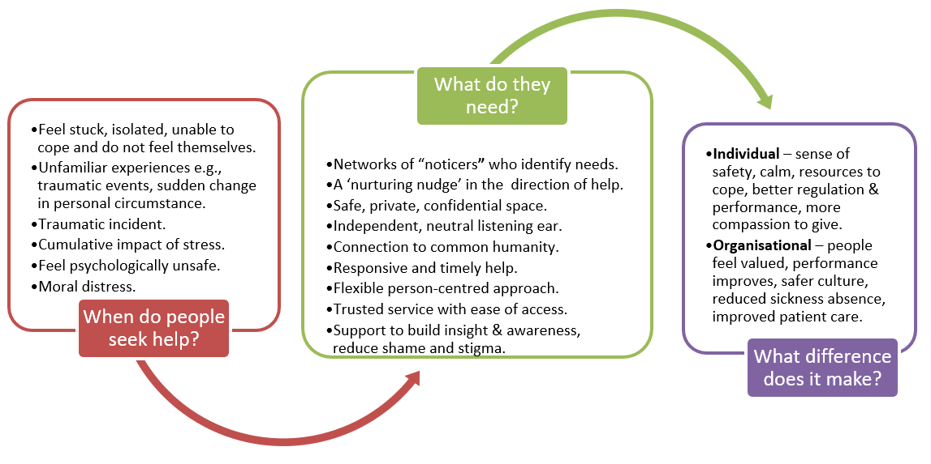

Further insights were gained from the qualitative data demonstrating the impact of the service:

“It's supported my resilience and allowed me to really think, encourage me and supporting me to think deeply about what was happening” (Matron).

“I felt like even what I’d learnt about what was happening with me, even without using any of the tools, just learning about what was happening with me physically helped me deal with it better.” (Clinical manager).

“These last two sessions 100% stopped me from going off sick, because other(s) that it's happened to have had, like months off work” (Physician Associate).

“So, in that time you’re off sick, which is then a cycle, you’re on anti-depressants which is another cycle. So, I'm proud enough to say that through working here that I've accessed this, and I've needed no sickness and no antidepressants. And I feel great” (Domestic).

“Just talking to her just gave me that springboards to kind of, you know, go right. OK. Yeah. I’m going to do something to help myself. So yeah, it was brilliant. The impact was amazing” (Programme manager).

The presence of SALS was also seen to make Alder Hey more connected with improved insights into difficulties within the organisation. SALS were able to identify themes emerging from teams enabling early intervention to address challenges. This acted as a safety net and promoted a culture of openness and psychological safety. As well as this, SALS were seen as spreading kindness and promoting a message of compassion in the spaces they work within. Participants also spoke about ‘how having SALS in the organisation having made them feel more valued and cared for by Alder Hey’. Investment in staff wellbeing was seen to improve the work produced, team morale, and the quality of patient care provided.

“I feel more valued by the organisation because SALS is there” (Clinical Research Nurse).

“We've got an organisation where our staff know that they've got a space in which that they can go to that they feel safe, that they feel listened to, and often that's all it is needed” (FTSU).

“I think that was really helpful that her knowledge of the organisation and what it needs to be able to do function effectively, was important” (Consultant).

“So, I think they are a really important gateway. I think they provide really valuable support, and I think it's really important that the organisation shows that we care in a way that I think is different and unique. And I think it's important that we care in an obvious way” (HR).

“Having to work with others when you're not feeling OK, it was tough. It would be the best path for me really to get myself OK, to work, to be able to contain it for the children that I was working with” (Team lead).

“And happier staff links back to that. A happier work environment which ultimately impacts patients and family experience because if you are dealing with a staff member who feels supported at work and a little culture of openness, then they are going to go above and beyond. They are going to do the job; they are going to give that patient the best experience because if they feel better within themselves, you can have less people leaving (Coordinator).

“It's rare to have that level of support … they are worth their weight in gold. Because it does make such a difference to people” (Senior biomedical scientist).

**3.3.13. Equality, Diversity and Inclusion**

## Alder Hey Children’s NHS Foundation Trust is dedicated to promoting equality, diversity, and inclusion, fostering a welcoming environment for our patients, families, visitors, and staff. We embrace a diverse workforce, acknowledging that everyone has unique backgrounds, experiences, beliefs, and perspectives. Valuing this diversity is key to our success, enabling us to provide the highest quality care to children, young people, and their families. Patient care is at the core of everything we do, reflecting Alder Hey’s values of Equality, Diversity, and Inclusion. These principles are embedded in our approach and are essential to achieving our organisational objectives. As a public sector organisation, we recognise our responsibility to create equal opportunities and champion inclusion, actively working to eliminate discrimination and build positive relationships, as outlined in the Equality Act 2010. Beyond being a legal duty, this is also the right thing to do. Alder Hey is committed to making a meaningful difference for our patients, families, and colleagues. We believe that everyone plays a role in fostering an inclusive culture, promoting a sense of belonging, and addressing inequality. We encourage and empower our people to collaborate, respect one another, value differences, and deliver the highest standard of care to children and young people.

**Progress 2024/25**

We are proud to align our efforts with national priorities to advance equality, diversity, and inclusion, tackle inequalities in our workforce, and cultivate an inclusive environment where staff feel valued, safe, supported, and inspired. Our progress would not be possible without the contributions of our staff networks and trade union representatives, who play a vital role in advocating for change, engaging colleagues, and challenging policies, practices, and behaviours. Staff involvement is essential to our success, and we will continue to encourage everyone to take part in shaping and supporting our equality, diversity, and inclusion efforts.

**Northwest BAME Assembly Anti-Racist Framework**

Racism and discrimination are key contributors to health inequalities, and Alder Hey is committed to addressing these disparities within the communities we serve. In 2023, the Northwest BAME Assembly introduced the Anti-Racist Framework—a strategic tool designed to support organisations in becoming intentionally and unapologetically anti-racist. The framework promotes the dismantling of structural racism and discrimination through collaboration, reflective practice, accountability, and decisive action. By integrating its recommended themes, deliverables, and actions into our organisational structures, policies, processes, and culture, we aim to drive meaningful change across both our workforce and service provision.

In November 2024 we co-developed an Anti-Racism Statement and Commitment with our Race Ethnicity and Cultural Heritage staff network members. This was launched at our weekly ‘Ask the Execs’ Session. Staff also took part in creating a video which highlights the meaning of being anti-racist. We continue to work towards achieving bronze status of the framework later this year.

**Staff Networks**

We strive to understand the experiences of our staff at Alder Hey, working collaboratively to ensure they feel supported, heard, and valued. Our growing staff networks continue to thrive, serving as a strong voice and a catalyst for positive change. Our growing staff networks continue to flourish and have been a welcomed support amongst our workforce:

* **The LGBTQIA+** has recently appointed a new Chair and they are continuing to work closely with the Head of EDI to support the implementation of the Navajo Charter mark recommendations in preparation for our reassessment in June 2025. The network members have also supported the Learning and Development team to create lived experience videos which will support and complement manager training. The network continues to work closely with other NHS Trusts within the region to develop plans to support Liverpool PRIDE In July. Last year we attended PRIDE and marched with other NHS Trust’s working collaboratively to ensure we were represented at PRIDE.
* **The REACH (Race, Equality and Cultural Heritage)** staff network continues to grow and make a positive impact across the organisation. The network is currently working with key stakeholders to develop a leadership programme tailored specifically for internationally educated staff. In October 2024, REACH supported a vibrant programme of events for Black History Month, including staff blogs and also a celebration event which took place in the Atrium with African dancers. They celebrated Diwali holding a Lunch & Learn session for staff explaining the meaning of Diwali to staff. It was a great session which was followed by some delicious food to celebrate the festival. The network members helped to co-develop an organisational Anti-Racism Statement and Commitment which was launched by the CEO.
* The **Armed Forces** staff network is making some exciting plans which will help provide support to armed Forces staff as well as children and young people from armed forces families. They are engaging with the local Armed Forces community and are working with local cadets to seek opportunities to work together and support our children and young people. They are planning the Remembrance service and other events throughout the year to celebrate the armed forces community. The network was awarded the Armed Forces Covenant Gold Award last year and the network chair attended a ceremony to collect the award.
* The **ACE** (Ability, Celebrate and Educate) Disabilities and Long-Term Conditions staff network recently held an engagement event in the Atrium to celebrate Neurodiversity week. It was a huge success raising awareness of neurodiversity with lots of staff making pledges to support the ACE staff network. There was also a Lunch & Learn session to raise awareness of Autism. The network members are currently working to develop a poster campaign which will launch next month. The campaign will highlight staff network member’s job roles, their disability, and how they all belong to Alder Hey. The idea of the campaign is to highlight inclusivity.

**Equality, Diversity, and Inclusion Steering Group**

The Trust Board endorsed the creation of the Equality, Diversity, and Inclusion (EDI) Steering Group in spring 2022. Chaired by a Non-Executive Director and EDI champion, the group continues to play a vital governance role, ensuring strategic alignment and oversight of all EDI-related matters.

Meeting bi-monthly, the Steering Group reviews progress against its work plan, reinforcing its responsibilities and establishing a clear reporting structure. Its membership includes Executive leaders, managers, and the chairs and deputy chairs of staff networks, who regularly provide updates and assurance on network activity. The EDI Steering Group also serves as a key forum for overseeing the development of action plans aligned with EDI frameworks, actively supporting and driving initiatives to achieve set objectives.

**National NHS Equality, Diversity, and Inclusion Improvement Plan**

We are committed to making improvements on equality, diversity, and inclusion (EDI) for our people. In support of this, we have reviewed our progress in relation to implementing the six High Impact Actions (HIA) set out in the EDI Improvement Plan which was launch in June 2023. We continue to make significant progress against each of the HIAs aligned to the Workforce Race Equality Standard (WRES), Workforce Disability Equality Standard (WDES), and the Gender Pay Gap (GPG), recommending priority areas to enable further improvement.

The six HIAs include:

* **High-impact action 1:** Chief executives, chairs and board members must have specific and measurable EDI objectives to which they will be individually and collectively accountable.
* **High-impact action 2:** Embed fair and inclusive recruitment processes and talent management strategies that target under-representation and lack of diversity.
* **High-impact action 3:** Develop and implement an improvement plan to eliminate pay gaps.
* **High-impact action 4:** Develop and implement an improvement plan to address health inequalities within the workforce.
* **High-impact action 5:** Implement a comprehensive induction, on boarding and development programme for internationally recruited staff.
* **High impact action 6:** Create an environment that eliminates the conditions in which bullying, discrimination, harassment and physical.

The Trust has undertaken a range of activities to support the implementation of the NHS EDI Improvement Plan and the 6 High Impact Actions. We have planned actions which support further progress, all of which will be monitored via the EDI Steering Group.

**Priorities for 2025/2026**

* The Trust will continue to analyse equality data to identify areas for improvement and to direct efforts toward clear, measurable objectives aligned with the National NHS Equality, Diversity, and Inclusion Improvement Plan.
* We will continue to collaborate with our equality staff networks to ensure our workforce has a meaningful voice in shaping and contributing to our plans.

Over the past 12 months, significant progress has been made, resulting in meaningful changes that positively impact both our staff and the children and young people we care for. We recognise, however, that there is still more to be done, and we remain committed to driving further improvement.

**3.3.1. Strong Foundations Leadership Programme**

Over the past year, Alder Hey has been building on its leadership development and support offer through the development of a Thriving Leaders framework. This is a key priority in our People Plan and has the aim of developing our leaders in line with the ambitions that we have set out in Vision 2030.

Building on the success of our Strong Foundations compassionate leadership programme, and responding to need in the organisation, in 2024 we launched a Strong Foundations Management Essentials programme consisting of the courses below, designed and delivered by subject matter experts across the Trust:

* Stepping into Management
* Crucial Conversations
* PDR / Appraisals
* Coaching Conversations
* Quality Improvement
* Introduction to Finance
* Introduction to Procurement
* Introduction to Risk Management
* Introduction to Human Resources
* Stress Risk Assessments
* Introduction to Equality, Diversity and Inclusion

This programme equips our leaders and managers with the more transactional leadership skills needed and provides more focussed support for example in giving and receiving feedback and inclusive practices. In 2024, over 300 staff attended these new sessions with further new topics planned for 2025.

The developing Thriving Leaders framework also encompasses our recently launched one-to-one leadership induction conversations with all new leaders who join the Trust or are promoted into their first leadership position, and our internal coaching offer which is delivered by 30 trained internal coaches.

**Strong Foundations Leadership Programme**

Our award-winning Strong Foundations compassionate leadership programme continues to be in high demand and goes from strength to strength. Crossing disciplines and service boundaries, the programme continues to develop connections between leaders so that they can form a circle of safety around the organisation and build the collective leadership capacity and skill needed to respond the changing organisational demands and context. Its focus on support, psychological safety, compassion, and connection has made it a critical part of the organisation and has a key role in developing our culture.

The course comprises three modules:

* Module 1 is about ‘Leading Me’ with a focus on self-awareness, self-management, inclusive leadership, and self-compassion.
* Module 2 shifts the focus to ‘Leading Others’ with training in building trust and psychological safety, giving and receiving feedback, improvement and quality.
* Module 3 is about ‘Developing Others’with a focus on facilitating coaching conversations.

Course content comprises a mixture of recorded presentation, information sheets, activities and video material (accessible via Moodle) with new learning and new connections supported and sustained through attendance at group sessions, at the end of each module. Approximate time commitment is 14 hours of independent learning via Moodle and 9 hours of group sessions delivered via Teams or face to face (23 hours in total).

**Outcomes and impacts**

Since the launch of the Programme in August 2019, almost 800 leaders and aspiring leaders (in 42 separate cohorts) have attended the programme. Although we have more than doubled our capacity to deliver the programme, the course is fully booked until September 2025 and we have a growing list of leaders awaiting the release of the next available in the autumn.

Our leaders consistently report feeling psychologically safe during sessions, suggesting facilitators create a safe space for healthy challenge and expression of different opinions. They also continue to benefit from more connection with each other and support often continuing their new relationships after the programme finishes. The chart below highlights feedback about the overall quality of training as well as a selection of comments from attendees.

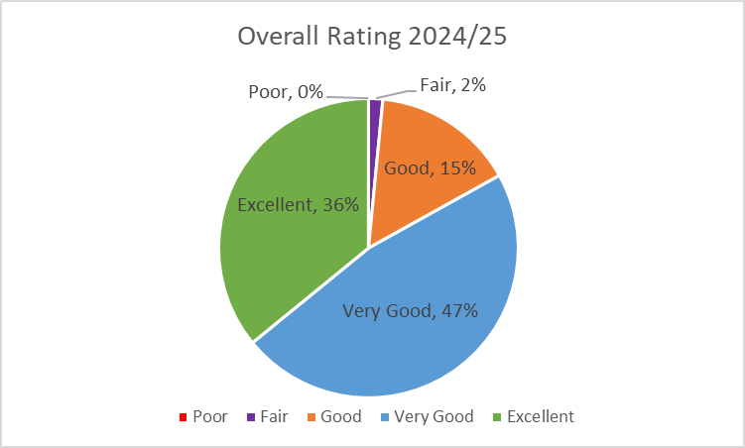

“Very interesting to understand and reflect more on self-compassion in a leadership role as well as learning skills to ensure avoiding burnout and promoting staff independence where appropriate.”

“I think for my own personal challenges the human kindness module was the most helpful. I also found the What's in a Name and Approaching Discomfort sessions very helpful because they gave me insight into how I can speak more supportively into situations rather than not saying anything because I don't know what to say.”

“Hearing other perspectives and using that to be able to reflect on my own experiences and how moving forward I can lead myself and others more positively.”

*“*Radical candour & asking for critical feedback, the feedback I got was so useful and opened up a two-way opportunity for this between me and my manager which we really benefited from.”

“The coaching and feedback given to me really helped to boost my confidence and has made me reflect upon how I work moving forward as a leader.”

“So much personal reflection done and positives to take forward and share with the team.”

“The opportunity to practice with our fellow colleagues was the most useful, so that we were able to give things a go in psychologically safe space.”

**Organisational impact**

The feedback gathered from participants in Strong Foundations demonstrates the value of the programme to our leaders and highlights the significance of this programme in creating a compassionate culture at Alder Hey. Indeed, in the 2024 NHS Staff Survey we achieved the highest score of anyone in our comparator group of 122 Acute and Community Trusts nationally for the people promise score “We are compassionate and inclusive”.

As well as the extremely positive feedback from attendees, we can see an impressive correlation between staff who attend the programme and retention rates with staff who complete the programme far less likely to leave the Trust within 12 months of completion. We are also able to track progression rates following attendance which shows that, on average, 10% of attendees progress to a higher band within 12 months of attendance.

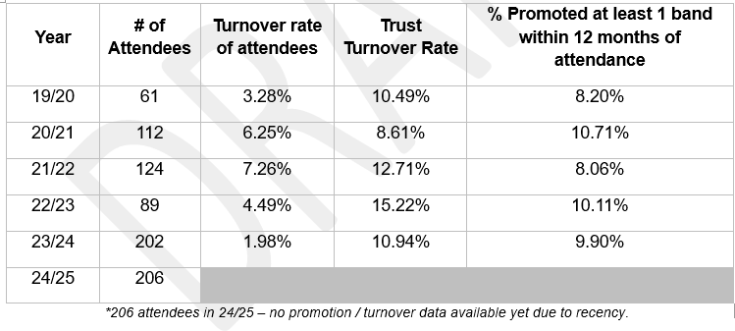

**Future Plans 2025/26**

* We will continue to expand our Thriving Leaders offer and develop a Leadership Faculty to ensure that we continue to support our leaders and managers to continually improve their ability to be effective and compassionate leaders.
* An area of focus will be Clinical Leadership following completion of a series of listening sessions with current Clinical Leaders which identified issues in how roles are designed, developed and supported.
* This group will also work closely to ensure that the Trust is aligned to and supports the implementation of the national work that is due imminently around a new Leadership and Management Framework from NHSE.

**3.3.4. Arts for Health Programme**

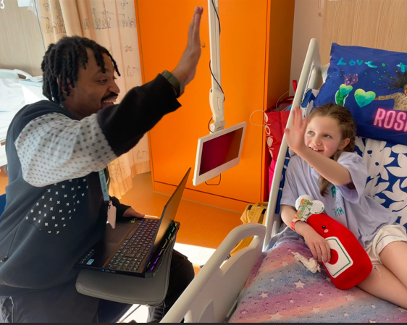During 2024/25 we have delivered an Arts Programme that delivers health benefits on the wards, high profile activities in public spaces, and productive relationships with external arts, educational and health partners. The programme comprises of participatory programme for patients and families, an environmental arts programme to enhance the buildings, and a live arts programme in clinical and public spaces. Activity supports children and young people (C&YP) in all areas of the hospital: in-patient wards, day units and clinics, emergency department, outpatients, Liverpool and Sefton CAMHS, the Gender Services Unit in Warrington and Sunflower House mental health in-patient unit. Activities take place in both the hospital, community and arts settings. We work with any patient from newborn babies to young adults. In addition, the arts for health service are once again running an expansive staff arts wellbeing programme, open to all staff.

The service operates an open-door policy on the main site, working with any patient referred by the Play/nursing/teaching staff on the in-patient wards on the day. With CAMHS and EDYS, the service take referrals from clinical teams and individual sessions are set up. Children and young people take the creative lead in all interactions and sessions are individually tailored to meet patient need.

The projects are managed by the full time Arts for Health Manager and supported by the part time Arts Project Coordinator. Our professional freelance arts team cover all areas of the arts; dance, music, visual arts, photography, animation, theatre and performance, digital arts, museum collections, fashion, comics and DJing. Over the last twelve months, we have been successful in recruiting artists with greater representation from BAME, disability and neurodiverse backgrounds.

In March 2025, the Arts for Health programme was delighted to win the Health and Wellbeing Award at the Liverpool City Region Culture and Creativity Awards:

[Eleven-year-old break dancer, Alder Hey and a mural project among Liverpool City Region Culture and Creativity Award winners](https://www.liverpoolcityregion-ca.gov.uk/news/eleven-year-old-break-dancer-alder-hey-and-a-mural-project-among-liverpool-city-region-culture-and-creativity-award-winners)

[Alder Hey Arts for Health scoop award | Alder Hey Children's Charity](https://www.alderheycharity.org/alder-hey-arts-for-health-scoop-health-and-wellbeing-award/)

Alder Hey is an active member of the National Arts in Health Network, a professional body aimed at standardising arts for health practice across the UK.

All posts and programmes are funded charitably by Alder Hey Children’s Charity and external Trusts and Foundations.

The service delivers on average 180 participatory workshops every month and we will have worked with over 10,000 patients in the last 12 months. This contrasts from 8,000 patients in 2023 - 24 and represents a 25% increase.

We deliver around 25 major programmes each year. We also deliver one off events and performances in the Trust’s Performance Space; this year, we took part in The Big Draw and National Creativity and Wellbeing Week as well as an extensive programme of music by Philharmonic musicians.

There are partnerships with many leading arts organisations in the Northwest and UK through our Cultural Champions programme: these include Tate Liverpool, Liverpool Philharmonic, Everyman and Playhouse Theatres, National Museums Liverpool, Shakespeare North, Live Music Now, DadaFest, Bluecoat Display Centre, Read for Good as well as many smaller arts organisations and charities. The programme encompasses music, dance, animation, visual arts, performance and theatre, comics, animation and film making, contemporary crafts, storytelling, and photography.

Outcomes

Our patient evaluation and feedback on our participatory programme consistently demonstrates the following:

* Significantly improves confidence and emotional resilience
* Significantly reduces anxiety and depression
* Significantly reduces isolation
* Improve communication and social skills
* Teaches children and young people new skills
* Provides new cultural and creative experiences

Highlights of 2024/25

Partnership with Royal Liverpool Philharmonic Orchestra

The partnership with the Philharmonic was established earlier this year but the programme got underway fully since September. The partnership brings two of the Philharmonic musicians, Gareth Twigg (bassoon) and Rachel Jones (violin) onto the in-patient wards to create music with patients. The programme has also seen a variety of other Philharmonic musicians participate in atrium and ‘pop up’ performances across all areas of the hospital including for the Christmas Lights Switch On. Their string quartet also performed with our Staff Orchestra for Louise Shepherd’s Farewell Lunch in October 2024. There have also been sessions with the Youth Forum, who curated one of the Christmas concerts, and young people on Sunflower House. Finally, staff have also been given the opportunity to attend concerts at the Philharmonic Hall through complimentary tickets.

The programme was featured on the Charity website in November 2024: [Alder Hey and Liverpool Philharmonic | Alder Hey Children's Charity](https://www.alderheycharity.org/alder-hey-and-liverpool-philharmonic-partnership-continues-to-thrive/)

Partnership with Shakespeare North

This six-week project took place from January to March 2025 in partnership with Shakespeare North, a newly opened theatre in Prescott, Liverpool. It introduced long term patients to four elements of Hip Hop (Rap, DJ, Graffiti art, Beatboxing) and shared the fascinating similarities between this modern genre and Shakespearean Prose. The participants learnt about iambic pentameter, rhythm, and language, developing their confidence through writing and performing where possible. Sessions were held on Ward 4B, 4A, 3A, 3C and in Sunflower House. We set up a DJ station on those areas, and visiting artists from Shakespeare North travelled around the wards, working with long term patients on developing rap, exploring beatboxing and learning how to create graffiti.

The programme was featured on the Charity website in March 2025: [Alder Hey celebrate creative collaboration with Shakespeare North | Alder Hey Children's Charity](https://www.alderheycharity.org/alder-hey-celebrates-creative-collaboration-with-shakespeare-north/)

Framing our Futures Animation Programme

This was a twelve-month animation project, working with partners Twin Vision, an animation and film media charity, and our Clinical Health Psychology team. We worked with over a hundred children and young people who had long term physical health conditions and associated mental health issues, on the creation and development of an animation. The animation explores what it is like to have a long-term physical health condition and how to live with this, from the child’s perspective. Children and young people were involved in all aspects of the production, from developing characters, writing scripts, editing and voice overs. The film was premiered in our new Medi-Cinema in February 2025, attended by patients, families and staff.

The programme was featured on the Charity website in February 2025: [Children in Need fund transformative Arts for Health animation | Alder Hey Children's Charity](https://www.alderheycharity.org/children-in-need-fund-transformative-arts-for-health-animation/)

Music Matters on the Move

Music Matters on The Move commenced in September 2024 and is being delivered through a series of twice weekly music sessions on the Oncology Unit. The programme is led by two highly experienced and skilled musicians: Georgina Aasgaard, a cellist, and Hedi Pinkerfeld, a guitarist, who work in partnership with Small Things Dance Collective, an award-winning dance company, who have been delivering dance and developmental movement sessions at Alder Hey since 2006. Small Things Dance Collective are Lisa Dowler, Artistic Director, and dance practitioners Sam Hickey, Paula Hampson and Louise Gibbons. This has introduced dance, developmental movement and relaxation into the music programme, delivering multi-sensory sessions which offer the patients multiple choices and possibilities.

Create Revive Thrive: Staff Arts Wellbeing Programme

The second year of Create Revive Thrive has been running since October 2024; this is a staff arts wellbeing programme which offers our colleagues to try their hand at a range of arts and creative activities to support wellbeing. Sessions are generally run after work time and are offered to staff through direct email and the intranet. Since the start of the programme last year, we have offered the following activities: Monthly Book Club; Rag Wreath Making; Six Weeks Ukulele Programme; Paper Crafts; Macrame and Upcycling; Mosaics; Decoupage; Candle Painting; Figure Drawing; Staff Orchestra; Six Week Visual Arts for Staff working in Sefton Borough, and Bath Bomb Making at LUSH in the city centre. We also contributed to a Staff Wellbeing Day held in the Institute and organised by SALS.

An article about the programme was featured on the Charity website in March: <https://www.alderheycharity.org/alder-hey-charity-continues-to-champion-staff-wellbeing/>

**Key priorities 2025/26 for the Arts for Health programme:**

* To increase the number children and young people participating in the arts programme.
* To increase support for mental wellbeing in children and young people, particularly those in long term care.
* To increase our social prescribing offer to support more children and young people accessing CAMHS.
* To support clinical objectives through creative programmes.
* To expand our partnership base to work with new cultural providers.
* To increase the diversity of our Arts practitioners and programmes
* To evaluate impact on children and young people through greater research

Future plans 2025/26

We have once again received significant funding from Alder Hey Children’s Charity to enable us to expand our programme, delivery partners and diversity of the programme throughout 2025 -26. All of the major programmes from 2024/25 will be running once again. In addition, we are prioritising:

Supporting children and young people with mental health issues

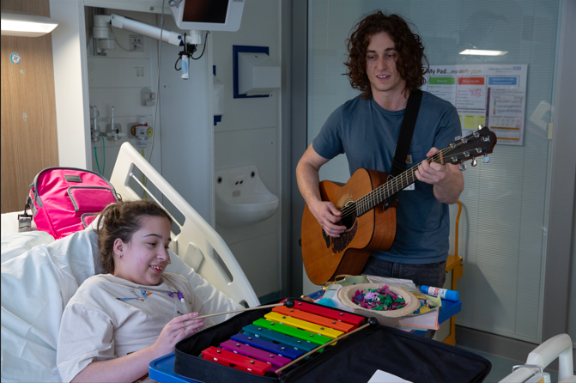We will be developing and expanding our participatory music programme, Minds Matter, with Live Music Now, a national music charity that supports emerging professional musicians and supports working in educational and healthcare settings. This programme supports children and young people across all areas of the hospital and in the community to improve their mental wellbeing.

We will also be continuing our provision for children and young people accessing CAMHS through our Dreamers Programme, which offers arts sessions of the young person’s choice on a one-to-one basis over a period of ten weeks. Activities include visual arts, printmaking, photography, special effects make up, rapping and song writing, Capoeira, pottery, voice acting, theatre and performance, and a wide range of music activities.

Research

We are a key stakeholder in a major three-year research programme, Arts4Us, led by Edgehill University and funded by UK Research and Innovation. This is one of the largest research grants of its kind ever awarded nationally in the arts and arts therapies. The research brings arts, health, community and research partners together to scale up place-based arts initiatives that support the mental health of children and young people aged 9 – 13 years, and the Arts Manager is one of the Co-Investigators. This research programme will also bring in approximately £13,000 over three years into the Charity to cover the Arts for Health Manager’s time.

We have also secured funding to work in partnership with Kerry Wilson, Reader and Associate Professor in Cultural Policy at Liverpool John Moores University to evaluate the social impact of our Lullaby Project, a programme that supports music making and the creation of bespoke lullabies with parents and carers on our Neo Natal Unit.

In summary the Arts for Health Programme is well established for children, young people and their families at Alder Hey. The Arts offer a unique vision of how the hospital experience can be vastly improved. Art defines the look and feel of the Trust’s main building and the expanding cultural campus. The creative programmes bring in energy, sense of purpose and personalised care to the journeys our patients make during their time with Alder Hey. The appointment of a new Project Coordinator has enabled the service to expand into areas not currently served, increase participations and meet the clinical demand from our healthcare professionals. We are also now able to focus on supporting staff wellbeing through creative programmes. Due to significant increased funding from the Alder Hey Children’s Charity in March 2025, we will be delivering more programmes than ever before throughout 2025/26.

**3.3.5. Nurse Staffing**

**Aims**:

* To have zero nursing vacancies.
* To sustain a resilient, registered nursing workforce, with up to 40 WTE over the baseline frontline nursing establishment to cover maternity leave, long term sick cover and fill ward/department vacancies.
* To have a proactive recruitment campaign, reflective of the local population.
* To deliver our 5- year nursing / AHP workforce strategy - completed
* To have a nursing workforce that have the right skills and receive the right training to deliver the highest quality nursing care.
* To retain our nurses via a clear retention framework.
* To proactively plan for future workforce requirements.
* To enable all nurses to reach their full potential, to succession plan and to have a clear development plan for nurse career trajectory.
* To promote and herald the nursing contribution to research.
* To support and develop our international nurse colleagues.

Changes or deficiencies in the nursing workforce can have a detrimental effect on the quality of care provided. Sub-optimal registered nurse staffing levels are associated with poorer quality interactions between patients and staff. In addition to the well-known patient safety risks, reports indicate a wider negative effect from low staffing, with adverse consequences for patient experiences and quality of care more generally. Patient outcomes, particularly safety and patient experience, are improved when organisations have the right people, with the right skills, in the right place at the right time.

The importance and guidance surrounding safe and sustainable staffing levels are enshrined in national professional nursing and regulatory standards, including NHSI developing workforce standards supporting providers to deliver high quality care through safe and effective staffing (2018); National Quality Board improvement tools for the care of children and neonates (2017); Royal College of Nursing guidelines for safe staffing levels in neonatal and paediatric settings (2013); Paediatric Intensive Care Society standards for the safe staffing of children in critical care settings; British Association for Perinatal Medicine regarding nurse staffing for neonates (2011); Nurse Staffing and Patient Outcomes (2016) and Quality Network for Inpatient CAMHS standards for care of children and young people requiring Tier 4 mental health care (2019), amongst many other documents.

In October 2024, the Trust took part in a nursing workforce review with NHSE and ICB leads; the review was attended by the Chief Nursing, AHP and Experience Officer and senior colleagues from nursing, HR and Finance. Positive feedback and assurance were received from NHSE and ICB partners.

The recruitment of Band 5 nurses is co-ordinated at specific points each year, to align to the local graduating students. We ensure we engage with all our locally graduating students within their final year of training by providing a recruitment discussion to share our recruitment process, and identify our support frameworks, in addition to answering any questions.

We continue to operate our ‘one stop’ recruitment events, when all shortlisted candidates attend the Trust, undertake the required recruitment elements (interview and medications test), and are informed on the day if they have been successful. This approach has a number of benefits and allows candidates to leave the event having already commenced all recruitment checks, ordered uniforms, and secured a job. In 2024/25 we successfully recruited 85 Band 5 nurses through the process above.

We operate a rotational recruitment pathway for all newly qualified nurses which enables them to be supported in their first job but has the flexibility for a range of skills to be consolidated across the medical and surgical divisions within the organisation throughout the first two years.

All new nurses to the organisation are supported by undertaking a 1-week induction programme, which ensures they are not only welcomed to the organisation, but that they also receive all the training and education required to equip them to undertake their role. They are then supported through a minimum 4-week supervisory period with further fundamental training provided and additional pastoral support.

Our preceptorship framework has been fully implemented, supported by our Trust preceptorship policy. As we continue to adhere to the standards identified within the National Preceptorship guidelines for nursing (NHSE 2022), we were awarded the National Preceptorship interim quality mark for Nursing (IQM) by NHSE. Through the framework newly qualified nurses are supported by regular engagement with a Professional Nurse Advocate (PNA), via group and individual restorative clinical supervision.

We have invested further in our nursing workforce in 2024/25, by continuing to support the role of Lead for Nurse Retention. This strategic role has enabled further development of our preceptorship framework and the embedding of the PNA role, both fundamental factors to ensure improvement in the retention of our new and existing nurses.

An additional area of focus for this role has been reviewing retention data specific to Alder Hey, which is now tracked and benchmarked against regional and national data. This supports targeted intervention and enables the Trust to demonstrate clear improvements.

We continue to support our internationally educated nurses exploring required development including access to the Florence Nightingale Leadership programme and have ongoing plans to further support career progression through our nursing career pathway project.

The Trust submits monthly workforce data to the commissioners via our workforce return portal (PWR). Following work that has been undertaken in relation to registered nurse recruitment, and our Care Support Worker Programme, the Trust is now submitting data that shows we have consistently achieved zero vacancies, and, on some occasions, we are over our established nursing number of registered nurses. There has been an increase in the number of vacancies for Band 3 Health Care Support Workers (HCA) however that is mainly due to changes in nursing models and an increased requirement for HCAs. The Trust continues to recruit into other gaps such as maternity leave, secondments, and long-term.

The Trust has continued to successfully recruit into vacancies through collaborative working with our education providers, national recruitment days and bespoke recruitment in specialty areas.

We continue to support 7 Registered Nurse Degree Apprentices; 4 learners have progressed into their third year and are progressing well, with aims to undertake recruitment into Band 5 nursing positions in June 2025. These are all overseen by a designated Practice Education Facilitator who links with our HEI partner organisation and ensures all elements of the academic and apprenticeship requirements are met.

Following completion of the successful pilot of the national Band 5 nursing competencies for children and young peoples’ nurses, we are now working to implement them across the organisation. These provide a clear framework of progression and expectation, spanning 2 years from commencement, and allow higher levels of specific achievement in specialist skills/knowledge across the organisation, as relevant to the patient group. All new nursing recruits are supported through this framework alongside their preceptorship, and mapping of the existing workforce is underway.

We continue to work to develop clear career opportunities for all groups within the nursing workforce which will be finalised later this year and will be inclusive of our support of internationally recruited nurses.

We are also undertaking work to explore recruitment to Band 3 healthcare support worker roles, offering consolidation of induction and training opportunities to support progress into these roles for candidates from the local community.

Work commenced to create a development programme for our Band 6 nurses, both those aspiring to undertake this role and those already in post. The programme will encourage the development of key skills and knowledge and provide assurance of the appropriate skillset of each candidate for the Band 6 role, providing consistency across the organisation. We have also recently participated in a regional pilot exploring a new toolkit for Band 6 nurses that has been developed and plan to continue to use this when further strengthening our Band 6 development programme. In 2025/26 the Trust is working in partnership with the RCN to develop a national Band 6 development programme and hope to pilot this later in 2025.

The Professional Nurse Advocate (PNA) role was launched in 2021 to ensure support for the nursing workforce following the covid pandemic. The PNA role is very diverse and includes quality improvement, restorative clinical supervision, evaluation, monitoring, education, and development. Our successful Professional Nurse Advocate programme is now being overseen by our Lead for Nurse Retention who continues to work towards the national, regional, and organisational requirements**.** Within Alder Hey there is a PNA strategy and action plan which has been created and is reviewed regularly. Currently all PNA’s are active in their local area, and support all recruited newly qualified nurses via our induction and preceptorship frameworks as well as providing support to the wider nursing workforce. There are a number of quality improvement projects being supported by PNA’s and an establishment of PNA support via organisational well-being processes. NHSE PNA ratio compliance now forms part of the Trust quality schedule with reports generated quarterly.

We continue to run our successful Care Support Worker Direct Programme, with all trainees successfully completing and taking up permanent or bank healthcare support worker positions at the Trust. This programme has been developed via initial funding from NHSE and allows recruitment of a local workforce that otherwise would not have routinely accessed a career in healthcare. The trainees normally take around three months to achieve the Care Certificate with many already having successfully completed their band 3 competencies. In the last year we have accommodated 3 Cohorts totalling 27 candidates, approximately 9 have gone into substantive contracts with the rest taking up flexible posts on the bank. This programme continues to be an integral part of our workforce strategy, and we are looking to link it in with our apprentice pathway.

Following the completion of the care certificate project all organisational Band 3 Healthcare assistants have, or are currently being supported to, achieve the care certificate. All future recruits will already have achieved this, in order to have met the job description requirements of the band 3 role, but local support for any remaining candidates can be provided as required.

All nurses are supported to complete the organisational Standards for Student Supervision and Assessment (SSSA) training enabling them to meet the Nursing and Midwifery Council (NMC) requirements to support and assess student nurses. As part of SSSA training we now also provide education in relation to the preceptor role and the introduction to coaching.

We continue to deliver an annual study day to all pre-registration nurses which are facilitated by the PEF team, with support from the Clinical Practice Educators, and have workbooks aligned to the professional proficiencies, to support achievement. These study days also enable students to engage with the PEF team at regular points throughout their training programme ensuring those requiring support can be identified and any requirements implemented. We also facilitate quarterly learner forums, for a range of learners within the organisation, to participate in shared learning, and also for us to utilise some dedicated time to understand learner experiences within the organisation currently.

We also deliver bi-monthly ‘cuppa and a catch up’ sessions, which enable the nursing students the opportunity to come together, meet with the PEF team and discuss any worries, concerns or celebrate achievements. This is a new project and has been extremely well received by the student nurses to support their wellbeing whilst undertaking clinical placement.

We have reviewed and amended the delivery of our Learner Forum, which is now facilitated bi-monthly. This is an opportunity for multi-professional learners to undertake an hour of learning and then an hour of listening together. This has been adapted to ensure there are topics of relevance to all learners across the medical, nursing and AHP fields, and is being delivered by the medical education, nurse PEF and AHP PEF teams.

The Practice Experience Recognition Certificate (PERC) is a relatively new project which enables us to identify students who demonstrate consistently exceptional skills in clinical practice. The PERC process enables assessors/ward managers/PEF’s the opportunity to nominate a student at each point of their training, providing evidence for the nomination which is then considered by the awarding board. Any student who is awarded a PERC in all years of their programme is then able to access an adjusted recruitment pathway, which provides more choices in relation to their area of preference. There is also the opportunity for ward managers to award a ‘lightening PERC,’ which is only applicable to students in year 3. This enables them immediate access to the adjusted recruitment pathway for the area the Ward Manager is linked to.

Additional Practice Learning Activities (APLA) is a resource that has been created to enable practice learning that takes place outside of the clinical environment to be recognised. We have developed an extensive data base of resources to aid students in their learning and offer guidance in relation to proficiency-based activities, to enhance their practice knowledge. This data base is available to all students and has been created in partnership with multidisciplinary teams within Alder Hey and our local university partners.

Learners are supported to be empowered to take control of, and responsibility for their own learning and via APLA are provided with opportunities to develop their own practice. This enables them to further work towards becoming independent, reflective, and professional practitioners. All of our pre-registration innovations were recognised when we were the winners of the ‘celebrating achievements and practice excellence award’ from University of Chester.

The Senior Nursing and AHP Team has delivered on all elements of the five-year nursing workforce strategy and associated implementation plan. A considerable amount of progress has been made in the areas of compliance with regulatory guidance, safe staffing, education and training, apprenticeships, development pathways and clinical academic careers. Our Strategy is now being re-written to reflect the objectives of the next 5 years.

#### Safe Staffing Levels

The Trust undertakes an annual review of all ward establishments in line with national guidance, service need, patient acuity and professional judgement and reports this to the Board. The Trust is now compliant with all the national workforce standards following further investment in the nursing workforce by the Trust Board.

Significant progress has been made in the implementation of evidence-based acuity tools to support workforce planning and establishment setting.

The following Safer Nursing Care Tools (SNCT) are available and applicable to wards and departments at Alder Hey:

|  |  |
| --- | --- |
| **Ward / Department:** | **SNCT:** |
| Ward 1C Cardiac | CYP (Children and Young People) |
| Ward 3A | CYP |
| Ward 3B | CYP |
| Ward 3C | CYP |
| Ward 4A | CYP |
| Ward 4B | CYP |
| Ward 4C | CYP |
| Sunflower House | MHOST (Mental Health Optimal Staffing Tool) |
| ED | ED (Emergency Department) |

The following wards and departments continue to follow the relevant national staffing standards as there is not an SNCT applicable (the tools cannot be adapted for use):

|  |  |
| --- | --- |
| **Ward / Department:** | **SNCT:** |
| Ward 1C Neonatal | BAPM (British Association of Perinatal Medicine) |
| PICU | PICS (Paediatric Intensive Care Society) |
| HDU | PICS |
| Burns Unit | RCN (Royal College of Nursing) |
| Renal Unit | RCN |
| EDU / PAU | RCN |
| SDCU | RCN |
| MDU | RCN |
| OPD | RCN |

In October 2023, senior nursing and AHP staff undertook training facilitated by NHSE to support the implementation of the CYP SNCT. In October 2024, senior staff from ED attended the ED SNCT, and senior staff from Sunflower House attended the MHOST SNCT training. All staff who attended training had to complete an inter-rater reliability assessment and the Chief Nursing, AHP and Experience Officer received confirmation that all staff successfully passed their assessment.

Patient acuity data was collected twice in year (February and July 2024) for 20 days for all patients on the ward in line with SNCT guidance on all inpatient wards who met the criteria for the CYP SNCT. Data was validated by senior staff who are not the budget holder for that ward. Going forward, the annual cycle will involve data collection for 30 days in January and June. Sunflower House and ED undertook their first data collection in February 2025.

The patient acuity data can be used as part of establishment setting by populating the CYP SNCT Ward Multipliers tool, however it is recommended that the data is collected a minimum of three times before it is used to set establishments, therefore the senior team used the data during the 2024 round of establishment reviews in shadow form. The Safer Staffing Faculty at NHSE have been extremely supportive and on hand to assist the team with any questions to support our phased implementation.

It remains essential that professional judgement is considered when using SNCT and the senior team are reviewing the impact of a high number of side rooms on the ward and the impact that any empty beds has had on the suggested WTE from the Ward Multipliers tool as empty beds were not scored.

Quality metrics, key performance indicators, outcomes and incidents were all reviewed as a core component of the safe staffing principles.

All establishment reviews were conducted in 2024. A multi-disciplinary team approach including Finance and HR was used. Reviews were based on achieving compliance with the national requirements (RCN / BAPM / PICS), patient acuity, professional judgement, benchmarking using the NHSE Model Health System, and review of compliance with key quality metrics and a review of CYP SNCT ward multipliers.

The Trust benchmarks against peers and reports Care Hours per Patient Day (CHPPD) monthly in the Safe Staffing and Patient Quality Indicator Report in the Integrated Performance Report. Data is compared and benchmarked with CHPPD figures from comparative wards enabling investigation to understand any significant variation and to make sure the right staff are being used in the right way in the right numbers. CHPPD includes total staff time spent on direct patient care including clinical time such as preparing medicines, documentation, and safeguarding.

Staffing RAG rating data has continued to show improvement with zero red shifts within the wards and departments in 2024/25.

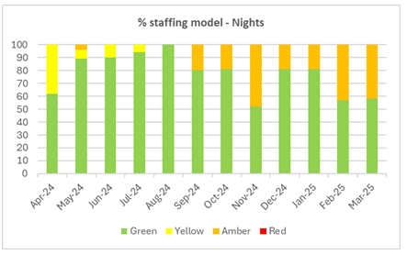

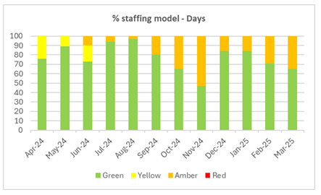

The senior nurse / AHP team have increased the oversight and scrutiny of bank shifts through the Trust’s daily Safer Staffing meeting with a decreased usage of temporary NHSP shifts.

In further progressing the work towards the aims of having zero nurse vacancies, sustaining a resilient nursing workforce, recruiting proactively, and ensuring the provision of a nursing workforce who have the right skills and receive the right training for the job, retaining our nurses, planning for future workforce requirements, enabling all nurses to reach their full potential, and promoting the nursing contribution to research, the Trust has made the following improvements.

**Improvements 2024/25**

**Recruitment and Retention:**

* 85 WTE front line registered nursing staff recruited in 2024/25.
* Vacancy rates consistency less than 2%, often reported via PWR as 0%.
* A responsive recruitment culture with evidence of strong partnership between senior nurses and human resource staff, notably working together on successful national recruitment days, plus a comprehensive induction and preceptorship programme for new nursing staff.
* Consolidation of our ‘one stop’ recruitment event, with all candidates being interviewed on the same day and if successful their recruitment team/admin appointment confirmed at the same time.
* Recruitment strategy partnership working with higher education institutes to attract potential student nurses from diverse backgrounds.
* The successful ongoing support of 7 Registered Nurse Degree Apprentices (RNDA).
* Continuation of a Nursing Retention Lead post to support a reduction in attrition rates and development of the retention offer.
* Further investment in the PEF workforce team to support delivery of our workforce and education programmes.

**Safe Staffing Levels**

* Staffing levels consistently higher than 85% throughout the year for open beds and the continued Daily Safer Staffing Huddle embedded as an integral part of our safer staffing plan. We have also started to become involved in the Safer nursing care tool national work, monitoring our staffing against the set dependency criteria. Two wards reported levels below 80%; however, this was due to a planned change in the nursing model. As such, the percentage compliance was not an accurate reflection of the staffing levels, which were in fact complaint with model.
* Carried out an annual staffing review against the RCN and local and national workforce drivers, with the results reported to Trust Board and any requirements addressed via business cases to IRG.

**Strong and Effective Leadership Structure**

* The Trust has continued to work towards being a national leading centre in the training, education and recruitment of paediatric nurses and Healthcare Support Workers (HCSW’s).
* Diversify recruitment strategies to be more representative of the population we serve.
* Ensure that staff have clear opportunities to develop, grow and progress in the organisation.
* Develop to embrace new roles and transition to a sustainable model for the future.
* Develop a clear structure for advanced and specialist roles; services will continue to be developed around the needs of children, young people, and their families, and will clearly align to the service needed to provide their care.
* Continued safe staffing levels of over 85%.
* Continue to meet the RCN safe staffing standards.
* Internal and external recruitment to senior nurse/ward managers positions.
* Internal promotion to Band 6 Ward Sister/Charge Nurse positions.
* Safer Staffing Huddle continues to be chaired by a senior nurse.
* Involvement in the regional pilot to develop a band 6 Developmental toolkit.
* Development framework for our Band 5 workforce.
* Further development of our PNA programme, with more PNA’s trained, delivering a greater number of supervision sessions. NHSE PNA ration compliance now forms part of the Trust quality schedule with reports generated quarterly.

**Educational Developments**

* Full implementation of the Supportive Coaching in Practice (SCIP) model across the organisation – encouraging empowerment of learners and peer support.
* Continued to support senior nurses and aspiring nurse leaders to undertake the MSc programme in Leadership enabling staff to gain the necessary skills and competencies to successfully fulfil senior nurse roles. Maintained and supported three senior nurses per year to participate.
* Support of 15 nursing staff to undertake the professional nurse advocate training with 8 now successfully completed.
* Practice education facilitators and clinical practice educators continue to address organisational education requirements and provide a streamlined approach to a wide variety of staff development opportunities. A workforce development flow chart had been devised to outline the workforce programmes available and the access criteria.
* Continued implementation of the national band 5 nurse child and young people’s nurse competencies.
* Development of practice-based learning packages, to support increasing numbers of learners and explore diversity of learning opportunities the organisation can offer had been undertaken.
* An annual development day has been implemented for pre-registration nurses facilitated by the PEF Team, to strengthen the applications of theoretical learning to practice, and to enable specific organisational learning opportunities to be undertaken.
* The facilitation of a bi-monthly learner forum to allow learners from all specialities to receive education from organisational experts and facilitate student engagement via a ‘listening hour’.
* Parity of esteem quality workstream to ensure staff are trained to care for children and young people to address all their physical and mental health needs, holistically.

**Quality Metrics**

* Continued utilisation of the quality audit tool across all wards; now built into the Trust risk management system.
* Continued assurance for the Trust around standards and quality via the Ward Accreditation Programme.
* Development of a new scoring matrix for the Ward Accreditation programme that maps across the current CQC self-assessment framework.
* Local challenge boards continue to monitor staffing at divisional level providing information for recruitment events.
* Patient safety meetings continue to provide assurance around our safety culture.
* Continued development of our Quality Rounds (QR) and associated action plans, monitored via divisional governance committees, with more involvement from our children and young people. (Quality rounds provide a space for dedicated time and support for teams / wards / departments to select a topic for further exploration. This may include audits, surveys of staff/patients/families, other methods of data collection, with a follow up session for feedback and action planning. Occurring fortnightly, they include staff, the Youth Forum and volunteers to undertake a short activity to support sourcing data to answer the question posed).

**Future Plans 2025/26**

* Review the recruitment process in line with the implementation of an updated Nursing and AHP Workforce Strategy.
* Establishment of a Nursing and AHP Workforce Strategy implementation plan.
* Continued recruitment into any vacancies.
* Continued monitoring vacancies, turnover rates and daily staffing levels with work feeding into regional retention committee and local workforce group.
* A real focus on retention with our Lead Nurse for retention looking to reduce attrition through a retention offer that incorporates preceptorship, well-being, engagement, flexible working opportunities, development and restorative supervision.
* Continued implementation of the Safer Nursing Care Tools and enhanced acuity and dependency scoring and monitoring to inform establishment reviews.
* Continue to monitor use of temporary staff and maximise substantive staff via E-roster to reduce temporary staff reliance.
* Continue to build on the education strategy; Continue to work closely with Human Resources team, SALS, PNA’s and wellbeing teams to support staff.
* Continue to work with Higher Education Institutions (HEIs) to train and recruit a workforce that is diverse, inclusive and reflective of our community.
* Facilitate, enhance, and maximise that full potential of the nursing workforce who have a wealth of ideas, innovative solutions and experience to further shape and develop evidence-based practice.
* Continue to develop the organisational establishment of the professional nurse advocate role and deliver the strategy.
* Delivery of our Band 5 development plan including preceptorship, clinical competencies and leadership skills.
* Development and implementation a Band 6 Development Programme to grow leadership and management knowledge, skill and behaviours in our senior nurses.
* Clinical skills review and development of a Training Needs Analysis (TNA) to address any gaps.
* Advancement to an organisational model of delivery of the Care Certificate for our healthcare support workforce.
* Continuation of the Trust preceptorship framework and standardised induction for all newly recruited healthcare support workers.
* Further development of the career pathway for the nursing workforce to clearly demonstrate the progression routes available.
* Continued development of our nursing workforce retention strategy and associated KPI’s.
* Application for the Multiprofessional National Preceptorship Quality Mark (July 2025).
* Support the development of a Paediatric Early Warning Tool training programme to ensure staff are supported to recognise and manage the deteriorating patient effectively.
* Roll out of our IV Therapy passport.

**3.3.6. Management of Complaints and Concerns**

The Trust is committed to ensuring all our children, young people (CYP) and their families receive the highest quality of care. Alder Hey places enormous value on the views and feedback from patients, parents and carers including when they raise concerns or submit formal complaints. In putting children and young people at the centre of all we do, we recognise this as an opportunity for them to contribute to improving services, patient experience and patient safety.

The Trust will always try to resolve any concerns at a local ward or departmental level, and through our Patient Advice and Liaison Service (PALS) will try to avoid escalation to a formal complaint, this of course always remains the right of the family, should their initial concerns not be resolved satisfactorily. Parents and carers who raise a formal complaint are offered the opportunity to attend a meeting to resolve their concerns in addition to receiving a written response.

The table below shows the number of formal complaints received which has increased from last year but is largely comparable to the last five years. The number of informal PALS concerns has remained high and increased; this is mainly associated with an increase in contacts in relation to appointment and treatment waiting times and an increase in demand for services such as mental health.

|  |  |  |  |  |  |  |  |  |  |
| --- | --- | --- | --- | --- | --- | --- | --- | --- | --- |
|  | **2016/ 2017** | **2017/ 2018** | **2018/ 2019** | **2019/ 2020** | **2020/ 2021** | **2021/ 2022** | **2022/ 2023** | **2023/ 2024** | **2024/ 2025** |
| **Formal complaints** | **66** | **83** | **121** | **114** | **159** | **158** | **154** | **142** | **165** |
| **PALS** | **1294** | **1349** | **1371** | **1279** | **915** | **1524** | **1904** | **1987** | **2047** |

The Trust aims to respond to concerns in a timely manner as we understand how important it is to families that their concerns are taken seriously, and that they are fully supported, and appropriate action is taken as quickly as possible to resolve any issues.

A continued key quality improvement driver for 2024/25 was to improve compliance with the Trust policy to resolve informal PALS concerns within 5 working days, and formal complaints within 25 working days. The Trust made highly significant improvements with an average of 91% of informal PALS concerns responded to within 5 working days and an average of 85% of formal complaints responded to within 25 working days. Staff from various areas, including nursing, medical, operational, risk and governance, complaints and PALS, and Patient Experience, worked together collaboratively to ensure patients and families have received a timely, compassionate and supportive resolution to their concerns and are committed to improving this further still. The Trust understands that timely management enables earlier identification of actions, lessons learned and potential improvements to benefit all our patients and families.

In 2024/25, the PALS office was developed further to become the Family Wellness Hub; a space where children, young people and their families can talk to staff who will support them and help resolve their concerns as quickly as possible.

**Learning from complaints and PALS**

Alder Hey is a learning organisation and uses complaints as a mechanism for taking forward improvements and changes in practice. Lessons learned and actions taken, because of formal complaints and informal PALS concerns during the year include the following:

**Lessons Learned**

* The importance of all dressings being fully removed to enable a full assessment of any potential wound or tissue damage.
* Communication is vital to ensure children, young people and families are fully aware of Trust processes and who they should contact if they need assistance.
* The use of One Drive may cause delay in recording patient information and duplication with the electronic health record.
* The Trust should have a blended diet policy.
* The Trust would benefit from an increased number of safe space beds.
* The referral process should be clearly communicated to patients and their families to reduce any anxieties.
* Training on learning and disability care should be available to all Emergency Department staff.
* Face to face training for school staff may still be required rather than virtual school training
* Staff / patient concerns not always recorded on the Paediatric Early Warning System (PEWS).
* It is important to ensure collaboration between the young person, the family and Alder Hey throughout an inpatient’s stay.
* All relevant therapeutic notes should be available to CAMHS Crisis Care to support more holistic review.
* The CAMHS Crisis Care service offer needs to be more available to children and young people in Sefton.
* Team to be aware of and adhere to agreements for treatment / assessment relating to community physiotherapy access.
* Explicit consent for attendance and involvement in appointments for student physiotherapists must always occur.

**Actions**

* Confirm at weekly Patient Pathway Co-Ordinator (PCO) meeting that all answer machines are being checked and that all queries are responded to within 2 working days.
* Staff reminded of the importance of fully explaining treatment plans to parents.
* Importance of full dressing removal added to ward-based study days.
* Orthopaedic team to consider additional training for prescribing of blood products for all new starters as part of the departmental induction.
* Review communication with local service providers to ensure continuity of care for patients.
* Reflection and recognition by the admin team on the impact to patients for the delays in receiving an appointment.
* Weekly access meetings have been implemented to discuss the Electronic Patient Pathway Form (ePPF) reports to ensure all pended appointments are made and sent out.
* Reminded all clinicians of the importance of completing the clinical documentation in the electronic patient record immediately after the consultation.
* Divisional governance review of how and why One Drive is used as this may cause delay in recording information and duplication.
* Department to engage with digital team to review all electronic pathways to ensure that they meet the requirements of the service and ensure adequate record keeping in real time.
* A blended diet policy has been devised.
* Business case submitted for the provision of more safe space beds.
* Ward staff updated on how to order specialist commodes.
* Education and training sessions arranged for all staff in the Emergency Department with the support of our Learning and Disability Team.
* Deliver face to face training to the staff at the school.
* Staff reminded of the criteria for referring patients to Urgent Treatment Centre (UTC).
* Ward staff have been reminded to record any concerns they have, or any concerns raised by the parent, in the patient notes.
* A business case has been submitted to purchase a blood gas machine.
* Revisit values-based learning package with all the team, including equality and diversity and the importance of demonstrating our Trusts values in our everyday practice
* Carry out staff observations of practice, focussing on staff and patient/family/carer interactions, to identify areas for improvement.
* Review of training compliance for Information Governance and share learning within monthly governance meeting.
* The service is embedding a new welcome meeting, which will take place within 5 days of the young person’s admission to Sunflower House. The aim of this meeting is to work collaboratively with the referrer, family and wider agencies from the start of the admission.
* Further Safeguarding training undertaken in Booking and Scheduling teams and referral teams regarding processes and who to follow.
* Review of CAMHS Crisis Care offer to children and young people attending other hospital ED to ensure that face to face assessment is provided if clinically appropriate.
* Request therapeutic notes from private therapist are added to AH records.
* All therapists to be reminded of requirement to gain consent for student physiotherapists to be present and to participate in patient contact. Records to be updated in relation to agreements for access to treatment and assessment.

The Trust is proud of the achievements made this year to support children, young people and families to raise concerns and to help resolve any issues and are committed to further improving in the coming year by further improving the feedback mechanisms for children and young people.

**3.3.10. NHS Volunteering England Including Family & Friends (FFT)**

**Alder Hey Volunteering Services**

Volunteers are crucial to the NHS’s vision for the future of health and social care. Volunteering plays a key role in enhancing the NHS's engagement with local communities. Volunteers bring personal life skills, perspectives, and a sense of community spirit that can significantly improve patient care and support services. Our established recruitment and training process ensures that the volunteer program is both accessible and inclusive, offering opportunities for volunteers from diverse backgrounds.

We are proud and privileged to have more than 146 active volunteers at Alder Hey with 37 in the recruitment process and 10 waiting to start.

Volunteers dedicated over 19,750 hours to the Trust providing companionship, play activities, and staff support all which provide an exceptional experience for our children, young people and families.

The Young Volunteering programme was launched in 2022 and began with 8 participants. There are now 18 active young volunteers, recruited from local schools or previous and current patients.

**Volunteers make a difference**

* Our volunteers offer a warm, friendly and inclusive welcome, making a positive first impression that is crucial for building trust and confidence.
* By assisting with non-clinical tasks, volunteers’ free up healthcare professionals to focus on patient care, improving efficiency and service delivery.
* Volunteers bring a wide range of skills, experiences, and perspectives, contributing to a more inclusive and innovative healthcare environment.
* Volunteering programmes promote health and wellbeing within the local community, encouraging active participation and a sense of purpose among volunteers.

**Enhancing our family’s experience**

**Family Support Role**

Volunteers visit all new admissions each day. They provide information and support which includes practical advice about free car parking, services, and how to give feedback. The Trust is supported by the Charity to provide emergency care packages and pyjamas to any families who need them, and the Family Support volunteers also gives these out.

This initial contact builds a link to the wider patient experience team who can be a source of ongoing support and advice during their admission. Conversations with new admissions allows for any initial concerns to be addressed and resolved at local level.

This role has been very well received with positive feedback from NHS Choices and Family and Friends Test.

**Pets as Therapy**

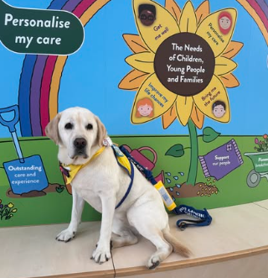Pets as Therapy (PAT) is a national charity which enhances health and wellbeing through the companionship of animals. Therapy animals are trained to be gentle, friendly, and patient, making them ideal companions for people in need of emotional and physical support. Therapy dogs provide many proven physical and emotional benefits such as reduced stress and anxiety, improved mood, reduced pain perception and lowered blood pressure and heart rate.

Alder Hey has had its very own registered PAT dog Holly and her owner Barry, with us for 8 years completed 500 visits before Holly retired this year. Holly brought a welcome distraction to our children, young people and families, and she offers the best cuddles as well as some light relief in often stressful situations.

Holly is a regular visitor to our eating disorder patients and our tier 4 mental health inpatient ward at Sunflower House. Thank you, Holly and Barry for everything you have done for our children, young people, families and staff over the years.

We are proud to welcome a new therapy dog Bonnie and her owner. They will be spending a lot of their time within our Catkin building supporting our Community and Mental Health services.

**Reading Circle and Books**

The Reading Circle takes place every Tuesday morning in the atrium of our hospital. Children and young people can pick a donated book to read with a volunteer and take it home. The team also takes the Reading Circle directly to children and young people on the wards taking a trolley full of books to choose from.

Research by the National Literacy Trust identified 1 in 5 parents and carers said they were buying fewer books for their children, increasing to 1 in 3 of those who were struggling financially because of the cost-of-living crisis. Working closely with our Charity we have had fantastic donations of books to provide to our children and young people.

**Arts, Crafts and Facepainting**

Volunteers deliver arts and crafts activities, along with face painting, in the main Atrium of the hospital each day. These activities are available for children and young people to enjoy while they wait, they provide:

* Distraction and Comfort: These activities provide a positive distraction for CYP, helping to reduce anxiety and stress associated with hospital and community visits.
* Engagement and Creativity: Arts and crafts stimulate creativity and keep CYP engaged, making their waiting time more enjoyable and productive.
* Social Interaction: Participating in group activities fosters social interaction, which can be particularly beneficial in a hospital setting.
* Emotional Well-being: Engaging in fun activities can improve the emotional well-being of CYP making their overall experience at the hospital more pleasant.
* Support for Parents/Carers/families: These activities may offer parents/carers/families a brief respite, knowing their children, young people are occupied and entertained in a safe environment.

**Play Support**

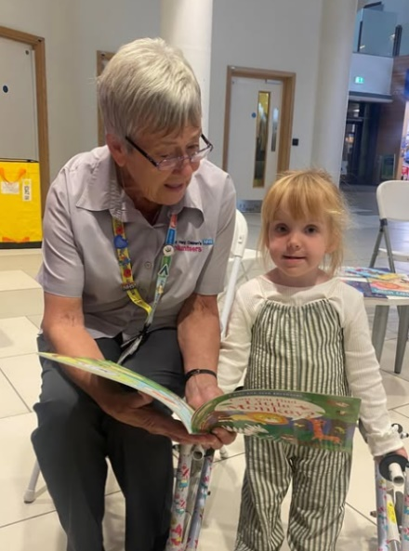Volunteers support the delivery of play activities to ensure all children and young people have the opportunity for play.

Volunteers placed on Renal Dialysis unit to provide companionship and pass the time with the patients who are there for several hours allowing parents and carers to take a break.

Matching volunteer talents and skills to individual children and young people to provide gaming activity, teaching chess, teaching knitting and providing artistic activities.

Volunteers can support our Health Play Specialists by cleaning toys, helping with displays, preparing the play area for activities and accompanying children and young people in our outdoor Play Decks.

**Achievements in 2024/25**

**Spiritual Care Volunteers**

The Spiritual Care volunteers offer huge support to our Spiritual Care team, with 14 actively volunteering. Their regular visiting on specific wards is greatly valued by families and is instrumental in building relationships with staff so that they are aware that support is always available for them.

A bespoke training program and a booklet have been designed by the Spiritual Care manager, specifically to help our volunteers, enabling them to leave something with parent, carers and families. It explains that the emotions and feelings that they may be experiencing such as loneliness, concern for the future, or being out of control are entirely normal in the hospital situation. If parents, carers or families wish to talk to somebody about their feelings, then they have the assurance that our volunteers and all our team are here to listen to their concerns at any time so that they never feel that they are alone. Spiritual Care Volunteers will listen, support, pray or offer blessings as requested.

**Special Events**

Volunteer participation at Christmas, Easter, Summer and Charity Events and other special occasions is outstanding. Their enthusiasm and time, allows us to bring these celebrations to children, young people and their families who are in hospital or visiting.

Last year’s Christmas decorations, including our own Santa’s grotto, was described as the best yet and we had Santa with us every day in December (despite Santa being very busy) and our volunteer elves brought magic to the Trust and some fantastic feedback from our visitors.

“Friendly staff. Greeted by young children who wished us a Merry Christmas and a happy new year”

“Brilliant staff, excellent environment, minimal wait times for appointment full of Christmas spirit with volunteers who were amazing with a choir and grotto, the Father Christmas was superb- thankyou”

“Unbelievable care from every single person we encountered. We were lucky enough to be there for the Christmas light switch on and the effort that was made for the children staying in the hospital was just incredible”

“Lovely staff and a beautiful hospital. The Christmas decorations and effort all the staff and volunteers go to, to make things nice for families is wonderful”

Volunteers also supported the catering team to deliver Christmas lunches to attending staff members.

The Alder Hey Charity has volunteer support at the annual Oli Walk, PJ launch and Grand National visit.

Volunteers supported community events including Hirschsprung's Disease Information Day, Community Physiotherapy Day and Research Events.

**Volunteer to Career**

In 2022 Alder Hey were part of the Helpforce Volunteer to Career (VtC) programme which helps talented and motivated young people into NHS careers via volunteer roles. Over 75% volunteers on the VtC programme have gained employment or moved into further training for a career in healthcare. Now embedded within our volunteer programme we continue to offer employability support in varied ways:

* Application, Interview and C.V. preparation via Wider Participation Team.
* 1-1 session with volunteer coordinator/manager to understand aspirations and career goals.
* Volunteers may apply for internal vacancies after 6 months regular attendance.
* Offering additional training through Learning and Development.
* Identifying pathways within the Trust for supported internships, apprenticeships and work experience.

During 2024/2025 volunteers have gained employment as housekeepers, physiotherapists, HCA’s, switchboard operators, and many are now in post or training as nurses and doctors.

**Young Volunteers**

Our young volunteers are an invaluable part of our Trust, dedicating time during their school holidays to make a difference. They take on roles such as patient safety partners, learning disability champions, and this year have become research champions. They participate in quality ward rounds, have helped select charity champions, and contribute to staff interviews. Their efforts not only support our Trust but also help them gain life skills and achieve formal qualifications, making a lasting impact on both their lives and the community. One of their most recent projects has been filming for the Alder Hey hospital virtual tour, designed specifically for children, young people and their families/carers. Recruitment has been via local schools with an emphasis on community engagement and social action.

**PLACE Inspection**

Volunteers take part in all our (Patient Led Assessment of the Care Environment) PLACE Lite and PLACE inspections and follow up the inspection ensuring highlighted concerns have been resolved. This year each team of assessors included a Young Volunteer or Forum member, to help identify the best possible environment for children and young people.

**Volunteering and Vision 2030**

Our future goals focus on enhancing the patient, colleague, and volunteer experience to align with the Trust's Vision 2030. Volunteers are integral to delivering outstanding care and creating a healthy, happy, and fair environment for everyone. Volunteering should be a mutually beneficial experience and our goals for 2025/26 centre around 3 pathways: Volunteer Training and Education; Staff Awareness; and Flexible Volunteer Opportunities.

Delivering an expanded training package for volunteers via internal Learning and Development courses and external sources will enhance their skills, increase employability, opportunities to meet new people, retain volunteers, and raising the profile of volunteering.

**In 2025/26**, the Trust will continue to engage widely and diversely through:

* **Community Partnerships**: Collaborate with local community organisations, cultural centres, and faith-based groups via our spiritual care team and their established links.
* **Culturally Relevant Communications**: Updating our messaging and materials to be culturally sensitive and relevant. Utilising our interpreting services and existing volunteers.
* **Community Events**: Participating in community events and activities to raise awareness about volunteering opportunities. Collaborating with the Alder Hey Charity, attending their organised events to reach a wider audience.
* **Social Media Campaigns**: Working closely with the Communications team to use social media platforms particularly popular with younger audiences, such as Instagram, TikTok, and Snapchat, to promote volunteering opportunities.
* **School and University Partnerships**: Work with schools, colleges, and universities and the Wider Participation Team to provide credible and recognisable academic qualifications.
* **Youth-Friendly Roles**: Design volunteer roles that are appealing to young people, such as tech-related tasks, social media management, or event planning.
* **Flexible Volunteering Options**: Offering flexible volunteering schedules that can accommodate responsibilities of carers. Removing a rigid “one size fits all” timetable. Offering term time/ holiday time volunteering, micro volunteer sessions and exploring remote/video volunteer roles.
* **Support Networks**: Create support networks for carers within the volunteer program, via SALS and external agencies (such as Health Junction/Citizens Advise (CA) Liverpool).
* **Young Carers Covenant:** Commit to the Young Carers Covenant and develop a bespoke recruitment and volunteer pathway for these individuals. Identify Young Carers who are service users initially as part of the project pilot.

**A Big Thank You**

Our volunteers are truly at the heart of our “Alder Hey Family”. Their dedication and compassion make a profound difference every day. They are often the first to greet our children, young people and visitors and set an impeccable first impression. They create a trusted, caring environment that fosters a positive patient experience from the moment someone walks through our doors. They provide invaluable support to our staff, offering a helping hand wherever needed. More importantly, they are a shoulder to lean on and a listening ear for our parents, carers and families, providing comfort and reassurance during challenging times.

Their selfless contributions and unwavering commitment help us deliver the highest standard of care and support to those we serve. We are deeply grateful for their continued dedication and the positive impact they have at Alder Hey.

***3.3.8. Ward/Department Accreditation Scheme***

In 2016, the Trust developed the Journey to the STARs (Safe Together Always Right) Ward Accreditation Scheme which was designed in partnership with children and young people. It is a quality and safety audit tool designed to give assurance of standards of practice by measuring the quality of care delivered by ward and departmental teams. Ward and departmental accreditation assessments have been shown to promote safer patient care by motivating staff and sharing best practice.

The accreditation assessment team comprises of both clinical and non-clinical staff from across the Trust. Each member of the team will undertake an aspect of the assessment which includes the following:

1. Interviewing the Ward / Departmental Manager.
2. Talking to patients and parents / carers and asking questions.
3. Asking staff questions.
4. Undertaking an observational audit of the environment and practice.
5. Reviewing 5 sets of clinical records (currently not undertaken in Outpatient clinics).

In 2024/25, the assessment criteria are aligned to the CQC Quality Statements set out within each of the 5 Key Questions. Ward and Departmental Managers continued to receive an award classification of Gold, Silver, Bronze or White but also received a CQC style rating of Outstanding, Good, or Requires Improvement utilising the CQC scoring principles. The team for each individual assessment is led by a senior nurse or Allied Health Professional (AHP) rostered to be part of the assessment team.

13 assessments were undertaken in year, with the remainder being undertaken in Quarter 1 of 2025/26. The assessment takes place unannounced except for community outpatient clinics, inpatient CAMHS, Dental and Community Nursing Team where there needs to be pre-planning with the lead to facilitate the assessment, however the service team are not made aware until the assessment team arrive therefore there is still an element of an unannounced visit in these areas. 11 of the assessments were unannounced, and 2 were partially announced.

Assessments are undertaken over a full morning or afternoon and the assessment lead provides immediate overall feedback to the Ward / Departmental manager including compliance with the mandatory checklist. Should any mandatory checklist fails be identified, this results in a White rating until the assessor returns to the area within 3 to 4 weeks to re-assess the element. If the failure is resolved, the Ward / Department receive the award reflected by the overall score. If there has been no significant improvement, then a full accreditation assessment is rescheduled.

In 2024/25 all Ward / Departmental Accreditation assessment documentation was reviewed and made available electronically via Excel. Moving forward, there is a plan to upload all assessments onto the Trust electronic risk management system to create a truly digital assessment and maximise efficiency.

The assessment criteria are triangulated and reported on aligned to the most relevant CQC Quality Statement within the relevant Key Question. The assessment criteria are then scored using both the traditional Ward Accreditation scoring and scoring each CQC Quality Statement. A dedicated senior nurse undertakes the initial scoring together with the lead assessor for the assessment. A dedicated senior AHP then independently reviews the scores and challenges as required. This approach provides assurance that all scoring has gone through a robust process of scrutiny and the outcome has been validated.

The outcome and report are presented to the senior ward / department team as soon as possible after the assessment. An action plan is then developed locally, and progress is monitored through the appropriate Divisional Integrated Governance meetings. An update and assurance report are received by the Trust Safety Quality Assurance Committee every six months. Themes identified through the assessments are shared widely with teams to share the learning and improve the experience and safety of our children, young people and families.

Of the 13 assessments conducted in 2024/25, the outcome has been shared with 10 of the teams. Of these 10, after the ward resolving any mandatory checklist fail, 3 wards and departments have been awarded Gold, 6 awarded Silver, and one awarded Bronze. Of these 10, 6 have been awarded Outstanding for the key question related to Caring, 4 for Responsive, 3 for Well-led, and 1 for Effective.

Several further improvements to the process are planned for 2025/26. Following completion of the assessments in Quarter 1, a full review of the assessment criteria is planned to be undertaken. This will be done in collaboration with the relevant senior leaders for the areas. Other planned improvements include:

* Review the departments included in the programme and identify other services which may benefit.
* Upload all assessment to Ideagen InPhase to ensure an end-to-end digital solution which maximises accuracy and efficiency.
* Transition fully to the CQC style scoring methodology.
* Review the CQC Quality Statements which do not currently have Ward / Department Accreditation assessment criteria aligned to them which could be added to enhance the assessment. For example, there are no criteria aligned to Workforce Equality, Diversity and Inclusion Quality Statement.
* Review and include relevant elements of Domain 1 of the EDS 2022 assessment.
* Review and cross reference the Ward / Department Accreditation assessment criteria with the national paediatric Acute Care Standards.
* Creation of a digital dashboard.
* Arrange a celebration event to present Ward / Department Accreditation awards.
* Continue to encourage the involvement of students and other staff to join assessments and work alongside a core team member.
* Involve Patient Safety Partners in assessments to work alongside a core team member.
* Update the Standard Operating Procedure.

The Trust is committed to continuous improvement, safety, quality and experience for all our children, young people and families, demonstrating the great work of staff supported by this process.

**3.3.9. The Alder Hey Academy**

**The Alder Hey Academy: Focusing on Learning, Education and Opportunity**

The Alder Hey Academy comprises Medical Education, Clinical Education, Learning and Development and Apprenticeships as well as being home to as our Inspiring Futures Programme and the Academy Events team. The Academy focuses on all things learning, education and opportunity related, ensuring that both current and future staff have the knowledge, skills, and confidence to undertake their roles effectively. We also support young people from across the region to achieve their potential through our Inspiring Futures Programme, collaborating with schools, colleges and wider partners to support those who may face a range of barriers to entering the workforce.

As a major provider of education and training for doctors, nurses, and allied health professionals we partner with several universities and other education providers to offer a range of learning opportunities for pre and post registration students as well as offering placements, work experience and shadowing opportunities to those at different stages in their career. In 2024/25 we welcomed over 1,000 medical students to Alder Hey on placement, from the University of Liverpool, Edge Hill University, and the University of Central Lancashire. We also provided almost 1500 clinical placements to nursing and allied health students as well as offering placement weeks for over 60 BTEC students and 164 students seeking work experience.

In addition, Alder Hey delivers several postgraduate modules and courses to support wider workforce development. Our academic partnership with Edge Hill University continues to develop, and this enables us to offer modules/awards in High Dependency Care and Paediatric Critical Care - both for our own staff and for colleagues working within HDU and PCC regionally and nationally. Proposals for expansion of our collaborative postgraduate programmes are underway with both Edge Hill and the University of Liverpool and we look forward to securing further growth in 25/26.

As a large employer with an ethical and social responsibility within the Liverpool City Region (LCR), expanding our apprenticeship offer is a key priority for us. In 2024/25, a further 40 staff started an apprenticeship, and we currently have almost 300 staff undertaking an apprenticeship across 49 different subjects.

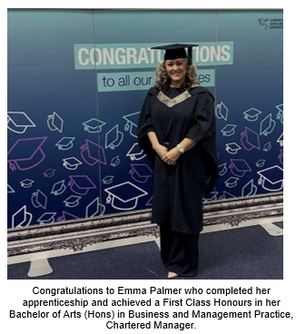New subjects being studied in 2024/25 include Health and Care Intelligence Specialist L7 (Masters), Speech and Language Therapist L6 (Degree), Biomedical Scientist L6 (Degree), Governance Officer L4, Data Technician L3 and Customer Service L2 - these subjects are supporting the Trust with addressing skills gaps and workforce and succession planning.

To maximise the opportunities available through apprenticeships, we work with nearly 40 different apprenticeship training providers across the North-West Region and beyond - including 13 Universities, 10 Colleges and 16 Independent Training Providers - and we are also working with new stakeholders for apprenticeship provision which include Arden University, Clear Quality, Riverside College, University of Manchester, University of Sheffield and the JGA-Group. Alder Hey remains one of the few NHS trusts to be awarded Matrix accreditation for our Information, Advice and Guidance (IAG) Service, and this ensures that colleagues and managers receive high quality support and impartial IAG about career-related apprenticeship decisions.

Ensuring we provide high quality learning opportunities is a major focus for us, and during the year we implemented several actions to improve colleague/student/resident doctor’s experience whilst at Alder Hey.

Many of these focused on broadening our learning and development offer, streamlining processes, focusing on wellbeing, supporting those with a range of additional needs, refreshing our induction and enhancing the learner ‘voice’. This focus will continue into 2025/26, with highlights from our enhancement work during 2024/25:

* Increasing our offer to staff

Over 6,000 individual learning sessions were offered in year. New regular monthly ‘Lunch and Learns’ have been introduced and continue to go from strength to strength. In addition, new ‘Management Essentials’ topics have been rolled out as part of an organisational wide offer for those embarking on a management / senior management role. 2024 saw our first Learning at Work week take place – which comprised a week of different activities showcasing the different opportunities available across the Trust. In addition, our first Celebration of Learning took place and was repeated in November.

* Streamlining booking and reminder systems

Use of our Electronic Staff Record (ESR) system has been enhanced to facilitate increased automation and reduce the administrative burden associated with managing course bookings, as well as improving the ability to generate reports. This has resulted in colleagues being able to book directly onto internal learning opportunities, receive a reminder to their outlook calendar automatically as well as being able to update their learning records with qualifications etc.

* Prospectus / Website

A refreshed Learning & Development Prospectus was launched in 2024/25 and the Learning and Development pages on the intranet have also been updated and are maintained on a regular basis to ensure currency.

* Piloting of new approach to rostering (Division of Medicine)

Work to implement a new self-rostering system for resident doctors was completed in-year. This aims to support and create an effective training environment that also meets the needs of the service, while enabling flexibility for doctors and the Trust, all of whom have a stake in the process. The new system is currently in its pilot phase and will be evaluated in-year. It is expected that outcomes may include: ensuring that there is safe and appropriate staffing for departments as a result of fair and consistent rostering processes; improved oversight and monitoring to align staffing levels with service needs, training opportunities, and the budgets in each department; better management and oversight of educational opportunities in order to allow doctors to meet the outcomes required for progression at the Annual Review of Competence Progression (ARCP); ensuring that all staff are able to complete all aspects of their role within working hours; improved planning and management of leave; increased opportunities for doctor involvement in rostering design, development and management of their rosters; better management and oversight of resources to increase effectiveness in workforce planning, with the aim of reducing reliance on temporary staffing arrangements.

* Refreshed Induction and Preceptorship
  + Receiving a good induction is critical to ensuring that all students, residents and colleagues feel welcome and orientated to Alder Hey. Our undergraduate medical student inductions continue to be reviewed under the direction of our Clinical Sub-Dean as does Induction for resident doctors. Our new Postgraduate Tutor is playing a key role in this, alongside the medical education team.
  + Alder Hey’s Corporate Induction was further enhanced in 24/25, with a new ‘marketplace’ showcasing a wide range of support and services to new colleagues.
  + All new nurses to the organisation are supported by undertaking a 1-week induction programme, which ensures they are not only welcomed to the organisation, but that they also receive all the training and education required to equip them to undertake their role. They are also supported through a 4-week supervisory period, with further fundamental training provided and additional pastoral support.
    - We have continued to invest in our nursing workforce, via the Lead for Nurse Retention role. This strategic role has embedded our preceptorship framework and the professional nurse advocate (PNA) role, both fundamental factors in ensuring the retention of our new and existing nurses.
* Student Engagement

We facilitate bi-monthly learner forums for a range of learners within the organisation, to participate in shared learning and to better understand learner experiences within the organisation.

* Career Pathways

Reflecting our commitment to workforce development, our new (virtual) Professional Development Hub was launched in December 2024 – providing an opportunity for staff across the organisation to explore career pathways, receive one to one advice and to consider development opportunities relevant to their role/s. In addition, work has been undertaken to create a development framework for all Band 5 nurses within the organisation - this is inclusive of their preceptorship period and details the opportunities available to staff in addition to the expectations of the organisation at designated points. We have also implemented the national nursing competencies for Band 5 Child and Young People nurses with our new recruits and are working to align existing nurses to these. There has been initial work undertaken to create a development programme for our Band 6 nurses – both those aspiring to undertake this role and those already in it. We are now working with the Royal College of Nursing to explore further developments in relation to this project and look forward to delivering this by the end of 2025.

* The Practice Experience Recognition Certificate (PERC)

The PERC is a relatively new project which enables us to identify students who demonstrate consistently, exceptional skills in clinical practice. The PERC process enables assessors/ward managers/Practice Educators the opportunity to nominate a student in each year of their training, providing evidence for the nomination which is then considered by the awarding board. Any student who is awarded a PERC in all years of their programme is then able to access an adjusted recruitment pathway, which provides more choices in relation to their area preference. There is also the opportunity for ward managers to award a ‘lightning PERC’ which is only applicable to students in Year 3. This provides immediate access to the adjust recruitment pathway for the area the ward manager is linked to.

Our in-house leadership development programme ‘Strong Foundations’, rooted in psychology around understanding self and others, continues to be both popular and impactful across all levels of the organisation and Insights Discovery is also offered to individuals and teams to support team dynamics and compassionate leadership. Wider development opportunities include coaching, mentoring and 360 feedback, all of which are co-ordinated by the Organisational Development team to ensure personalised/team-based support and development is available when/where it is needed most.

The Academy Learning and Development (L&D) Team have spent time ensuring that courses and events are more visible to staff across the Trust and the L&D team are integrated more fully within team discussions and workforce planning activities to develop a greater understanding of learning needs. They have also worked tirelessly with divisional leads, HR colleagues and subject matter experts to deliver on our requirement to ensure staff are compliant with mandatory training and PDRs and we have consistently exceeded our 90% target for mandatory training and achieved over 90% for band 7+ PDR completions.

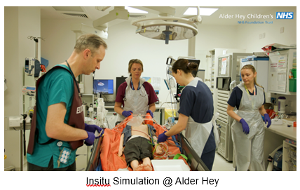SIM-TEL

SIM-TEL refers to the integration of simulation-based education (SBE) and technology-enhanced learning (TEL) to support healthcare education and training. In addition to our regular programme of SIM activity across the Trust, highlights from our SIM-TEL activities in 2024/25 include:

* Delivery of virtual simulation to the Paediatric Intensive Care Society congress which was held in Liverpool. This involved integrating the use of MS HoloLens in live streaming the team leader view to the Conference Centre, allowing open discussion and participation from remote delegates.
* Live streaming of insitu Emergency Department (ED) simulation to regional Emergency Medicine trainees.
* Recording insitu ED simulation with integrated teaching points and rationale for treatment for University of Lancaster medical students.
* Producing instructional simulation video for emergency hysterotomy within the ED.
* Integration of dance as distraction therapy using VR with play specialist team and Small Things Dance Collective.
* Creating instructional and presentational videos for Infectious Diseases team, PICU, Dental, Innovation and supporting The Academy’s international collaborations.

To strengthen the resilience, availability and quality of simulation throughout the Trust, in 2024/25 we worked with national SIM-TEL leads on how best to grow our SIM-TEL capacity and capability and have committed to piloting the “Becoming Simulation Faculty” (BSF) programme in 25/26. This is an NHSE initiative and is designed to support colleagues across healthcare organisations as they explore the basics of education and learning with simulation and immersive learning approaches, and to provide a platform on which further local workforce educator development can be based. The programme comprises several eLearning topics and face to face workshops, along with mentoring and peer support. After completing the programme, colleagues will have a recognised credential that they can carry with them.

As a leading provider of Paediatric care, we are keen to maximise opportunities for sharing our knowledge and expertise and to learn from others. We host a range of conferences and events throughout the year - some highlights include: the National Practical Course in Paediatric Otolaryngology (NPCPO); an ENT Coblation course; the 6th Annual Vestibular Conference (which attracted delegates from across the globe), our AHP Day, the Alder Hey Celebration of Learning, our Annual Careers Event for local schools and colleges and the prestigious Christmas Lecture featuring Prof Sir Albert Aynsley-Green.

Wider highlights include our collaboration with Liverpool Medical Institute to offer an Aspiring Medics Programme (designed to enthuse, inspire, and support the next generation of doctors) and our work with Manchester Metropolitan University and the Alder Centre for Education which ensures that all trainee teachers at MMU hear first-hand from young people about their experiences of mental health and how teachers/schools can best support them.

Reflecting our role as an anchor organisation within the city and given the need to attract talent from across a wide range of communities, we continue to work with internal and external partners to deliver our Inspiring Futures programmes. As part of this we:

* Offer supported internships in partnership with Liverpool City Council, DFN Project Search and the NHS University Hospitals of Liverpool Group. A number of young people are currently on the programme, which sees them develop skills across a range of placement areas during the year, with the aim of securing employment at the end of the programme.
* Develop new partnerships to maximise the value of our placements and work experience opportunities for local young people with specific support needs.
* Support a range of local careers related events for both primary and secondary schools.
* Run our Aspiring Medics Programme for those interested in medicine as a career.
* Partner with The King’s Trust to offer employment support for young people aged 16-29.
* Collaborate with Cheshire and Merseyside ICS and other local organisations in terms of providing career-related support for care experienced young people and advocating for this group.
* Design and deliver bespoke projects for young people who experience multiple challenges to entering the workforce.
* Deliver careers focused sessions and wider activities for Elevate Business Partners, who provide a wide range of meaningful connections between education and the business community across Liverpool. We work extensively with children aged 5 - 17 to ignite a passion for learning, to raise aspirations and build self-confidence. Reflective of our work in this area, we were delighted to be awarded EBP Patron Status in 2024.

**3.3.11. Quality Improvement**

**Brilliant Basics Improvement System**

Brilliant Basics is our approach to improvement. During 2024/25 the focus was on using the approach to support:

* Vision 2030: integrating improvement principles into strategic change.
* Leaders: tailored learning to develop knowledge, skills and habits to support the development of high performing teams that have effective problem solving and continuously improve.
* Effective and productive sub-board committee meetings: aligning the use of data to drive focussed improvement alongside existing assurance mechanisms.
* Productivity improvement: teams and services utilising improvement principles to deliver change.

Our learning and development programme has embedded opportunities to develop practical improvement skills for everyone at all levels within the organisation. We have several ways in which everyone is supported to undertake improvement in Alder Hey either through individual learning or team-based approaches delivered in person, online or self-paced through a digital platform. In total we have trained one eighth of staff in our main problem-solving methodology and supported 29 teams to develop their continuous improvement journey.

The value of this learning is brought to fruition by the organisation working in an improvement way; by this being the way we work colleagues will utilise the skills, routines and behaviours they have learned and put them into action.

We have expanded our learning and development offer this year by developing a new Lean session. This has supported teams to reduce waste and has been instrumental in supporting quality service delivery.

Our diverse network of Improvement Connectors has doubled this year.  We now have 36 colleagues with enhanced improvement expertise directly supporting their team’s improvement efforts. They have also started to support further capability building within their teams which is supporting our approach to sustainable spread of improvement skills.

Our SharePoint site further supports the development of the culture of improvement within the organisation by being the central place for resources for learning and sharing improvement stories across the organisation.

Moving forward into 2025, we are committed to continuing our journey of improvement. We will keep refining our approaches, listening to feedback, and adapting our methods to meet the evolving needs of our patients and staff.

Mainstreaming improvement is not just about making changes - it’s about embedding a mindset of continuous improvement across the entire organisation. We have seen an increase in our achievement of NHS IMPACT standards this year and will continue to utilise this framework to assess our progress.

**Objectives that have been set for 2025/2026 are**:

* Continued capability and capacity building with greater emphasis on evaluation of impact in practice.
* Mainstream improvement tools, routines and leadership behaviours into Vision 2030 deployment utilising NHS IMPACT programme standards for assurance.
* Focussed support for patient experience, patient safety and clinical effectiveness and outcomes to embed the improvement approach.

**3.3.12. Quality Assurance Rounds**

Quality Assurance Rounds (QARs) are designed to be learning events to support the golden thread of Ward to Board assurance, in terms of compliance with the CQC five key lines of enquiry (KLOE’S): safe, responsive, effective, caring, and well-led plus the associated Health and Social Care Act regulations.

In March 2024, CQC introduced a new single assessment framework that applies to all providers, local authorities, and integrated care systems. The central focus remains on the CQC four ratings and five key questions, but key lines of enquiry and prompts have been replaced with new ‘Quality Statements.’

In response, the QAR pack was updated in 2024 to align with both the CQC single assessment framework and the Trusts Vision 2030 strategy.

Although the introduction of MS teams has been successful during Covid pandemic, it is recognised that the use of MS teams for QARs has its limitations including the inability for all stakeholders to showcase the environment in which they work.

Following the agreed hybrid approach to Quality Assurance Round (QAR) process by Safety and Quality Assurance Committee in April 2024, for the 17 QAR undertaken between September 24 and February 25, 4 QARs were undertaken at face-to-face meetings and 13 QARs via MS teams.

During 2024/25 a total of 32 QARs were undertaken. The findings from those QAR’s identified challenges regarding recruitment and workforce, service delivery, lack of financial support, transition of children into adult services and IT network concerns. Those themes are reflective of the current risks scored at 12 or over on the trust risk register.

However, despite the challenges several successes noted including:

* Staff and team resilience and willingness to go the extra mile throughout the continued high levels of referrals.
* Reduction of long waiter list to zero 65-week RTT in Paediatric Dentistry.
* Emergency Dept continues to achieve key ED targets.
* Achievement of zero 65 week wait target through meticulous management of the waiting list and appointment of staff in ENT.
* Discharge rate of 62% following development of a local opt-in/out programme for ENT which saw letters being sent to over 2000 patients.

Additional positives shared during the QARs are noted below:

* Appointment of youth worker in diabetes service created a positive effect on children and young people and staff.
* A complaint from a young person about her experience at the Rainbow SARC saw the creation and introduction of ‘Bella Bags’. The bags are given to every child and young person attending the Rainbow SARC and include high quality personal care items.

Next steps in the QAR process are to:

* Explore a process for the triangulation of QAR findings with those findings from the fortnightly quality rounds (QRs) and revised ward/service accreditation process to enable celebration and sharing of key successes across the organisation and a fuller understanding of any key team/service challenges.
* Provide service level QAR summary updates in future reports to enable sharing of achievements and challenges across the organisation.
* Continue the monitoring and assurance of progression with all identified risks via Risk Management Forum.
* Re -evaluate the impact of the transition from the current MS Teams delivery of all QARs to the agreed hybrid approach.
* Revisit the feedback process from the revised QAR process and hybrid approach to further improve the process and experience for all staff involved in QARs.

**3.3.13. Delivering Outstanding Care and Experience**

* Alder Hey is committed to being a safe place for children and young people to receive healthcare. This year we continued to drive improvement in patient safety through our Patient Safety Board, delivering against the patient safety strategy and our PSIRP.
* We have laid the foundations to transition our Patient Experience and Clinical Effectiveness Boards to work in the same Brilliant Basics approach and drafted our Quality Strategy ready for launch in Q1 2025/26.
* With ongoing work through our tissue viability team, we saw an 86% reduction in grade 2 pressure injury, with a noticeable reduction in device related pressure. We have also continued to see a reduction in medication errors, particularly those relating to TPN through the quality improvement work of those teams.
* Alder Hey has continued to see a rise in non-elective demand through our Emergency Department. Building work on the new urgent care centre is underway and the teams have been piloting new pathways of care, including the development of paediatric Same Day Emergency Care pathways in readiness for opening in 2025/26.
* We launched ‘Our Promises’ to children and young people and their families and developed our children, young people’s charter in association with our young volunteers and our Forum. We committed to provided free meals to resident parents as part of Sophies Legacy which has had a positive impact for our families.
* We opened our state-of-the-art cinema in association with the Alder Hey Children’s Charity and Medicinema UK, the first cinema in a dedicated Children’s Hospital in the UK. The cinema provides distraction, enjoyment and fun to children and young people in our care at no cost to them or the NHS. Since opening in November 2024 over 1000 children and young people have enjoyed the benefit of escapism through film.
* We recruited to our Patient Safety Investigators and our Patient Safety Partners as part of our continued embedding of PSIRF.
* We were selected as a pilot site for phase 1 implementation of Martha’s Rule. At the end of the pilot Alder Hey have deployed Martha’s Rule into all inpatient areas with the use of a what’s app process for parents and staff to escalate directly to the Response Team.

**Appendix 1. Reporting against core indicators**

The report provides historical data, and benchmarked data where available and includes the prescribed indicators based on the NHS Improvement Single Oversight Framework.

|  |  |
| --- | --- |
|  | **2024 - 25** |

|  |  |  |  |  |  |
| --- | --- | --- | --- | --- | --- |
| **Indicator** | **Thresh old** | **QTR 1** | **QTR 2** | **QTR 3** | **QTR 4** |
| C. Difficile Numbers – Due to Lapses in Care | 0 | **0** | **0** | **0** | **0** |
| C. Difficile – Rates Per 100,000 Bed Days | n/a | **0** | **0** | **0** | **0** |
| 18-week RTT Target Open Pathways (Patients Still Waiting for Treatment) | 92% | **54.94%** | **54.13%** | **56.76%** | **55.82%** |
| All Cancers: Two Week GP Referrals | 93% | **100%** | **98.8%** | **97.4%** | **98.7%** |
| All Cancers: One Month Diagnosis (Decision to Treat) to Treatment | 70% | **100%** | **95.45%** | **100%** | **99.73%** |
| All Cancers: 31 Days Until Subsequent Treatments | 98% | **100%** | **100%** | **100%** | **100%** |
| A&E – Total Time in A&E (95th Percentile) <4hours | 76% | **85.99%** | **87.98%** | **78.67%** | **79.20%** |
| Readmission Rate - Within 28 days of Discharge | 0-15 | **7.01%** | **6.36%** | **8.45%** | **6.57%** |
| 16+ | **3.42%** | **3.22%** | **2.56%** | **3.54%** |
| Staff Survey Results  :% of Staff Who Would Recommend the Trust as a Provider of Care to Their Family or Friends |  | **89.5%** | | | |
| Staff Survey Results:  % of Staff Experiencing Harassment, Bullying or Abuse from Staff in Last 12 Months | n/a | **12.21%** | | | |
| Staff Survey Results:  % Believing That Trust Provides Equal Opportunities for Career Progression or Promotion for the Work-  force Race Equality Standard |  | **63.72%** | | | |
| Rate of Patient Safety Incidents Per 1000 Bed Days | n/a | **107.95** | **92.65** | **90.46** | **86.69** |
| Total Patient Safety | n/a | **1885** | **1515** | **1579** | **1565** |
| Incidents and the Percentage that Result in Severe Harm or Death | n/a | **0%** | **0%** | **0.09%** | **0.09%** |
| Diagnostics % Waiting Under 6 Weeks | 99% | **86.14%** | **83.79%** | **94.10%** | **95.92%** |

**ANNEX 1:**

**STATEMENT ON THE QUALITY REPORT BY PARTNER ORGANISATIONS**

**TERRY FERGUSON**, Information and Project Officer Healthwatch Liverpool

Commentary from Healthwatch organisations Healthwatch Liverpool Comment – Alder Hey Children’s Hospital Quality Account 2024/2025

Healthwatch Liverpool welcomes the opportunity to comment on this 2024-25 Quality Account for Alder Hey. We base our commentary on this report, Patient Experience & Engagement Group (PEEG) meetings and enquiries received throughout the year.

At Healthwatch we recognise the challenges faced by Alder Hey this year and applaud the support they gave to those affected by the Southport attack.

Alder Hey have remained pro-active providing opportunities for collaborative working and we appreciate the effort put into joint working. The Director of Nursing has made sure that patient voice is prioritised and has kept the impact of patient experience at the forefront of every meeting. Including young people on some ward rounds is admirable allowing for patients to feedback to peers with similar lived experience. At Healthwatch we are excited to see the changes these young people make and hope the adults rise to the challenge to help deliver them.

Alder Hey’s nursing retention and recruitment programme continues successfully with vacancies kept under the 2% level and routinely hitting 0%. This is also shown in safe staffing levels being routinely higher than 85% and not having any red rated shifts across wards or departments over the year. The continuation of the nursing retention role shows a commitment to upskilling and retaining the existing nursing staff at Alder Hey and staff wanting to stay, is always a good result. This will allow for staff to gain experience and feel valued. It creates a more consistent experience for patients who get to see the same staff each visit. Staff assured us in their presentation that they remain committed to helping the next generation of nursing students however they can.

We applaud the commitment at Alder Hey to embrace the implementation of Martha’s rule as a phase 1 pilot site and their goal to deploy it across all inpatient areas. The promotion of Martha’s rule to both staff and patients’ families will help create an environment where people are empowered to speak up and know that staff should listen. The promotion of Martha’s rule alongside the patient safety incident response plan priority of recognition and escalation of declining patients should allow for greater safeguards against unrecognised patient decline.

The multiple methods of communication offered to families to communicate about Martha’s rule is admirable and should empower people to raise concerns. We would caution on overreliance of the automated translation software found in WhatsApp and similar apps. Mistranslations can occur leading to miscommunication and frustration. We advise that a robust interpretation service is still available to support staff and families.

Alder Hey have again reported increases in concerns raised to the Patient Advice and Liaison Team (PALS) as well as no reduction in formal complaints raised. The key reasons for these concerns raised are attributed to appointment and treatment waiting times and an increase in demand for services such as mental health. A proactive approach to supporting families who fall into these categories may prove beneficial, with support provided in the interim period before treatment. We hope that Alder Hey continues to focus on supporting patients with their mental health and the focus on early intervention with the CAMHS crisis care service helps address these needs.

The treatment of over 82% of patients within 4 hours of arrival to the Emergency Department means Alder Hey is outperforming the national target of 72% even at a period when demand for the service is increasing. There are also reductions in the waiting times for follow up and elective care, which is very encouraging.

The introduction of a Play Service team across all days of the week is a positive development. It allows for patients to maintain active and entertaining lives, when in hospital. This will mean no children will miss out on opportunities to learn and have fun. It also shows that Alder Hey’s commitment to the 7-Day Hospital Services Programme does not stop at medical support.

The continued excellence of the Tissue Viability team and staff members in reducing pressure ulcers remains a major positive with no category 4 pressure ulcers reported and a significant reduction in category 1 and 2 ulcers. There was a category 3 pressure ulcer reported but we understand that this was unavoidable due to the equipment the patient required. The success of the Alder Hey team in not only matching their success from last year but improving upon them is making a fantastic impact on patient care at Alder Hey.  Every ulcer avoided is evidence of the effort the staff are making to keep patients safe and comfortable.

We look forward to continuing collaborating with Alder Hey to share the views of patients and families. It will be exciting to see the results of Alder Hey’s multiple improvement plans and how it benefits patients. We look forward to seeing the Trust’s priorities for 2024/2025 and the changes these bring.

Healthwatch Liverpool will continue to monitor the feedback we receive from clients and make sure that Alder Hey hears all their concerns and praise that they share with us.

**Diane Blair**, Manager Healthwatch Sefton

##### Commentary from Healthwatch organisations Healthwatch Sefton Comment – Alder Hey Children’s Hospital Quality Account 2024/2025

Unfortunately, Healthwatch Sefton has not had the capacity to review quality accounts this year and this email confirms that we will not be submitting feedback for inclusion this year.

**Chris Douglas**, Executive Director of Nursing & Care

NHS Cheshire and Merseyside ICB

NHS Cheshire and Merseyside Integrated Care Board (ICB) has worked closely with Alder Hey Children’s NHS Foundation Trust throughout 2024/25 and recognise the achievements made with regards to quality throughout the year.

NHS Cheshire and Merseyside ICB note the quality priorities have not been included within the draft quality account and we will look to understand these further during existing meetings.

The Trust is committed to continuous improvement, safety, quality and experience for all children, young people and their families. The commitment is reflected throughout the 2024/25 Quality Account and evidenced by the Trusts many successes and achievements. Notable examples include:

* Participation in PSIRF MIAA audit review and receiving a “substantial” assurance rating.
* Learning from incidents (Never Events) and continuous development of PSIRF processes. It is positive to see how the Trust use incidents to progress learning/improvement (safer waiting list/lost to follow-up, data breaches thematic reviews) and demonstrates good engagement with staff and patients/families.
* The appointment of children and young people as Patient Safety Partners.
* Creation of Alder Hey Children’s Hospital virtual tour designed specifically for children, young people, and their families/carers with an aim to reduce anxiety prior to attending the Trust.
* The opening of the state of the art cinema in association with Alder Hey Children’s Charity and Medicinema UK; the first cinema in a dedication Children’s Hospital in the UK. The cinema is a great addition for those children and young people who have been in hospital for a while, providing a sense of normality.
* Fully compliant with Martha’s rule components 1 and 2 and continuing to evolve to component 3. It is positive to see how Marthas Law is helping raise incidents/issues to the Trust from patient/parent perspective and how the Trust responds positively to this.
* Noted reduction in medicines safety incidents in the last 12 months. NHS Cheshire and Merseyside No 1 Lakeside, 920 Centre Park Square Warrington, WA1 1QY Communications@cheshireandmerseyside.nhs.uk Cheshireandmerseyside.nhs.uk
* Participation in UK research with vaping clinic.
* Progress made in relation to the 7 Day Hospital Service Programme and plans in place for 2025/26.
* Continued reduction in Category 2 pressure ulcers; achieving an 84% reduction compared to last year.
* Improved workforce retention: particularly those staff employed in Band 5 roles.

Collaborative work between the Trust and the Race Ethnicity and Cultural Heritage staff network has resulted in the co-development of the Anti-Racism Statement and Commitment. NHS Cheshire and Merseyside applaud the collaborative work and the commitment to addressing racism and discrimination.

Staff survey results continue to show an increase in improved employee satisfaction, with 73.96% of staff stating they would recommend Alder Hey Hospital NHS Foundation Trust as a place to work. This year-on-year improvement further demonstrates a strong commitment to continued organisational development. It is encouraging to see the Trust recognise the positive progress made whilst acknowledging further improvement work.

The Trust active clinical audit programme has been described within the account, including rationale for those National Clinical Audits which have been partially completed. We will work with the Trust to agree an approach that will allow full submission towards National Clinical Audits. Comprehensive improvement action plans are in place to address the recommendations identified as part of the clinical audits to improve the quality of health care provided. This assures oversight of clinical effectiveness. We will continue to work closely with the Trust to understand more of the clinical audit findings requiring action during 2025/26 and support this delivery to allow further improvement journeys to be presented in the next quality account.

The Trust’s open learning culture is evident in the account and outlines a number of learning opportunities that have been identified in relation to mortality. The Trust undertakes mortality reviews for not only for those cases where deaths are unexpected or flagged through an incident, but also for all inpatient deaths. This comprehensive approach demonstrates a strong commitment to learning, transparency and improvement. We will again work closely with the Trust to oversee the improvements made against these learning points.

Finally, it is recognised that the individual effort of staff and teams within the Trust make a huge impact to patient care. This is strongly recognised within the account through the highlighted awards and achievements during 2024/25.

Yours sincerely



Chris Douglas MBE (she/her)