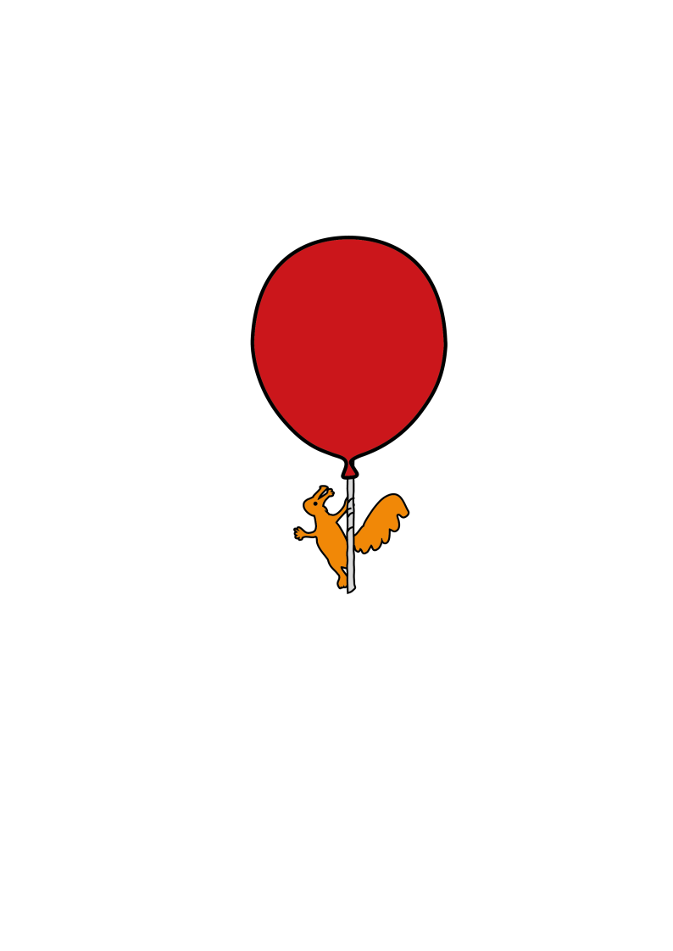



Ophthalmology

**My Eye Patch**

Information for children 5+ years

**Name:**

**Patch worn over: Right Eye Left Eye**

**For …… hours per day**

**Why do I need to wear my patch?**

You have two eyes.



[](https://www.google.co.uk/url?sa=i&rct=j&q=&esrc=s&source=images&cd=&ved=2ahUKEwjJ5qX9oariAhVEzBoKHdV-B9wQjRx6BAgBEAU&url=https://www.pngkey.com/detail/u2q8a9q8r5a9q8y3_15-png-cartoon-eyes-for-free-download-on/&psig=AOvVaw2JoCKrJ-70jqAAttOOF9nU&ust=1558447053670636)

But sometimes one eye is not as strong as the other so this eye needs extra help to see better.

You might need to wear glasses.

[](http://www.google.co.uk/url?sa=i&rct=j&q=&esrc=s&source=images&cd=&cad=rja&uact=8&ved=2ahUKEwik3JywoqriAhVGbBoKHXdNCNUQjRx6BAgBEAU&url=http://www.images.signarama.com.au/search/cartoon%20eyes%20with%20glasses.html&psig=AOvVaw0JjOMbTl8cMBM0JhjRBdLz&ust=1558447196994609)

You may also need to wear an eye patch to hide one eye to make the other eye work harder.

**How long will I have to wear my patch?**

When you play the pictures or letter game with the Orthoptist they will tell you. You will not have to wear your patch forever! Just until your eye gets stronger.

**What do patches look like?**

The patches have lots of different colours and patterns on them. You can choose which one you would like to put on each day.



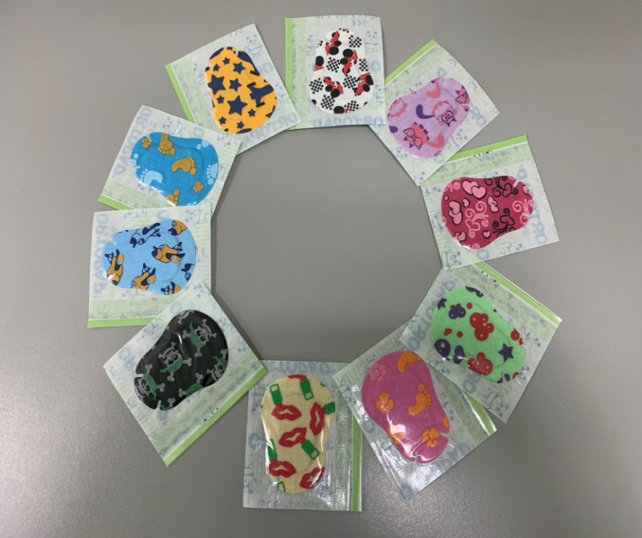

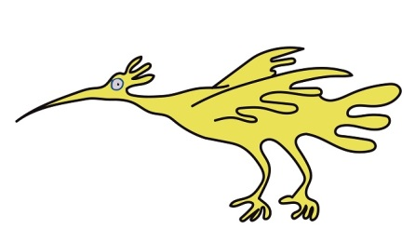

If you have any problems with these sticky patches you may be given a material patch that goes on your glasses. Which looks like this:

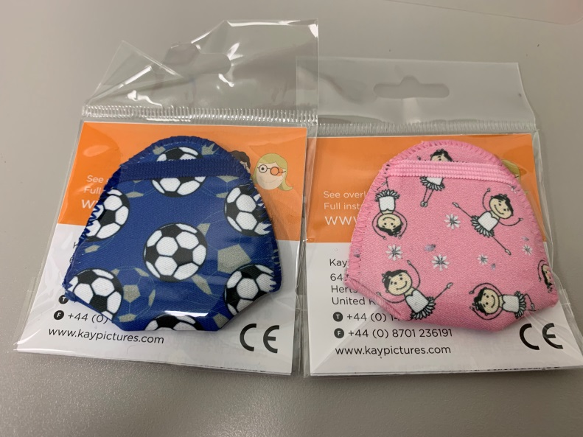

**Do I have to wear my eye patch at nursery or school?**

If you don’t want to wear your eye patch at nursery or school then you can wear it at home.

As long as you wear it for as long as the orthoptist has told you to, then you can wear your patch whenever you want.

**What can I do with my eye patch on?**

You can do all the things you normally enjoy doing such as:

* [](http://www.google.co.uk/url?sa=i&rct=j&q=&esrc=s&source=images&cd=&ved=2ahUKEwib3ObvoqriAhUGnxQKHUe5DPwQjRx6BAgBEAU&url=http://clipart-library.com/cartoon-book.html&psig=AOvVaw2mTA1NqWRxcc55tOHRrLjG&ust=1558447324685499)Read a story
* [](https://img.talkandroid.com/uploads/2011/11/ARCHOS-80-G9-ambiance-Asphalt.jpg)Colouring in
* Play on your tablet
* It is important that you do not try to peep when you have your patch on

This leaflet only gives general information. You must always discuss the individual treatment of your child with the appropriate member of staff. Do not rely on this leaflet alone for information about your child’s treatment.

This information can be made available in other languages and formats if requested.

Alder Hey Children’s NHS Foundation Trust

Alder Hey

Eaton Road

****Liverpool

L12 2AP

****Tel: 0151 228 4811

[www.alderhey.nhs.uk](http://www.alderhey.nhs.uk)

**© Alder Hey Review Date: MAY 2028 PIAG: 232**