

Haematology Department

**Sickle Cell Crisis – Incentive Spirometry**

Information for Parents and Carers

**Introduction**

This leaflet aims to provide you with general information about incentive spirometry in sickle cell disorders. If you are ever worried about your child, please contact your Sickle Cell Team or take your child to the Accident and Emergency Department.

**What is incentive spirometry?**

Incentive spirometry is a medical device that is used to help with breathing exercises. It will help your child to take deep breaths. Deep breathing exercises increase lung expansion by opening up the air sacs, which help to reduce the breathing problems.

**Incentive spirometry devices**

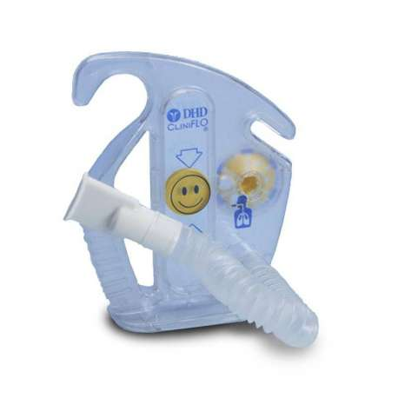 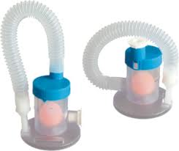

**Why is incentive spirometry used in sickle cell disease?**

When children and young people with sickle cell disease have a crisis, the pain they experience makes them feel reluctant to take deep breaths. Also, some pain medicines that belong to the opioid family, such as morphine, that are used to treat sickle cell crisis can also cause shallow and slow breathing. All of these things put your child at risk of developing a chest infection or a chest crisis. Incentive spirometry has been shown to reduce this risk and help expand the lungs.

**When should my child use the incentive spirometry?**

·  When your child has a crisis particularly if it is into their back, stomach or chest OR

·  When they are having a severe crisis with a pain score over 7 and are having difficulty moving/ walking.

**How does my child use incentive spirometry?**

Your child should sit up and hold the incentive spirometer upright.

They should:

* Place the mouthpiece of the incentive spirometer into their mouth. Make sure they make a good seal with their lips.
* Breathe out (exhale) normally.

* Breathe in (inhale) slowly and deeply. The ball in the incentive spirometer will rise as they take a breath in. Try to get your child to get the ball to rise as high as they can.
* ****Your child should hold their breath for a few (three –five) seconds, then slowly release their breath and exhale.
* **Repeat this routine 10 times (ensuring a good technique)**

**How often should they use the incentive spirometry?**

You should encourage your child to use the incentive spirometry **every two hours** when they are awake. You don’t need to wake your child up during the night to do it. If they are awake during the night, you can perform incentive spirometry.



**QR code: Scan the image below with your mobile device to watch a tutorial of how to use the device and cleaning**

[https://www.youtube.com/watch?v=eYLMVxK7AxE&t](https://mail.alderhey.nhs.uk/owa/redir.aspx?C=5Z7lXQg4pJqyuY0bgV6l5zKd2HnvPNZThul9mJeWExYXXC-O1DLXCA..&URL=https%3a%2f%2fwww.youtube.com%2fwatch%3fv%3deYLMVxK7AxE%26t)

**What if my child cannot use an incentive spirometer?**

Your child will be shown by a physiotherapist how to use the incentive spirometer. If they are unable to use if or are too young, then you can encourage deep breathing by getting them to blow bubbles or play blowing games. Also, movement and activity will encourage your child to naturally take deeper breaths which is recommended.

**Can my child use an incentive spirometer at home?**

Your child will be given an incentive spirometer when they are in hospital, and you will be able to take this home for use in the short term. You should encourage your child to use it every time they have a crisis and ensure the tube and mouthpiece are kept clean.

**Are there any other things that I should be doing for my child?**

* **Mobilising**

It is very important to ensure that your child is walking and moving as normally as possible. This will naturally encourage deep breaths. Also encourage your child to maintain arm flexibility by stretching their arms up (see diagram below), putting their hands on their heads and circling the arms.



* **Posture**

****Ensure your child keeps a good posture.

* **Pain management**

Ensure that your child gets adequate pain medication

**What should I do if I am worried about my child?**

**If you are worried about your child, then contact your Sickle Cell Team or bring them to Accident and Emergency Department for review.**

**Further information**

If you have any questions or want any further information, please contact your Sickle Cell Team on 0151 252 5079.

**Useful websites**

[www.alderhey.nhs.uk](http://www.alderhey.nhs.uk)

[www.sicklecellsociety.org](http://www.sicklecellsociety.org)

**References**

Bellet, P. et al (1995) Incentive Spirometry to Prevent Acute Pulmonary complications in Sickle Cell Diseases. The New England Journal of Medicine. 333 (11) September, 699-703

Chacko, G.M., Cohen, A.J., Javed, S.T., Ogunnaya, F.U. and Cheng, Y. (2024). Assessing Compliance of Incentive Spirometry in Hospitalized Patients with Acute Sickle Cell Crisis. *Blood*, *144*, p.7528.

Alder Hey Children's NHS Foundation Trust is neither liable for the contents of any external internet site listed, nor does it endorse any commercial product or service mentioned or advised on any of the sites.

This leaflet only gives general information. You must always discuss the individual treatment of your child with the appropriate member of staff. Do not rely on this leaflet alone for information about your child’s treatment.

This information can be made available in other languages and formats if requested.

Alder Hey Children’s NHS Foundation Trust

Alder Hey

Eaton Road

****Liverpool

****L12 2AP

Tel: 0151 228 4811

[www.alderhey.nhs.uk](http://www.alderhey.nhs.uk)

**© Alder Hey Review Date: June 2028 PIAG: M4**