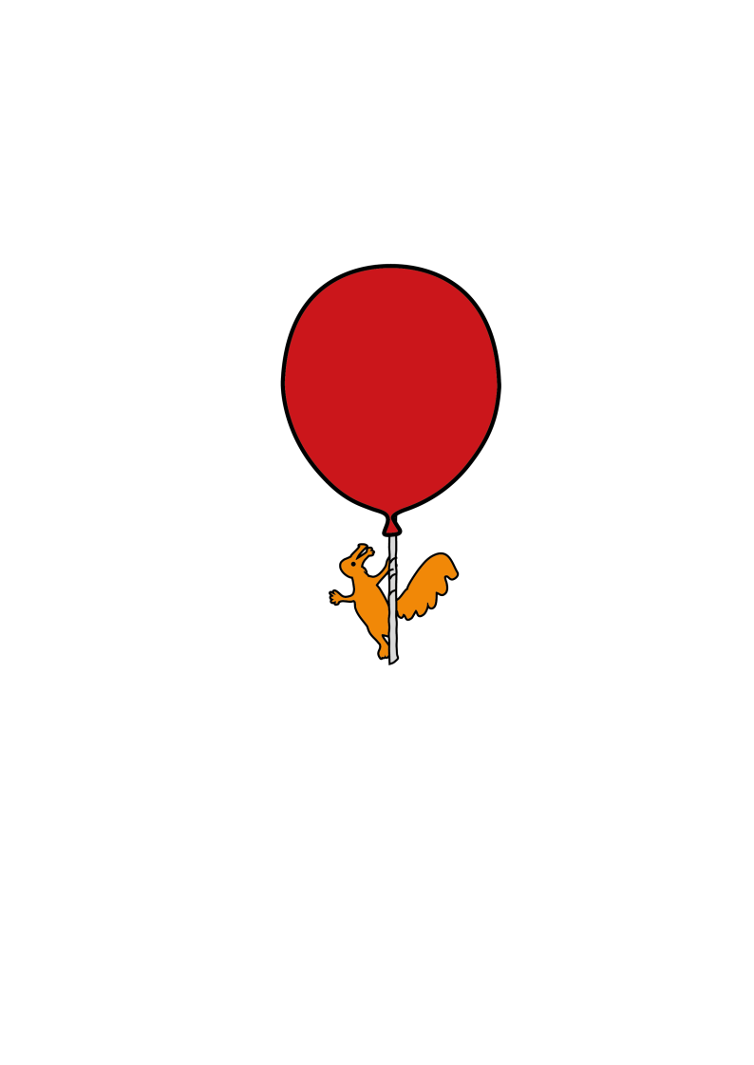

Ophthalmology department

**Contact lenses for children**

Information for parents and young people

**Why has my child been fitted with contact lenses?**

The most common reasons for children to be fitted with contact lenses in the hospital are: following cataract surgery, to correct significant amounts of long-sightedness (hypermetropia), short sightedness (myopia), astigmatism, or to enhance the appearance of an eye. Not all children who wear glasses are eligible to have contact lenses from the hospital, but your optometrist can advise you.

When a child has a strong glasses prescription the spectacle lenses can be thick and heavy. They will usually get the best vision when looking through the centre of the lenses as thick lenses can give distorted vision around the edges. In these cases contact lenses may give the child better peripheral vision.

**Successful contact lens wear**

****As your child has been supplied with contact lenses it is important to know how to care for them correctly. If you have any questions about this, please discuss with your optometrist.

**How do I clean the contact lenses?**

It is important to always wash your hands before handling the contact lenses.

For soft contact lenses (multi-purpose solution)

* After removal, place the contact lens in the palm of your hand, facing upwards like a bowl.
* Put a few drops of the multi-purpose solution onto the lens and rub gently, but firmly, with your finger for 20-30 seconds.
* Then rinse with the solution
* Place the contact lens in it’s case, fill with fresh solution and leave for a minimum of 6 hours.
* **Never rinse or store your contact lenses in tap water.**

Always clean your contact lenses with your solution as directed by the manufacturer’s instructions.

If the lenses have not been worn for more than a week the solution in the case should be changed. The lenses should be cleaned again before they are used.

**Do I need to clean the case?**

You should empty the contact lens case of solution every morning after inserting the contact lenses, rinse it with saline or multi-purpose solution and then leave to air dry. You should replace the case at least every 3 months. **Never rinse the case with tap water**.

Remember - do not put a clean contact lens into a dirty case.

**How long should the contact lenses be worn for?**

Most soft lenses are designed to be inserted in the morning and removed in the evening. Some contact lenses for young children and babies can be worn continuously for up to a month. Your optometrist will advise you of the maximum wearing time for your lenses.

**Where do I get my contact lens solutions from?**

Solutions are usually provided by the hospital when you attend clinic appointments. However, if you run out, solutions are readily available from most pharmacies, supermarkets or opticians.

**When will my next appointment be?**

After an appointment to learn how to insert and remove the contact lenses, regular aftercare appointments will be needed. This may be when you come to see the consultant for a check-up or at a separate contact lens clinic appointment. At these appointments the optometrist will check that the contact lenses are fitting properly and that the prescription is correct. They will also check the eyes for any signs of contact lens related problems. It is important that you attend all your appointments, even if you are having no problems, as your optometrist can detect early signs of problems before you are able to notice them. If you are unable to attend an appointment please contact the appointments office as soon as possible to re-arrange on 0151 252 5358.

**Should my child wear their contact lenses to appointments?**

Yes, they should attend all aftercare appointments wearing their contact lenses (preferably having had them in for more than an hour). Bring your case and glasses to the appointments.

**What problems can happen when wearing contact lenses?**

If your child complains of pain (or shows signs of pain) when the lens is first inserted then you may have some dust under your lens. Remove the lens and clean as per your recommended regime. Only re-insert if the eye looks and feels comfortable. Discomfort can also be caused by a damaged contact lenses or soft lenses being inside out. Never wear a damaged contact lens. If the discomfort is caused by a dusty or damaged contact lens, then the symptoms should resolve once the contact lens is removed.

Infections are rare but can be serious and can cause symptoms of redness, irritation, pain, light sensitivity and blurred vision. These symptoms are not resolved by removing the contact lenses. See contact details below for urgent advice if you suspect an infection.

**What are the risks of contact lens wear?**

Serious contact lens-related infections are rare and can affect about 4 in 10,000 patients. For those patients with poor hygiene, or who over wear their contact lenses, this risk greatly increases.

**Can I reduce the risk of infection?**

There are simple steps which you can take to reduce the risk of infection. Good contact lens hygiene is important as poor hygiene makes you four-times more likely to acquire an infection. Sleeping in your contact lenses that are not designed to be worn overnight increases your chances of an infection by about four-times.

**What should I do if the eye is red and/or painful?**

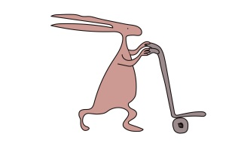If your child’s eye becomes red and/or painful whilst wearing the contact lenses, you should remove the lens immediately. If the redness/pain doesn't resolve after removing the lens, then please contact the contact lens clinic during clinic hours or attend accident and

emergency at Alder Hey out-of-hours. If there is a problem in one eye it is best to

remove both lenses and wear their glasses.

Do not insert your child’s lenses if they are unwell.

**Can my child swim in their contact lenses?**

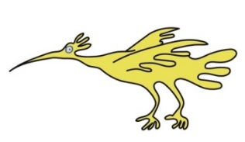It is best to remove your child’s contact lenses before swimming as contact with water increases the risk of infection. It is ok to leave the lenses in babies for bathing but be careful not to get any water in their eyes.

**Flying in contact lenses?**

Aeroplane cabins are usually very dry so it is best to remove contact lenses before flying.

**What happens if I miss an appointment?**

It is very important to attend all your aftercare appointments to ensure that your contact lenses are fitting correctly and to detect any contact lens associated eye problems. If you cannot attend an appointment please contact the appointments desk as soon as possible to rearrange

**For further information**

If you have any queries or need further information please telephone the Ophthalmology Department on: 0151 252 5215. For non-urgent queries or contact lens requests email [optical.services@alderhey.nhs.uk](mailto:optical.services@alderhey.nhs.uk) with ‘FAO of Optometrist’ as email title.

This leaflet only gives general information. You must always discuss the individual treatment of your child with the appropriate member of staff. Do not rely on this leaflet alone for information about your child’s treatment.

This information can be made available in other languages and formats if requested.

Alder Hey Children’s NHS Foundation Trust

Alder Hey

Eaton Road

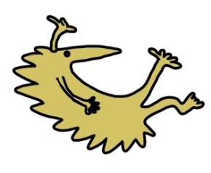Liverpool

L12 2AP

Tel: 0151 228 4811

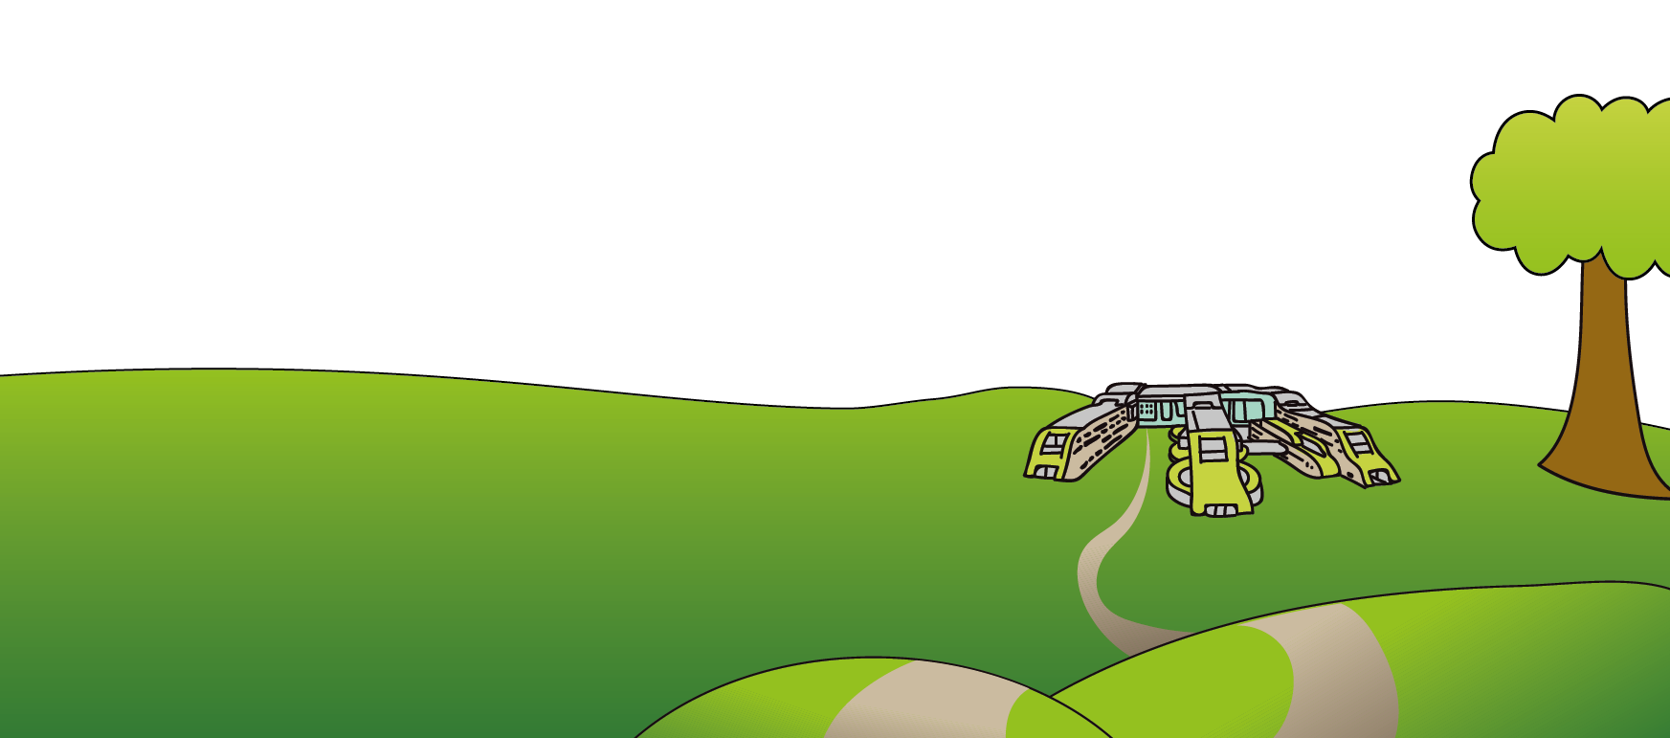[www.alderhey.nhs.uk](http://www.alderhey.nhs.uk)

**© Alder Hey Review Date: May 2028 PIAG: 331**