**Since my child has tics does it also mean that they have**

**Tourette Syndrome?**

That is very unlikely. Tourette Syndrome is an uncommon condition. For a diagnosis of Tourette Syndrome, children must have several types of tics, and they must have been present for more than a year. One of these tics must be a repeated sound that they make for example clearing the throat.

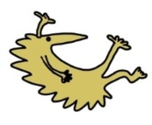Children with Tourette Syndrome usually have problems with their behaviour as well. They may have problems with concentrating or fidgeting (ADHD) and they may also have quite obsessional (obsessive compulsive disorder) or rigid behaviour.

This may have been discussed with you today, but don’t be afraid to ask if this is what you are worried about.

You can also find out more about tics on Your Child’s Health website: <http://www.yourchildshealth.nhs.uk/>

You can also read about Tourette Syndrome on the Tourette Syndrome Association (UK) website: <http://www.tsa.org.uk>

This leaflet only gives general information. You must always discuss the individual treatment of your child with the appropriate member of staff. Do not rely on this leaflet alone for information about your child’s treatment. This information can be made available in other languages and formats if requested

Alder Hey Children’s NHS Foundation Trust

Eaton Road

Liverpool

L12 2AP

Tel: 0151 228 4811

[www.alderhey.nhs.uk](http://www.alderhey.nhs.uk)

**© Alder Hey Review Date: June 2028 PIAG: 302**



**Department of General Paediatrics**

**Tics**

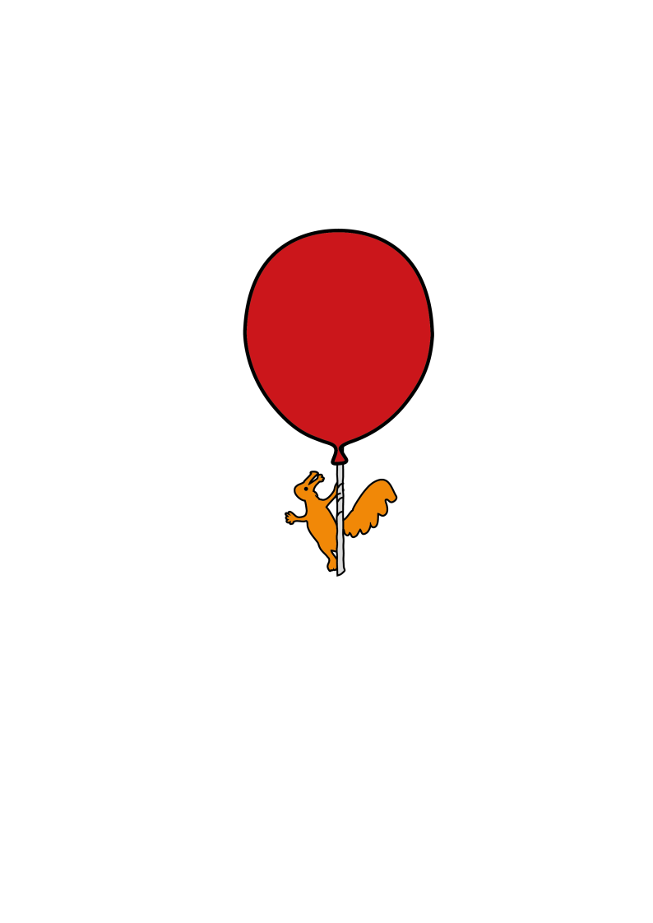

**Information for patients,**

**parents and carers**

**What are tics?**

Tics are rapid and repeated involuntary movements that usually affect the face and neck. They are sometimes referred to as ‘habits’ or ‘mannerisms.

**What have you noticed?**

Tics take the form of repeated eye blinking, shoulder shrugging, clearing of the throat, sniffing, grimacing or twitching of the face, coughing or twisting of the neck. Usually, children do the same movement repeatedly. Children can have more than one tic at a time, or the types of tics can change from one form to another over several weeks or months

**Who can be affected by tics?**

****Tics affect all age groups but are commonest in school-age children. They affect up to 20 percent of children in this age group. Tics are much more common in boys. Quite often there is another family member who also has tics.

**At what age do tics start?**

Tics tend to start between the ages of 7 and 9 years but can start at any age.

**What causes tics?**

We do not know what causes tics. Sometimes they may appear after stressful situations like accidents, illnesses or social problems. They may be noticed after taking certain medicines for example some of the treatments for hyperactivity disorder (or ADHD as it is also called).

**Are tics present throughout the day and night?**

No. Tics can occur occasionally or very frequently throughout the day but they are never present during sleep.

**Can tics stop if the child tries or concentrates on this?**

Not really. But some children may be able to partially control them for a short period of time. For example, when the child goes to see the doctor about the tics!

**Is there anything that makes tics worse?**

Yes. Tics increase when there is stress and when a child is anxious or tired. They may also be more noticeable when the child is relaxed and in their own house. Parents often notice this after school.

**Are there any medicines that can treat tics?**

Fortunately, tics usually stop on their own, but children can have tics for several years. Most parents feel reassured when they have had an explanation about tics, and do not want to consider any treatments for their child. If tics become noticeable and are making the child’s life difficult at school, the child themselves may ask for treatment.

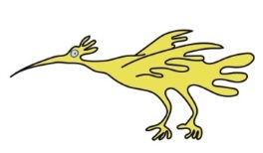All the medicines we use for tics have potential side effects. The doctors who have been seeing your child will think very carefully about whether they would recommend any treatments for the tics. They will probably want some information from school before considering this as well.

**Is there anything I can do to help my child?**

You can help your child by not telling them off about the tics. Ignoring the tics might help by reducing their anxiety. You could also reassure your child that the tics generally get better with time.

**What else could I do?**

You can also help your child by finding out if they are experiencing problems at school or with their friends. You could also explain to the teachers so that they understand what is happening to your child and also that they ignore the tics just as you do at home.

**What do I do if the tics do not improve?**

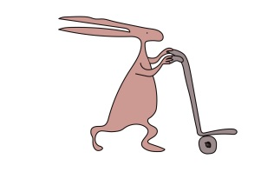If the tics do not improve within one year you should see your family doctor. Your doctor may refer you to a specialist, who may prescribe some medication if the tics are very troublesome or interfering with your child’s social life.