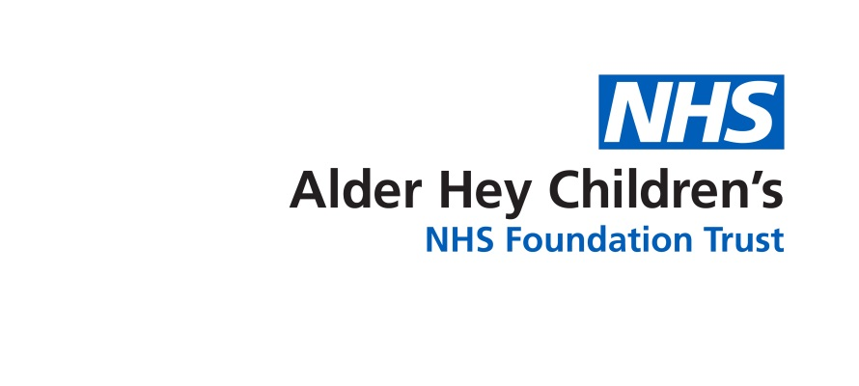

**NEUROFIBROMATOSIS Type 1 (NF1) Paediatric Service at Alder Hey Children Hospital**

**Information for parents and carers**

**Why has my child been referred to NF1 clinic ?**

You are being referred to Neurofibromatosis type 1 clinic because your child has been diagnosed with or a health professional has a high suspicion of your child having NF1. The NF1 clinic works closely with your local team to provide ongoing surveillance, guidance and signposting and involves specialists as needed to manage your childs NF1.

**What is Neurofibromatosis type 1 -NF1?**

Neurofibromatosis type 1 is a common inherited genetic condition with a birth incidence of 1 in 3000 of the population. About half of the people are the first to be affected in their family. The condition mainly affects the skin and the nervous system though any organ can be involved. However there are multiple complications linked to NF1 and the severity and type of clinical presentations can vary, even within families.

**What are the early signs of Neurofibromatosis Type 1?**

The early signs of NF1 are café au lait spots (flat brown birthmarks) on the skin, freckles in unusual places, and neurofibromas (growths) on the skin. One third of people with NF1 will have one or more medical complication during their lifetime.

**How is Neurofibromatosis Type 1 diagnosed?**

There are specific clinical criteria that help in confirming a diagnosis of NF1 and your doctor will be able to make a diagnosis based on this. Your doctor may also organise Genetic testing to aid diagnosis or refer you to a genetics service.

**What treatment/ management is available for my childs NF1?**

If someone has NF1, they will have it for life. There is as yet no specific medical treatment to cure, prevent or reverse the features of NF1. Some people may never experience health complications and some may develop complications that are known to be common with NF1. Regular NF1 surveillance by NF1 multidisciplinary team is essential to identify and treat any complications early involving other specialities for further guidance and management as required. The NF1 team also keep up to date and offer any newer treatmenst opportunities as they become available. We do not recommend any routine scans but would organise any investigations as clinically indicated.We sometimes may provide you an opportunity to take part in research projects but that is entirely voluntary.

**What is NF1 Surveillance?**

Regular screening of organs which are likely to get affected by NF1, through examination of whole body including skin, bone, eyes, spine, oral cavity, neurological & systematic examination at regular intervals. The children are usually seen annually or as clinically appropriate for review of their NF1condition. Occasionally the clinician may organise or recommend investigations as clinically indicated. These can be performed at Alder Hey or locally as agreed.

**What happens to the results?**

The results of any Investigtions will be updated to family and relevant team once available. If required any scans will get discussed in our multidisciplinary meeting and the outcome will be fed back to family and local team; if they are organised locally we will request any investigations to be shared with us and we can advice on next steps as needed.

**What does the NF1 service provide?**

Our Specialist multidisciplinary team will offer detailed assessment to discuss the needs of the child or young person. This will usually be a face to face appointment in a clinic setting. If needed further intervention or other specialty referrals are required, these will be organised as appropriate.We also provide a transition clinic to discuss options when the child is ready to move to adult services.

**Who will be present in the NF1 clinic?**

Consultant Paediatrician with expertise in NF1 and/ or an NF1 specialist Physician Associate is always present. Also present is our NF1 Nurse advisor. Sometimes you may be invited to attend a specialist joint clinic with the Consultant Geneticist if clinically indicated.

**How do I get a referral to the NF1 service?**

Referrals will be accepted from a Paediatrician, Geneticist or any clinician who can make a diagnosis of NF1 or strongly suspects a child of having NF1 through detailed clinical letter or preferably via our online referral form.

**Referral criteria**

The child or young person must have a confirmed diagnosis of NF1 or most likely to have NF1 who have been seen by a Paediatrician or Genetic consultant. For children from out of the Liverpool area, there must be a named Paediatric consultant who can support the child locally and be the first point of contact as needed.

**What are the possible outcomes from the service?**

We provide ongoing surveillance,clinical assessment, investigations, intervention, signposting and review of children with NF1 regularly until transition.

**How often will my child need to be seen?**

Usually every 12-15 months. There are some variations depending on health need.

**What if I have further questions?**

If you have any NF1 related concerns or queries then you can contact the NF1 Team through a generic email or you can liaise with the NF1 advisor and we will get back to you within 5 working days. However for any emergencies or general health concerns you should approach your local pathways / emergency department as appropriate.

**Our Contact:**

NF1 Team

Community Division

Alder Hey Children Hospital

Eaton Road

Liverpool

L12 2AP

Tel: 0151 228 4811

Email: [commpaedsqueries@alderhey.nhs.uk](mailto:commpaedsqueries@alderhey.nhs.uk)

**Further Information & Support:**

**Nerve Tumours UK Specialist Support**

Nerve Tumours UK helps fund a team of Support Specialists in a number of regions across the United Kingdom. These specialists work to improve the lives of those affected by Neurofibromatosis and provide crucial support to patients and families. They can be contacted through Nerve Tumours UK Website at <https://nervetumours.org.uk>

**National Helpline**

Open Mondays and Wednesdays 9am - 5pm, if you need someone to talk to or some help getting to the right place. Call 07939 046 030 or email helpline@nervetumours.org.uk.

**Patient Advice and Liaison Service for Alder Hey (PALS)**

Tel: 0151 252 5161

This leaflet only gives general information. You must always discuss the individual treatment of your child with the appropriate member of staff. Do not rely on this leaflet alone for information about your child’s treatment.

This information can be made available in other languages and formats if requested.

[www.alderhey.nhs.uk](http://www.alderhey.nhs.uk)

**© Alder Hey Review Date: May 2028 PIAG: 612**

