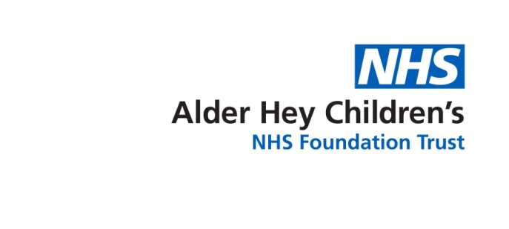

**Cow’s Milk Protein Allergy (Delayed)**

Information for parents and carers

**Introduction**

This leaflet is aimed at providing parents and carers with information about a condition called Cow’s Milk Protein Allergy. This leaflet applies to delayed reaction to cows milk, not immediate.

**What is Cow’s Milk Protein Allergy?**

Cow’s Milk Protein Allergy occurs when the body’s immune (defence) system mistakenly recognises the proteins found in cow’s milk as potentially harmful. This causes the immune system to become sensitised so that the next time cow’s milk is consumed, the immune system remembers that the protein may be harmful and reacts to it, producing allergic symptoms.

There are 2 types of Cow’s Milk Protein Allergy, depending on how the immune system reacts:

Symptoms that are ‘delayed’ (slow to appear). This is called Non IgE mediated allergy and is the most common type of milk allergy in infants. Symptoms tend to develop from 2 hours after drinking milk but can take up to 72 hours. If cow’s milk continues to be consumed in the diet, the immune system will continue to produce symptoms over days or even weeks. Symptoms of this type of allergy include:

· Skin reactions (itchy, red rash or significant eczema) · Diarrhoea/ constipation

· Vomiting · Blood or mucous in stool

· Colic · Weight loss or not gaining weight as expected

**This leaflet is designed for babies with suspected delayed Cow’s Milk Protein Allergy**

****The other type of milk allergy happens when the symptoms are ‘immediate’ (quick to appear) and are caused by a different part of the immune system, reacting in a different way. These symptoms are caused by the immunoglobulin E antibody (called IgE) and tend to happen within minutes of consuming cow’s milk or up to 2 hours afterwards. Symptoms of this type of allergy include:-

* Hives (nettle rash)
* Swelling of the lips and itching
* Vomiting/ diarrhoea
* Severe reactions (Anaphylaxis) – these are rare and include difficulty breathing,

wheeze, becoming faint or floppy.

**If your child suffers signs of anaphylaxis go to A&E / Call 999 as appropriate.**

**This leaflet is not designed for babies that are suspected of having IgE mediated allergy.**

It is important not to confuse cow’s milk protein allergy with lactose intolerance. Lactose intolerance is an inability of the gut to breakdown milk sugar (lactose). It is exceptionally rare in infants. It is also worth noting that lactose free foods may still contain cow’s milk proteins.

**How is a delayed (Non IgE) Mediated Allergy diagnosed?**

If delayed cow’s milk allergy is suspected, skin prick testing and/ or blood tests are not helpful. The diagnosis for delayed allergy needs to be confirmed or excluded by starting a trial elimination of all cow’s milk protein, either from you baby’s diet if they are formula fed or from the mother’s diet if breast fed.

After the elimination trial (usually 4-6 weeks after eliminating cow’s milk from the diet) you will be advised to gradually reintroduce cow’s milk into your baby’s diet over a period of about one week, either by introducing formula or by reintroducing milk products into mum’s diet. This process will show if any improvement in your baby’s health was actually due to milk allergy. If allergy is the cause, symptoms can be expected to return within the first few days of reintroducing cow’s milk. If this happens, it will be necessary to return to the cow’s milk free diet. Cow’s Milk Protein Allergy will then be confirmed and you will be referred to a community paediatric dietitian for further follow up and management.

It is very important that the diagnosis is confirmed this way (as per NICE quality standard guidelines) as without this Cow’s Milk Protein Allergy is likely to be over diagnosed and lead to inappropriate management of symptoms and an unnecessarily restrictive diet.

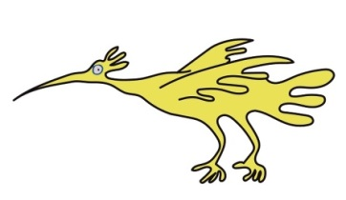It is, however, important to note that many of the symptoms of delayed milk allergy such as eczema, colic, vomiting and diarrhoea are very common in infants and will often be due to other, simple causes.

**Managing a cow’s milk protein allergy**

Breastfeeding—if you are breastfeeding and your baby’s Doctor thinks they may have a

Cow’s Milk Protein Allergy, you will need to cut out cow’s milk protein from your diet (you should ask for a referral to a dietitian to help with this). The proteins in cow’s milk are called casein and whey; you should look for these in ingredients as well as ‘milk’ when choosing foods that you are unsure about containing milk. You should also avoid goat and sheep milk as the proteins found in these milks are very similar to those found in cow’s milk.

Formula feeding —your baby’s formula will need to be changed to a hypoallergenic (low allergy) formula. Extensively hydrolysed formulas still contain cow’s milk protein but they have been broken into smaller pieces so the immune system is less likely to identify them as harmful. Most infants with Cow’s Milk Protein Allergy will tolerate these. For those who still have symptoms on extensively hydrolysed formula an amino acid formula is required, this formula is not based on cow’s milk and the protein is completely broken down.

Combination feeding- If you are feeding your baby with breast milk and formula milk, your baby’s formula will need to change to a hypoallergenic formula (see above for further information). You may also need to cut cow’s milk protein from your diet but this will depend on whether your baby reacts to the milk proteins in formula only or in formula and breast milk, the healthcare professional advising you can help guide you with this.

We understand that caring for babies with a cow’s milk protein allergy can be difficult and stressful. We would like to reassure you that symptoms will settle in most babies once the cow’s milk proteins are removed from their diet. Most children with cow’s milk protein allergy are able to tolerate cow’s milk by the age of 2; your dietitian will talk you through the reintroduction of cow’s milk into your child’s diet.

**What if my baby doesn’t like the new formula?**

Extensively hydrolysed and amino acid formulas taste and smell different to regular formulas. Most younger babies will take the new formula with no problems but if your baby does have problems taking the formula you can try gradually introducing it by mixing it with regular formula. For example 2oz hypoallergenic formula, 5oz regular formula in a 7oz bottle and then gradually increase the hypoallergenic formula and decrease the regular formula until you baby is taking full bottles of hypoallergenic formula.

**When should I see a Doctor?**

You should see a doctor if:-

· There are new concerns such as marked distress, feeding difficulties or faltering growth

· Vomiting becomes persistently projectile

· There is bile stained (green or yellow green) vomiting or blood in the vomit

· There is blood in your baby’s poo

· Your baby is under 3 months and develops a fever

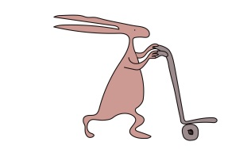· If your child suffers an immediate allergic reaction (becomes breathless or faint/ floppy) **go to A&E/ call 999 as appropriate**

**Who to contact for further information or support?**

Your Health Visitor/ Midwife

Infant feeding helpline - 0151 702 4293 (babies under 6 weeks born at LWH)

Breast feeding support - BAMBIS Liverpool - 0151 233 6874

Breast feeding support Sefton - 0151 291 8010 / 07752661408

Bosom Buddies (Knowsley) - 0151 244 3269

[www.allergyuk.org](http://www.allergyuk.org)

[https://www.bda.uk.com/resource/children-with-cows-milk-allergy.html](https://urldefense.proofpoint.com/v2/url?u=https-3A__www.bda.uk.com_resource_children-2Dwith-2Dcows-2Dmilk-2Dallergy.html&d=DwMFAw&c=bMxC-A1upgdsx4J2OmDkk2Eep4PyO1BA6pjHrrW-ii0&r=ZNatX2iRDNPF54Aeo6LFy5zVPvuX6cun3mYEp34cpwM&m=2mgZ8raV1zyijLMc4Vg7u5BEqhr_63jVZQsafg8J-bk&s=tHyx9GbjP2GKeOOw9Q-f4PIIHjN9Qc4IaWhVgLXe9TU&e=)

[https://www.bda.uk.com/resource/milk-allergy.html](https://urldefense.proofpoint.com/v2/url?u=https-3A__www.bda.uk.com_resource_milk-2Dallergy.html&d=DwMFAw&c=bMxC-A1upgdsx4J2OmDkk2Eep4PyO1BA6pjHrrW-ii0&r=ZNatX2iRDNPF54Aeo6LFy5zVPvuX6cun3mYEp34cpwM&m=2mgZ8raV1zyijLMc4Vg7u5BEqhr_63jVZQsafg8J-bk&s=cOdeEtTYEw6RwbsfxHMXWW-42m5ViQ_z5AD31JVKBEs&e=)

[https://www.bda.uk.com/resource/food-allergy-intolerance-testing.html](https://urldefense.proofpoint.com/v2/url?u=https-3A__www.bda.uk.com_resource_food-2Dallergy-2Dintolerance-2Dtesting.html&d=DwMFAw&c=bMxC-A1upgdsx4J2OmDkk2Eep4PyO1BA6pjHrrW-ii0&r=ZNatX2iRDNPF54Aeo6LFy5zVPvuX6cun3mYEp34cpwM&m=2mgZ8raV1zyijLMc4Vg7u5BEqhr_63jVZQsafg8J-bk&s=HoflxiKw6AODdsDwDfVFE9AaEiT5C1S7vJJq09NuMKU&e=)

This leaflet only gives general information. You must always discuss the individual treatment of your child with the appropriate member of staff. Do not rely on this leaflet alone for information about your child’s treatment.

This information can be made available in other languages and formats if requested.

****Alder Hey Children’s NHS Foundation Trust

Alder Hey

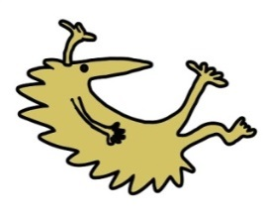Eaton Road

Liverpool

L12 2AP

Tel: 0151 228 4811

[www.alderhey.nhs.uk](http://www.alderhey.nhs.uk)

**© Alder Hey Review Date: February 2028 PIAG: 0022**