**Further reading**

For more information on VRE; what you can do to help and what we do at Alder Hey to stop the spread, please use the following QR codes/website links;

<https://www.nhs.uk/conditions/respiratory-syncytial-virus-rsv/>



[www.alderhey.com](http://www.alderhey.com)



Made with help from xxx aged x

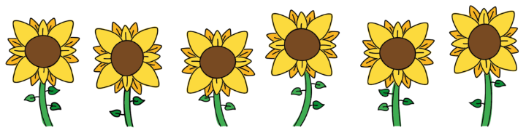

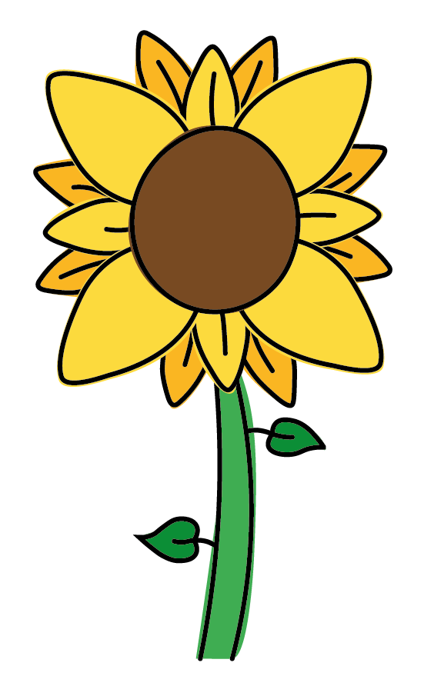

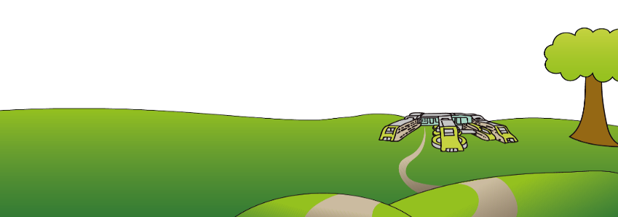

Alder Hey Children’s NHS Foundation Trust

Alder Hey

Eaton Road

Liverpool

L12 2AP

Tel: 0151 228 4811

[www.alderhey.nhs.uk](http://www.alderhey.nhs.uk)

**© Alder Hey PIAG: 44**

**Review Date: April 2028**

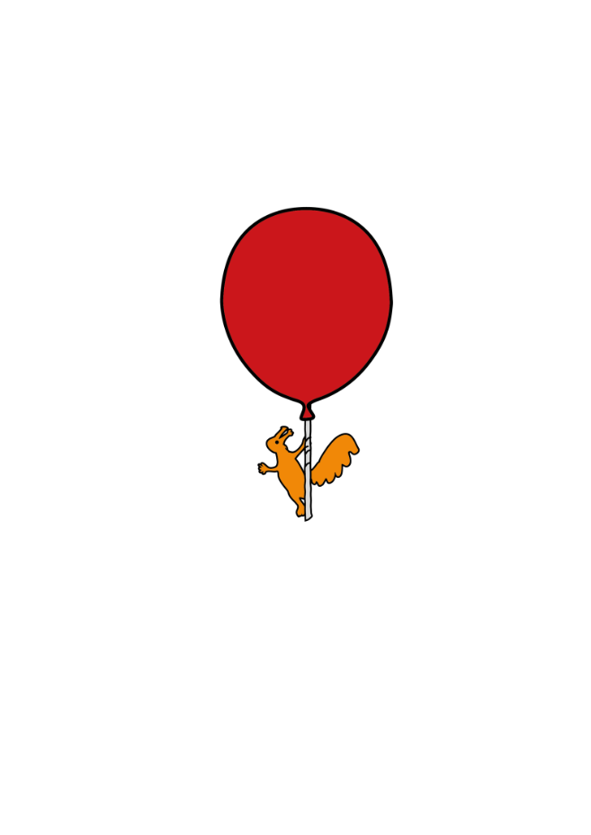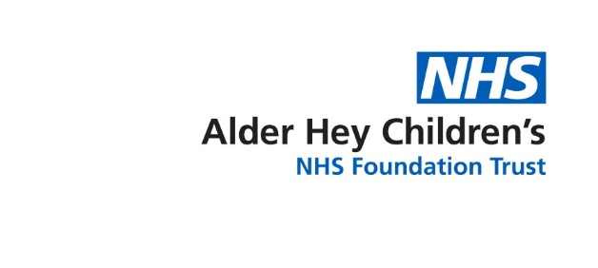

Infection Prevention & Control

**RSV**

**Respiratory Syncytial Virus**

**Information for Parents & Carers**



**What is RSV?**

**(Respiratory syncytial virus)**

Respiratory syncytial virus (RSV) is a frequent cause of coughs and colds. RSV is very common, almost all children get it at least once before they're 2 years old. Children with RSV usually get better by themselves, but can sometimes require treatment in more serious cases. This is especially true for premature babies, babies under 6 months old and children with weakened immune systems or long-term heart and lung conditions. In babies, RSV is a common cause of a type of chest infection called [*bronchiolitis*](https://www.nhs.uk/conditions/bronchiolitis/). This can cause breathing problems and sometimes needs to be treated in hospital.

**What are the signs, symptoms of RSV?**

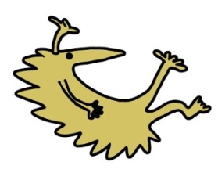Symptoms of an RSV infection usually start within a few days of getting infected. Most people only get cold-like symptoms, such as:

* a runny or blocked nose
* a cough
* sneezing
* tiredness
* a high temperature – signs include your back or chest feeling hotter than usual, sweatiness and shivering (chills)

Babies with RSV may also be irritable and feed less than usual.

**How do people become carriers and how are they identified?**

RSV is spread by droplets from coughs and sneezes. It can live on surfaces or objects for several hours.

Someone with RSV will normally be contagious for 1 to 2 days before symptoms start. Most people are contagious for 3 to 8 days. Some infants and people with weakened immune systems may be contagious for up to 4 weeks. In hospital we use a simple test called a PCR to confirm if a child has RSV, this is a swab usually taken from the nose or throat. The results are usually back within 1-2 days.

**How to reduce risk of transmission?**

Droplet and Contact

You may notice the isolation poster on your door, this is to advise any staff entering how best to reduce the risk of transmission. You can help too by;

* Ensuring cubicle door remains closed
* Cleaning hands before/after leaving the cubicle
* Ensuring staff clean hands before they provide care
* Not accessing communal areas where possible
* If you must leave the cubicle, wear a surgical facemask

**Hand Hygiene**

The most important thing you can do to protect yourself and others is to wash your hands often and effectively.

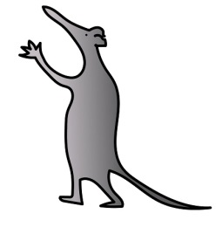

**Help us keep you and our other patients safe. Clean hands are healthy hands!**