This leaflet only gives general information. You must always discuss the individual treatment of your child with the appropriate member of staff. Do not rely on this leaflet alone for information about your child’s treatment.

This information can be made available in other languages and formats if requested

Alder Hey Children’s NHS Foundation Trust

Eaton Road

****Liverpool

L12 2AP

****Tel: 0151 228 4811

[www.alderhey.nhs.uk](http://www.alderhey.nhs.uk)

**© Alder Hey Review Date: March 2028 PIAG:409**



**Department for Clinical Health Psychology**

**Support for feeling anxious about hospital procedures**

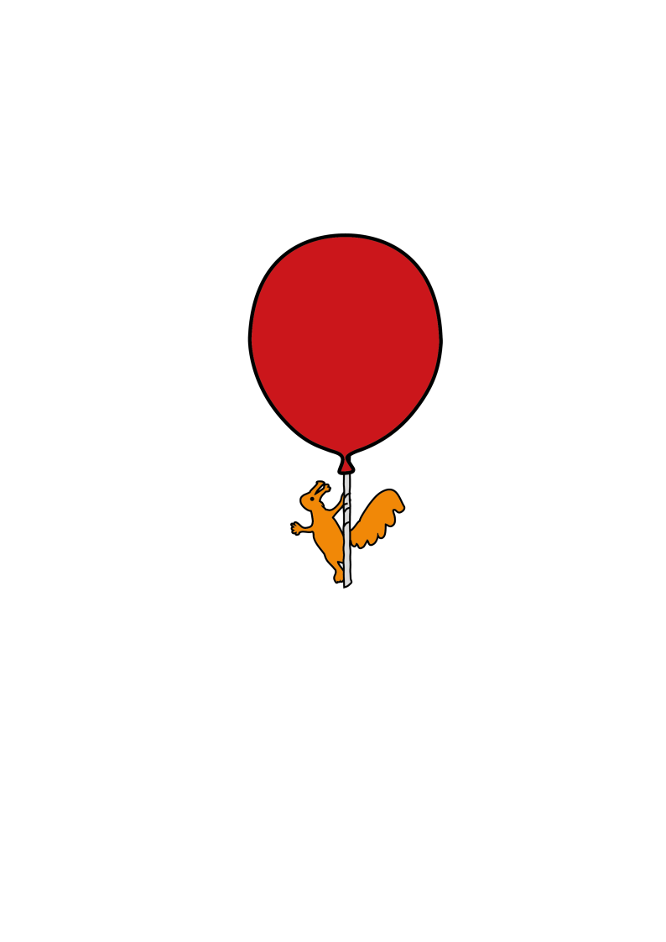

**Information for adolescent patients,**

**parents and carers**

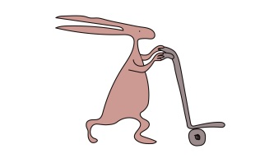

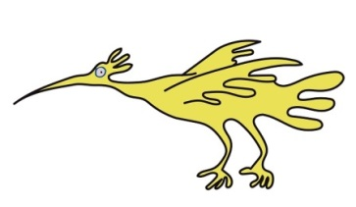

**Introduction**

Feeling anxious is something that every person experiences at some point-it is a really common feeling. ‘Anxiety’ can be called different things, for example some people call it worry, fear, feeling nervous or feeling scared.

To understand anxiety, it is important to understand how the way we think, feel, behave and how our body feels, are all linked. Below is an image of a “hot cross bun” showing how all of these things are connected.

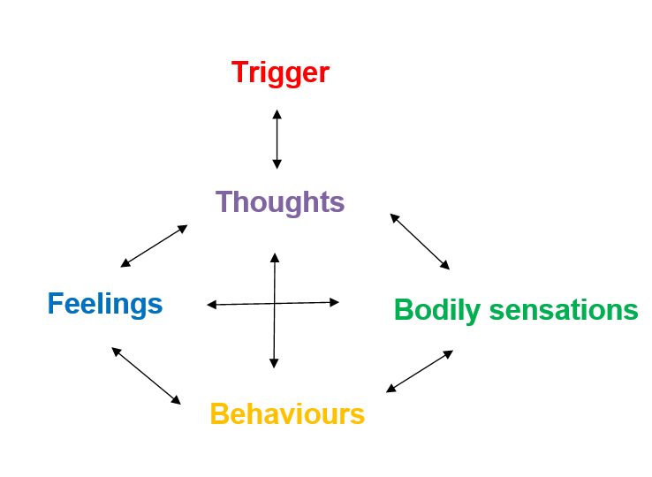

Our thoughts can be triggered for many different reasons. This could be a memory from the past or because of something that is happening in the present. The way we think can then affect the way we feel. When this happens, this can make us experience particular bodily sensations such as a fast heartbeat. These can in turn impact on our behaviour.

It is important to think about the effect each one of these can gave our experiences of coming to hospital for a procedure.

For example, a common thought people may have when having a blood test is that the needle is going to hurt them. This can make them scared, cry and not want to have the blood test. Whereas someone else could have a different thought, and they could think back to the last time they had a blood test and how well they coped with that. Or someone else may think that the blood test may not hurt as much as they think it will.

Many people fear hospital procedures to some extent. When a person’s fear about having these procedures becomes consistent, then it may become a bit more of a problem for them. Anxiety around procedures is really common. For some people, even just being reminded of procedures or having to read or think about them can make them feel scared. People may worry that a procedure might be painful or might be worried about what to expect.

Worrying about procedures can also make people feel lots of uncomfortable physical symptoms in their body, such as:

* An increase in heart rate
* Shortness of breath
* Feeling sick, feeling sweaty
* Feeling faint

As a result, people with procedural anxiety might try to avoid having procedures done or might endure a procedure with intense anxiety. The physical feelings that occur when we are worried are **really normal**. It is our body’s way of letting us know that it thinks we are at risk, even if we aren’t! While the physical symptoms can feel really uncomfortable, **they are not dangerous**, and they will go away eventually.

There are things we can do to help us to feel calmer in situations where we are nervous, such as before attending hospital for a procedure. Here are some of the things that can help:

**Planning**

****Do you have any questions?**

Before coming in for a procedure, you might have questions about what it will involve or why it needs to be done. If you have any questions about the procedure, it can be helpful to ask your medical team. Having a better understanding about what is going to happen can help to reduce feelings of worry. You can also plan who you would like to come along with you to the appointment and how you would like them to support you. For example, whether you want them to provide reassurance or help to distract you.

**Has anything helped in the past?**

Think about whether there is anything that has helped you to cope with procedures before. Could you use something like this to help you again?

**Our wider team can support you!**

There are options at the hospital for play specialists to support those who feel particularly anxious, and they can even meet with young people before a procedure to talk through what it will involve and show what equipment would be used. There are also possible options like numbing cream and ‘cold spray’ (used to numb parts of your body) that can be used to help young people who are worried about the procedures.

**Talk to Us**

If you have an appointment or admission coming up where you know you will have a procedure, then let your team know beforehand if you are feeling nervous about it - we can help support you to reduce your worries.

**Relaxation Strategies**

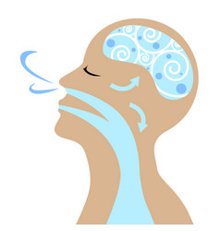Relaxation strategies can help to ease some of the uncomfortable physical symptoms people feel when they are worried. Learning to use relaxation techniques is like learning to swim, it takes regular practise! Try to set time aside each day to practise relaxation strategies when you feel safe at home. That way when you are really worried (like before an upcoming procedure), you have the skills ready to help you!

**Breathing for relaxation:** When we feel worried, we can begin to breathe very fast from our chest. This can cause us to feel dizzy, which can make us even more worried about what is happening in our body. A good way to breathe calmly is to breathe from deep within your tummy, and not from your chest. You should be able to notice your chest staying still, and your tummy moving in and out a little. You can put one hand low down on your belly to feel this. Relaxed and slow breathing can be really helpful when trying to manage the uncomfortable feelings of worry. You can try box or rainbow breathing like on the next page!

There are also YouTube videos and apps such as Headspace and Calm that can talk you through using relaxation strategies.



**Guided imagery**

Guided imagery is also a helpful strategy for managing worries and stress. It involves visualising positive, peaceful settings and experiencing these situations using all of your senses (vision, taste, sound, smell and touch).

Like other relaxation strategies the more you practise it, the easier it becomes. Here are some guided imagery scripts and videos that you could try:

* [www.youtube.com/watch?v=6TywQETck8E](http://www.youtube.com/watch?v=6TywQETck8E)
* [www.youtube.com/watch?v=lgSbF_xH9LU](http://www.youtube.com/watch?v=lgSbF_xH9LU)
* [www.choc.org/programs-services/integrative-health/guided-imagery/](https://www.choc.org/programs-services/integrative-health/guided-imagery/)
* [www.headspace.com/meditation/guided-imagery](https://www.headspace.com/meditation/guided-imagery)

**Distraction**

Distraction techniques are a good way to stop yourself from spending too much time worrying. Having something that you can distract yourself with means that you can focus on an activity that you enjoy, rather than spending your time focusing on your worries.

Here are some things that you could do for distraction:

* Doodle/Colour
* Read a book
* Listen to music or a podcast
* Watch videos
* Use phone apps
* Talk to the people around you
* Bring along stress or fidget toys and gadgets

**Key Points to Remember**

* Don’t be embarrassed or ashamed if you feel worried about an upcoming procedure. This is a really common fear (even in adults) and you are not alone.
* Think about what helps you when you feel worried.
* Ask your medical team any questions that you might have about the procedure, and why it is needed.
* Practise relaxation techniques in the run up and on the day of a procedure. Remember the uncomfortable feelings that come with worry will reduce.
* Lots of procedures often end up being not as scary as our thoughts initially told us.
* There are teams within Alder Hey who exist to support young people who are fearful of procedures, particularly when their fear feels really severe for them.



Leaflet produced by the Clinical Health Psychology team at Alder Hey Children’s Hospital

Email: [ClinicalHealthPsychology@alderhey.nhs.uk](mailto:ClinicalHealthPsychology@alderhey.nhs.uk)

Telephone no: 0151 252 5586