**Further reading**

For more information on MRSA; what you can do to help and what we do at Alder Hey to stop the spread, please use the following QR codes/website links;

<https://www.nhs.uk/conditions/mrsa>



[www.alderhey.com](http://www.alderhey.com)



Made with help from xxx aged x





Alder Hey Children’s NHS Foundation Trust

Alder Hey

Eaton Road

Liverpool

L12 2AP

Tel: 0151 228 4811

[www.alderhey.nhs.uk](http://www.alderhey.nhs.uk)

**© Alder Hey PIAG: 34**

**Review Date: April 2028**

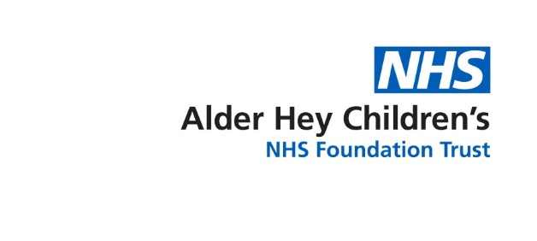

Infection Prevention & Control

**MRSA**

**Meticillin Resistant Staphylococcus Aureus**

**Information for Parents & Carers**



**What IS MRSA?**

(Meticillin Resistant Staphylococcus Aureus)

We all have bacteria living in our skin. This is known as *colonisation*, a person who is colonised is said to be a *carrier. Staphylococcus Aureus* is one such type of bacteria that usually lives on the skin and is found in the nose of 30-40% of healthy people. This bacterium (bug) is often harmless, carrying it does not mean you have an infection. However if it develops resistance to common antibiotics, it becomes MRSA. If this newly resistant bacteria gains entry into the body (via cuts and wounds etc.) it can then cause infection which can sometimes be difficult to treat. For more serious infections, antibiotics may be given via a drip.

**What are the signs and symptoms of MRSA?**

Most people with MRSA on their skin do not have any symptoms this is because carriers of MRSA have a resistant strain of an otherwise very normal bug. Often they do not even know they carry it, but should bacteria enter the skin you may notice it;

* is painful and swollen
* feels warm when you touch it
* may ooze or leak
* looks red – though this may be harder to see on brown or black skin

Sometimes your doctor might prescribe *decolonisation*- this is a simple anti-biotic wash to be used in place of shampoo/shower gel when you bathe.

**How do people become carriers and how are they identified?**

It can be difficult to say exactly how people pick up MRSA. Risk factors for MRSA include, having been an inpatient in a hospital abroad or in the UK where MRSA patients were present, or if you have been in contact with a carrier elsewhere, or multiple/long courses of antibiotics. We carry out *surveillance*, actively looking for resistant organisms. MRSA is most often found in the nose and groin so we will swab these areas . Results of these swabs are usually available within two to three days.

**How to reduce risk of transmission?**

You may notice the CONTACT isolation poster on your door, this is to advise any staff entering how best to reduce the risk of transmission. You can help too by;

•Cleaning hands before/after leaving the cubicle  
•Ensure staff clean hands before they provide cares  
•Do not access communal areas/atrium without first cleaning your hands

**What happens when I go home?**

****MRSA will not delay your discharge home. You can carry on as normal, and practice good hand hygiene. Although MRSA can go away with time it is not guaranteed, therefore if you return to Alder Hey for further treatment you will always be nursed in a single room with the same additional precautions.

**Hand Hygiene**

The most important thing you can do to protect yourself and others is to wash your hands often and effectively.**

**Help us keep you and our other patients safe. Clean hands are healthy hands!**