**Further reading**

For more information on MRSA; what you can do to help and what we do at Alder Hey to stop the spread, please use the following QR codes/website links;

[www.nhs.uk/conditions/ESBL](http://www.nhs.uk/conditions/ESBL)



[www.alderhey.com](http://www.alderhey.com)



Made with help from xxx aged x







Alder Hey Children’s NHS Foundation Trust

Alder Hey

Eaton Road

Liverpool

L12 2AP

Tel: 0151 228 4811

[www.alderhey.nhs.uk](http://www.alderhey.nhs.uk)

**© Alder Hey PIAG: 128**

**Review Date: April 2028**

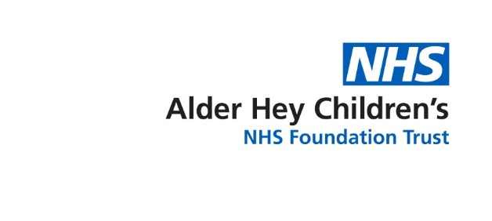

Infection Prevention & Control

**ESBL  
Extended Spectrum Beta Lactamase**

**Information for Parents & Carers**



**What is ESBL?   
(**Extended Spectrum Beta Lactamase)

We all have bacteria living in our guts. This is known as *colonisation* and a person who is colonised is said to be a *carrier.* This bacteria is often harmless, however if it gets somewhere it shoudn’t, such as the bladder or bloodstream it can cause infection

Beta lactamases are enzymes (chemicals) made by various different kinds of bacteria. These chemicals can make certain types of antibiotics ineffective reducing the amount of choices available to treat the infections they cause. Different types of bacteria are able to produce this enzyme e.g. E.Coli, Klebisella and Enterobacter. These bacteria are commonly known as the Coliforms and they live in the gut.

**What are the signs, symptoms of ESBL?**

Carriers of ESBL have a resistant strain of an otherwise very normal bowel bug. As a result carriers will have no signs or symptoms and require no treatment. However, carriers of ESBL will be nursed in isolation with additional precautions to ensure that ESBL does not move from their bowel to any other site on them, and does not spread to other patients present on the ward. ESBL can cause

* Fever
* Urinary Tract Infections (Bladder infections)
* Chest infections
* Wound infections

**How do people become carriers and how are they identified?**

It can be difficult to say exactly how people pick up ESBL. Risk factors for ESBL include, having been an inpatient in a hospital abroad or in the UK where ESBL patients were present, or if you have been in contact with a carrier elsewhere, or multiple/long courses of antibiotics. We carry out *surveillance*, actively looking for resistant organisms. ESBL is most often found in the gut to we will usually ask for a poo sample . Results of these swabs are usually available within two to three days.

**How to reduce risk of transmission?**

You may notice the CONTACT isolation poster on your door, this is to advise any staff entering how best to reduce the risk of transmission. You can help too by;

•Cleaning hands before/after leaving the cubicle  
•Ensure staff clean hands before they provide cares  
•Do not access communal areas/atrium without first cleaning your hands

**What happens when I go home?**

****ESBL will not delay your discharge home. You can carry on as normal, and practice good hand hygiene. Although ESBL can go away with time it is not guaranteed, therefore if you return to Alder Hey for further treatment you will always be nursed in a single room with the same additional precautions.

**Hand Hygiene**

The most important thing you can do to protect yourself and others is to wash your hands often and effectively.

**Help us keep you and our other patients safe. Clean hands are healthy hands!**