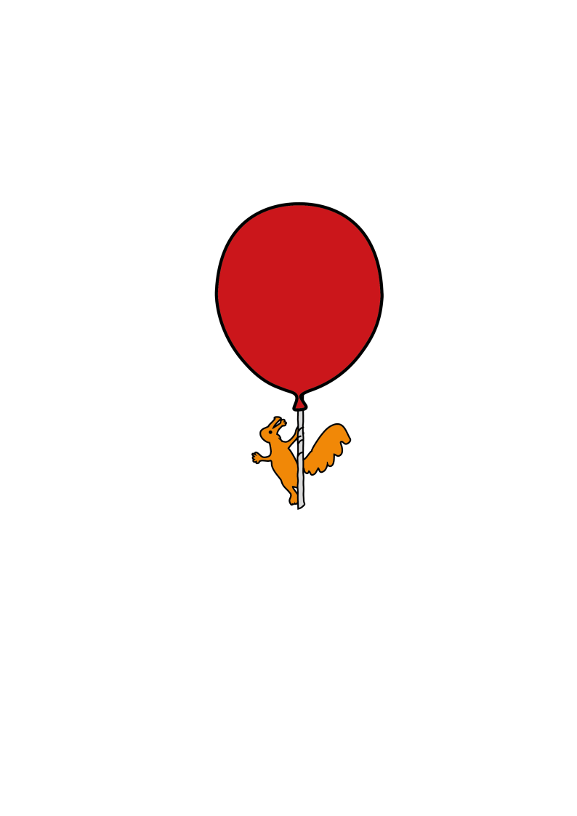

Nuclear Medicine

**Advice after scan**

Information for Parent/Carer

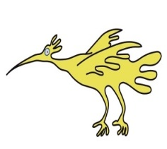



**After your Nuclear Medicine Scan**

If your child is not having any further scans or tests, you will be free to go home. A consultant radiologist will send a report about the scan to your child’s doctor.

**For the first 24 hours at home**

Give your child plenty to drink. This will help the radioactive isotope pass out of their body as quickly as possible.

If your child is toilet-trained, they should go to the toilet, empty their bladders more frequently and wash their hands thoroughly after.

If your child is in nappies or pads, you should change them frequently and dispose of the dirty nappy or pad in an outside bin. Wash your hands thoroughly after nappy or pad changing.

If clothing becomes contaminated with bodily fluids, place the clothing in a plastic bag and store (away from people) for 24 hours before washing.

Children should not be bathed on the evening of the scan. This is to prevent urinating into the bath and making the bath water radioactive.

If you are pregnant or think you could be pregnant, if possible, avoid contact with your child’s bodily fluids, such as urine (wee), faeces (poo) and vomit.

There is no need to stop giving your child essential love and care.

Your child should carry on taking their regular medications as usual. The radioactive isotope will not affect them in any way.

If you have any questions, please telephone the Nuclear Medicine department on 0151 252 5332.

This leaflet only gives general information. You must always discuss the individual treatment of your child with the appropriate member of staff. Do not rely on this leaflet alone for information about your child’s treatment.

This information can be made available in other languages and formats if requested.

Please have a look at our virtual map [**https://bit.ly/3TKgoXi**](https://bit.ly/3TKgoXi) prior to your visit. Here you will find - 360° walk-through of over 188,000 square feet of Alder Hey captured in 4K.

- 156 interactive 'hotspots'.

- 74 videos explaining what happens when you have a procedure or arrive for an appointment.

- Virtual signage to help you find your way around.

****Alder Hey Children’s NHS Foundation Trust

Alder Hey

Eaton Road

Liverpool

L12 2AP

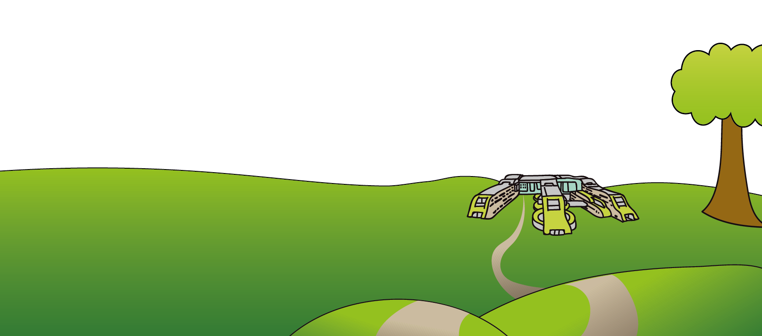

Tel: 0151 228 4811

[www.alderhey.nhs.uk](http://www.alderhey.nhs.uk)

**© Alder Hey Review Date: PIAG:**