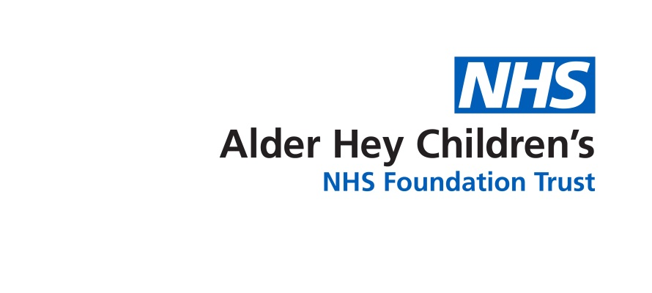

Community Speech and Language Therapy

**Producing /s/ - ‘lisp’ advice**

Information for parents/carers and settings



**Introduction**

A lisp sound quality is created when ‘s’ is being produced with the tongue between the teeth (interdental lisp).

* Help your child to hear the difference between ‘s’ and the sound they produce.
* Encourage your child to tuck their tongue **behind** their teeth when saying the ‘s’ sound.
* Show them using a mirror to have their teeth together and give a big smile.
* Try with just the ‘s’ sound on its own first, and then once your child can do this clearly, move onto practicing the ‘s’ sound in words.
* You can also start by your child having their tongue between their teeth and gradually moving it backwards into the correct position, whilst producing the sound.
* Ask them to start spotting ‘s’ words in their reading book, for example ‘see’ ‘said’ ‘sun’
* Once they are producing ‘s’ consistently while reading try to have 5-minute chats where you focus on remembering clear ‘s’ during your conversations.

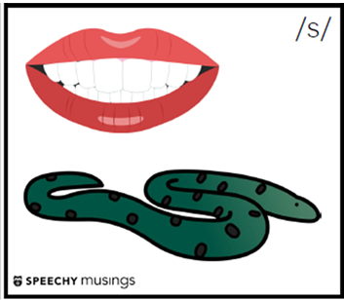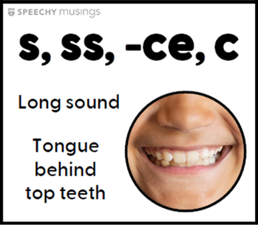

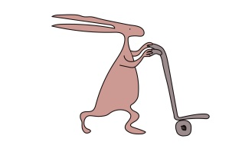

**Alder Hey Community Speech and Language Therapy Department**

**Sefton (0151 247 6109) Liverpool (0151 295 3990)**

[**Childrensslt@alderhey.nhs.uk**](mailto:Childrensslt@alderhey.nhs.uk)

[Speech and language therapy - Alder Hey Children's Hospital Trust](https://www.alderhey.nhs.uk/services/speech-and-language-therapy/)

(click this link or type into search engine)

This leaflet only gives general information. You must always discuss the individual treatment of your child with the appropriate member of staff. Do not rely on this leaflet alone for information about your child’s treatment.

This information can be made available in other languages and formats if requested.

****Alder Hey Children’s NHS Foundation Trust

Alder Hey

Eaton Road

Liverpool

L12 2AP

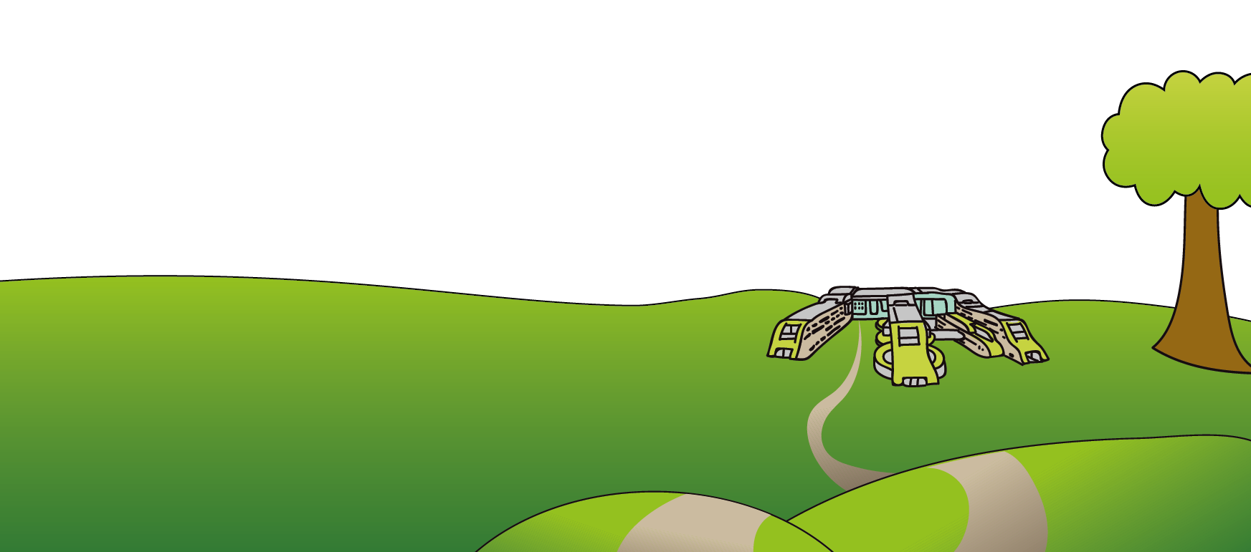

Tel: 0151 228 4811

[www.alderhey.nhs.uk](http://www.alderhey.nhs.uk)

**© Alder Hey Review Date: March 2028 PIAG: 600**