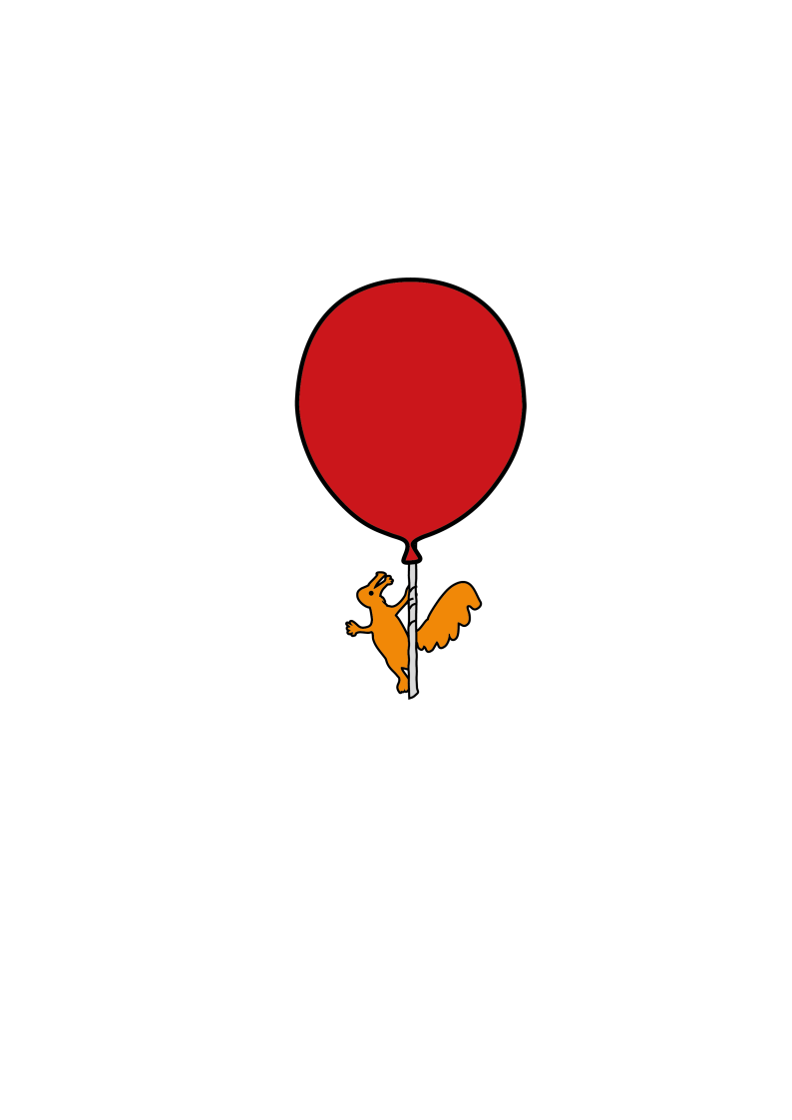



Childrens’ Speech and Language Therapy Service

**Interpret your child’s message**

Information for parents and carers and settings

**Your child may already be sending you lots of messages:**

|  |  |
| --- | --- |
| Non-verbally | such as by using gesture or facial expressions |
| Vocally | by making a sound and possibly by using a word |
| Verbally | by using words but the words don’t always match their intended message e.g. they say “do you want juice?” to mean “I want juice” |
| Repeating language they have heard before | e.g. from other people, from the TV, from books |
| Babble along using their own language |  |

**Acknowledge**

* Listen
* Show an interest: show that you are listening by nodding or with your facial expression
* Respond to their communication (your response might be a smile, words or doing what is asked)
* Respond to requests (by doing what they are asking)
* Acknowledge even if you don’t understand the message, try to work it out.

**Be a detective**

* Pay attention to what your child is doing and ‘saying’ and interpret their message – what do you think they are trying to say?
* Say what you think they are trying to say, for example they pull you to the door and you think they want to go out, you could say *‘out’* or *‘go’* (and then you are modelling the words they could use next time)
* If they made sounds or used words repeat what they have said, even if you are not sure of the words, it might help to work out the message
* Do not ask a question but give the words that your child could say; you should say the words you child would use in that situation (e.g. if they pull you to the box of cars you can say ‘cars’ rather than ‘do you want the cars?, saying ‘cars’ models the words your child can say when they are ready)

**Say what your child might want to say**

* Use natural language in a friendly, interesting voice (use an up and down tone that catches their attention)
* If your child uses actions or sounds to communicate keep your language simple, you are using a model your child may be able to copy (say the words your child could use in that situation, don’t respond with a question)

For example: Your child points to the cupboard while holding a cup.

You say “*juice*” or “*juice please*” (NOT “do you want juice?”)

Your child shakes his head when you try to give him his car.

You say “*no. no car*”. (NOT “don’t you want your car?”)

Your child pulls at your top and makes a noise.

You say “*daddy*” (NOT “do you want me?”)

* If your child uses words but they don’t match their message exactly you can say it back the way they could next time.

For example, Your child points to the fridge and says “do you want a yoghurt?”

You say *“I want a yoghurt”*

* If you are not sure of the message, try guessing. You may be right!

Your child may not copy you straight away but don’t give up, keep modelling the words and pausing to give them a chance to copy (don’t make them copy you and don’t ask them to say it)

**Think about how your child sends a message to you.** You might find it useful to fill in the table below.

|  |  |  |
| --- | --- | --- |
| What your child did or said | What you think they meant | The language you will model |
| E.g. handed you a pack of crisps | Will you open the crisps | *“Open”*  *“open please”*  *“open the crisps”*  (if your child replies “yes” you may have used a questioning voice, remember to make a statement, not ask a question) |
|  |  |  |
|  |  |  |

**Speech and Language Therapy Department**

[Childrensslt@alderhey.nhs.uk](mailto:Childrensslt@alderhey.nhs.uk)Sefton: 0151 247 6109 Liverpool: 0151 295 3990

This leaflet only gives general information. You must always discuss the individual treatment of your child with the appropriate member of staff. Do not rely on this leaflet alone for information about your child’s treatment.

This information can be made available in other languages and formats if requested.

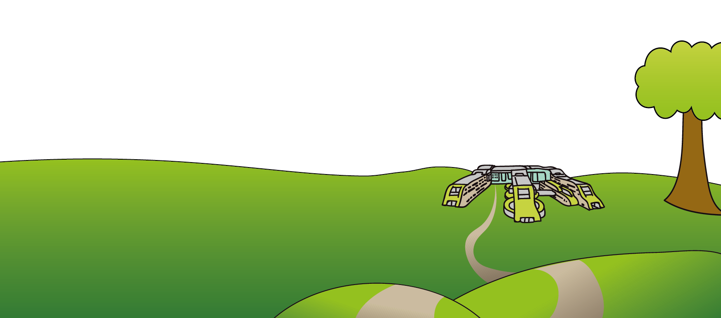Alder Hey Children’s NHS Foundation Trust

Alder Hey

Eaton Road

Liverpool

L12 2AP

Tel: 0151 228 4811

[www.alderhey.nhs.uk](http://www.alderhey.nhs.uk)

**© Alder Hey Review Date: April PIAG: 608**