**What will the Speech and Language Therapist do?**

For young people with DLD to be supported, it is important for them to learn and practice skills within their everyday environments.

The Speech and Language Therapist will work alongside the people in these environments (e.g. parents/carers, setting staff) to identify the areas of need and provide advice and/or modelling of strategies. We aim to train the key adults to enable them to continue to support the child’s communication skills on a daily basis.

**Where can I find out more?**

* [www.dldandme.co.uk](http://www.dldandme.co.uk)
* [www.naplic.org.uk](http://www.naplic.org.uk)
* www.radld.org/about/dld
* Videos about DLD on the RADLD YouTube channel

If you need to contact the Community Speech and Language Therapy Services for Liverpool or Sefton, please email [childrensslt@alderhey.nhs.uk](mailto:childrensslt@alderhey.nhs.uk)

[Speech and language therapy - Alder Hey Children's Hospital Trust](https://www.alderhey.nhs.uk/services/speech-and-language-therapy/)

(click this link or type into search engine)

This leaflet only gives general information. You must always discuss the individual treatment of your child with the appropriate member of staff. Do not rely on this leaflet alone for information about your child’s treatment.

This information can be made available in other languages and formats if requested.

Alder Hey Children’s NHS Foundation Trust

Eaton Road

Liverpool

L12 2AP

Tel: 0151 228 4811

[www.alderhey.nhs.uk](http://www.alderhey.nhs.uk)

**© Alder Hey**

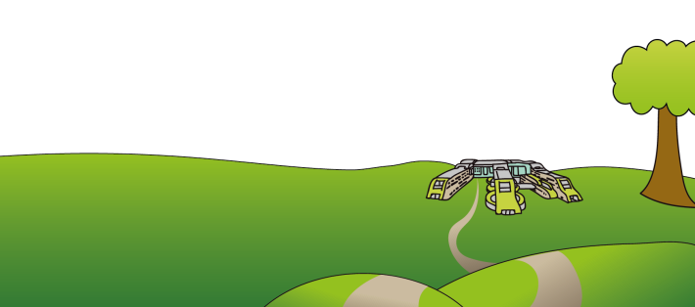**Review Date: March 2028**

**PIAG: 591**

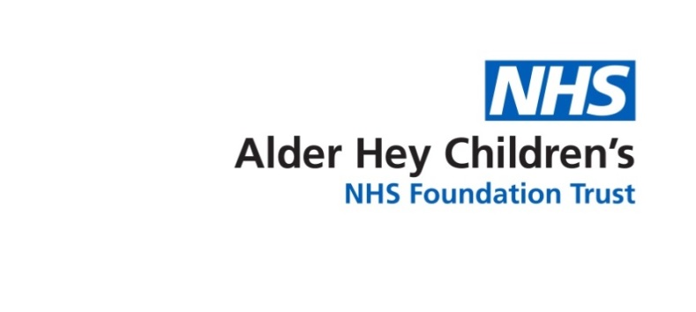

**Speech and Language Therapy**

**Developmental Language Disorder (DLD) in Secondary Schools**

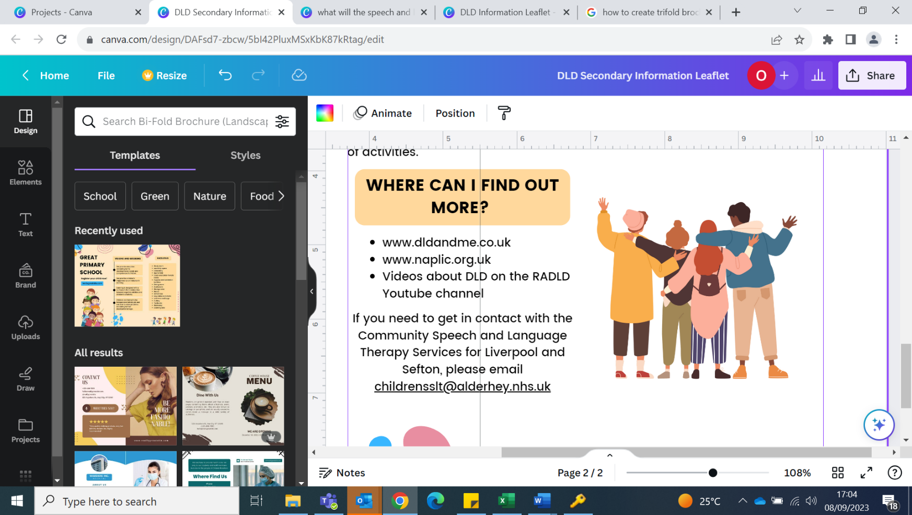

**Information for**

**parents/carers and setting staff**

**What is DLD?**

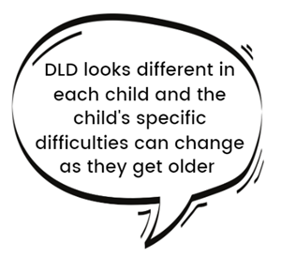DLD stands for Developmental Language Disorder. DLD is when a child or young person has significant and persistent difficulties understanding and/or using all known languages. These difficulties create obstacles to communication and learning in everyday life.

There is no known cause of DLD but it can run in families. DLD is **not** caused by emotional difficulties, parenting style, being multilingual or having other medical conditions (e.g. d/Deafness, Autism, learning difficulties).

Children and young people with DLD may have other difficulties as well (e.g. ADHD, dyslexia and speech sound difficulties).

Children and young people with a biomedical condition (e.g. d/Deafness, Autism, brain injury,) can have a co-occurring Language Disorder.

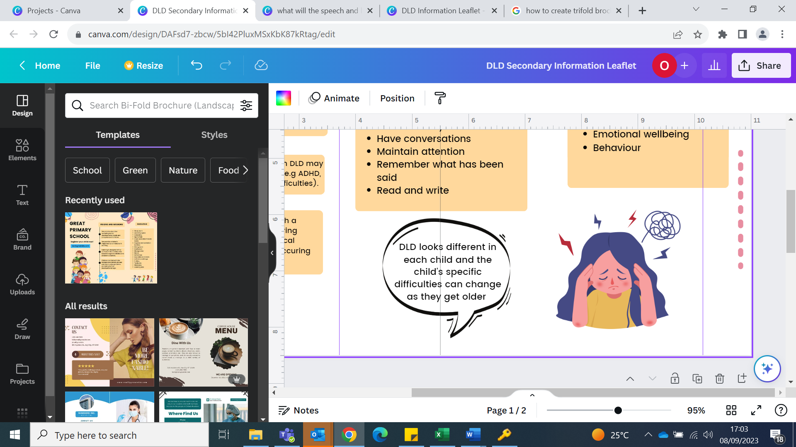

**Signs of DLD**

Young people with DLD may find it difficult to:

* Understand vocabulary
* Follow multi-step instructions
* Answer inference questions
* Remember spoken information
* Respond quickly to questions
* Use a range of vocabulary (instead they use non-specific language, e.g. ‘stuff’, ‘thing’)
* Sequence words in the correct order
* Use tenses accurately
* Produce extended sentences
* Clearly re-tell a story or event
* Form and maintain friendships
* Understand puns, idioms, jokes, sarcasm and slang
* Maintain attention
* Read and write
* Understand and manage their emotions

**Impact**

DLD is a long-term condition which can impact:

* Learning and achievement in school
* Maintaining relationships
* Emotional wellbeing (higher levels of social stress and victimisation)
* Behaviour (difficulties with conflict, problem-solving skills)

**How to support a young person with DLD**

**Get the young person’s attention** - say their name before talking to them.

**Use visuals** – such as photos, pictures, objects and demonstrations alongside spoken information

**Check understanding** - Ask the young person to demonstrate or explain what they have been asked to do.

**Use Task Planners** – Write/draw each step of the activity to be ticked off as it is completed.

**Be aware of difficulties with inference** – Answering ‘why?’ and ‘how?’ questions will be difficult, especially when dysregulated. Reduce all language until the young person is regulated.

**Target vocabulary essential for learning** – Topic vocabulary (e.g. photosynthesis, oxygen) and instruction words (e.g. analyse, discuss).

**Reduce language and slow down** - Use simple vocabulary, short instructions and allow extra time for answering questions.

**Use visual story boards** – Ask the student to draw out an event in a ‘comic-strip’ style if they are struggling to explain it or understand what happened, e.g. social situation, a play, reading text.