**What will the Speech and Language Therapist do?**

For children with DLD to be supported, it is important for them to learn and practice skills within their everyday environments.

The Speech and Language Therapist will work alongside the people in these environments (e.g. parents/carers, setting staff) to identify the areas of need and provide advice and/or modelling of activities and strategies.

We aim to train the key adults to enable them to continue to support the child’s communication skills on a daily basis

**Where can I find out more?**

* www.dldandme.co.uk
* [www.naplic.org.uk](http://www.naplic.org.uk)
* www.radld.org/about/dld
* Videos about DLD on the RADLD YouTube channel

If you need to contact the Community Speech and Language Therapy Services for Liverpool or Sefton, please email [childrensslt@alderhey.nhs.uk](mailto:childrensslt@alderhey.nhs.uk)

[Speech and language therapy - Alder Hey Children's Hospital Trust](https://www.alderhey.nhs.uk/services/speech-and-language-therapy/)

(click this link or type into search engine)

This leaflet only gives general information. You must always discuss the individual treatment of your child with the appropriate member of staff. Do not rely on this leaflet alone for information about your child’s treatment.

This information can be made available in other languages and formats if requested.

Alder Hey Children’s NHS Foundation Trust

Eaton Road

Liverpool

L12 2AP

Tel: 0151 228 4811

[www.alderhey.nhs.uk](http://www.alderhey.nhs.uk)

**© Alder Hey**

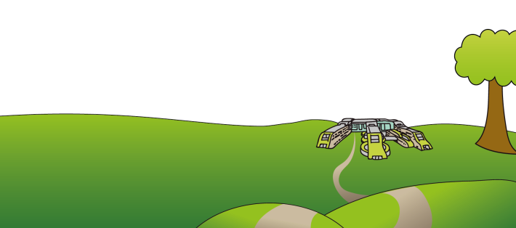**Review Date: January 2028**

**PIAG: 582**

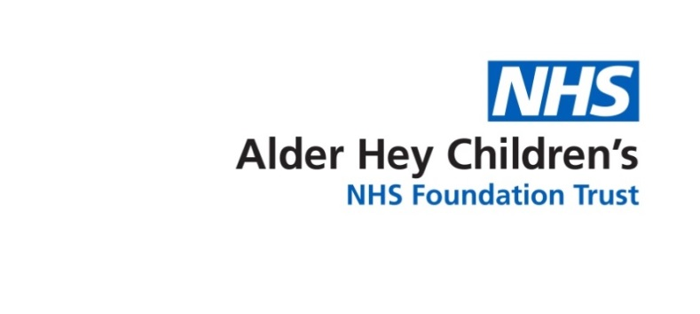

**Speech and Language Therapy**

**Developmental Language Disorder (DLD)**



**Information for**

**parents/carers and setting staff**

**What is DLD?**

DLD stands for Developmental Language Disorder. DLD is when a child or young person has significant and persistent difficulties understanding and/or using all known languages. These difficulties create obstacles to communication and learning in everyday life.

There is no known cause of DLD but it can run in families. DLD is **not** caused by emotional difficulties, parenting style, being multilingual or having other medical conditions (e.g. d/Deafness, Autism, learning difficulties).

Children and young people with DLD may have other difficulties as well (e.g. ADHD, dyslexia and speech sound difficulties).

Children and young people with a biomedical condition (e.g. d/Deafness, Autism, brain injury) can have a co-occurring Language Disorder.

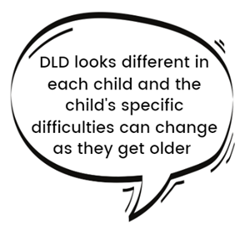

**Signs of DLD**

Children with DLD may find it difficult to:

* Understand words
* Follow instructions
* Answer questions
* Find the right words to express ideas
* Sequence words in the correct order
* Re-tell a story or event
* Use tenses accurately
* Have conversations
* Maintain attention
* Remember what has been said
* 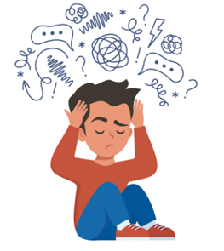Read and write

**Impact**

DLD is a long-term condition which can impact:

* Learning and achievement in school
* Joining in with other children
* Following what is happening in the classroom or playground
* Emotional wellbeing
* Behaviour

**How to support a child with DLD**

**Get your child’s attention** - say their name before asking questions or giving instruction so they know when to listen.

**Show them** - Use pictures, objects and demonstrations alongside spoken information.

**Check understanding** - Ask the child to demonstrate or explain what they have been asked to do.

**Reduce language** - Use simple vocabulary and short instructions.

**Comment more, question less** - Answering questions can be difficult and pressurising. Comment on what they are doing instead. Repeat what they say with correct grammar.

**Slow down** - Talk slowly with pauses and allow extra time for talking and answering questions.

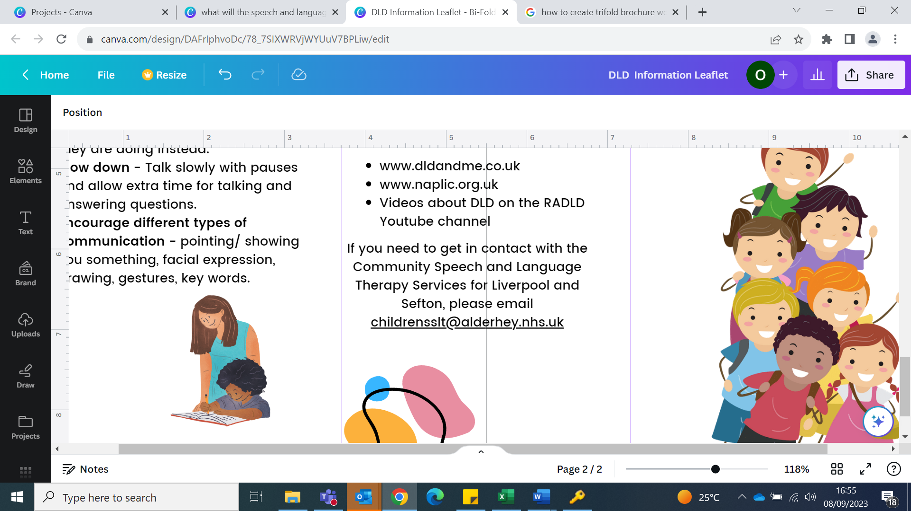**Encourage different types of communication** - pointing/ showing you something, facial expression, drawing, gestures, key words.