

Childrens’ Speech and Language Therapy Service

**Developing Early Communication Skills and Creating Opportunities**

**Information for parents and carers and settings**



**How to support your child’s communication with others:**

You can help your child by positively responding to and encouraging their communication attempts. Even if it may not be obvious, all your child’s noises and movements are meaningful.

When playing with your child, make sure you are face-to-face with them, if they find this comfortable. Use lots of facial expressions and fun sounds to encourage your child to look at you, e.g. “wow!” and “ooooh!”.

**Play together:**

Children learn through playing with other people. One of the most important things they learn is how to relate to another person in a fun way. Make sure you have fun too.

Choose games you already know your child likes, here are some ideas to try:

* Sit face-face with your child and sing nursery rhymes or songs together. Encourage your child to join in with your sounds and actions. Pause and wait to see how they join in or show you they want the song to continue.
* Lots of children enjoy rough-and-tumble play and this gives plenty of opportunities to communicate through touch, sounds, laughter and movement. You can pause and wait to see if they show you they want to continue the game.
* Some children enjoy sharing picture books or puzzles: talk about what *they* look at or point to.
* As your child learns the games you play together, they will begin to recognise them and guess what you are going to do, e.g. as you sing “round and round the garden”, your child will know they are going to be tickled.



**Create opportunities for your child to communicate throughout the day**

**(give them a reason to communicate).**

**Always try to wait for your child to respond or initiate (start something). Communication is not just about talking, it can be a body movement, a facial expression, gesture/signing, an attempt at a word, a noise.**

Use pauses in your play routines; to build anticipation (your child waiting for what will come next)

* e.g. when tickling your child’s feet, wait for them to put their foot in your hand to indicate that they want more.
* When passing a ball or rolling a toy backwards and forwards, say “ready, steady…” and wait to see if your child looks at you or makes a noise or giggles.
* Sing rhymes with your child and pause at an appropriate point so they can show you they want you to carry on.

Do something that is unexpected.

* e.g. when giving your child a snack ‘forget’ to open their crisps for them and wait for some signal that they need help. Then say what they would if they could “help” or “Open the crisps”.
* Or put something silly on your head and wait for them to notice. Use your facial expression and say what they would if they could “Oh, silly mummy” or “uh oh!”

Offer your child choices throughout the day, e.g. toys, food, drink, books etc.

* Offer a choice of 2 objects, showing them and naming them at the same time, for example ‘juice or water?’

Wait for a definite response from your child before giving them the chosen item – a look, reach, sound or change in body posture may be the way the child indicates they want something. You don’t need to wait for your child to say what they want, look for even the smallest way they are communicating with you and respond.

Once they have shown you what they want, name it e.g. “want the apple”

Make sounds for the toys you and your child are playing with. These may include; animal sounds, transport noises, “Wheee!” on the slide, “Pop!” with bubbles. Enjoy any attempts your child makes to copy your sounds.

**Speech and Language Therapy Department**

[Childrensslt@alderhey.nhs.uk](mailto:Childrensslt@alderhey.nhs.uk)Sefton: 0151 247 6109 Liverpool: 0151 295 3990

This leaflet only gives general information. You must always discuss the individual treatment of your child with the appropriate member of staff. Do not rely on this leaflet alone for information about your child’s treatment.

This information can be made available in other languages and formats if requested.

Please have a look at our virtual map <https://bit.ly/3TKgoXi> prior to your visit. Here you will find - 360° walk-through of over 188,000 square feet of Alder Hey captured in 4K.

- 156 interactive 'hotspots'.

- 74 videos explaining what happens when you have a procedure or arrive for an appointment.

- Virtual signage to help you find your way around.

****Alder Hey Children’s NHS Foundation Trust

Alder Hey

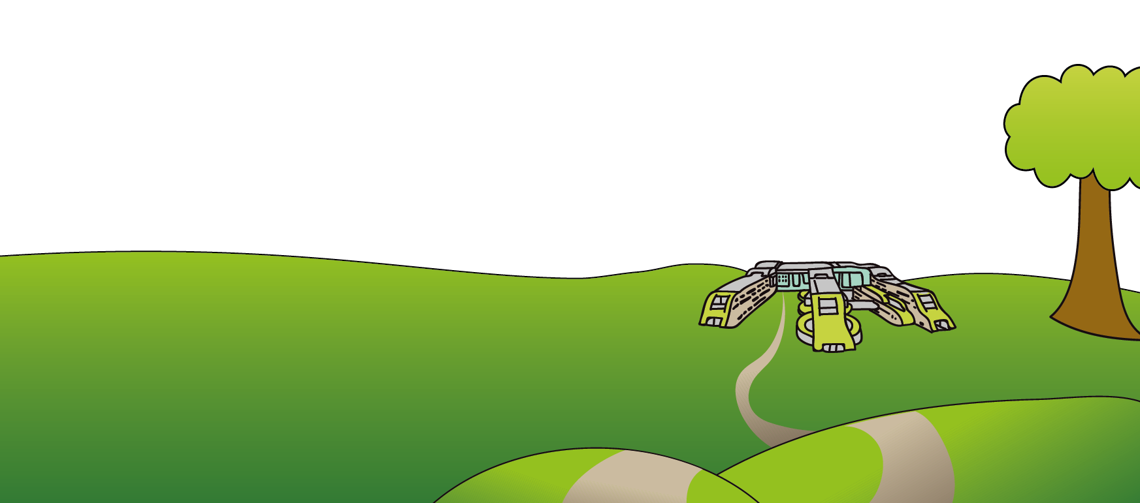Eaton Road

Liverpool

L12 2AP

Tel: 0151 228 4811

[www.alderhey.nhs.uk](http://www.alderhey.nhs.uk)

**© Alder Hey Review Date: February 2028 PIAG: 587**