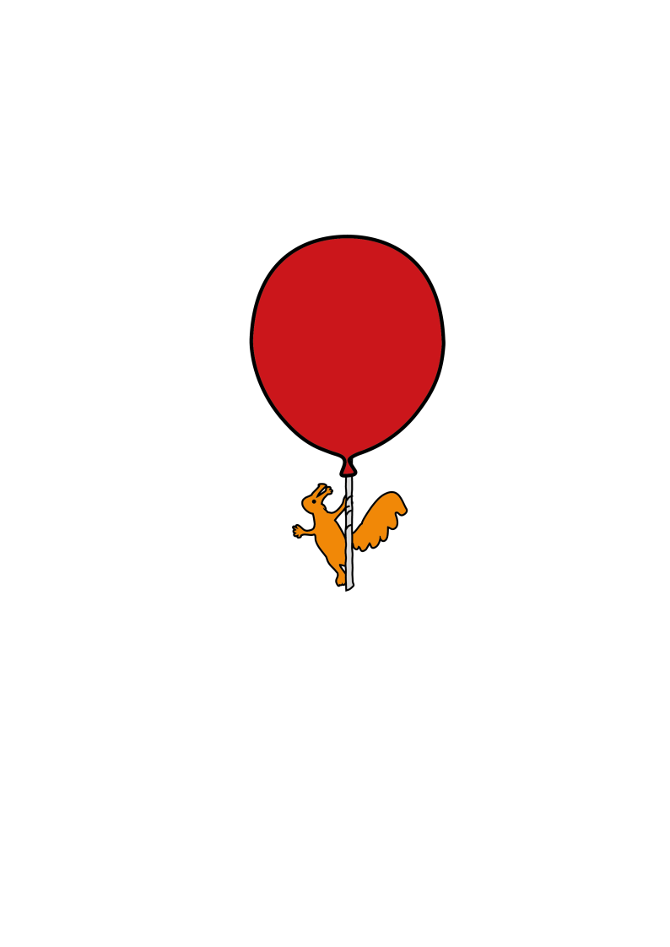

Community Speech and Language Therapy

**Activities to Build Attention and Listening Skills in Older Children**

Information for parents/carers and schools – to be used in conjunction with **Attention and Listening Skills** information leaflet

**Lotto, Snap and Memory Pair Games** - or any other motivational type games. Gradually increase the amount of time spent on each game.

**Drawing Games** - The child has to listen to instructions about what to draw, e.g draw a red circle or draw a house with a green door. Make the instructions harder and longer as the child’s skills develop.

**Guessing Games** - play games such as “20 questions”, “guess who” games. Place objects or pictures in a bag, take turns to choose one and then the other children ask questions to guess what the object is i.e. is it an animal? does it live on a farm? You could also play “I spy” games and charades.

**Action Games** – Play ‘Simon Says’ by giving instructions for the child to carry out. Make the instructions harder and longer as the child’s skills develop, e.g “Simon says, touch your head and then your nose”.

**Name Games** - e.g. who stole the cookie from the cookie jar…. “Jack stole …..” Any other story or song which involves names or buzz words, e.g picking a letter and asking the child to name as many words beginning with the letter or word association games (ball, kick, football…).

**Story Books** - Listen to a short story and see if the child can respond to simple questions about what happened. Can they predict what will happen or how the story will end? Can they retell the story in their own words?

**Memory Games:**

**Kim’s Game** - Place four or more items on the floor. The child closes their eyes then once they open them, they have to try to guess which items you have removed.

**“I went to the shops, and I bought…”** - Play this in a small group or with individual children and increase the number of items the child has to remember. You can also change the topic of the game, e.g “I went to the park, and I saw…”, “I went to the beach, and I saw…”.

**Shopping List Game** - Make a list of items that you want the child to find in the classroom/at home. Gradually increase the amount of items that the child has to remember.

**Sefton (0151 247 6109) Liverpool (0151 295 3990)**

[**Childrensslt@alderhey.nhs.uk**](mailto:Childrensslt@alderhey.nhs.uk)

[Speech and language therapy - Alder Hey Children's Hospital Trust](https://www.alderhey.nhs.uk/services/speech-and-language-therapy/)

(click this link or type into search engine)

This leaflet only gives general information. You must always discuss the individual treatment of your child with the appropriate member of staff. Do not rely on this leaflet alone for information about your child’s treatment.

****This information can be made available in other languages and formats if requested.

Alder Hey Children’s NHS Foundation Trust

Alder Hey

Eaton Road

Liverpool

L12 2AP

Tel: 0151 228 4811

[www.alderhey.nhs.uk](http://www.alderhey.nhs.uk)

**© Alder Hey Review Date: March 2028 PIAG: 602**