**What will happen after a test?**

The results of a test are confidential and will be shared with the child’s GP and person with parental responsibility (parents, social worker) so that they can effectively safeguard care planning.

If any results are positive, you will be called back for further assessment by the Infectious Diseases Team.

The Infectious Diseases Team will discuss any potential risks of transmission and discuss / arrange testing for anyone else felt to be at risk.

**I have been caring for a young person who has been referred**

If you have been caring for a young person and were not aware of their associated risk of BBI, there is no need to panic. The likelihood of transmission is low providing you have been following local authority health and safety guidance.

We would advise you wait until the child / young person’s results are available and discuss your options with the Infectious Diseases Team.

**Alder Hey Children in Care and Infectious Diseases Teams** **recommends that all Foster Carers and residential workers should** **be immunised against Hepatitis B.**



**Keeping yourself and others protected**

Please remember the routes of transmission are: Blood getting in to someone else’s blood, Mother to baby and unprotected sex. Household activities should continue in the same way.

* Make sure you thoroughly wash and dry your hands after going the toilet / changing nappies
* If someone in the house has Hepatitis B you should not share toothbrushes or razors, and household members should be vaccinated against Hepatitis B.

This leaflet only gives general information. You must always discuss individual treatment with the appropriate member of staff. Do not rely on this leaflet alone for information about treatment.

This information can be made available in other languages and formats if requested.

Alder Hey Children’s NHS Foundation Trust

Alder Hey

Eaton Road

Liverpool

L12 2AP

Tel: 0151 228 4811

www.alderhey.nhs.uk

**© Alder Hey**

**Review Date: February 2028**

**PIAG: 176**

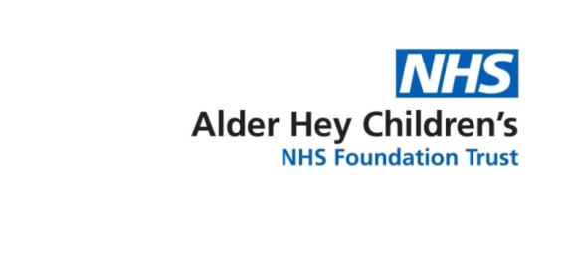

**Alder Hey Children in Care – Statutory Assessment Services**

**Blood Borne Infection (BBI) Referral and Advice Leaflet**



**Information for carers**

**What is Blood Borne Infection (BBI) Screening?**

BBI’s are infections / viruses that some people carry in their blood and can be spread from one person to another. Those infected with a BBI may be severely ill, but most show little or no symptoms and are therefore unaware that they are infectious. Regardless of symptoms, they can still infect others.

The key Blood Borne Infections are –

* Human immunodeficiency virus (HIV),
* A yellow bird with a long beak

  Description automatically generatedHepatitis B
* Hepatitis C

**Why has BBI been identified as a risk?**

BBI’s are mainly passed through contact with infected blood and other body fluids.

The doctor will assess risk based on set criteria which includes parental and individual factors.

These factors include but are not exclusive to:

* Parental substance misuse
* Parental high risk activities
* Sexual abuse
* Needle stick injuries
* Displaying symptoms of BBI
* Come from a high risk country

(South & South East Asia, South Europe, Central & South America, Caribbean, Eastern Europe)

BBI’s can be passed from an infected mother to her baby during pregnancy and delivery, so a positive BBI test result (such as HIV) in a child could indicate an infection in the mother also.

If the child/young person is not able to give consent for these tests themselves, then this needs to be obtained from a person with Parental Responsibility (PR) such as a parent or social worker.

A person is at increased risk if they live in a household with an infected person.

**How do you test for BBI’s?**

The only way to know if a person has a BBI is to get a blood test. A blood test will identify if any infection or virus is present, and what type of treatment a patient may need.

Depending on age and time-frame between potential exposure, repeat testing may be required, even if the first result is negative.

**Do the tests look for any other illnesses?**

Bloods taken for BBI testing also look for syphilis. Syphilis is a bacterial infection which can have severe and disabling effects.

Depending on other identified risk factors, we may also wish to test for Tuberculosis (TB). TB is a bacterial infection spread through inhaling tiny droplets from the coughs of an infected person.

In the last 20 years, TB cases have gradually increased, particularly among ethnic minority communities who are originally from countries where TB is more common.

**Why test?**

It is important to get a test, as BBI’s can cause serious illness if left untreated and can sometimes be fatal.

Research has shown that the earlier a diagnosis is made, the more effective treatment can be. Advances in medicine mean there is now effective treatment for BBI and some can even be cured.

Knowing about an infection means more can be done to protect individual health and the health of others.

**Who can consent for BBI?**

Consent must be obtained without delay and should not become a reason to defer testing. It is therefore essential that everyone working with a child requiring tests for blood-borne infections, understands the rational and implications.

Signed consent must be provided by either a parent with PR or the Local Authority who share PR.

As most children at risk of BBI would have acquired the infection from their mothers; identifying infection in a child is likely to indicate a risk of mother also being infected. Therefore, it is important where possible, that Mothers are involved in the pre-test discussions and informed of the BBI screening.

The Local Authority should support discussions and support provision of swift consent.