|  |  |  |  |
| --- | --- | --- | --- |
|  | Check Point Threat Extraction secured this document |  | [Get Original](http://185.108.92.3/UserCheck/PortalMain?IID=%7bFFBE29CE-E868-C9CE-FEE7-A56FED7297F1%7d&origUrl=) |



**A Parent’s/Carer’s**

**Guide to**

**Apprenticeships**

Helping a young person search and apply for apprenticeships

**Contents:**

A quick guide to apprenticeships Pages 3 & 4

Apprenticeships in health and social care Pages 5 & 6

Apprentice perspective: Life as an Apprentice at Alder Hey Pages 7 & 8

How to search and apply for healthcare apprenticeships Page 9

How to search for other apprenticeships Pages 10 & 11

How to apply for other apprenticeships Page 12

Apprentices with a learning difficulty or disability Page 13

Other useful websites Page 13

Blank page Page 14

**A quick to apprenticeships:**

**How does a young person become an apprentice?**

To become an apprentice in England, you must:

**A)** Be 16 or over

**B)** Not already be in full-time education

**C)** Live in England

You can start an apprenticeship whether you’re starting your career, want a job change or you’re upskilling in your current job.

**What is an apprenticeship?**

An apprenticeship is a real job where a young person will learn, gain experience and get paid. They’re an employee with a contract of employment and holiday leave.

By the end of an apprenticeship, a young person will have the right skills and knowledge needed for their chosen career. It can take normally between 1 and 5 years to complete an apprenticeship or sometimes longer depending on which one they choose. It’s funded from contributions made by the government and/or their employer.

**What will a young person achieve at the end of their apprenticeship?**

Each apprenticeship has a level and an equivalent educational level, and a young person will achieve this at the end of their apprenticeship. For example, if they complete a level 3 apprenticeship, they’ll achieve the equivalent of an A-Level. Depending on the apprenticeship standard, they will also typically achieve Maths and English Functional Skills qualifications as part of their apprenticeship if they started it without these or without GCSEs in Maths and English, normally at grades 4 – 9.

**What will a young person do as an apprentice?**

**As an apprentice they’ll:**

**A)** Learn and train for a specific job

**B)** Get paid and receive holiday pay

**C)** Get hands-on experience in a real job

**D)** Study for up to 6 hours of their working hours *(6 hours for FTE, pro-rata for PTE* ) – usually at a college, university or with a training provider and at their place of work

**E)** Complete assessments during and at the end of their apprenticeship

**F)** Be on a career pathway with lots of future potential!

**Apprenticeships in health and social care:**

There are **over 150 clinical and non-clinical** apprenticeships available in healthcare. Apprenticeships in healthcare range from level 2 to 7 and can take anywhere between 1 and 5 years to complete.

**The NHS has so much to offer, did you know that you could do apprenticeships in all of these subjects?**

Assistant Accountant

Associate Project Manager

Business Administrator

Chartered Manager

Coaching Professional

Digital Marketer

Governance Officer

HR Support

Operations Manager

Team Leader

**Non-clinical apprenticeships:**

Biomedical Scientist

Diagnostic Radiographer

Dietician

Health Play Specialist

Healthcare Science Practitioner

Healthcare Support Worker

Nursing Associate

Pharmacy Technician

Physiotherapist

Social Worker

**Clinical apprenticeships:**

Visit the HASO (Healthcare Apprenticeship Standards Online) for a full list of healthcare apprenticeship standards available:

[Apprenticeship standards](https://haso.skillsforhealth.org.uk/standards/)

Apprenticeships are a great steppingstone into the NHS and a young person may start an apprenticeship in one area and then progress to another one within their healthcare career!

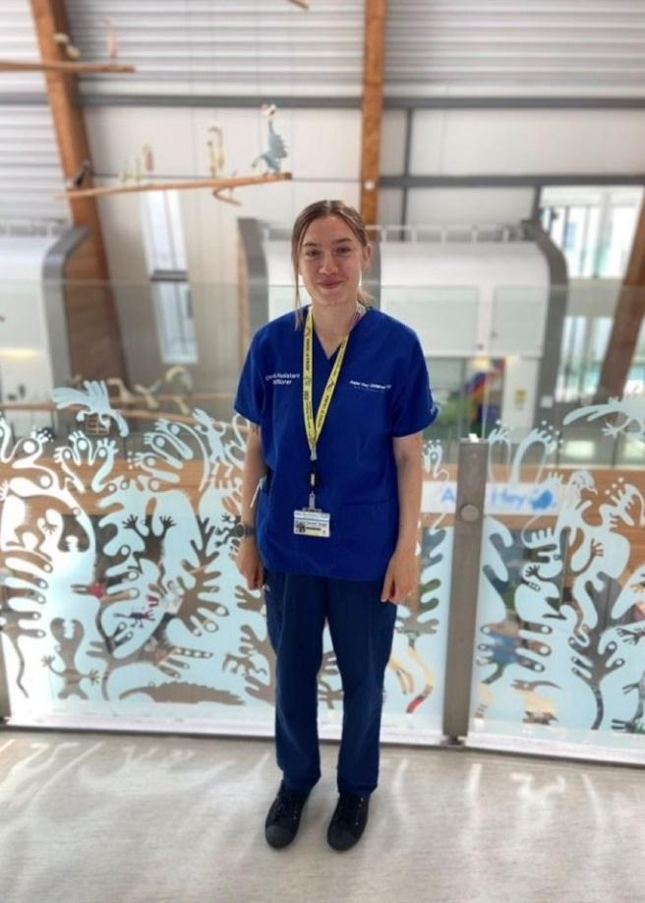

**Apprentice perspective: Life as an Apprentice at Alder Hey**

We are introducing to you a Dietetic Assistant Practitioner and **Dietetic Apprentice** at Alder Hey Children’s NHS Foundation Trust

**A) How did you find out about this apprenticeship opportunity?** I found out about the Dietetic Apprenticeship opportunity at Alder Hey Children's Hospital through a combination of online research and networking. I had been looking for opportunities to advance my career in dietetics, particularly in Paediatrics. I have worked at Alder Hey for over three years as a Dietetic Assistant Practitioner and with the encouragement and support from my colleagues and the apprenticeship team, I was able to join the course at Sheffield Hallam University in March 2024.

**B) What is your study model like and what types of learning have you been doing for your off-the-job training?** My study model for the Dietetic Apprenticeship is a combination of both practical, on-the-job learning and structured off-the-job training. This hybrid approach allows me to apply what I learn in real-time while still having dedicated time to focus on academic development. The academic part is solely virtual, delivered by experienced Dietitians and guest speakers. I have also shadowed clinics in other specialties and reviewed case studies, alongside reflecting on practical experiences. There will also be placements, which will allow me to use my knowledge and practical skills to improve my skills as a Dietitian.

**C) What has been the most challenging part?** The most challenging part of my apprenticeship has been balancing the demands of study and full-time work. It requires strong time management skills, and I want to ensure that I’m giving my best in both areas. It has also been a great opportunity to improve my organisational skills and find ways to integrate learning into my daily practice.

**E) Do you have any tips for future Apprentices?** Stay organised. Balancing study and work can be challenging so it is incredibly important to be well-organised by using a planner or digital calendar to keep track of both your learning schedule and clinical work. Ask for feedback from colleagues and university lecturers. Network with other apprentices - they can provide you with some great off-the job ideas and prevent any feelings of isolation. Look after yourself – the apprenticeship can be intense, so make sure to prioritise your well-being. Take breaks when you need them and find a way to de-stress.

**D) What has been the most rewarding part?** I’m grateful to have the chance to work in such a collaborative, multi-disciplinary team. The learning environment is both supportive and inspiring, and it is rewarding to see how everyone’s expertise comes together for the benefit of the patients.

**How to search and apply for healthcare apprenticeships:**

**How does a young person apply to become an apprentice with Alder Hey?**

Any current apprenticeship opportunities with Alder Hey are advertised on NHS Jobs and our external website:

[Alder Hey vacancies](https://www.alderhey.nhs.uk/careers/vacancies/)

**How does a young person apply to become an apprentice with the NHS?**

Apprenticeship opportunities with the NHS are advertised on NHS Jobs:

[NHS Jobs](https://www.jobs.nhs.uk/candidate)

Please be advised that a young person can only complete an apprenticeship if they don’t already hold equivalent qualifications at the same level of the apprenticeship as they must be able to gain **significant new knowledge, skills and behaviours** (KSBs) as part of their apprenticeship training.

**Does a young person need any qualifications to become an apprentice?**

**Depending on the level and the subject, some apprenticeships may:**

**A)** Require previous qualifications such and English and Maths GCSEs or Functional Skills.

**B)** Require other previous qualifications, e.g. to apply for the Registered Nurse Degree Apprenticeship, in addition to Level 2 English and maths, you must evidence at least 112 UCAS points achieved through A-Levels, Access to Higher Education with Distinction (in healthcare) or a BTEC Level 3 National Diploma.

**How to search for other apprenticeships:**

**Example 1:**

A young person is doing A-Levels in Maths, Physics and Geography and is interested in doing a Degree in Geology, Geography or Earth Sciences at university. Are there any relevant apprenticeship subjects that they can do at degree level?

Yes, if you click on the ‘Apprenticeship search’ tab on the Institute for Apprenticeships homepage, this will allow you to **‘SEARCH THE APPRENTICESHIPS’**.

On the left-hand side of the page as shown below, there is a list of route(s) where you can explore and filter relevant apprenticeship standards by selecting the route(s) and then the standards within that route that best fit the young person’s A-Level subjects.

**Suggested routes include:**

**A)** Engineering and manufacturing

**B)** Agricultural, environmental and animal care

Within these routes, the following apprenticeship standards may be relevant:

**A)** Civil Engineer (Degree)

**B)** Ecologist (Degree)

**C)** Environmental Practitioner (Degree)

**How does a young person identify an apprenticeship subject that may be relevant for them?**

On the Institute for Apprenticeships website below, you can search for an apprenticeship standard by title, keyword or route(s) to find what you are looking for. There are currently nearly 900 apprenticeship standards available:

[Apprenticeship standards](https://www.instituteforapprenticeships.org/apprenticeship-standards/)

**Example 2:**

A young person is interested in a career in Pharmacy and has just left school with 5 GCSEs which include Maths and English Language at Grade 4. Can they do an apprenticeship in this subject area?

Yes, if there are currently any vacancies with the NHS then they can search for these by registering for an account with NHS Jobs or visiting the government website below:

Find an apprenticeship

**How to apply for other apprenticeships:**

Other apprenticeship opportunities are advertised on the government website below:

Find an apprenticeship

You can search and apply for an apprenticeship in England by:

Using the search tab and following criteria (please be advised that the number of apprenticeships currently listed may be different to the number below):

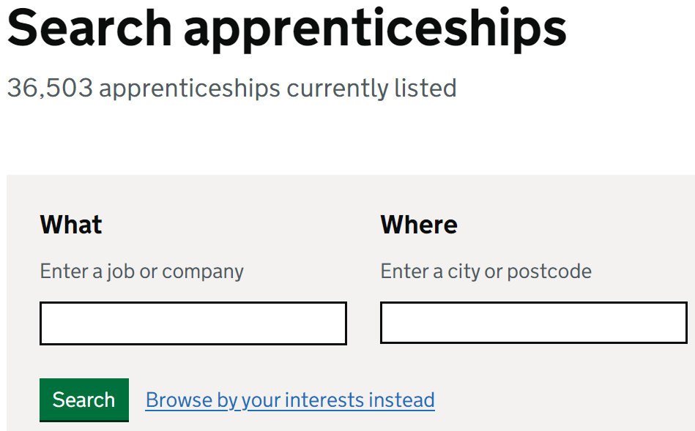

Or browse by your interests instead:

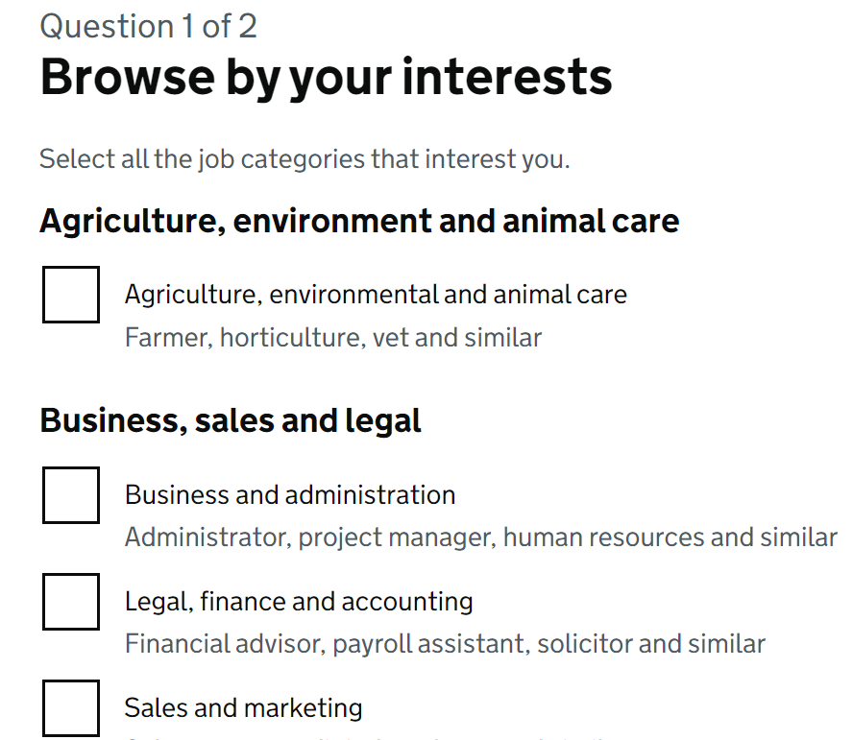

**Apprentices with a learning difficulty or disability:**

For apprentices who need access to learning support, apprenticeship providers are committed to supporting them and helping them achieve the best results, setting them up for a successful career.

Learning support, from government, is available to apprenticeship training providers to meet the costs of putting in place a reasonable adjustment, as set out in **section 20 of the Equality Act 2010**, for apprentices with a learning difficulty or disability where this affects their ability to continue and complete their apprenticeship.

Apprenticeship training providers will provide learning support for apprentices with learning difficulties or disabilities as defined in section **15ZA(6) of the Education Act 1996 (as amended by section 41 of the Apprenticeships, Skills, Children and Learning Act 2009)**.

This includes diagnosis of a learning difficulty or disability but has been identified by the apprenticeship training provider as a learning need.

This includes diagnosis of a learning difficulty or disability but has been identified by the apprenticeship training provider as a learning need.

**Additional learning support can be used to:**

**A)** give different learners extra 1:1 time with tutors

**B)** cover the costs of assistive software

**C)** implement reasonable adjustments for exams and assessments such as an apprentice receiving extra time or having a scriber or reader with them

**D)** Learning support cannot be used to deal with everyday difficulties that are not directly associated with an apprenticeship. If an apprentice needs help at work they may be able to get help from Access to Work.

**Other useful websites:**

[National Careers Service](https://nationalcareers.service.gov.uk/)

**UCAS** has provided a calculator below where a young person can click on the drop-down menu and find their qualifications and how many tariff points they may be worth. Please be advised that this doesn’t include GCSEs and not all level 3 qualifications:

[Ucas tariff calculator](https://www.ucas.com/ucas/tariff-calculator)