**Contact Us**

If you have any problems or questions, please contact a member of

the team who will be happy to discuss them with you.

Telephone: 0151 282 4569

Email: [craniofacial@alderhey.nhs.uk](mailto:craniofacial@alderhey.nhs.uk)

Craniofacial nurses bleep **153** via switchboard

**Craniofacial Nurse Specialists**

Jane England – [jane.england@alderhey.nhs.uk](mailto:jane.england@alderhey.nhs.uk)

Luci Russell – [luci.russell@alderhey.nhs.uk](mailto:luci.russell@alderhey.nhs.uk)



Alder Hey Children’s NHS Foundation Trust

Eaton Road

Liverpool

L12 2AP

Tel: 0151 228 4811

[www.alderhey.nhs.uk](http://www.alderhey.nhs.uk)

**© Alder Hey Review DECEMBER 2027 PIAG: 506**

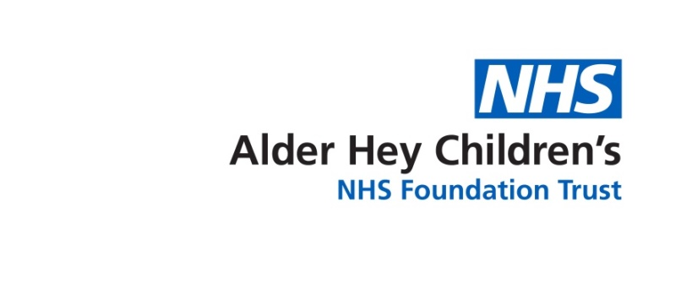

**Admission to Hospital**



**Information for**

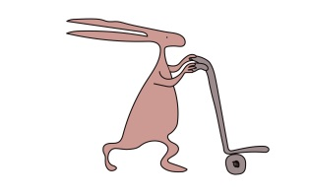**patients, parents and carers**



**Surgery Date**

* This booklet has been written to help you prepare for what will happen over the next few weeks before your child’s operation.
* The timing of your child’s operation will depend on the diagnosis and his/her age, your surgeon should have given you a rough idea of when this will be.
* Once a surgery date has been allocated for your child. The nurse specialists will contact you to arrange a pre op day. This is usually 3-5 days prior to surgery.
* The anaesthetic pre op triage team will be in touch to complete an assessment over the phone for your child. If your child is under more than one specialty locally or at Alder Hey, you may be required to attend an anaesthetic lead clinic for your child to be assessed face to face.

**Pre Op Day**

* Attending pre op is mandatory, this may mean it is an additional journey to the hospital prior to surgery date.
* Investigations needed on this day include; blood tests, 3D photographs, anaesthetic review, informed consent, clinical exam and medical history taking.

**Ward 4A**

* **Contact Number – 0151 282 4490 / 4492**
* Your child will be admitted to Ward 4A, which has a total of 32 beds. 16 neurosurgical beds and 16 specialist surgery beds. This also includes 6 high dependency bed.
* Ward 4A cares for children from birth to their late teens.
* Craniofacial cases are usually nursed in the high dependency bay area post operatively.
* The ward has many staff members who may care for your child, these include:

**Nursing sister/Charge nurse - Navy blue tunic   
Staff nurse - Royal blue tunic   
Assistant Practitioner - Pale blue tunic   
Health care assistant - White tunic   
Student nurse - Grey tunic**   
**Play specialist - Lilac tunic**   
**Housekeeper - Black tunic**   
**Clinical Nurse Specialists - Purple tunic**

**PALS (Patient Advisory Liasion Service)**

* A free and confidential service provided by the Trust. PALS office is on the ground floor of the hospital.

**Mealtimes**

* Breakfast, lunch and dinner will be provided for your child. There is a chef based on the ward and a menu to order from.
* Please keep visitors to a minimum during mealtimes.
* Baby milk can also be provided. Please bring at least 24 hours of feeds in case the milk kitchen is closed when you are admitted.
* Breakfast 0800 - 0900 (cereal, toast, juice, milk etc)
* Lunch 1145 - 1245 (cooked fresh by on ward chef)
* Dinner 1630 - 1730 (cooked fresh by on ward chef)
* If your child has a special diet for religious obligations or medical needs the ward can cater for this and offer alternatives. Please inform ward staff of dietary needs.
* There is a parents kitchen located in yellow pod, this includes a fridge, hot kettle tap and microwave to prepare food.

**Visiting**

* We operate an open-door policy for parents/carers, visiting at any time during the day.
* **ONE** parent is welcome to stay overnight.
* Other visitors can visit between 2:30pm – 7:30pm.
* Please keep visitors to a minimum as space around the bed side is limited.
* 4 visitors are allowed at any one time in the main ward area and 2 visitors in the high dependency area.
* Please supervise siblings and visiting children at all times.
* Upon leaving and entering the ward, please use the hygiene gels provided.

**Ward Safety**

* Hot drinks must have lids on if brought or made on the ward.
* Keep the bedside clutter free and belongings to a minimum, staff need easy access to the patient at all times, in particular in an emergency. There are small lockers/cupboards at the beside to keep some belongings in.
* Specialist equipment is for the use of staff only. Please do not touch or silence alarms.

**Playroom**

* There is a playroom located on the ward in yellow pod, for use of patients and siblings. We ask to always supervise children, be respectful of toys and leave the area tidy.
* Our play specialist can also help provide activities/toys for your child.

**Chapel**

* The Sanctuary is located on the 2nd floor. This facility is available for all religious denominations.

**Getting Ready**

* Clothing – it is advised to bring comfy and loose clothing.
* Comforter – If already used, we recommended to bring to give a sense of security for your child with something familiar from home.
* Toiletries/Bedding – Bedding can be provided. Please bring everyday items you would normally use at home.
* Feeding – Sterilizing and expressing facilities available on the ward.

**Ronald McDonald House**

* There is the facility of Ronald McDonald house where parents can stay whilst your child is in hospital. This is located on the hospital grounds.
* Ronald McDonald is a facility provided by a charitable trust and rooms are provided based on circumstances and duration of admission.
* A referral can be made once your child has been admitted.
* Unfortunately, we cannot guarantee availability of a room within Ronald McDonald house.

**Accommodation nearby**



Premier Inn Premier Inn (Roby)

Queens Drive, L13 0DL Roby Road, L36 4HD

Travelodge

502 Queens Drive, L13 0AS

**Parking**

* There is a multi-storey Car Park on site. Accessed by East Prescot Road.
* Visitors can pay for parking before exiting in the Atrium.

**Atrium**

* **Treetops** restaurant is the main hospital restaurant on the ground floor;

Monday - Friday  
Breakfast served 07:30am – 10:30am  
Lunch/afternoon service – 11:45am – 6:45pm

Saturday/Sunday  
Breakfast 08:00am – 10:30am  
Lunch/afternoon service – 11:45 – 6:00pm  
  
A selection of hot and cod beverages, sandwiches and snacks are available from 07:30am – 07:00pm

* **WHSmiths**   
  Monday – Friday: 07:00am – 08:00pm  
  Saturday: 0900am – 06:00pm  
  Sunday: 0800am – 06:00pm



* **Costa Coffee**Monday – Friday: 07:00am – 06:00pm  
  Saturday: 0900am – 05:00pm  
  Sunday: 0800am – 04:00pm