**Contact us**

If you have any problems or questions, please contact a member of

the team who will be happy to discuss them with you.

Orthotics Telephone: 0151 252 5318

Orthotics Fax: 0151 252 5319

Craniofacial Nurse specialists: 0151 282 4608 / Bleep 135 via switchboard.

Email: orthotics@alderhey.nhs.uk / craniofacial@alderhey.nhs.uk

This leaflet only provides general information. You must always discuss the individual treatment with the appropriate staff member.

Do not rely on this leaflet alone for information about the treatment.

This information can be made available in other languages and formats if requested

Alder Hey Children’s NHS Foundation Trust

Eaton Road

Liverpool

L12 2AP

Tel: 0151 228 4811

[www.alderhey.nhs.uk](http://www.alderhey.nhs.uk)

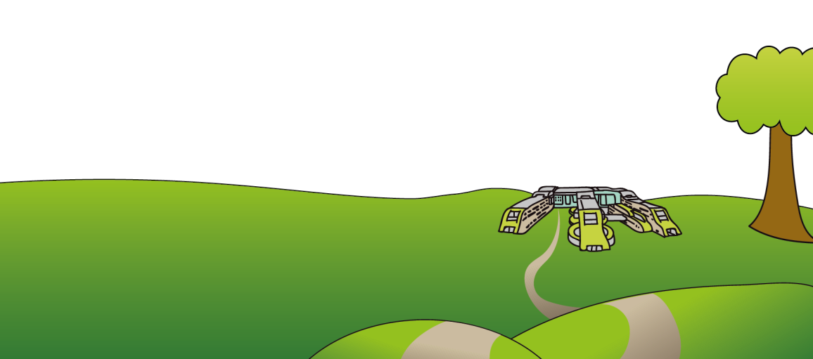Information originally produced by Orthotics department at Alder Hey. Revised by LR / RG in January 2023

**© Alder Hey Review Date: December 2027 PIAG: 449**

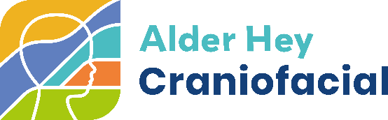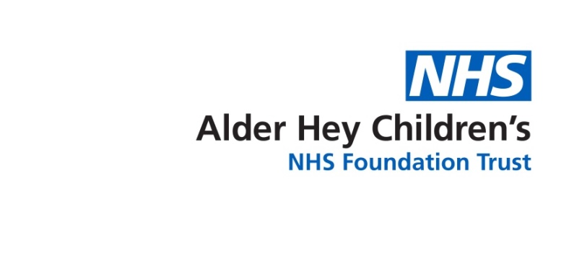

**Orthotics & Craniofacial Department**

**Helmet therapy for**

**craniosynostosis**

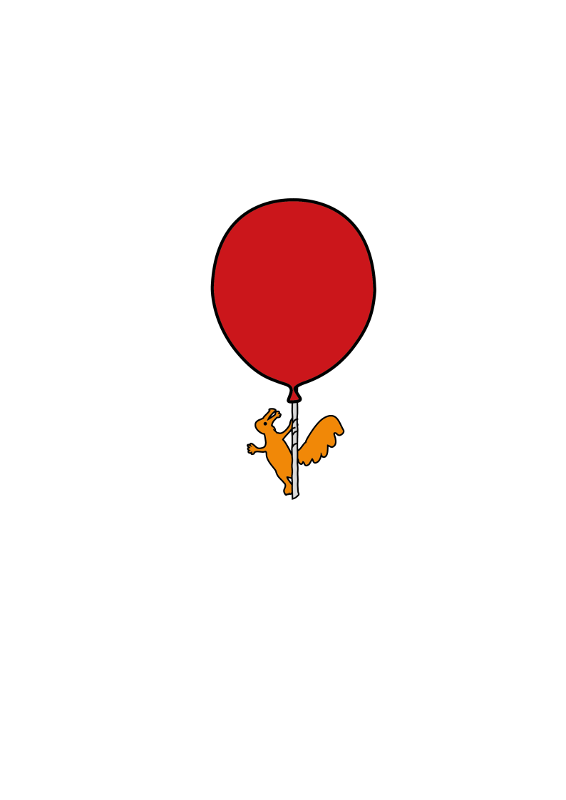

**Information for**

**patients, parents and carers**

**Why has a helmet been prescribed and what is my child entitled to?**

* Your child has been prescribed a helmet following an endoscopic strip craniectomy for craniosynostosis.
* You will be provided with up to **3 helmets over 12 months**.

**What is involved in measuring for the helmet?**

* 3D images will be taken following your child’s surgery and the helmet will be created from this specifically for your child’s head shape and will be fitted at a later date.
* Your baby’s head shape will change more rapidly at the beginning of the process due to brain growth rate at this age. Therefore, we closely monitor this.

**Why does my baby need more than one helmet?**

* As your baby’s head grows, all the changes cannot be accommodated within the one helmet.
* A change in helmet is dependent upon your child’s head growth and shape change. Orthotics advise on the appropriate time for this.

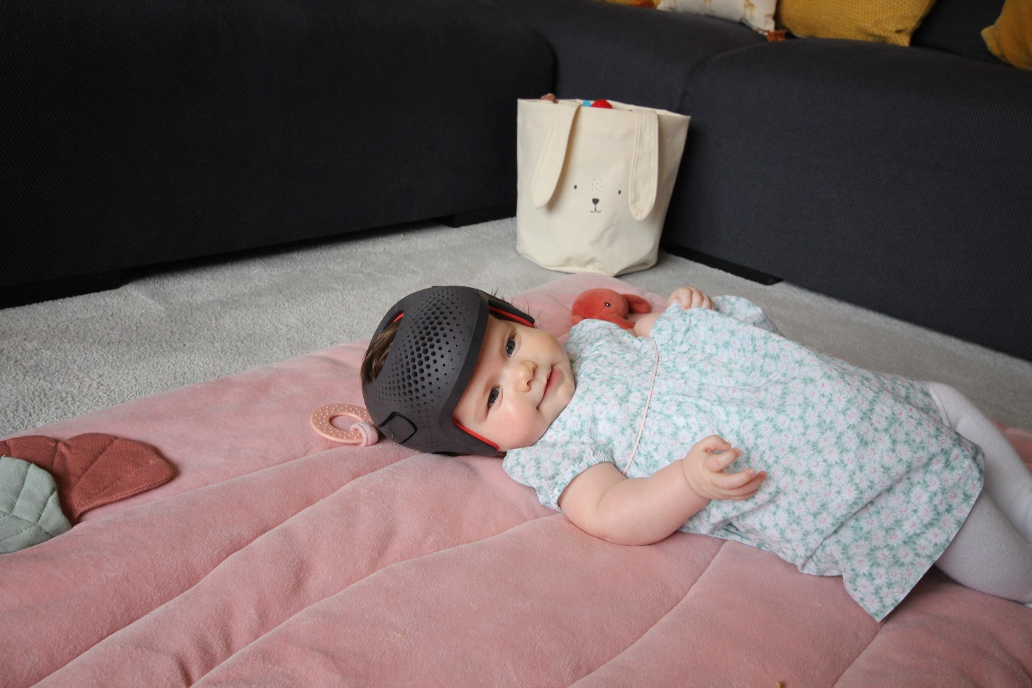

Figure 1Images gained with parental consent

**Craniofacial & Orthotics – Appointments**

Date of surgery:

|  |  |  |  |  |
| --- | --- | --- | --- | --- |
| **Timeline** | **Date** | **Appointment Type** | **Time** | **3D Photos** |
| Pre op |  | Craniofacial |  |  |
| Day 5 |  | Orthotics – 1st helmet  2D & 3D Images |  |  |
| Day 14-18 |  | Craniofacial & Orthotics – fit helmet |  |  |
| Week 4 |  | Orthotics – 2 Week  Review |  |  |
| Week 8 |  | Craniofacial &  Orthotics |  |  |
| Week 12 |  | Orthotics |  |  |
| Week 16 |  | Craniofacial & Orthotics |  |  |
| Week 20 |  | Craniofacial &  Orthotics |  |  |
| Week 24 |  | Craniofacial & Orthotics |  |  |
| Week 30 |  | Craniofacial & Orthotics |  |  |
| Month 9 |  | Craniofacial &  Orthotics |  |  |
| Week 52 |  | Craniofacial |  |  |

**\*\*Please note, appointments are booked on a review-by-review basis. Consultant led reviews as and when applicable or required, usually midway and end of treatment.**

**Cautions**

* If your baby has a fever above 38 degrees Celsius, the helmet should be removed until the fever is controlled.
* If this continues for more than 2 days, contact the orthotics department.

**Cleaning the helmet**

* It is important to keep the inside of the helmet, and your baby’s head clean to prevent germs.
* To clean the helmet, clean the inside with a baby wipe. If it is very dirty, use a little mild baby shampoo and a face cloth but ensure it is **fully dried** before putting the helmet back on.
* Do not immerse the helmet in water or apply heat.
* Only clean with baby shampoo and water unless advised otherwise by craniofacial nurse specialists.

**Skin Care**

* Your baby may get some redness or heat rash, this should resolve when having a breakout of the helmet. If it does not resolve/reduce or there are any signs of blistering**.**
* **In the first instance please contact the craniofacial nurse specialists, we will advise you as necessary to contact tissue viability or the orthotics team.**
* To look after your baby’s skin whilst in the helmet, a mild daily moisturiser (E45) is recommended to keep the skin moisturised. It is NOT recommended to use Sudocrem.

**IMPORTANT**

* Any questions, worries or concerns contact craniofacial nurse specialists.
* All advice re helmet therapy **must** be given only by craniofacial and orthotics at Alder Hey.
* Bring this leaflet with you to each review to record appointments.

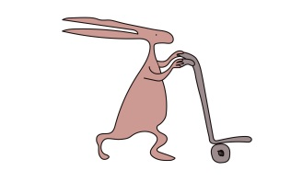**Notes**

………………………………………………………………………………

………………………………………………………………………………

………………………………………………………………………………

………………………………………………………………………………

………………………………………………………………………………

………………………………………………………………………………

………………………………………………………………………………

………………………………………………………………………………

………………………………………………………………………………

………………………………………………………………………………

………………………………………………………………………………

………………………………………………………………………………

………………………………………………………………………………

………………………………………………………………………………

………………………………………………………………………………

………………………………………………………………………………

………………………………………………………………………………

………………………………………………………………………………

**Getting started**

* The helmet must be worn for 23 hours per day.
* The helmet must be donned and removed by opening BOTH clips, not just one side. This will cause breakages.
* The first few days are the most difficult as it is a time of adaption for all of you.
* The helmet should be treated as an additional layer of clothes and therefore to counteract the increase in body temperature, a layer of their clothing should be removed i.e., a vest or a blanket.

**How is the helmet fitted, and adjusting the helmet**

* The helmet will be designed from 3D photographs by TiMBANDAir™ and fitted by one of our trained Orthotists in clinic.
* You **MAY** be provided with additional pads at the first appointment. It is your responsibility to bring these with you to every review appointment. **DO NOT** add or remove these yourself without instruction from the clinician.
* You may find the helmet starts to become looser over the first few weeks. This is normal and will be addressed at review.

