After your appointment
After your appointment, the doctor will make some notes about you and give these to the adults around you who are helping to keep you happy and healthy.

If you want to tell us how it went, ask an adult to help by scanning this QR code:



And that is it!

So, we can't wait to see you soon and if you have any questions before your appointment, feel free to ask your carer to give us a call or to send us an email.



This leaflet only gives general information. You must always discuss the individual treatment of your child with the appropriate member of staff. Do not rely on this leaflet alone for information about your child’s treatment.
This information can be made available in other languages and formats if requested.
Alder Hey Children’s NHS Foundation Trust
Safeguarding and Statutory Assessment Services

Eaton Road
Liverpool
L12 2AP
Tel: 0151 252 5122
Email: ahc-tr.SASteam@nhs.net
www.alderhey.nhs.uk
© Alder Hey

Review Date: July 2024
PIAG: 579



Safeguarding and
Statutory Assessment
Services

Information for Children attending an
Initial Health Assessment (IHA)



What you need to know



Hi

We're so excited to see you soon at your health assessment. We have been asked to see you to check you are healthy and we are really interested to know how you are feeling.

We know it might feel a bit new or different, but don't worry, we're here to help make it easy for you.

If you're feeling nervous, try taking some deep breaths. It can help you feel calm and relaxed.



When you arrive at Alder Hey, you'll meet some of our team. They're here to help you and make sure you feel comfortable. These might be doctors, nurses, or health care assistants.

What will happen?

Equipment

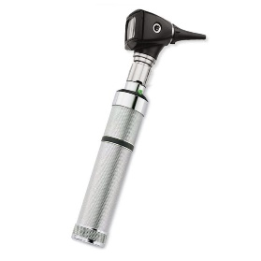
You might see some interesting tools and gadgets around. They're just things to help the doctor understand how your body is doing. Feel free to ask questions about them!




Taking Care of You

We want to make sure you're feeling your best! Our team will talk to you about things like eating healthy foods, getting enough sleep, and staying active.



Other teams in the hospital

They may need to see you too. You will be told all about this by the doctor if you need any special tests.
Top Tips for a great

appointment

Just be You!


You're amazing just the way you are! Don't be afraid to tell us all about you during the appointment.

Ask Questions

If you don't understand something, that's okay! Our team is here to answer all your questions.


Bring things with you


Sometimes we feel better if we have something to play with or do in case we have to wait around. It might help to have a drink or a snack.




