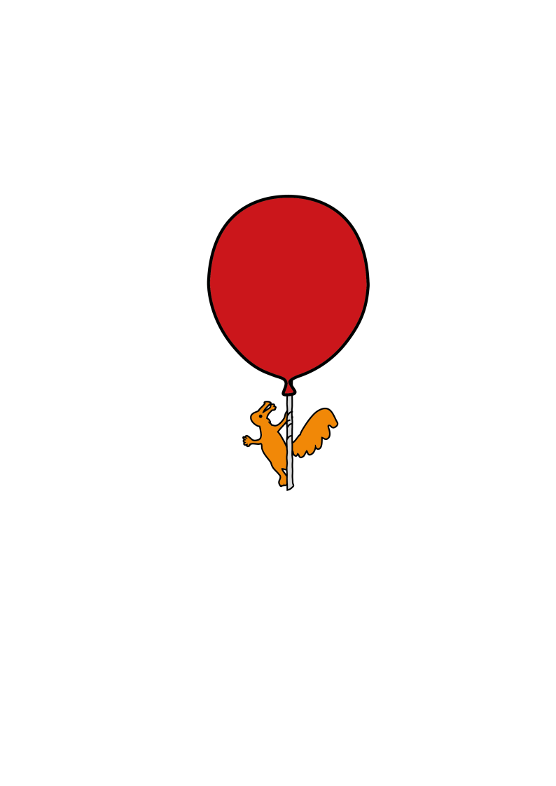

Developmental Paediatrics

**Osteopenia in Children with Complex Disability**

Information for Parents/Carers

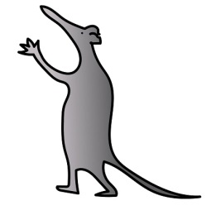

**What is Osteopenia?**

Osteopenia is when bone density (how much bone tissue you have inside your bones) is lower than average. The bones are weaker than normal but not weak enough to be called osteoporosis. Osteopenia is a risk factor for developing fractures (broken bones).

Children who have difficulties moving or are unable to move/stand are at risk of developing weaker bones.

**What can be done to manage Osteopenia?**

If your child has been diagnosed with Osteopenia, there are measures that can be followed to reduce the impact, keep the bones healthy and reduce the risk of developing osteoporosis

**Exercise**

Participating in regular weight bearing and exercise helps to maintain a healthy bone structure. Your child should participate in some form of physical activity daily. A physiotherapist will be able to advise how to achieve physical activity in the best way for your child. If you need further advice speak to your child's physiotherapist or request a referral.

**Nutrition**

A balanced diet with adequate amounts of calcium and vitamin D is essential to maintain healthy bones

**Pain**

Most children with osteopenia do not have any symptoms.If your child is not able to tell you they are in pain look out for other signs such as grimacing, crying, and sweating. If they are showing any of these signs and you cannot account for another reason, a fracture should be considered and investigated.   
  
**What are the treatments for Osteopenia?**

Your doctor may request blood tests to ensure your child has a normal level of Calcium, Magnesium, Alkaline Phosphatase and Vitamin D levels. Some children who have low levels might be prescribed supplements.

Your doctor may arrange further scans to measure bone density and refer your child to a specialist Bone clinic, depending on how weak the bones are and the risk of breaking a bone.

**Handling a child with Osteopenia**

Children with osteopenia, who are unable to move themselves, should be moved and handled correctly to prevent broken bones/fractures.

This could mean using a hoist or other moving and handling equipment like slide sheets, and ensuring you support the whole of a child’s limbs, not just the joint.

You may also need to modify play and game activities to limit risk of injury.

If your child receives chest physiotherapy you need to consider the amount of force, the direction the force is applied in and the area force is applied to.

If you are unsure about the safest way to move, handle, play or perform chest physiotherapy with your child, contact your local physiotherapist or moving and handling team.

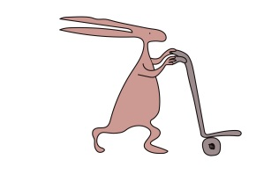

This leaflet only gives general information. You must always discuss the individual treatment of your child with the appropriate member of staff. Do not rely on this leaflet alone for information about your child’s treatment.

This information can be made available in other languages and formats if requested.

Alder Hey Children’s NHS Foundation Trust

Alder Hey

Eaton Road

Liverpoo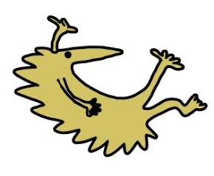l

L12 2AP

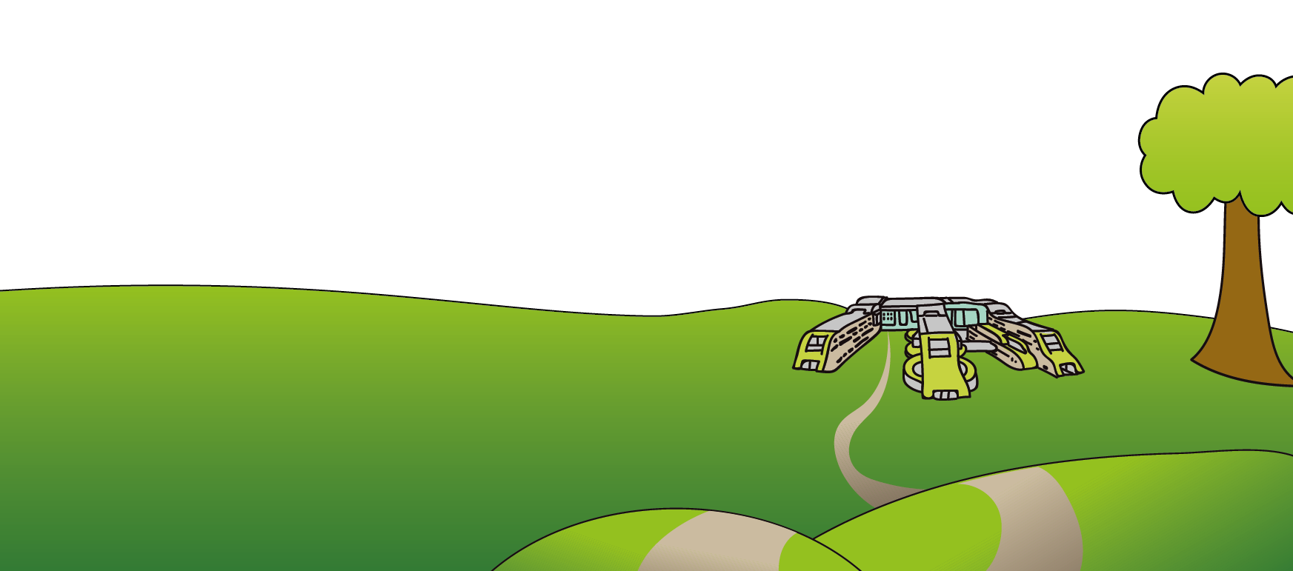Tel: 0151 228 4811

[www.alderhey.nhs.uk](http://www.alderhey.nhs.uk)

**© Alder Hey Review Date: August 2028 PIAG: 362**