**Care of the device**

* Each device will require different care, during your fitting appointment the Orthotist will describe this to you in detail.

What issues do I need to be aware of?

* Some devices may lead to marking of the skin, which is normal, as is a build-up of some hard skin. Provided this is not excessive or painful and discolouration clears within 30 minutes of removing the device, this is nothing to worry about.
* Sometimes devices can lead to sores, blisters, pain or rubbing, if any of this arises, contact the department.

**Contact us**

If you have any problems or questions, please contact a member of

the team who will be happy to discuss them with you.

Telephone: 0151 252 5318

Email: orthotics@alderhey.nhs.uk

This leaflet only provides general information. You must always discuss the individual treatment with the appropriate staff member.

Do not rely on this leaflet alone for information about the treatment.

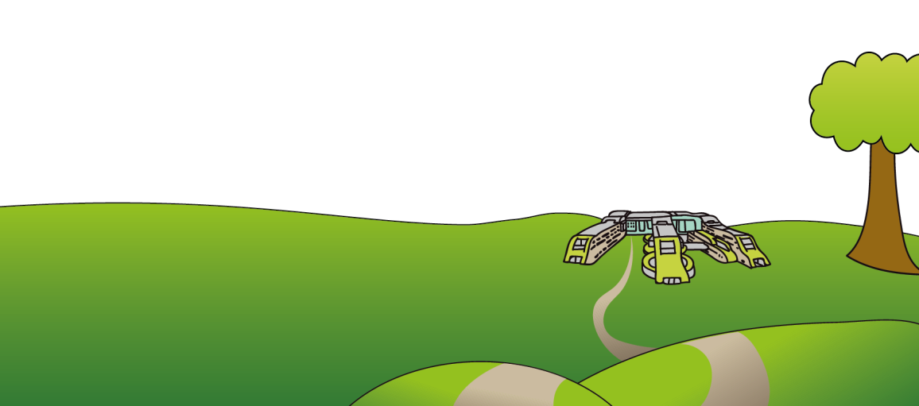This information can be made available in other languages and formats if requested

Alder Hey Children’s NHS Foundation Trust

Eaton Road

Liverpool

L12 2AP

Tel: 0151 228 4811

[www.alderhey.nhs.uk](http://www.alderhey.nhs.uk)

**© Alder Hey Review Date: July 2027 PIAG: 153**



**Orthotics Department:**

**Who are we &**

**what do we do?**

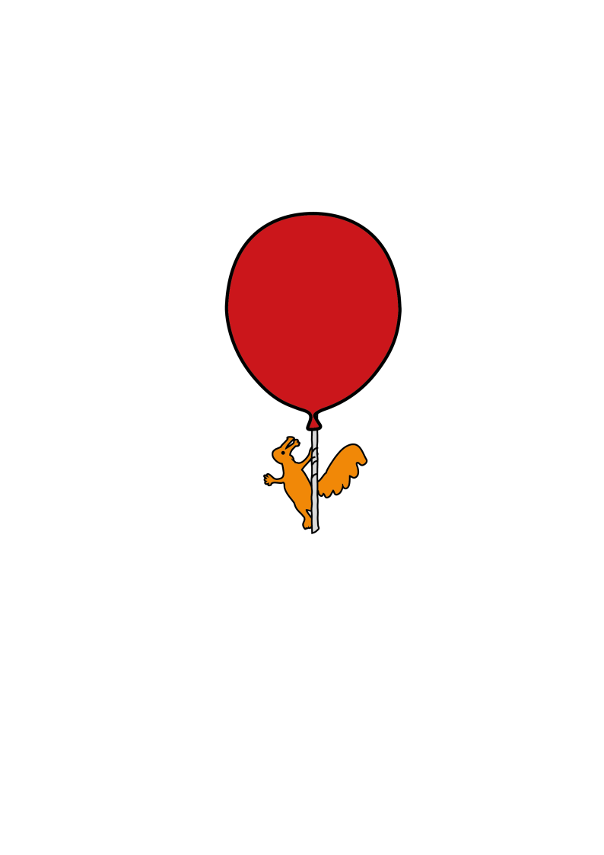

**Information for**

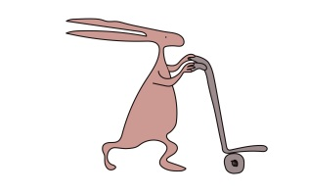**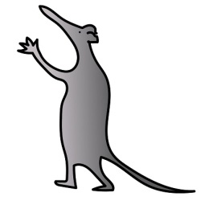patients, parents and carers**

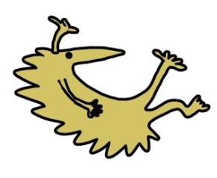

**What is an Orthoses?**

* An external device which supports a body part weakened by disease, defect or trauma.
* Orthotics can support and control a limb by limiting movement or immobilizing a limb. Alternatively, an orthosis may enable movement of the body part. They can also be used to reduce weight bearing pressure; to correct shape, position and function or as a rehabilitation device i.e. after removal of a cast. All may lead to a reduction in pain, spasticity, muscle tone and/or slow down progression of a deformity.
* They may be used for many conditions including:

1) Cerebral Palsy

2) Scoliosis

3) Spina Bifida

4) Neuromuscular disorders

5) Talipes (Club foot)

6) Many foot disorders

* These orthoses may be:
* Specialist footwear or adaptations to own footwear
* Insoles
* Ankle Foot Orthoses (AFO) or Knee Ankle Foot Orthoses (KAFO)
* Spinal braces using specialist 3D equipment
* Protective Helmets
* Wigs
* Wrist braces
* Other

**How is an orthotic device fitted, and what is my child’s entitlement?**

* The orthotic device will be fitted by one of our trained Orthotists in clinic
* If the device is a lower limb device, please attend clinic with appropriate footwear that fastens rather than slips on. It is advisable to attend with a few different styles of footwear but to not purchase new footwear until you have the device as it may alter the size that your child wears.
* The Orthotist will advise you on how to properly fit the device and of when and how long the device needs to be worn for.
* Your child is entitled to 1 device at a time due to regular growth in children. The only exception to this is with adaptions to your child’s own footwear; 2 pairs will be adapted at one time.

**Will I receive my device straight away?**

* The Orthotist may be able to provide a stock/off the shelf device on the same day, if suitable to your child’s needs.
* The Orthotist may have to take appropriate measures, scans or casts and either order a device in, make adaptions to a stock product or have a bespoke device made. You will be asked to return for a fitting appointment at a further date.

**Zero Tolerance Policy**

* We operate a zero tolerance policy to abuse towards our staff; both physical and verbal.
* Any patient or relative found to be in breach of this policy may be asked to leave. Please have respect for our team whilst they look after you.