

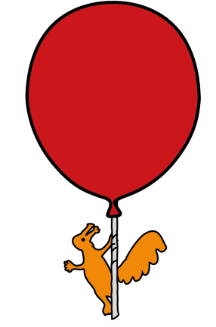
Endocrine Department
Oral Glucose Tolerance Test (OGTT)
Information for parents and carers

Introduction

This leaflet aims to provide you with some information about Oral Glucose Tolerance Test, what it involves and how long it will take.

Oral Glucose Tolerance Test

An oral glucose tolerance test (OGTT) measures how well the body processes glucose (sugar),
for example its uptake into the bloodstream for use by the cells as an energy source. Your child’s Insulin levels will also be measured during this test.

What will happen?

We will need to take blood samples to measure the blood glucose (sugar) levels.
Once the first blood sample has been taken, your child will be asked to drink a measured amount of a sugar based drink over five to ten minutes.

The last blood sample will usually take place two hours after your child has drunk the sugar based drink.

How will it happen?

The most convenient way to take blood samples is by placing a plastic needle (cannula) in a vein. This is usually on the back of the hand or inside the elbow with a valve (tap) attached. We can apply a local anesthetic cream before doing the test to prevent pain or discomfort. The cream will take approximately 45 minutes to become effective.

Can my child eat and drink before the test?

No. Your child should NOT have any food or drink for eight hours before the test, including chewing gum. They MAY DRINK any amount of plain unflavoured WATER.

How long will the test take?

The test should last two to three hours throughout the course of a morning. Once the cannula is in place, your child will be able to relax in an armchair on the ward.

Your child should not have any food or drink (except water) before they have their last blood test.

After the two hour test your child will be offered lunch.

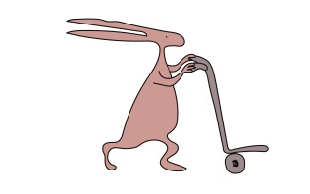
Once the blood tests are completed and your child has had something to eat they will be discharged from the unit.

Are there any side effects?

No.

How do I prepare my child?

It is important to talk to your child about the test, explaining as simply as possible what will happen.

What should we do if we cannot attend the appointment?

If the date or time is not convenient, please contact either the Medical Day Case Unit (G4) reception and another appointment will be arranged. If the appointment is not needed, please let us know as soon as possible and we will offer this appointment to another patient.

Medical Day Case Unit reception: 0151 282 4769 Monday – Friday 8.00 am – 5.00pm
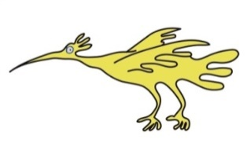
For further information

Please telephone the Endocrine Nurse Specialists on: 0151 252 5534

Monday – Friday 8:00 am – 5:00 pm or leave a message on the answer machine.

This leaflet only gives general information. You must always discuss the individual treatment of your child with the appropriate member of staff. Do not rely on this leaflet alone for information about your child’s treatment.

This information can be made available in other languages and formats if requested.

Alder Hey Children’s NHS Foundation Trust
Alder Hey
Eaton Road
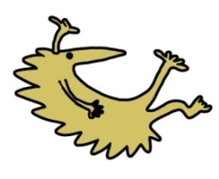
Liverpool
L12 2AP

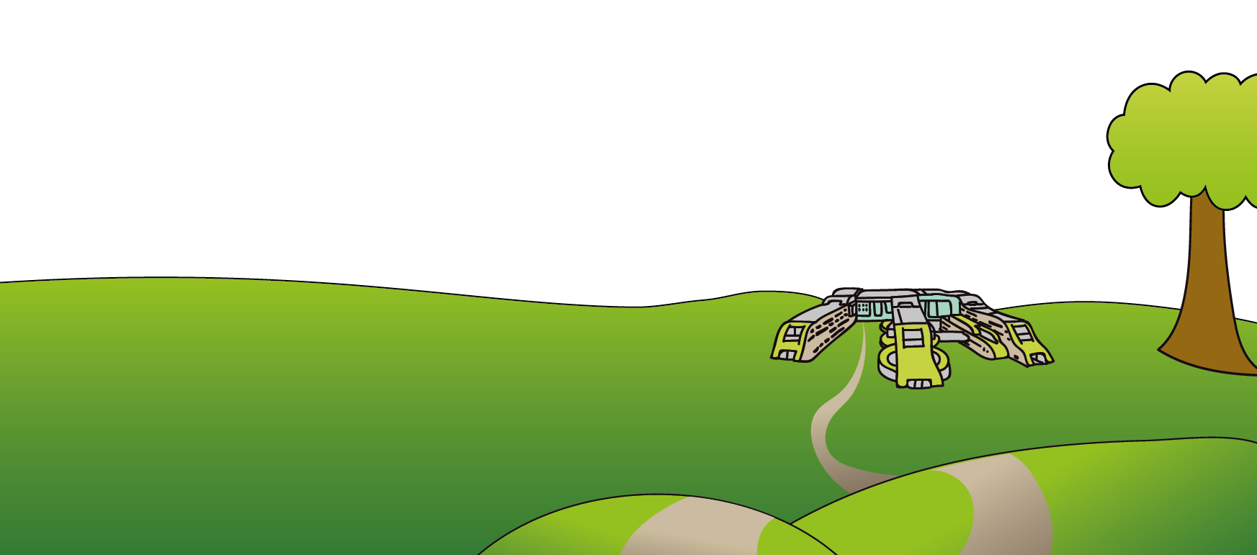
Tel: 0151 228 4811
www.alderhey.nhs.uk

© Alder Hey Review Date: July 2028 PIAG: 62

