
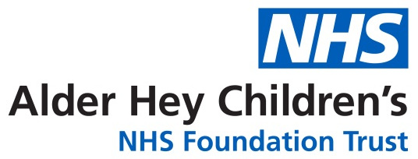

Outpatient Parenteral Antimicrobial Therapy Service

OPAT: Going Home with IV Antibiotics

Information for parents and carers

This leaflet aims to provide you with some information about a service called OPAT.
What is Outpatient Parenteral Antimicrobial Therapy (OPAT)?
Children can be given antibiotics in different ways: they may receive antibiotics by mouth (orally) or directly into their veins, known as intravenous (IV) or parenteral therapy. Some children can receive IV antibiotics safely in their home by trained and experienced nurses, or by a parent/carer, or at a local children’s unit as an outpatient.
When a patient receives IV antibiotics without having to stay in hospital this is called Outpatient Parenteral Antibiotic Therapy (OPAT).
Do all children go onto the OPAT service?
This service is not suitable for all children receiving IV antibiotics (for example, not all antibiotics can be given at home or might need to be administered too frequently). Your doctors may suggest the service for your child and the OPAT team will need to check they agree it is appropriate and safe. Even if a child is suitable for OPAT, the child (depending on age) or parents can of course choose not to use the service. It is essential that nursing staff have up to date contact details of parents/carers and where the child lives/stays before consideration for OPAT.
The benefits of the OPAT service

We will try to ensure that the OPAT service is tailored to the individual needs of your child and family. Some children can have treatment provided in their own home, others may need to travel daily to a nearby hospital. We will explain the options to you. Children who can continue treatment out of hospital can usually spend more time with their family and friends and some may also be able to return to school. This may help to speed recovery and reduce pressures on the family.
Potential risks
Before a child goes home their parents will have received all the information they need about medicines and their side effects, as well as caring for the IV lines at home.
Allergic reactions
It is important to remember that allergic reactions can occur with any medicine at any time. Children will receive at least one dose of their antibiotic in Alder Hey Hospital to ensure they do not develop a severe reaction at the start of treatment. When at home please seek immediate medical attention if your child develops any of the following symptoms: a rash, facial swelling or difficulty in breathing.
Intravenous access
We try to send all OPAT patients home with IV access that will last for the length of their treatment, however sometimes despite excellent care cannulas or long lines may need replacing or treatment altered if the IV access stops working. The type of access and replacement options will be discussed with you and your child.
Who will give the IV antibiotics?
It depends on your area and we will discuss with you the available options.
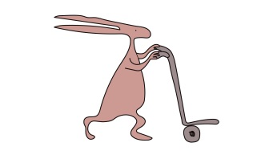
Some areas have Community Nurses who can travel to your home to administer the antibiotics but other areas don’t have this facility and you may need to attend your local hospital daily for antibiotics. Some areas do a mixture and have Community Nurses during the week but you may need to attend your local unit at the weekend. In some circumstance parents/carers can be trained to administer certain antibiotics.
How long will IV treatment last?
This varies from one child to another. One child may need a few days of IV treatment, another child may need several weeks of IV treatment.
Review of progress
All children are reviewed by discussion in a weekly virtual ward round in the hospital, with feedback from the community team and any recent test results. Some children need to have blood monitoring whilst on OPAT – this will be discussed with you before you go home. The team who looked after you may ask you to return either during or after your child’s treatment for a clinic appointment. Sometimes the planned length of treatment or medicines used may need to change as a result and this will be discussed with you.
Improving the service
Feedback from patients, families and carers allows us to improve the quality of care we provide. After completion of treatment we would like to contact you via telephone or text message, to complete a short survey about your experiences. If you do not wish to participate in this please let the OPAT nurse know before you are discharged home, or contact us on the number below.
Who to contact for help or further information
The OPAT nurse can be contacted between 08.30am-4pm, Monday-Friday for advice about treatment or lines on 0151 228 4811 extension 3251
If you can’t contact the OPAT team call 0151 228 4811 and ask the switchboard operator to bleep the IV/OPAT team for you.

If you have a question or problem that cannot wait until the OPAT and Community Nursing Team are available please contact the Accident and Emergency Department at Alder Hey or your local hospital.
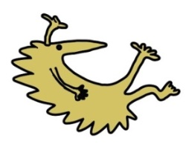
This leaflet only gives general information. You must always discuss the individual treatment of your child with the appropriate member of staff. Do not rely on this leaflet alone for information about your child’s treatment. This information can be made available in other languages and formats if requested.
Alder Hey Children’s NHS Foundation Trust
Eaton Road
Liverpool
L12 2AP

Tel: 0151 228 4811
www.alderhey.nhs.uk

© Alder Hey Review Date: August 2028 PIAG: 98

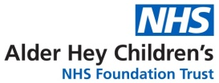

OPAT plan at discharge
(Please note this is a provisional plan and may change after discharge)

Name: …………………………………………………  NHS No: ……………………………………………….  AH No: ………………………… DoB: ……./ …… / …… |  |  | OR |  | AFFIX PATIENT  ID LABEL
Intravenous (OPAT) phase of treatment
Your child is being discharged on the following antimicrobials:
Route*  …….  …….  ……. | Antimicrobial name  ………………………………………  ………………………………………  ……………………………………… | Doses / day  ………….  ………….  …………. |  | Approximate end date  …………………………….  …………………………….  …………………………….
*IV = intravenous, PO = by mouth (‘per oral’)
Follow-on treatment
(once intravenous phase complete)
None needed – all antibiotics to stop
On approx. ……. / ……. / ……… date your child should change to:
Route*  …….  …….  ……. | Antimicrobial name  ………………………………………  ………………………………………  ……………………………………… | Doses / day  ………….  ………….  …………. |  | Approximate end date  …………………………….  …………………………….  …………………………….
Clinic Follow up
None planned  With …………………………………….. team: |  |  | To be advised, but in approx. ……. Weeks  Date: ………….. Time: ………….. Place: ……………..
Blood monitoring
No blood tests planned during OPAT  Weekly blood tests: Standard: FBC, U&E, LFT, CRP  Research: FBC, U&E, LFT, CRP, PCT (procalcitonin)  Additional tests (please specify): …………………………………………………………….. |  |  |  |  |  | Blood tests ideally on a Monday each week during OPAT. For Liverpool children tests can be requested as an order set within Meditech – search for ‘OPAT’

