**What issues do I need to be aware of?**

* Some marking of the skin is normal, as is a build-up of some hard skin. Provided this is not excessive, painful and discolouration clears, this is nothing to worry about. If your child experiences any of the above, contact the department.
* Sometimes insoles can lead to sores, blisters, pain or rubbing, if any of this arises, contact the department.
* Regularly check the condition of your child’s feet, before and after use.
* Please regularly check the condition of the insole also. Check for sharp edges or loose/broken areas of the insole that may cause damage to the feet.
* If you find any issues with the feet or insoles themselves, contact the department for advice.

**Contact us**

If you have any problems or questions please contact a member of

the team who will be happy to discuss them with you.

Telephone: 0151 252 5318

Email: orthotics@alderhey.nhs.uk

This leaflet only provides general information. You must always discuss the individual treatment with the appropriate staff member.

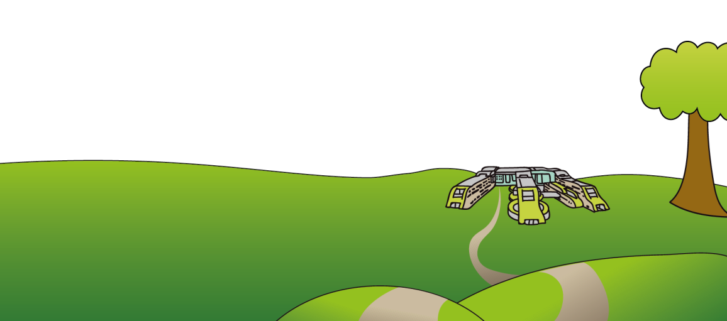Do not rely on this leaflet alone for information about the treatment.

This information can be made available in other languages and formats if requested

Alder Hey Children’s NHS Foundation Trust

Eaton Road

Liverpool

L12 2AP

Tel: 0151 228 4811

[www.alderhey.nhs.uk](http://www.alderhey.nhs.uk)

**© Alder Hey Review Date: July 2027 PIAG: 156**



**Orthotics Department**

**Insoles**

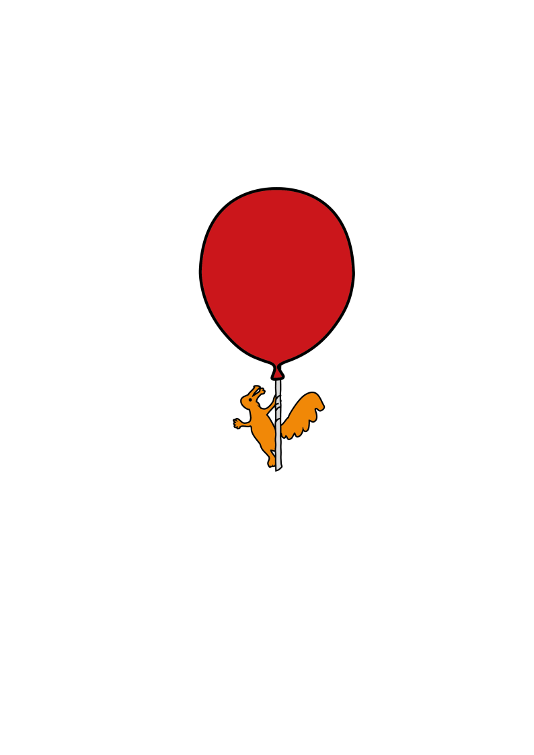

**Information for**

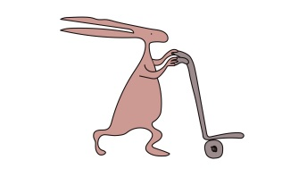**patients, parents and carers**

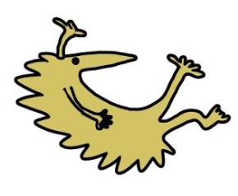

**What are insoles for and what is my child entitled to?**

* Insoles usually fit into your child’s regular footwear and are provided to treat a foot condition or sometimes for knee pain.
* Due to regular changes and growth in children, each child is entitled to 1 pair of insoles at a time, although you may purchase another from the department. The cost of this will differ dependant on the style of insole prescribed.
* A new pair will be provided if the original device is deemed beyond repair or no longer clinically effective by the Orthotist or the Technician within the department.
* We need to see your child for reviews at least every 6 months to keep the current referral open.

**Care of the insoles**

* Try to keep the insoles dry. However, if they do get wet, remove them from the footwear and leave them to dry, away from direct heat. i.e. do not place them on a radiator or in front of a heater/fire as the material will become deformed.
* It is your responsibility to bring the device to the orthotics department for repairs as and when necessary in-between review appointments.

**How are insoles fitted, and wearing the insoles.**

* The insoles will be fitted by one of our trained Orthotists in clinic
* Please attend clinic with appropriate footwear that fastens rather than slips on. It is advisable to attend with a few different styles of footwear but to not purchase new footwear until you have the insoles.
* The Orthotist will advise you on how to properly fit your child’s insoles into shoes for when you need to swap them over.
* The Orthotist will advise you of when and how long the insoles need to be worn for. They will also advise you of the initial wearing in period to allow your child to adjust to wearing the insoles gradually. This reduces the risk of any issues arising, i.e. blisters.

**What footwear does my child need to wear with insoles?**

* A lower opening i.e. a lower tongue, the easier it will be to get the device and the foot into the shoe.
* Slip on shoes are not suitable as they do not provide adequate support to hold the foot in the correction position on the insole or in the actual shoe itself.
* A shoe with a removable insole also provides extra depth to accommodate the insoles.
* Please always wear socks with the insoles.