


Renal Department

Home Haemodialysis

Information for parents, carers & patients

Introduction

This information is for children and young people (CYP) and their parents and carers who are:

- Waiting to start on haemodialysis.
- Currently receiving haemodialysis in hospital via a central venous catheter (CVC) or arteriovenous fistula (AVF).

- Currently receiving peritoneal dialysis at home.
This leaflet will provide information on:
- Kidney failure
- Home haemodialysis
- Training requirements
- An introduction to the team
- Provide information and support to your questions
This information is a guide, if you require any further information or have queries, the home therapies team will be happy to discuss.

What is Kidney failure?

The kidneys are twin organs and have an important role in keeping the body healthy in the following ways:

- Removal of waste products from the body in the urine.
- Control the amount of water in the body and remove excess fluid.
- Regulation of the body’s chemistry, maintaining correct levels of salt, potassium, calcium and phosphate needed for good bone health.
- Control of blood pressure.
- Manufacture of new red blood cells.
Most people are born with two kidneys, however some people are born with one. If one kidney does not function or needs to be removed the remaining kidney can do the work of two. When the kidney/s fail and are unable to perform their normal functions, dialysis is needed to keep you fit and well.

Alder Hey provides peritoneal dialysis and haemodialysis. Historically haemodialysis was only available in hospital and performed by the nurses, however we now offer home haemodialysis. Please read the information on dialysis on infoKID www.infokid.org.uk for full kidney failure and dialysis information.
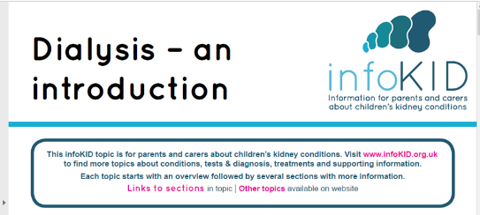

What is haemodialysis?
Haemodialysis (HD) is a form of dialysis that uses a machine with an ‘artificial kidney’ which filters the blood. Blood is pumped out of the body around a circuit through the artificial kidney where it is cleaned and then returned to the body. The machine pumps fluid known as the dialysate into the dialyser. Waste products, salts and excess water are filtered out of the blood into the dialysate.

Preparing for haemodialysis

Please see the Infokid leaflets on Haemodialysis & Haemodialysis fistula: www.infokid.org.uk
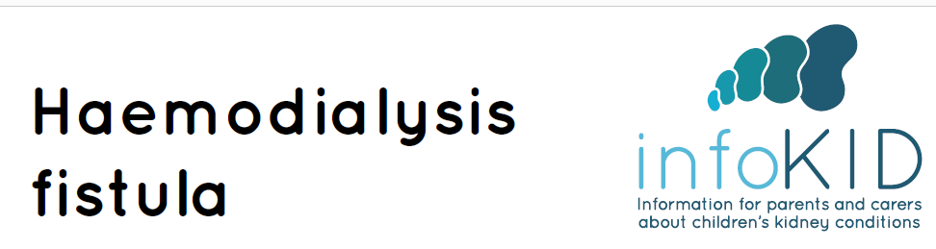

Before dialysis can start, your child or young person will need a procedure to get access to his or her bloodstream. A central venous catheter (CVC) or central venous line is a long, thin tube that is placed into one of the large blood vessels in the body. It usually exits at the chest, and this is known as the exit site.

The procedure is done in theatre under a general anaesthetic. There are 2 lumens on the catheter which connect to the tubing on the dialysis circuit, a red and a blue. The red one takes blood out from your body and the blue returns clean blood back to your body.

The CVC will have a dressing over the exit site and you as parent / carer will be trained to change this. CVC is permanent and needs to be cared for to prevent infections.

Another option for long-term use is an arteriovenous fistula (AVF), where the two blood vessels are connected to make one larger, stronger blood vessel. For regular dialysis sessions two needles are inserted into the fistula and removed at the end. You may apply cream prior to dialysis to numb the area.

The fistula is created in theatre by a vascular surgeon and is left to develop for at least 6 to 8 weeks before use. During this time the vein becomes stronger. The fistula will be assessed, and when ready to be used you will be taught how to access this. You will work through a thorough training package, supported by the home therapies team.

What is Home Haemodialysis?
Home haemodialysis is the provision of haemodialysis within the home performed by parent / carer (or the child or young person themselves if old enough). The home haemodialysis machine is different to the haemodialysis machines used in hospital. It does not require permanent plumbing modifications within the home as it uses pre made sterile bags of dialysis fluid.

The home haemodialysis machine we use at Alder Hey is called the NXStage system one. It has been designed specifically for home use. It takes into account factors such as: size, simplicity, portability and flexibility in order to make home haemodialysis a realistic option for patients by adjusting to their needs and lifestyle.

What are the benefits of home haemodialysis?
Kidney failure and the need for dialysis can have a major impact on life. Being able to have dialysis at home can help reduce some of this impact. The benefits of home haemodialysis include:

- Less time spent travelling to & from hospital, waiting for transport and delays waiting to get on the machine
- More flexibility as it allows you to dialyse at a time that suits. It enables valuable family time for carers to work, and children to attend nursery, school or college.
- Long, slow dialysis has shown to be beneficial and better tolerated. Home haemodialysis dialysis will give you the option to increase dialysis time and frequency
- It potentially lessens diet and fluid restrictions if dialysing more frequently
- It potentially reduces the number of medications, if dialysing more frequently
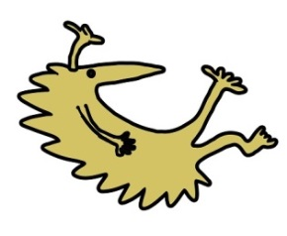
- Frequent dialysis lessens the build-up of toxins and fluids in between sessions making child or young person feel better.
- Better control of blood pressure
- Direct involvment of carer in the child or young person’s treatment
- As the machine is portable it enables local travel.
- General improvement in wellbeing
Are there any disadvantages of home haemodialysis?
- Home Haemodialysis requires a commitment from carers as they are responsible for providing the treatment, adhering to the prescription and submitting records. However, training, support and guidance will be given from the home therapies team.
- Your dialysis room / area will become medicalised.
- You will need adequate storage to accommodate a month’s supply of supplies.
What do I need at home?
The home therapies team will visit your home to perform a home assessment, and this will check for suitability.

You will need to allocate a room where the dialysis can occur safely. This needs to be in close proximity to hand washing facilities and a drain outlet.

You will need somewhere to store one month’s supply of equipment. If storage is an issue we can help by supplying a shed.

NXStage will supply a dialysis machine and the supplies needed for dialysis. However you will need to supply a table for the machine to sit on, (this needs to measure at least 38cm x 38cm x 48cm and be able to sustain a weight of 68kg).

You will also need to supply a comfortable chair, unless your child is going to dialyse on their bed as the sessions may be 4-5 hours.

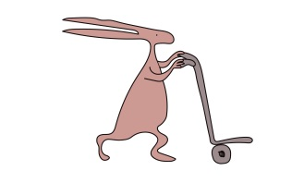
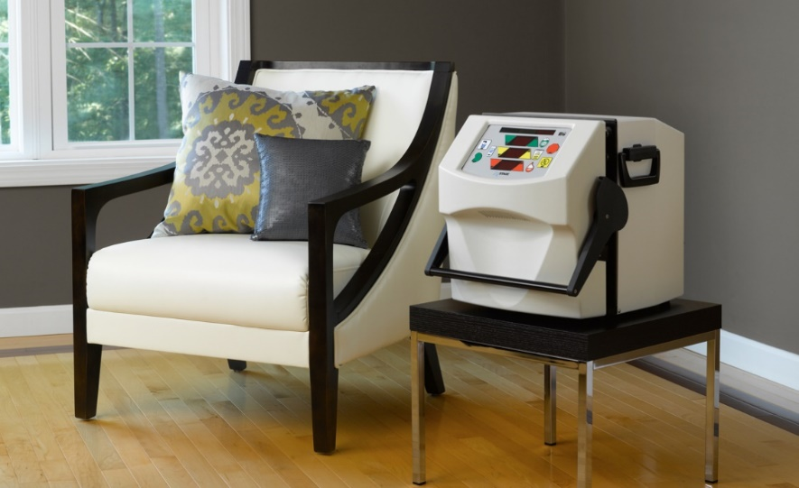

How will I be trained?
If home haemodialysis is the preferred option training will be provided on:

- All aspects of preparing, setting up, connection, performing the dialysis and safe disconnection at the end.
- How to check your child’s blood pressure, pulse rate, weight and temperature and their importance when planning the dialysis session.
- How to follow the dialysis prescription
- Weight and blood pressure limits and when to contact the hospital
- How to access a CVC and care for the exit site or AVF depending on your child’s vascular access.
- How to give an injection to help with anaemia
- How to check and order stock
- How to complete record sheets and submit to the home therapies nurse
- Emergency procedures by the home therapies nurse.
- What to do if you have a problem
How long is the training?
When all training competencies have been achieved and an established dialysis regime is in place, a start date will be agreed. The home therapies team will coordinate this process and be there to support the initial sessions at home. The training will take place on the renal unit and will be a minimum of 2-3 months. Children or young people who are old enough can be trained or assist. It is important you have the written instructions visible and follow them carefully to avoid complications. Your technique will be assessed yearly or after a hospital admission.

What can your child or young person do whilst on dialysis at home?
Whilst on dialysis your child or young person can watch TV, complete homework, read or play games. However, electronic devices must not be plugged into the mains whilst on dialysis, ensure these are charged up prior to starting dialysis.

Your child or young person can eat and drink during the dialysis session. But, we recommend he/she eat a small snack at the start of dialysis rather than near the end as sometimes people can feel poorly if eating near the end. Any drinks during dialysis will need to be counted into the fluid allowance.

Whilst on dialysis blood pressure, temperature, pulse rate and machine readings will be checked every hour. It is important your child or young person informs you if they feel unwell at any time during dialysis.

What support will we get at home?
The home therapies team will be in regular contact to provide support and guidance. You will need to complete record charts and submit these to the home therapies team after each dialysis session.

You will need to keep an eye on stock levels and give a stock take once a month to NXStage who will give you a delivery date. The home therapies team will arrange for waste collection of all your used supplies. You will need to comply with your local council procedures for waste collection.

You will need to attend hospital for regular reviews, have blood tests and intravenous iron, if required. You will also have the opportunity to discuss your treatment in general with the renal team which includes consultant, home therapies team, advanced nurse practitioners, pharmacist and dietician.

What happens if my child is unwell at home?
If you have any concerns regarding your child or young person you should contact the home therapies team for advice. If admission is required you will be admitted to the renal ward at Alder Hey. In emergency situations your child or young person will be stabilised at their nearest hospital. Once stabilised he/she can be trasferred to Alder Hey Hospital and receive their dialysis at Alder Hey Renal Unit.

What happens if we have machine problems?
You will be given the phone number for NXStage who will provide 24/7 technical advice. If you require a new machine this will be organised for you. You will be provided with contact details.

Is home haemodialysis suitable for everyone?
Unfortunately not everyone is suitable for home haemodialysis. Patients must be established on in-centre haemodialysis and be stable on dialysis before home haemodialysis can be considered.
Some patients are too complex to have dialysis outside the hospital. Geographical area may exclude some patients from home haemodialysis.

The consultants, advanced nurse practitioners or home therapies team will be able to discuss further and advise on options for home therapies.

Once you have started home haemodialysis, there is always the option to change to in-centre haemodialysis.

Useful contacts
- Home Dialysis Therapies Team – Leah & Tracy office & procedure room - 0151 282 4782
- Advanced Nurse Practitioners for Nephrology - Laura - 0151 282 4812
- Switchboard - Ask for Neprology (Kidney Team) - 0151 228 4811

For additional information on kidney failure and haemodialysis please visit: www.infokid.org.uk or www.kidney.org

For additional information on NXStage haemodialysis machine for home haemodialysis please visit: www.nxstage.co.uk

This leaflet only gives general information. You must always discuss the individual treatment of your child with the appropriate member of staff. Do not rely on this leaflet alone for information about your child’s treatment.

This information can be made available in other languages and formats if requested.

Alder Hey Children’s NHS Foundation Trust
Alder Hey
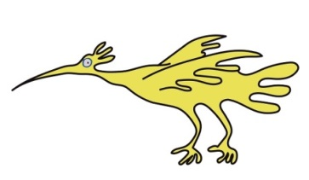
Eaton Road
Liverpool
L12 2AP

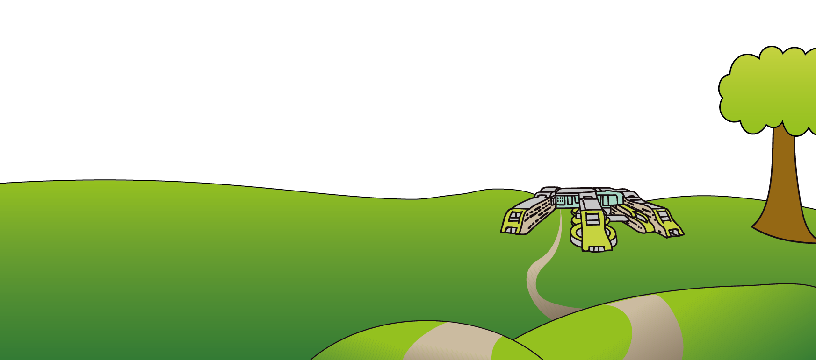
Tel: 0151 228 4811
www.alderhey.nhs.uk

© Alder Hey Review Date: November 2027 PIAG: 361

